UNITED STATES

SECURITIES AND EXCHANGE COMMISSION

WASHINGTON, DC 20549

FORM 10-Q

(Mark One)

- QUARTERLY REPORT PURSUANT TO SECTION 13 OR 15(d) OF THE SECURITIES EXCHANGE ACT OF 1934

For the quarterly period ended March 31, 2022

OR

- TRANSITION REPORT PURSUANT TO SECTION 13 OR 15(d) OF THE SECURITIES EXCHANGE ACT OF 1934

For the transition period from to

Commission File Number: 001-39390
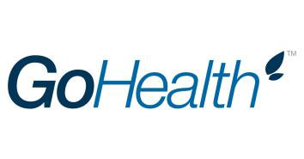

GoHealth, Inc.

(Exact name of registrant as specified in its charter)

_________________________

Delaware | 85-0563805
(State or other jurisdiction of incorporation or organization) | (I.R.S. Employer Identification No.)
214 West Huron St.
Chicago, Illinois | 60654
(Address of principal executive offices) | (Zip Code)
(312) 386-8200
(Registrant’s telephone number, including area code)
N/A

(Former name, former address and former fiscal year, if changed since last report)

_________________________

Securities registered pursuant to Section 12(b) of the Act:
 |  |  |  | Name of each exchange
Title of each class |  | Trading Symbol(s) |  | on which registered
Class A Common Stock, |  | GOCO |  | The Nasdaq Global Market
$0.0001 par value per share

Indicate by check mark whether the registrant: (1) has filed all reports required to be filed by Section 13 or 15(d) of the Securities Exchange Act of 1934 during the preceding 12 months (or for such shorter period that the registrant was required to file such reports), and (2) has been subject to such filing requirements for the past 90 days. Yes ☒ No ☐

Indicate by check mark whether the registrant has submitted electronically every Interactive Data File required to be submitted pursuant to Rule 405 of Regulation S-T (§ 232.405 of this chapter) during the preceding 12 months (or for such shorter period that the registrant was required to submit such files). Yes ☒ No ☐

Indicate by check mark whether the registrant is a large accelerated filer, an accelerated filer, a non-accelerated filer, a smaller reporting company, or an emerging growth company. See the definitions of “large accelerated filer,” “accelerated filer,” “smaller reporting company,” and “emerging growth company” in Rule 12b-2 of the Exchange Act.

Large accelerated filer | ☒ | Smaller reporting company | ☐
Non-accelerated filer | ☐ | Emerging growth company | ☐
Accelerated filer | ☐

If an emerging growth company, indicate by check mark if the registrant has elected not to use the extended transition period for complying with any new or revised financial accounting standards provided pursuant to Section 13(a) of the Exchange Act. ☐

Indicate by check mark whether the registrant is a shell company (as defined in Rule 12b-2 of the Exchange Act). Yes ☐ No ☒

As of May 3, 2022, the registrant had 121,782,131 shares of Class A common stock, $0.0001 par value per share, outstanding and 199,223,623 shares of Class B common stock, $0.0001 par value per share, outstanding.

 |  |  |  |  |  |  |  |  |  |  |  | TABLE OF CONTENTS
 |  |  |  |  |  |  |  |  |  |  |  |  |  |  |  |  |  |  |  |  | PAGE
 |  |  |  |  |  |  |  |  |  |  | PART I - FINANCIAL INFORMATION
ITEM 1. | FINANCIAL STATEMENTS. |  |  |  |  |  |  |  |  |  |  |  |  |  |  |  |  |  |  |  | 4
 | CONDENSED CONSOLIDATED FINANCIAL STATEMENTS |  |  |  |  |  |  |  |  |  |  |  |  |  |  |  |  |  |  |  | 4
 |  | CONDENSED CONSOLIDATED STATEMENTS OF OPERATIONS |  |  |  |  |  |  |  |  |  |  |  |  |  |  |  |  |  |  | 4
 |  | CONDENSED CONSOLIDATED STATEMENTS OF COMPREHENSIVE INCOME (LOSS) |  |  |  |  |  |  |  |  |  |  |  |  |  |  |  |  |  |  | 5
 |  | CONDENSED CONSOLIDATED BALANCE SHEETS |  |  |  |  |  |  |  |  |  |  |  |  |  |  |  |  |  |  | 6
 |  | CONDENSED CONSOLIDATED STATEMENTS OF CHANGES IN STOCKHOLDERS’ EQUITY |  |  |  |  |  |  |  |  |  |  |  |  |  |  |  |  |  |  | 7
 |  | CONDENSED CONSOLIDATED STATEMENTS OF CASH FLOWS |  |  |  |  |  |  |  |  |  |  |  |  |  |  |  |  |  |  | 8
 |  | NOTES TO CONDENSED CONSOLIDATED FINANCIAL STATEMENTS |  |  |  |  |  |  |  |  |  |  |  |  |  |  |  |  |  |  | 9
ITEM 2. | MANAGEMENT’S DISCUSSION AND ANALYSIS OF FINANCIAL CONDITIONS AND RESULTS OF OPERATIONS. |  |  |  |  |  |  |  |  |  |  |  |  |  |  |  |  |  |  |  | 23
ITEM 3. | QUANTITATIVE AND QUALITATIVE DISCLOSURES ABOUT MARKET RISK. |  |  |  |  |  |  |  |  |  |  |  |  |  |  |  |  |  |  |  | 34
ITEM 4. | CONTROLS AND PROCEDURES. |  |  |  |  |  |  |  |  |  |  |  |  |  |  |  |  |  |  |  | 34
 |  |  |  |  |  |  |  |  |  |  |  | PART II - OTHER INFORMATION
ITEM 1. | LEGAL PROCEEDINGS. |  |  |  |  |  |  |  |  |  |  |  |  |  |  |  |  |  |  |  | 36
ITEM 1A. | RISK FACTORS. |  |  |  |  |  |  |  |  |  |  |  |  |  |  |  |  |  |  |  | 36
ITEM 2. | UNREGISTERED SALES OF EQUITY SECURITIES AND USE OF PROCEEDS. |  |  |  |  |  |  |  |  |  |  |  |  |  |  |  |  |  |  |  | 38
ITEM 3. | DEFAULT UPON SENIOR SECURITIES. |  |  |  |  |  |  |  |  |  |  |  |  |  |  |  |  |  |  |  | 38
ITEM 4. | MINE SAFETY DISCLOSURES. |  |  |  |  |  |  |  |  |  |  |  |  |  |  |  |  |  |  |  | 38
ITEM 5. | OTHER INFORMATION. |  |  |  |  |  |  |  |  |  |  |  |  |  |  |  |  |  |  |  | 38
ITEM 6. | EXHIBITS. |  |  |  |  |  |  |  |  |  |  |  |  |  |  |  |  |  |  |  | 39
 | SIGNATURES |  |  |  |  |  |  |  |  |  |  |  |  |  |  |  |  |  |  |  | 40

CAUTIONARY NOTE REGARDING FORWARD-LOOKING STATEMENTS

This Quarterly Report on Form 10-Q contains forward-looking statements. We intend such forward-looking statements to be covered by the safe harbor provisions for forward-looking statements contained in Section 27A of the Securities Act of 1933, as amended, (“the Securities Act”) and Section 21E of the Securities Exchange Act of 1934, as amended, (“the Exchange Act”). All statements other than statements of historical facts contained in this Quarterly Report on Form 10-Q may be forward-looking statements. Statements regarding our future results of operations and financial position, business strategy and plans and objectives of management for future operations, including, among others, statements regarding our expected growth, future capital expenditures and debt service obligations, are forward-looking statements.

In some cases, you can identify forward-looking statements by terms, such as “may,” “will,” “should,” “expects,” “plans,” “anticipates,” “could,” “intends,” “targets,” “projects,” “contemplates,” “believes,” “estimates,” “predicts,” “potential” or “continue” or the negative of these terms or other similar expressions. The forward-looking statements in this Quarterly Report on Form 10-Q are only predictions. Accordingly, we caution you that any such forward-looking statements are not guarantees of future performance and are subject to risks, assumptions and uncertainties that are difficult to predict.

Although we believe that the expectations reflected in these forward-looking statements are reasonable as of the date made, actual results may prove to be materially different from the results expressed or implied by the forward-looking statements.

These forward-looking statements speak only as of the date of this Quarterly Report on Form 10-Q and are subject to a number of important factors that could cause actual results to differ materially from those in the forward-looking statements, including but not limited to the following: the marketing and sale of Medicare plans are subject to numerous, complex and frequently changing laws, regulations and guidelines; our business may be harmed if we lose our relationships with carriers or if our relationships with carriers change; our failure to grow our customer base or retain our existing customers; carriers may reduce the commissions paid to us and change their underwriting practices in ways that reduce the number of, or impact the renewal or approval rates of, insurance policies sold through our platform; factors that impact our estimate of LTV (as defined below) may be adversely impacted; our management and independent auditors have identified a material weakness in our internal controls over financial reporting, and we may be unable to develop, implement and maintain appropriate controls in future periods, which may lead to errors or omissions in our financial statements; the potential delisting of our common stock from the NASDAQ; volatility in general economic conditions, including inflation, interest rates, and other commodity prices and exchange rates may impact our financial position and performance; we currently depend on a small group of carriers for a substantial portion of our revenue; information technology system failures could interrupt our operations; our ability to sell Medicare-related health insurance plans is largely dependent on our licensed health insurance agents; operating and growing our business may require additional capital; we may lose key employees or fail to attract qualified employees; the Founders and Centerbridge have significant influence over us, including control over decisions that require the approval of stockholders; and other important factors described in the section titled “Risk Factors” in our Annual Report on Form 10-K for the year ended December 31, 2021 (the “2021 Form 10-K”), the section titled “Management’s Discussion and Analysis of Financial Condition and Results of Operations” in this Quarterly Report on Form 10-Q, and in our other filings with the Securities and Exchange Commission.

You should read this Quarterly Report on Form 10-Q and the documents that we reference in this Quarterly Report on Form 10-Q completely and with the understanding that our actual future results may be materially different from what we expect. We qualify all of our forward-looking statements by these cautionary statements. Except as required by applicable law, we do not plan to publicly update or revise any forward-looking statements contained herein, whether as a result of any new information, future events, changed circumstances or otherwise.

CERTAIN DEFINITIONS

As used in this Quarterly Report on Form 10-Q, unless the context otherwise requires:

- “we,” “us,” “our,” the “Company,” “GoHealth” and similar references refer to GoHealth, Inc., and, unless otherwise stated, all of its direct and indirect subsidiaries, including GoHealth Holdings, LLC (formerly known as Blizzard Parent, LLC).

- “Blocker Company” refers to an entity affiliated with Centerbridge that was an indirect owner of LLC Interests in GoHealth Holdings, LLC prior to the Transactions and is taxable as a corporation for U.S. federal income tax purposes.

- “Blocker Shareholders” refer to entities affiliated with Centerbridge, the owners of the Blocker Company prior to the Transactions, who exchanged their interests in the Blocker Company for shares of our Class A common stock and cash in connection with the consummation of the Transactions.

- “Centerbridge” refers to Centerbridge Capital Partners III, L.P., our sponsor and a Delaware limited partnership, certain funds affiliated with Centerbridge Capital Partners III, L.P. and other entities over which Centerbridge Capital Partners III, L.P. has voting control (including any such fund or entity formed to hold shares of Class A common stock for the Blocker Shareholders).

GoHealth, Inc. | 2022 Form 10-Q | 1

- “Centerbridge Acquisition” or “Acquisition” refers to the acquisition, on September 13, 2019, by Centerbridge, indirectly through a subsidiary of GoHealth Holdings, LLC (formerly known as Blizzard Parent, LLC), an entity formed in contemplation of the acquisition, of a 100% interest in Norvax.

- “Continuing Equity Owners” refer collectively to direct or indirect holders of LLC Interests and our Class B common stock immediately following consummation of the Transactions, including Centerbridge, Norwest Equity Partners, NVX Holdings, our Founders, the Former Profits Unit Holders and certain executive officers, employees and other minority investors and their respective permitted transferees who may, following the consummation of our IPO, exchange at each of their respective options (subject in certain circumstances to time-based vesting requirements and certain other restrictions), in whole or in part from time to time, their LLC Interests (along with an equal number of shares of Class B common stock (and such shares shall be immediately cancelled)) for, at our election (determined solely by our independent directors (within the meaning of the listing rules of The Nasdaq Global Market (the “Nasdaq rules”)) who are disinterested), cash or newly-issued shares of our Class A common stock.

- “Founders” refer to Brandon M. Cruz, our Co-Founder and Chief Strategy Officer and Special Advisor to the Executive Team, and Clinton P. Jones, our Co-Founder and Chief Executive Officer.

- “Former Profits Unit Holders” refers collectively to certain of our directors and certain current and former officers and employees, in each case, who directly or indirectly held existing vested and unvested profits units, which were comprised of profits units that have time-based vesting conditions and profits units that have performance-based vesting conditions, of GoHealth Holdings, LLC pursuant to GoHealth Holdings, LLC’s existing profits unit plan and who received LLC Interests in exchange for their profits units in connection with the Transactions. LLC Interests received in exchange for unvested profits units remain subject to their existing time-based vesting requirements. Profit units with performance-based vesting conditions fully vested as such conditions were met in connection with our IPO.

- “GoHealth Holdings, LLC Agreement” refers to GoHealth Holdings, LLC’s amended and restated limited liability company agreement, as further amended, which became effective substantially concurrently with or prior to the consummation of our IPO.

- “LLC Interests” refer to the common units of GoHealth Holdings, LLC, including those that we purchased with a portion of the net proceeds from our IPO.

- “Norvax” refers to Norvax, LLC, a Delaware limited liability company and a subsidiary of GoHealth Holdings, LLC.

- “NVX Holdings” refers to NVX Holdings, Inc., a Delaware corporation that is controlled by the Founders.

- “Transactions” refer to our IPO and certain organizational transactions that were effected in connection with our IPO, and the application of the net proceeds therefrom.

GoHealth, Inc. is a holding company and the sole managing member of GoHealth Holdings, LLC, and its principal asset consists of LLC Interests.

KEY TERMS AND PERFORMANCE INDICATORS; NON-GAAP FINANCIAL MEASURES

Throughout this Quarterly Report on Form 10-Q, we use a number of key terms and provide a number of key performance indicators used by management. We define these terms and key performance indicators as follows:

- “Adjusted EBITDA” represents, as applicable for the period, EBITDA as further adjusted for certain items discussed in Item 2. Management’s Discussion and Analysis of Financial Condition and Results of Operations.

- “Adjusted EBITDA Margin” refers to Adjusted EBITDA divided by net revenues.

- “Approved Submissions” refer to Submitted Policies approved by carriers for the identified product during the indicated period.

- “CAC” refers to the cost to convert a prospect into a customer less other non-commission carrier revenue for such period. CAC is comprised of cost of revenue, marketing and advertising expenses and customer care and enrollment expenses less other revenue and is presented on a per commissionable Approved Submission basis.

- “EBITDA” represents net income (loss) before interest expense, income tax expense (benefit) and depreciation and amortization expense.

GoHealth, Inc. | 2022 Form 10-Q | 2

- “LTV” refers to the Lifetime Value of Commissions per Approved Submission, which we define as aggregate commissions estimated to be collected over the estimated life of all commissionable Approved Submissions for the relevant period based on multiple factors, including but not limited to, contracted commission rates, carrier mix and expected policy persistency with applied constraints.

- “LTV Per Approved Submission” refers to the Lifetime Value of Commissions per Approved Submission, which we define as (i) aggregate commissions estimated to be collected over the estimated life of all commissionable Approved Submissions for the relevant period based on multiple factors, including but not limited to, contracted commission rates, carrier mix and expected policy persistency with applied constraints, excluding revenue adjustments recorded in the period, but relating to performance obligations satisfied in prior periods, divided by (ii) the number of commissionable Approved Submissions for such period.

- “LTV/CAC” refers to the Lifetime Value of Commissions per Consumer Acquisition Cost, which we define as (i) aggregate commissions estimated to be collected over the estimated life of all commissionable Approved Submissions for the relevant period based on multiple factors, including but not limited to, contracted commission rates, carrier mix and expected policy persistency with applied constraints, excluding revenue adjustments recorded in the period, but relating to performance obligations satisfied in prior periods, divided by (ii) the cost to convert a prospect into a customer less other non-commission carrier revenue for such period, or CAC. CAC is comprised of cost of revenue, marketing and advertising expenses and customer care and enrollment expenses less enterprise revenue, excluding cost of revenue adjustments recorded in the period, but relating to performance obligations satisfied in prior periods, and is presented on a per commissionable Approved Submission basis.

- “Submitted Policies” refer to completed applications that, with respect to each such application, the consumer has authorized us to submit to the carrier.

We use supplemental measures of our performance that are derived from our consolidated financial information, but which are not presented in our Condensed Consolidated Financial Statements prepared in accordance with U.S. generally accepted accounting principles (“GAAP”). These non-GAAP financial measures include EBITDA; Adjusted EBITDA and Adjusted EBITDA Margin. Adjusted EBITDA is the primary financial performance measure used by management to evaluate its business and monitor its results of operations.

We use non-GAAP financial measures to supplement financial information presented on a GAAP basis. We believe that excluding certain items from our GAAP results allows management to better understand our consolidated financial performance from period to period and better project our future consolidated financial performance as forecasts are developed at a level of detail different from that used to prepare GAAP-based financial measures. Moreover, we believe these non-GAAP financial measures provide our stakeholders with useful information to help them evaluate our operating results by facilitating an enhanced understanding of our operating performance and enabling them to make more meaningful period to period comparisons. There are limitations to the use of the non-GAAP financial measures presented in this Quarterly Report on Form 10-Q. For example, our non-GAAP financial measures may not be comparable to similarly titled measures of other companies. Other companies, including companies in our industry, may calculate non-GAAP financial measures differently than we do, limiting the usefulness of those measures for comparative purposes.

The non-GAAP financial measures are not meant to be considered as indicators of performance in isolation from or as a substitute for net income (loss) prepared in accordance with GAAP, and should be read only in conjunction with financial information presented on a GAAP basis. Reconciliations of each of EBITDA and Adjusted EBITDA to its most directly comparable GAAP financial measure, net income (loss), are presented in the tables below in this Quarterly Report on Form 10-Q. We encourage you to review the reconciliations in conjunction with the presentation of the non-GAAP financial measures for each of the periods presented. In future periods, we may exclude similar items, may incur income and expenses similar to these excluded items and include other expenses, costs and non-recurring items.

GoHealth, Inc. | 2022 Form 10-Q | 3

PART I - Financial Information

ITEM 1. FINANCIAL STATEMENTS.

CONDENSED CONSOLIDATED FINANCIAL STATEMENTS

GOHEALTH, INC.

CONDENSED CONSOLIDATED STATEMENTS OF OPERATIONS

(in thousands, except per share amounts, unaudited)

 |  |  |  |  | Three months ended Mar. 31,
 |  |  |  |  | 2022 |  |  | 2021
Net revenues:
Commission |  |  | $ |  | 209,639 |  | $ | 173,981
Enterprise |  |  |  |  | 60,954 |  |  | 30,198
Net revenues |  |  |  |  | 270,593 |  |  | 204,179
Operating expenses:
Cost of revenue |  |  |  |  | 67,923 |  |  | 48,375
Marketing and advertising |  |  |  |  | 84,033 |  |  | 54,484
Customer care and enrollment |  |  |  |  | 78,455 |  |  | 47,094
Technology |  |  |  |  | 12,759 |  |  | 9,617
General and administrative |  |  |  |  | 29,217 |  |  | 19,685
Amortization of intangible assets |  |  |  |  | 23,514 |  |  | 23,514
Total operating expenses |  |  |  |  | 295,901 |  |  | 202,769
Income (loss) from operations |  |  |  |  | (25,308) |  |  | 1,410
Interest expense |  |  |  |  | 11,398 |  |  | 8,688
Other (income) expense, net |  |  |  |  | 63 |  |  | 13
Income (loss) before income taxes |  |  |  |  | (36,769) |  |  | (7,291)
Income tax (benefit) expense |  |  |  |  | 472 |  |  | (31)
Net income (loss) |  |  |  |  | (37,241) |  |  | (7,260)
Net income (loss) attributable to non-controlling interests |  |  |  |  | (23,758) |  |  | (5,173)
Net income (loss) attributable to GoHealth, Inc. |  |  | $ |  | (13,483) |  | $ | (2,087)
Net loss per share (Note 7):
Net loss per share of Class A common stock — basic and diluted |  |  | $ |  | (0.12) |  | $ | (0.02)
Weighted-average shares of Class A common stock outstanding — basic and diluted |  |  |  |  | 116,207 |  |  | 92,343
The accompanying Notes are an integral part of these Condensed Consolidated Financial Statements
GoHealth, Inc. |  | 2022 Form 10-Q
GoHealth, Inc. |  | 2022 Form 10-Q | 4

GOHEALTH, INC.

CONDENSED CONSOLIDATED STATEMENTS OF COMPREHENSIVE INCOME (LOSS)

(in thousands, unaudited)

 |  |  |  |  | Three months ended Mar. 31,
 |  |  |  |  | 2022 |  |  | 2021
Net income (loss) |  |  | $ |  | (37,241) |  | $ | (7,260)
Other comprehensive income (loss):
Foreign currency translation adjustments |  |  |  |  | (117) |  |  | 7
Comprehensive income (loss) |  |  |  |  | (37,358) |  |  | (7,253)
Comprehensive income (loss) attributable to non-controlling interests |  |  |  |  | (23,833) |  |  | (5,168)
Comprehensive income (loss) attributable to GoHealth, Inc. |  |  | $ |  | (13,525) |  | $ | (2,085)
The accompanying Notes are an integral part of these Condensed Consolidated Financial Statements.
GoHealth, Inc. |  | 2022 Form 10-Q
GoHealth, Inc. |  | 2022 Form 10-Q | 5

GOHEALTH, INC.

CONDENSED CONSOLIDATED BALANCE SHEETS

(in thousands, except per share amounts, unaudited)

 |  |  |  |  | Mar. 31, 2022 |  |  | Dec. 31, 2021
Assets
Current assets:
Cash and cash equivalents |  |  |  | $ | 129,628 |  | $ | 84,361
Accounts receivable, net of allowance for doubtful accounts of $926 in 2022 and $558 in 2021 |  |  |  |  | 40,117 |  |  | 17,276
Commissions receivable - current |  |  |  |  | 189,287 |  |  | 268,663
Prepaid expense and other current assets |  |  |  |  | 32,730 |  |  | 58,695
Total current assets |  |  |  |  | 391,762 |  |  | 428,995
Commissions receivable - non-current |  |  |  |  | 947,280 |  |  | 993,844
Operating lease ROU asset |  |  |  |  | 22,044 |  |  | 23,462
Other long-term assets |  |  |  |  | 2,857 |  |  | 3,608
Property, equipment, and capitalized software, net |  |  |  |  | 27,863 |  |  | 24,273
Intangible assets, net |  |  |  |  | 571,154 |  |  | 594,669
Total assets |  |  |  | $ | 1,962,960 |  | $ | 2,068,851
Liabilities and Stockholders’ Equity
Current liabilities:
Accounts payable |  |  |  | $ | 25,797 |  | $ | 39,843
Accrued liabilities |  |  |  |  | 34,724 |  |  | 52,788
Commissions payable - current |  |  |  |  | 56,645 |  |  | 104,160
Short-term operating lease liability |  |  |  |  | 6,249 |  |  | 6,126
Deferred revenue |  |  |  |  | 1,137 |  |  | 536
Current portion of long-term debt |  |  |  |  | 5,270 |  |  | 5,270
Other current liabilities |  |  |  |  | 11,067 |  |  | 8,344
Total current liabilities |  |  |  |  | 140,889 |  |  | 217,067
Non-current liabilities:
Commissions payable - non-current |  |  |  |  | 281,250 |  |  | 274,403
Long-term operating lease liability |  |  |  |  | 18,185 |  |  | 19,776
Long-term debt, net of current portion |  |  |  |  | 662,678 |  |  | 665,115
Total non-current liabilities |  |  |  |  | 962,113 |  |  | 959,294
Commitments and Contingencies (Note 11)
Stockholders’ equity:
Class A common stock – $0.0001 par value; 1,100,000 shares authorized; 121,944 and 115,487 shares issued; 121,775 and 115,487 shares |  |  |  |  | 12 |  |  | 11
outstanding at March 31, 2022 and December 31, 2021, respectively. |  |  |  |  | 12 |  |  | 11
Class B common stock – $0.0001 par value; 581,346 and 587,360 shares authorized; 199,338 and 205,352 shares issued and outstanding at March 31, |  |  |  |  | 20 |  |  | 21
2022 and December 31, 2021, respectively. |  |  |  |  | 20 |  |  | 21
Preferred stock – $0.0001 par value; 20,000 shares authorized; no shares issued and outstanding at March 31, 2022 and December 31, 2021. |  |  |  |  | — |  |  | —
Treasury stock – at cost; 169 shares of Class A common stock at March 31, 2022 |  |  |  |  | (329) |  |  | —
Additional paid-in capital |  |  |  |  | 583,323 |  |  | 561,447
Accumulated other comprehensive income (loss) |  |  |  |  | (101) |  |  | (59)
Accumulated deficit |  |  |  |  | (221,800) |  |  | (208,317)
Total stockholders’ equity attributable to GoHealth, Inc. |  |  |  |  | 361,125 |  |  | 353,103
Non-controlling interests |  |  |  |  | 498,833 |  |  | 539,387
Total stockholders’ equity |  |  |  |  | 859,958 |  |  | 892,490
Total liabilities and stockholders’ equity |  |  |  | $ | 1,962,960 |  | $ | 2,068,851
The accompanying Notes are an integral part of these Condensed Consolidated Financial Statements.
GoHealth, Inc. |  | 2022 Form 10-Q
GoHealth, Inc. |  | 2022 Form 10-Q | 6

GOHEALTH, INC.

CONDENSED CONSOLIDATED STATEMENTS OF CHANGES IN STOCKHOLDERS’ EQUITY

(in thousands, unaudited)

 |  |  |  |  |  |  |  |  |  |  |  |  |  |  |  |  |  |  | Three months ended Mar. 31, 2022
 | Class A Common Stock |  |  |  |  |  |  | Class B Common Stock |  |  |  |  |  |  |  | Treasury Stock
 | Shares |  | Amount |  |  |  |  | Shares |  |  |  |  | Amount |  |  | Shares |  |  | Amount |  | Additional Paid-In |  |  |  |  | Accumulated Deficit |  |  |  |  |  | Accumulated Other |  |  |  |  | Non-Controlling |  |  |  | Stockholders’ Equity
 | Shares |  | Amount |  |  |  |  |  |  |  |  |  |  |  |  |  |  |  | Amount |  |  | Capital |  |  |  |  |  |  |  |  | Comprehensive Income (Loss) |  |  |  |  |  | Interest
Balance at Jan. 1, 2022 | 115,487 |  | $ | 11 |  |  |  | 205,352 |  | $ |  |  | 21 |  |  | — |  | $ | — |  | $ | 561,447 |  |  | $ |  | (208,317) |  |  | $ |  | (59) |  |  | $ |  | 539,387 |  |  | $ |  | 892,490
Net loss |  |  |  |  |  |  |  |  |  |  |  |  |  |  |  |  |  |  |  |  |  |  |  |  |  |  | (13,483) |  |  |  |  |  |  |  |  |  | (23,758) |  |  |  |  | (37,241)
Issuance of Class A common shares
related to share-based compensation | 513 |  |  | — |  |  |  |  |  |  |  |  |  |  |  |  |  |  |  |  |  | — |  |  |  |  |  |  |  |  |  |  |  |  |  |  |  |  |  |  |  | —
plans | 513 |  |  |  |  |  |  |  |  |  |  |  |  |  |  |  |  |  |  |  |  |  |  |  |  |  |  |  |  |  |  |  |  |  |  |  |  |  |  |  |  | —
Share-based compensation expense |  |  |  |  |  |  |  |  |  |  |  |  |  |  |  |  |  |  |  |  |  | 5,155 |  |  |  |  |  |  |  |  |  |  |  |  |  |  |  |  |  |  |  | 5,155
Foreign currency translation adjustment |  |  |  |  |  |  |  |  |  |  |  |  |  |  |  |  |  |  |  |  |  |  |  |  |  |  |  |  |  |  |  | (42) |  |  |  |  | (75) |  |  |  |  | (117)
Class A common shares repurchased for |  |  |  |  |  |  |  |  |  |  |  |  |  |  |  | (169) |  |  | (329) |  |  |  |  |  |  |  |  |  |  |  |  |  |  |  |  |  |  |  |  |  |  | (329)
employee tax withholdings |  |  |  |  |  |  |  |  |  |  |  |  |  |  |  | (169) |  |  | (329) |  |  |  |  |  |  |  |  |  |  |  |  |  |  |  |  |  |  |  |  |  |  | (329)
Forfeitures of Time-Vesting Units |  |  |  |  |  |  |  | (70) |  |  |  |  | — |  |  |  |  |  |  |  |  |  |  |  |  |  |  |  |  |  |  |  |  |  |  |  |  |  |  |  |  | —
Redemption of LLC Interests | 5,944 |  |  | 1 |  |  |  | (5,944) |  |  |  |  | (1) |  |  |  |  |  |  |  |  | 16,721 |  |  |  |  |  |  |  |  |  |  |  |  |  |  | (16,721) |  |  |  |  | —
Balance at Mar. 31, 2022 | 121,944 |  | $ | 12 |  |  |  | 199,338 |  |  |  | $ | 20 |  |  | (169) |  | $ | (329) |  | $ | 583,323 |  |  | $ |  | (221,800) |  |  | $ |  | (101) |  |  | $ |  | 498,833 |  |  | $ |  | 859,958
 |  |  |  |  |  |  |  |  |  |  |  |  |  |  |  |  |  |  |  |  |  | Three months ended Mar. 31, 2021
 |  |  |  |  |  |  |  | Class A Common Stock |  |  |  |  |  |  |  | Class B Common Stock
 |  |  |  |  |  |  |  | Shares |  |  |  |  | Amount |  |  | Shares |  |  | Amount |  | Additional Paid-In |  |  |  |  |  | Accumulated Deficit |  |  |  |  | Accumulated Other |  |  |  |  | Non-Controlling |  |  |  |  | Stockholders’ Equity
 |  |  |  |  |  |  |  | Shares |  |  |  |  |  |  |  |  |  |  | Amount |  |  | Capital |  |  |  |  |  |  |  |  |  | Comprehensive Income (Loss) |  |  |  |  | Interest
Balance at Jan. 1, 2021 |  |  |  |  |  |  |  | 84,196 |  | $ |  |  | 8 |  |  | 236,997 |  | $ | 24 |  | $ | 399,169 |  |  | $ |  | (18,802) |  |  | $ |  | 17 |  |  | $ |  | 1,018,739 |  |  | $ |  | 1,399,155
Cumulative impact of Topic 842 |  |  |  |  |  |  |  |  |  |  |  |  |  |  |  |  |  |  |  |  |  |  |  |  |  |  | (17) |  |  |  |  |  |  |  |  |  | (46) |  |  |  |  | (63)
Cumulative impact of Topic 326 |  |  |  |  |  |  |  |  |  |  |  |  |  |  |  |  |  |  |  |  |  |  |  |  |  |  | (141) |  |  |  |  |  |  |  |  |  | (398) |  |  |  |  | (539)
Net loss |  |  |  |  |  |  |  |  |  |  |  |  |  |  |  |  |  |  |  |  |  |  |  |  |  |  | (2,087) |  |  |  |  |  |  |  |  |  | (5,173) |  |  |  |  | (7,260)
Issuance of Class A common shares related to share-based compensation |  |  |  |  |  |  |  | 12 |  |  |  |  | — |  |  |  |  |  |  |  |  |  |  |  |  |  |  |  |  |  |  |  |  |  |  |  |  |  |  |  |  | —
plans |  |  |  |  |  |  |  | 12
Share-based compensation expense |  |  |  |  |  |  |  |  |  |  |  |  |  |  |  |  |  |  |  |  |  | 5,112 |  |  |  |  |  |  |  |  |  |  |  |  |  |  |  |  |  |  |  | 5,112
Foreign currency translation adjustment |  |  |  |  |  |  |  |  |  |  |  |  |  |  |  |  |  |  |  |  |  |  |  |  |  |  |  |  |  |  |  | 2 |  |  |  |  | 5 |  |  |  |  | 7
Forfeitures of Time-Vesting Units |  |  |  |  |  |  |  |  |  |  |  |  |  |  |  | (81) |  |  | — |  |  |  |  |  |  |  |  |  |  |  |  |  |  |  |  |  |  |  |  |  |  | —
Redemption of LLC Interests |  |  |  |  |  |  |  | 14,310 |  |  |  |  | 2 |  |  | (14,310) |  |  | (2) |  |  | 61,655 |  |  |  |  |  |  |  |  |  |  |  |  |  |  | (61,655) |  |  |  |  | —
Balance at Mar. 31, 2021 |  |  |  |  |  |  |  | 98,518 |  | $ |  |  | 10 |  |  | 222,606 |  | $ | 22 |  |  | 465,936 |  |  | $ |  | (21,047) |  |  | $ |  | 19 |  |  | $ |  | 951,472 |  |  | $ |  | 1,396,412

The accompanying Notes are an integral part of these Condensed Consolidated Financial Statements.

GoHealth, Inc. | 2022 Form 10-Q | 7

GOHEALTH, INC.

CONDENSED CONSOLIDATED STATEMENTS OF CASH FLOWS

(in thousands, unaudited)

Three months ended
Mar. 31,

 | 2022 |  |  |  | 2021
Operating Activities
Net loss | $ | (37,241) |  | $ | (7,260)
Adjustments to reconcile net income (loss) to net cash provided by (used in) operating activities:
Share-based compensation |  | 5,155 |  |  | 5,112
Depreciation and amortization |  | 2,434 |  |  | 1,853
Amortization of intangible assets |  | 23,514 |  |  | 23,514
Amortization of debt discount and issuance costs |  | 664 |  |  | 684
Non-cash lease expense |  | 1,418 |  |  | 1,216
Other non-cash items |  | (37) |  |  | (480)
Changes in assets and liabilities:
Accounts receivable |  | (22,888) |  |  | (1,661)
Commissions receivable |  | 126,024 |  |  | 9,508
Prepaid expenses and other assets |  | 26,659 |  |  | 9,227
Accounts payable |  | (14,073) |  |  | 1,570
Accrued liabilities |  | (18,393) |  |  | (783)
Deferred revenue |  | 601 |  |  | 13
Commissions payable |  | (40,668) |  |  | (10,818)
Operating lease liabilities |  | (1,468) |  |  | (1,188)
Other liabilities |  | 2,785 |  |  | 695
Net cash provided by operating activities |  | 54,486 |  |  | 31,202
Investing Activities
Purchases of property, equipment and software |  | (5,997) |  |  | (3,740)
Net cash used in investing activities |  | (5,997) |  |  | (3,740)
Financing Activities
Repayment of borrowings |  | (1,318) |  |  | (1,043)
Debt issuance cost payments |  | (1,725) |  |  | —
Principal payments under finance lease obligations |  | (62) |  |  | (76)
Cash received on advancement to NVX Holdings, Inc. |  | — |  |  | 3,395
Net cash (used in) provided by financing activities |  | (3,105) |  |  | 2,276
Effect of exchange rate changes on cash and cash equivalents |  | (117) |  |  | 7
Increase in cash and cash equivalents |  | 45,267 |  |  | 29,745
Cash and cash equivalents at beginning of period |  | 84,361 |  |  | 144,234
Cash and cash equivalents at end of period | $ | 129,628 |  | $ | 173,979
Supplemental Disclosure of Cash Flow Information
Non-cash investing and financing activities:
Purchases of property, equipment and software included in accounts payable | $ | 2,734 |  | $ | 1,690

The accompanying Notes are an integral part of these Condensed Consolidated Financial Statements.

GoHealth, Inc. | 2022 Form 10-Q | 8

GOHEALTH, INC.

NOTES TO CONDENSED CONSOLIDATED FINANCIAL STATEMENTS

(In thousands, except per share amounts, unaudited)

- DESCRIPTION OF BUSINESS AND SIGNIFICANT ACCOUNTING POLICIES Description of Business

GoHealth, Inc. (the “Company”) is a leading health insurance marketplace and Medicare-focused digital health company whose mission is to improve access to healthcare in America. The Company works with insurance carriers to provide solutions to efficiently enroll individuals in health insurance plans. The Company’s proprietary technology platform leverages modern machine-learning algorithms powered by nearly two decades of insurance purchasing behavior to reimagine the optimal process for helping individuals find the best health insurance plan for their specific needs. The Company’s insurance agents leverage the power of its vertically integrated customer acquisition platform to enroll members in Medicare and individual and family plans. Certain of the Company’s operations do business as GoHealth, LLC (“GoHealth”), a wholly owned subsidiary of the Company that was founded in 2001.

The Company was incorporated in Delaware on March 27, 2020 for the purpose of facilitating the Company’s initial public offering (“the IPO”) and other related transactions in order to carry on the business of GoHealth Holdings, LLC (formerly known as Blizzard Parent, LLC), a Delaware limited liability company, and its wholly owned subsidiaries (collectively, "GHH, LLC"). Following the IPO and pursuant to a reorganization into a holding company structure, the Company is a holding company and its principal asset is a controlling equity interest in GHH, LLC. As the sole managing member of GHH, LLC, the Company operates and controls all of the business and affairs of GHH, LLC, and through GHH, LLC and its subsidiaries, conducts its business.

Basis of Presentation and Significant Accounting Policies

In connection with the IPO, the Company became the sole managing member of GHH, LLC and controls the management of GHH, LLC. As a result, the Company consolidates GHH, LLC’s financial results in its Condensed Consolidated Financial Statements and reports a non-controlling interest for the economic interest in GHH, LLC held by the Continuing Equity Owners. Substantially concurrently with the consummation of the IPO, the existing limited liability company agreement of GHH, LLC was amended and restated to, among other things, recapitalize its capital structure by creating a single new class of units (the “common units”) and provide for a right of redemption of common units (subject in certain circumstances to time-based vesting requirements and certain other restrictions) in exchange for, at the Company’s election, cash or newly-issued shares of Class A common stock on a one-for-one basis. In connection with any redemption, the Company will receive a corresponding number of common units, increasing the Company’s total ownership interest in GHH, LLC.

Net income and loss is allocated to the Continuing Equity Owners on a pro rata basis, assuming that any Class B common units that are subject to time-based vesting requirements are fully vested.

GHH, LLC is a holding company with no operating assets or operations and was formed to acquire a 100% equity interest in Norvax, LLC (“Norvax”). On May 6, 2020, Blizzard Parent, LLC changed its name to GoHealth Holdings, LLC. GHH, LLC owns 100% of Blizzard Midco, LLC, which owns 100% of Norvax. For all of the periods reported in these Condensed Consolidated Financial Statements, GHH, LLC has not and does not have any material operations on a standalone basis, and all of the operations of GHH, LLC are carried out by Norvax.

The accompanying Condensed Consolidated Financial Statements have been prepared in accordance with U.S. generally accepted accounting principles (“GAAP”) for interim financial information, but do not include all information and footnote disclosures required under GAAP for annual financial statements. In the opinion of management, the interim Condensed Consolidated Financial Statements include all adjustments, consisting only of normal recurring adjustments, necessary for the fair presentation of the Company’s financial position, results of operations and cash flows as of the dates and for the periods presented. All intercompany transactions and balances are eliminated in consolidation. Certain prior period amounts have been reclassified to conform with the current period presentation. Effective on December 31, 2021, we lost our emerging growth company ("EGC") status, which accelerated the adoption of Accounting Standards Update (“ASU”) 2016-02, Leases and ASU 2019-11, Financial Instruments – Credit Losses. As a result, we recast our previously reported consolidated financial statements effective January 1, 2021 to reflect the adoption of these standards.

Use of Estimates

The preparation of the Condensed Consolidated Financial Statements in conformity with GAAP requires management to make estimates, judgments, and assumptions that affect the reported amounts of assets and liabilities at the date of the Condensed Consolidated Financial Statements, and the reported amounts of revenues and expenses during the reporting periods. The Company bases its estimates on historical experience and on various other assumptions that management believes are reasonable under the circumstances, the results of which form the basis for making judgments about carrying values of assets

GoHealth, Inc. | 2022 Form 10-Q | 9

and liabilities that are not readily apparent from other sources. Actual results could differ from those estimates. There have been no material changes to the Company’s significant accounting policies as discussed in the notes to the Company’s audited consolidated financial statements as of and for the year ended December 31, 2021.

Seasonality

A greater number of the Company’s Medicare-related health insurance plans are sold in its fourth quarter during the Medicare annual enrollment period when Medicare-eligible individuals are permitted to change their Medicare Advantage and Medicare Part D prescription drug coverage for the following year. As a result, the Company’s Medicare plan-related commission revenue is typically highest in the Company’s fourth quarter.

The majority of the Company’s individual and family health insurance plans are sold in its fourth quarter during the annual open enrollment period as defined under the federal Patient Protection and ACA and related amendments in the Health Care and Education Reconciliation Act. Individuals and families generally are not able to purchase individual and family health insurance outside of the open enrollment period, unless they qualify for a special enrollment period as a result of certain qualifying events, such as losing employer-sponsored health insurance or moving to another state. As a result, the Company’s individual and family plan-related commission revenue is typically highest in the Company’s fourth quarter.

Recent Accounting Pronouncements

Recently Adopted Accounting Pronouncements

In February 2016, the Financial Accounting Standards Board (“FASB”) issued Accounting Standards Update (“ASU”) 2016-02, Leases (Topic 842). The guidance specifies that lessees will need to recognize a right-of-use asset and a lease liability for virtually all their leases except those which meet the definition of a short-term lease. For income statement purposes, the FASB retained a dual model, requiring leases to be classified as either operating or financing. Classification will be based on criteria that are similar to those applied in current lease accounting, but without explicit bright lines. The Company adopted the new guidance effective January 1, 2021. The Company elected the optional transition method which allows entities to continue to apply historical accounting guidance in the comparative periods presented in the year of adoption. At transition, lessees and lessors may elect to apply a package of practical expedients permitting entities not to reassess: (i) whether any expired or existing contracts are or contain leases; (ii) lease classification for any expired or existing leases and (iii) whether initial direct costs for any expired or existing leases qualify for capitalization under the amended guidance. These practical expedients must be elected as a package and consistently applied. The Company applied the package of practical expedients upon adoption. As a result of adopting this standard, on January 1, 2021, the Company recorded lease liabilities of $29.3 million, right-of-use assets of $28.0 million, and an immaterial cumulative catch-up adjustment to opening equity. The adoption of this new standard did not have a material impact on the Company’s consolidated statements of operations, comprehensive income (loss), or cash flows. The Company has included expanded disclosures on the condensed consolidated balance sheets and in Note 10 to the Condensed Consolidated Financial Statements.

In November 2019, the FASB issued ASU 2019-11, Financial Instruments – Credit Losses (Topic 326), which amends the guidance for accounting for assets that are potentially subject to credit risk. The amendments affect contract assets, loans, debt securities, trade receivables, net investments in leases, off-balance-sheet credit exposures, reinsurance receivables, and any other financial assets not excluded from the scope that have the contractual right to receive cash. The Company adopted the new guidance effective January 1, 2021. As a result of adopting this standard, on January 1, 2021, the Company recorded a cumulative adjustment to opening equity of $0.5 million. The adoption of this new standard did not have a material impact on the Company’s consolidated statements of operations, comprehensive income (loss), or cash flows.

2. FAIR VALUE MEASUREMENTS

The Company defines fair value as the price that would be received for an asset or paid to transfer a liability (an exit price) in the principal or most advantageous market for the asset or liability in an orderly transaction between market participants on the measurement date. Valuation techniques the Company uses to measure fair value maximize the use of observable inputs and minimize the use of unobservable inputs. The Company classifies the inputs used to measure fair value into the following hierarchy:

Level 1 Inputs

Level 2 Inputs

Level 3 Inputs

Unadjusted quoted prices in active markets for identical assets or liabilities.

Unadjusted quoted prices in active markets for similar assets or liabilities; unadjusted quoted prices for identical or similar assets or liabilities in markets that are not active; inputs other than quoted prices that are observable for the asset or liability.
Unobservable inputs for the asset or liability.

Fair Value Measurements

GoHealth, Inc. | 2022 Form 10-Q | 10

The carrying amount of certain financial instruments, including cash and cash equivalents, accounts receivable, unbilled receivables, commissions receivable, accounts payable, accrued expenses, and commissions payable approximate fair value due to the short maturity of these instruments. Commissions receivable are recorded at constrained lifetime values. The carrying value of debt approximates fair value due to the variable nature of interest rates.

- GOODWILL AND INTANGIBLE ASSETS, NET Goodwill

During 2019, the Company allocated $380.3 million and $6.2 million of the goodwill recognized in connection with the Acquisition to its Medicare—Internal segment and Medicare—External segment, respectively, based on an estimate of the relative fair value of each reportable segment.

The Company tests goodwill for impairment at the reporting unit level annually on November 30th and whenever events or circumstances make it more likely than not that an impairment may have occurred. A reporting unit is an operating segment or one level below an operating segment to which goodwill is assigned when initially recorded. The Company has four reporting units, which are the same as its four operating segments.

Fourth Quarter 2021 Goodwill Impairment Charges

During the annual enrollment period in the fourth quarter of 2021, the Company and the broader industry experienced an increase in consumer shopping which led to lower policy persistency than anticipated and resulted in lower LTV performance. Additionally, operating margins in the fourth quarter of 2021 declined significantly, which was primarily driven by tight labor markets and resulted in higher than expected customer care and enrollment costs. As such and in connection with the Company’s annual and long-range planning process, which coincided with the Company’s annual goodwill impairment test as of November 30, 2021, the Company determined the Medicare— Internal and Medicare— External reporting units’ financial performance were lower than previously anticipated. As a result, the Company’s quantitative goodwill impairment test indicated that the fair values of the Medicare— Internal and Medicare— External reporting units no longer exceeded their carrying values, and the Company recognized goodwill impairment charges of $380.3 million and $6.2 million for the Medicare-Internal and Medicare— External reporting units, respectively, representing the full amount of goodwill associated with these reporting units.

The quantitative goodwill impairment test performed by the Company as of November 30, 2021, included significant level 3 fair value estimates and assumptions including, among others, cash flow projections and selecting an appropriate discount rate.

There was no impairment of goodwill for the three months ended March 31, 2021.

Intangible Assets

The gross carrying amounts, accumulated amortization and net carrying amounts of the Company’s definite-lived amortizable intangible assets, as well as its indefinite-lived intangible trade names, are as follows:

 |  |  |  |  |  |  |  | Mar. 31, 2022
(in thousands) |  |  |  | Gross Carrying Amount |  |  |  | Accumulated Amortization |  |  | Net Carrying Amount
Developed technology |  |  | $ | 496,000 |  |  | $ | 180,686 |  | $ | 315,314
Customer relationships |  |  |  | 232,000 |  |  |  | 59,160 |  |  | 172,840
Total intangible assets subject to amortization |  |  | $ | 728,000 |  |  | $ | 239,846 |  | $ | 488,154
Indefinite-lived trade names
Indefinite-lived trade names |  |  |  |  |  |  |  |  |  |  | 83,000
Total intangible assets |  |  |  |  |  |  |  |  |  | $ | 571,154
 |  |  |  |  |  |  |  | Dec. 31, 2021
(in thousands) |  |  |  | Gross Carrying Amount |  |  |  | Accumulated Amortization |  |  | Net Carrying Amount
Developed technology |  |  | $ | 496,000 |  |  | $ | 162,971 |  | $ | 333,029
Customer relationships |  |  |  | 232,000 |  |  |  | 53,360 |  |  | 178,640
Total intangible assets subject to amortization |  |  | $ | 728,000 |  |  | $ | 216,331 |  | $ | 511,669
Indefinite-lived trade names
Indefinite-lived trade names |  |  |  |  |  |  |  |  |  |  | 83,000
Total intangible assets |  |  |  |  |  |  |  |  |  | $ | 594,669
There was no impairment of intangible assets for the three months ended March 31, 2022 and 2021.
GoHealth, Inc. |  | 2022 Form 10-Q
GoHealth, Inc. |  | 2022 Form 10-Q |  |  | 11

As of March 31, 2022, expected amortization expense related to intangible assets for each of the five succeeding years is as follows:

(in thousands) |  | Developed Technology |  |  | Customer Relationships |  |  | Total
Remainder of 2022 | $ | 53,143 |  | $ | 17,400 |  | $ | 70,543
2023 |  | 70,857 |  |  | 23,200 |  |  | 94,057
2024 |  | 70,857 |  |  | 23,200 |  |  | 94,057
2025 |  | 70,857 |  |  | 23,200 |  |  | 94,057
2026 |  | 49,600 |  |  | 23,200 |  |  | 72,800
Thereafter |  | — |  |  | 62,640 |  |  | 62,640
Total | $ | 315,314 |  | $ | 172,840 |  | $ | 488,154

4. LONG-TERM DEBT

The Company’s long-term debt consisted of the following:

(in thousands) |  | Mar. 31, 2022 |  |  | Dec. 31, 2021
Term Loan Facilities | $ | 522,085 |  | $ | 523,403
Revolving Credit Facilities |  | 155,000 |  |  | 155,000
Less: Unamortized debt discount and issuance costs |  | (9,137) |  |  | (8,018)
Total debt | $ | 667,948 |  | $ | 670,385
Less: Current portion of long-term debt |  | (5,270) |  |  | (5,270)
Total long-term debt | $ | 662,678 |  | $ | 665,115

Term Loan Facilities

On September 13, 2019, Norvax (“the Borrower”) entered into a first lien credit agreement (the “Credit Agreement”) which provided for a $300.0 million aggregate principal amount senior secured term loan facility (the “Initial Term Loan Facility”). During 2020, the Company entered into a series of amendments to the Credit Agreement to provide for, among other items as further described below, $117.0 million of incremental term loans (the “Incremental Term Loan Facility”).

On June 11, 2021, the Company entered into Amendment No. 5 to the Credit Agreement and Incremental Facility Agreement (“Amendment No. 5”). Amendment No. 5 created a new class of incremental term loans (the “2021 Incremental Term Loans”) in an aggregate principal amount equal to $310.0 million, which was used to refinance $295.5 million of outstanding principal under the Initial Term Loan Facility, pay the related accrued interest and fund the prepayment premium. In connection with Amendment No. 5 and the refinancing of the Initial Term Loan, the Company recognized an $11.9 million loss on debt extinguishment, representing the 2% prepayment premium of $5.9 million and the write-down of deferred financing costs and debt discounts of $6.0 million. The Company incurred $1.7 million of debt issuance costs associated with Amendment No. 5, which are being amortized over the life of the debt to interest expense using the effective interest method.

On November 10, 2021, the Company entered into Amendment No. 6 to the Credit Agreement and Incremental Facility Agreement (“Amendment No. 6”). Amendment No. 6 provided $100.0 million of incremental term loans (the “2021-2 Incremental Term Loans”). The Company incurred $2.5 million of debt issuance costs associated with Amendment No. 6, which are being amortized over the life of the debt to interest expense using the effective interest method.

The Company collectively refers to the Initial Term Loan, Incremental Term Loan Facility, the 2021 Incremental Term Loans, and the 2021-2 Incremental Term Loans as the “Term Loan Facilities”.

As of March 31, 2022, the Company had a principal amount of $114.7 million, $307.7 million, and $99.7 million outstanding under the Incremental Term Loan Facility, the 2021 Incremental Term Loans, and the 2021-2 Incremental Term Loans, respectively. As of December 31, 2021, the Company had a principal amount of $115.0 million $308.4 million, and $100.0 million outstanding under the Incremental Term Loan Facility, the 2021 Incremental Term Loans, and the 2021-2 Incremental Term Loans, respectively. The Incremental Term Loan Facility effective interest rate was 7.5% at both March 31, 2022 and December 31, 2021. Both the 2021 Incremental Term Loans and the 2021-2 Incremental Term Loans effective interest rate was 7.5% and 6.0% at March 31, 2022 and December 31, 2021, respectively.

Borrowings under the Incremental Term Loan Facility are, at the option of the Borrower, either (i) alternate base rate (“ABR”) plus 5.50% per annum or (ii) LIBOR plus 6.50% per annum. The 2021 Incremental Term Loans from and after the 2021-2 Incremental Term Loans Closing Date, or November 10, 2021, and the 2021-2 Incremental Term Loans, bear interest at either (i) ABR plus 4.00% per annum or (ii) LIBOR plus 5.00% per annum.

GoHealth, Inc. | 2022 Form 10-Q | 12

On March 14, 2022, the Company entered into Amendment No. 7 to the Credit Agreement and Incremental Facility Agreement (“Amendment No. 7”). Amendment No. 7 provided that (a) the 2021 Incremental Term Loans, from and after the Amendment No. 7 Effective Date, will bear interest at either (i) ABR plus 5.50% per annum or (ii) LIBOR plus 6.50% per annum and (b) the 2021-2 Incremental Term Loans, from and after the Amendment No. 7 Effective Date, will bear interest at either (i) ABR plus 5.50% per annum or (ii) LIBOR plus 6.50% per annum. Amendment No. 7 further amended the Credit Agreement to remove testing of the Net Leverage Ratio for the December 31, 2021 period and increased the maximum permitted Net Leverage Ratio for future reporting periods through March 31, 2023. The Company incurred $1.7 million of debt issuance costs associated with Amendment No. 7, which are being amortized over the life of the debt to interest expense using the effective interest method.

The Term Loan Facilities are payable in quarterly installments in the principal amount of 0.25% of the original principal amount. The remaining unpaid balance on the Term Loan Facilities, together with all accrued and unpaid interest thereon, is due and payable on or prior to September 13, 2025.

Revolving Credit Facilities

The Credit Agreement provided for a $30.0 million aggregate principal amount senior secured revolving credit facility (the “Revolving Credit Facility”). During 2020, the Company entered into a series of amendments to the Credit Agreement to provide for $28.0 million of incremental revolving credit (the “Incremental Revolving Credit Facilities”).

On May 7, 2021, the Company entered into a fourth amendment to the Credit Agreement, which provided $142.0 million of incremental revolving credit (the “Incremental No. 4 Revolving Credit Facility”), for a total amount of $200.0 million.

The Company collectively refers to the Revolving Credit Facility, the Incremental Revolving Credit Facilities, and the Incremental No. 4 Revolving Credit Facility as the “Revolving Credit Facilities”.

Amendment No. 5, as described above, also separated the Revolving Credit Facilities into two classes of revolving commitments consisting of Class A Revolving Commitments in the amount of $30.0 million and Class B Revolving Commitments in the amount of $170.0 million.

Borrowings under the Class A Revolving Commitments bear interest at either ABR plus 5.50% per annum or LIBOR plus 6.50% per annum. Borrowings under the Class B Revolving Commitments bear interest at either ABR plus 3.00% per annum or LIBOR plus 4.00% per annum. The Borrower is required to pay a commitment fee of 0.50% per annum under the Revolving Credit Facilities.

The Company had $23.2 million outstanding under the Class A Revolving Credit Facilities and $131.8 million outstanding under the Class B Revolving Credit Facilities as of both March 31, 2022 and December 31, 2021. The Revolving Credit Facilities have a remaining capacity of $45.0 million in the aggregate as of March 31, 2022. The Class A Revolving Credit Facilities and Class B Revolving Credit Facilities effective interest rates at both March 31, 2022 and December 31, 2021 was 7.5% and 5.0%, respectively.

Outstanding borrowings under the Revolving Credit Facilities do not amortize and are due and payable on September 13, 2024.

The Borrower’s obligations under the Term Loan Facilities and Revolving Credit Facilities are guaranteed by Blizzard Midco, LLC and certain of the Borrower’s subsidiaries. All obligations under the Credit Agreement are secured by a first priority lien on substantially all of the assets of the Borrower, including a pledge of all of the equity interests of its subsidiaries. The Credit Agreement contains customary events of default and financial and non-financial covenants. The Company is in compliance with all covenants as of March 31, 2022.

5. STOCKHOLDERS' EQUITY AND MEMBERS' EQUITY

In connection with the Company’s IPO in July 2020, the Company’s Board of Directors approved an amended and restated certificate of incorporation and amended and restated bylaws. The amended and restated certificate of incorporation authorizes the issuance of up to 1,100,000 shares of Class A common stock, 690,000 shares of Class B common stock and 20,000 shares of preferred stock, each having a par value of $0.0001 per share. The number of shares of Class B common stock authorized is reduced for redemptions and forfeitures as they occur.

The Company’s amended and restated certificate of incorporation and the GoHealth Holdings, LLC Agreement require that the Company and GoHealth Holdings, LLC at all times maintain a one-to-one ratio between the number of shares of Class A common stock issued by the Company and the number of LLC Interests owned by the Company, except as otherwise determined by the Company. Additionally, the Company’s amended and restated certificate of incorporation and the GoHealth Holdings, LLC Agreement require that the Company and GoHealth Holdings, LLC at all times maintain a one-to-one ratio between the number of shares of Class B common stock owned by the Continuing Equity Owners and their respective permitted transferees and the number of LLC Interests owned by the Continuing Equity Owners and their respective permitted transferees, except as otherwise determined by the Company. Only the Continuing Equity Owners and the permitted transferees of Class B

GoHealth, Inc. | 2022 Form 10-Q | 13

common stock are permitted to hold shares of Class B common stock. Shares of Class B common stock are transferable for shares of Class A common stock only together with an equal number of LLC Interests.

Holders of shares of the Company’s Class A common stock are entitled to one vote for each share held of record on all matters submitted to a vote of stockholders. Each share of Class B common stock entitles its holders to one vote per share on all matters presented to the Company’s stockholders generally. Holders of shares of Class B common stock will vote together with holders of the Company’s Class A common stock as a single class on all matters presented to the Company’s stockholders for their vote or approval, except for certain amendments to the Company’s amended and restated certificate of incorporation or as otherwise required by applicable law or the amended and restated certificate of incorporation. Holders of our Class B common stock are not entitled to participate in any dividends declared by our board of directors. Under the terms of the Company’s amended and restated certificate of incorporation, the Company’s board of directors is authorized to direct the Company to issue shares of preferred stock in one or more series without stockholder approval. The Company’s board of directors has the discretion to determine the rights, preferences, privileges and restrictions, including voting rights, dividend rights, conversion rights, redemption privileges and liquidation preferences, of each series of preferred stock.

The Continuing Equity Owners may, subject to certain exceptions, from time to time at each of their options require GoHealth Holdings, LLC to redeem all or a portion of their LLC Interests in exchange for, at the Company’s election (determined by at least two of the Company’s independent directors who are disinterested), newly-issued shares of Class A common stock on a one-for-one basis, or to the extent there is cash available from a secondary offering, a cash payment equal to a volume weighted average market price of one share of the Company’s Class A common stock for each LLC Interest so redeemed, in each case, in accordance with the terms of the GoHealth Holdings, LLC Agreement.

The weighted average ownership percentages for the applicable reporting periods are used to attribute net income (loss) and other comprehensive income (loss) to the Company and the non-controlling interest holders. The non-controlling interest holders' weighted average ownership percentages for the three months ended March 31, 2022 and 2021 were 63.8%, and 71.2%, respectively.

Upon the Company’s dissolution or liquidation, after payment in full of all amounts required to be paid to creditors and to the holders of preferred stock having liquidation preferences, if any, holders of Class A common stock and Class B common stock will be entitled to receive ratable portions of the Company’s remaining assets available for distribution; provided, that the holders of Class B common stock shall not be entitled to receive more than $0.0001 per share of Class B common stock and upon receiving such amount, shall not be entitled to receive any of the Company’s other assets or funds with respect to such shares of Class B common stock.

6. SHARE-BASED COMPENSATION PLANS

The following table summarizes share-based compensation expense by operating function for the periods presented:

 |  | Three months ended Mar. 31,
(in thousands) |  | 2022 |  |  | 2021
Marketing and advertising | $ | 441 |  | $ | 337
Customer care and enrollment |  | 631 |  |  | 796
Technology |  | 982 |  |  | 747
General and administrative |  | 3,101 |  |  | 3,232
Total share-based compensation expense | $ | 5,155 |  | $ | 5,112

2021 Employment Inducement Award Plan

On December 19, 2021, the Company’s Board of Directors approved the adoption of the GoHealth, Inc. 2021 Employment Inducement Award Plan (the “Inducement Award Plan”). In accordance with Rule 5635(c)(4), awards under the Inducement Award Plan may only be made to a newly hired employee who has not previously been a member of the Board of Directors, or an employee who is being rehired following a bona fide period of non-employment by the Company or a subsidiary, as a material inducement to the employee’s entering into employment with the Company or its subsidiary. An aggregate of 4,000 shares of the Company’s Class A common stock have been reserved for issuance under the Inducement Award Plan.

Performance Stock Units (“PSUs”)

During 2021, the Company granted to certain of its employees 489 shares of Class A common stock issuable pursuant to PSUs. The criteria for the market-based PSUs is based on the Company’s total shareholder return (“TSR”) relative to the TSR of the common stock of a pre-defined industry peer group. TSR is measured at the end of the performance period, which is generally the period commencing on the grant date and ending on the three-year anniversary of the grant date. Depending on the relative TSR achieved, the number of PSUs earned can vary from 0% of the target award to a maximum of 200% of the target award.

GoHealth, Inc. | 2022 Form 10-Q | 14

The Company estimated the grant-date fair value of the awards subject to a market condition using a Monte Carlo simulation model, using the following weighted-average assumptions: risk-free interest rate of 0.2% and annualized volatility of 72.0%. The grant-date fair value of the PSUs was $22.17. The Company recognizes the grant-date fair value of PSUs as compensation expense on a straight-line basis over the three-year performance period. For the three months ended March 31, 2022 and 2021, the Company recorded share-based compensation expense related to PSUs of $0.9 million and $0.5 million, respectively.

2020 Employee Stock Purchase Plan (“2020 ESPP”)

On July 7, 2020, the Company adopted the 2020 Employee Stock Purchase Plan (“ESPP”), which became effective on the same date. The purpose of the 2020 ESPP is to provide the Company's eligible employees with an opportunity to purchase designated shares of the Company’s Class A common stock at a price equal to 85% of the lower of the closing price at the beginning or end of each offering period. During the three months ended March 31, 2022 and 2021, the Company issued no shares of Class A common stock through the ESPP. For the three months ended March 31, 2022 and 2021, the Company recorded share-based compensation expense related to the 2020 ESPP of $0.2 million and $0.1 million, respectively.

Stock Option Repricing

On April 25, 2022 and in accordance with the terms of the GoHealth, Inc. 2020 Incentive Award Plan, the Company’s Board of Directors approved a stock option repricing (the “Repricing”) where the exercise price of each Relevant Option (as defined below) was reduced to $1.05 per share, the average trailing 20 trading day closing price of the Company’s Class A common stock as of market close on the day of board approval. “Relevant Options” are all outstanding stock options as of April 25, 2022 (vested or unvested) to acquire shares of the Company’s Class A common stock that were issued to currently employed employees prior to April 1, 2022, but excluding stock options granted to certain executive officers. Except for the reduction in the exercise price of the Relevant Options, all outstanding stock options will continue to remain outstanding in accordance with their current terms and conditions. The Company is in the process of determining the incremental compensation cost associated with the Repricing.

7. NET LOSS PER SHARE

Basic loss per share is computed by dividing net loss attributable to GoHealth, Inc. by the weighted-average number of shares of Class A common stock outstanding during the period. Diluted loss per share is computed giving effect to all potentially dilutive shares. Diluted loss per share for all periods presented is the same as basic loss per share as the inclusion of potentially issuable shares would be antidilutive.

A reconciliation of the numerator and denominator used in the calculation of basic and diluted net loss per share of Class A common stock is as follows:

 |  | Three months ended Mar. 31,
(in thousands, except per share amounts) |  | 2022 |  |  | 2021
Numerator:
Net loss | $ | (37,241) |  | $ | (7,260)
Less: Net loss attributable to non-controlling interests |  | (23,758) |  |  | (5,173)
Net loss attributable to GoHealth, Inc. |  | (13,483) |  |  | (2,087)
Denominator:
Weighted-average shares of Class A common stock outstanding—basic |  | 116,207 |  |  | 92,343
Effect of dilutive securities |  | — |  |  | —
Weighted-average shares of Class A common stock outstanding—diluted |  | 116,207 |  |  | 92,343
Net loss per share of Class A common stock—basic and diluted | $ | (0.12) |  | $ | (0.02)

The following number of shares were excluded from the calculation of diluted loss per share because the effect of including such potentially dilutive shares would have been antidilutive:

 | Mar. 31,
(in thousands) | 2022 | 2021
Class A common stock issuable pursuant to equity awards | 6,375 | 6,539
Class B common stock | 199,338 | 222,606

Shares of Class B common stock do not share in earnings and are not participating securities. Accordingly, separate presentation of loss per share of Class B common stock under the two-class method has not been presented.

8. INCOME TAXES

GoHealth, Inc. | 2022 Form 10-Q | 15

The Company is taxed as a corporation for income tax purposes and is subject to federal, state, and local taxes on the income allocated to it from GHH, LLC based upon the Company’s economic interest in GHH, LLC. The Company is the sole managing member of GHH, LLC and, as a result, consolidates the financial results of GHH, LLC. GHH, LLC is a limited liability company taxed as a partnership for income tax purposes, and the subsidiaries of GHH, LLC are limited liability companies for income tax purposes except for a subsidiary and its foreign subsidiary, which are taxed as a corporation and foreign disregarded entity, respectively. As such, GHH, LLC does not pay any federal income taxes, as income or loss is included in the tax returns of the individual members. Additionally, certain wholly-owned entities taxed as corporations are subject to federal, state, and foreign income taxes in the jurisdictions in which they operate, and accruals for such taxes are included in the Condensed Consolidated Financial Statements.

The Company’s effective tax rate for the three months ended March 31, 2022 and 2021 was (1.28)% and 0.43%, respectively. The effective tax rate for each period is lower than the statutory tax rate primarily due to the effect of loss entities for which the Company excludes from its annual effective tax rate calculation and loss attributable to non-controlling interests.

Tax Receivable Agreement (“TRA”)

In connection with the IPO, the Company entered into a TRA with GHH, LLC, the Continuing Equity Owners and the Blocker Shareholders that will provide for the payment by the Company to the Continuing Equity Owners and the Blocker Shareholders of 85% of the amount of tax benefits, if any, that the Company actually realizes (or in some circumstances is deemed to realize). The amounts payable under the TRA will vary depending upon a number of factors, including the amount, character, and timing of the taxable income of the Company in the future. As of March 31, 2022, the Company has determined there is no resulting liability related to the TRA. Should the Company determine that the TRA liability will be considered probable at a future date based on new information, any changes will be recorded within income from continuing operations at that time.

9. REVENUE

Revenue Recognition for Variable Consideration

The Company’s variable consideration includes the total estimated lifetime value (“LTV”) it expects to receive for selling an insurance product after the carrier approves an application. The consideration is variable based on the amount of time it estimates a policy will remain in force, which is based on historical experience or carrier experience to the extent available, industry data, and expectations as to future retention rates. Additionally, the Company considers the application of a constraint and only recognizes the amount of variable consideration that it believes is probable that it will be entitled to receive and will not be subject to a significant revenue reversal in the future. Due to lower persistency observed during the three months ended March 31, 2022 and declining LTV estimates, the Company applied an incremental LTV constraint to all Medicare policies sold in the first quarter of 2022.

On a quarterly basis, the Company re-estimates LTV at a vintage level for outstanding vintages, reviews and monitors changes in the data used to estimate LTV, as well as the cash received for each vintage as compared to the original estimates. The difference between cash received for each vintage and the respective estimated LTV can be significant and may or may not be indicative of the need to adjust revenue for prior period vintages. Changes in LTV may result in an increase or a decrease to revenue and a corresponding change to commissions receivable. The Company analyzes these differences and to the extent the Company believes differences in the estimates are indicative of a change to prior period LTVs, the Company will adjust revenue for the affected vintages at the time such determination is made and when it is probable that a significant reversal in the amount of cumulative revenue recognized will not occur. For the three months ended March 31, 2022 and 2021, the Company recorded negative revenue adjustments of $2.6 million and $2.2 million, respectively, for changes in estimates relating to performance obligations satisfied in prior periods.

GoHealth, Inc. | 2022 Form 10-Q | 16

Disaggregation of Revenue

The table below depicts the disaggregation of revenue by product, and is consistent with how the Company evaluates its financial performance:

 |  | Three months ended Mar. 31,
(in thousands) |  | 2022 |  |  | 2021
Commission revenue:
Medicare:
Medicare Advantage | $ | 206,634 |  | $ | 168,148
Medicare Supplement |  | 312 |  |  | 784
Prescription Drug Plans |  | 1,254 |  |  | 553
Total Medicare |  | 208,200 |  |  | 169,485
Individual and Family Plan:
Fixed Indemnity |  | 381 |  |  | 2,781
Short-term |  | 171 |  |  | 400
Major Medical |  | 72 |  |  | 201
Total Individual and Family Plan |  | 624 |  |  | 3,382
Ancillary |  | 811 |  |  | 1,108
Small Group |  | 4 |  |  | 6
Total commission revenue |  | 209,639 |  |  | 173,981
Enterprise revenue:
Partner Marketing and Enrollment Services |  | 40,664 |  |  | 21,857
Direct Partner Campaigns |  | 20,116 |  |  | 8,102
Other |  | 174 |  |  | 239
Total enterprise revenue |  | 60,954 |  |  | 30,198
Net revenues | $ | 270,593 |  | $ | 204,179

Contract Assets and Liabilities

The company records contract assets and contract liabilities from contracts with customers as it relates to commissions receivable, commissions payable and deferred revenue. Commissions receivable represents estimated variable consideration for commissions to be received from insurance carriers for performance obligations that have been satisfied. Commissions payable represents estimated commissions to be paid to the Company’s external agents and other partners. Deferred revenue includes amounts collected for partner marketing and enrollment services and technology licensing and implementation fees in advance of the Company satisfying its performance obligations for such customers. The Company had unbilled receivables for performance-based enrollment fees as of March 31, 2022 and December 31, 2021 of $5.5 million and $20.1 million, respectively, which are recorded in prepaid expenses and other current assets on the Condensed Consolidated Balance Sheets. There are no other contract liabilities or contract assets recorded by the Company.

For both the three months ended March 31, 2022 and 2021, the Company recognized $0.1 million of revenue that was deferred as of December 31, 2021 and December 31, 2020, respectively.

Commissions Receivable

Our contracts with carriers expose us to credit risk as a financial loss could be incurred if the counterparty does not fulfill its financial obligation. While we are exposed to credit losses due to the potential non-performance of our counterparties, we consider the risk of this remote. We estimate our maximum credit risk in determining the commissions receivable amount recorded on the balance sheet.

Commissions receivable activity is summarized as follows:

GoHealth, Inc. | 2022 Form 10-Q | 17

 |  | Three months ended Mar. 31,
(in thousands) |  | 2022 |  |  | 2021
Beginning balance | $ | 1,262,507 |  | $ | 809,859
Commission revenue |  | 209,639 |  |  | 173,981
Cash receipts |  | (335,663) |  |  | (183,489)
Allowance for credit loss |  | 84 |  |  | 6
Ending balance | $ | 1,136,567 |  | $ | 800,357
Less: Commissions receivable - current |  | 189,287 |  |  | 98,157
Commissions receivable - non-current | $ | 947,280 |  | $ | 702,200

10. LEASES

Effect of Standard Adoption

We adopted ASU 2016-02, Leases (Topic 842), effective January 1, 2021, using the optional transition method which allows entities to continue to apply historical accounting guidance in the comparative periods presented in the year of adoption. We elected the package of practical expedients permitted under the transition guidance within Accounting Standards Codification Topic 842 ("ASC 842") which, among other items, allowed us to carry forward the historical lease classifications. As such, we applied the modified retrospective approach as of the adoption date to those lease contracts for which we have taken possession of the property as of January 1, 2021. Results for reporting periods beginning on or after January 1, 2021 are presented under ASC 842.

Upon transition, on January 1, 2021, we recorded the following increases (decreases) to the respective line items on the Consolidated Balance Sheet:

(in thousands) | Adjustment as of January 1,
(in thousands) |  | 2021
Operating lease ROU asset | $ | 28,044
Property, equipment and capitalized software, net |  | (63)
Short-term operating lease liabilities |  | 5,118
Other current liabilities |  | (1,231)
Long-term operating lease liabilities |  | 24,156
Accumulated deficit |  | (17)
Non-controlling interests |  | (46)

Nature of Leases

Under ASC 842, we determine if an arrangement is a lease at inception of the arrangement. We have entered into operating and finance lease agreements with lease periods expiring between 2022 and 2032. Operating leases primarily consist of real estate and data centers, and finance leases primarily consist of office equipment.

As of January 1, 2021, with the adoption of ASC 842, leases are included in operating lease right-of-use (“ROU”) assets and lease liabilities on our Condensed Consolidated Balance Sheets. Operating lease ROU assets and lease liabilities are recognized at the lease commencement date. Operating lease ROU assets represent our right to use an underlying asset and are based upon the lease liabilities adjusted for prepayments or accrued lease payments, initial direct costs, lease incentives, and impairment of operating lease assets. Lease liabilities represent the present value of lease payments over the lease term. The implicit rate within each lease is not readily determinable and therefore we use our incremental borrowing rate at the lease commencement date to determine the present value of the lease payments. The determination of the incremental borrowing rate requires judgement. We determined our incremental borrowing rate for each lease using indicative bank borrowing rates, adjusted for various factors including level of collateralization, term and treasury yield curves to align with the terms of the respective lease.

The Company has elected the following practical expedients for all classes of leased assets:

- Adopt the short-term lease exception for leases with terms of twelve months or less and account for them as if they were operating leases under ASC 840; and

- Apply the practical expedient of combining lease and non-lease components.

Our lease terms may include options to extend or terminate the lease when it is reasonably certain that we will exercise that option. We do not include any renewal options in the lease terms for calculating lease liability, as the renewal options allow us to

GoHealth, Inc. | 2022 Form 10-Q | 18

maintain operational flexibility and we are not reasonably certain that we will exercise these renewal options at the time of lease commencement.

Lease expense for operating lease payments is recognized on a straight-line basis over the lease term.

Components of lease expense are as follows, all recorded within operating expenses in the Condensed Consolidated Statement of Operations:

 |  | Three months ended Mar. 31,
(in thousands) |  | 2022 |  |  | 2021
Finance lease cost (1) | $ | 61 |  | $ | 85
Operating lease cost |  | 1,947 |  |  | 1,796
Short-term lease cost (2) |  | 83 |  |  | 119
Variable lease cost (3) |  | 44 |  |  | 43
Sublease income |  | (275) |  |  | —
Total net lease expense | $ | 1,860 |  | $ | 2,043

- Primarily consists of amortization of finance lease right-of-use assets and an immaterial amount of interest on finance lease liabilities recorded in operating expenses and interest expense in the condensed consolidated statements of operations.
- Includes costs related to leases, which at the commencement date, have a lease term of 12 months or less.

- Includes costs made by the Company for the right to use an underlying asset that vary because of changes in facts or circumstances occurring after the commencement date, other than the passage of time.

On May 12, 2020, the Company entered into a lease agreement with Wilson Tech 5, LLC, for a proposed site in Lindon, Utah, beginning in 2022. The Company will not have access to the leased premises until construction is complete, the “commencement date,” and is not deemed to be the owner during the construction period. This lease agreement expires ten years after the commencement date. The Company did not make any lease payments during the three months ended March 31, 2022 and 2021 under this lease. The initial base annual rent will be approximately $4.6 million beginning in mid-2022. On February 15, 2022, the Company entered into a lease agreement for a site in Slovakia related to our Slovakian operations. The lease is expected to commence on October 1, 2022 with a lease term through March 31, 2030.

As of March 31, 2022, future minimum lease payments for finance and operating leases consisted of the following:

(in thousands) |  | Finance Leases |  |  | Operating Leases
Remainder of 2022 | $ | 42 |  | $ | 5,666
2023 |  | — |  |  | 7,584
2024 |  | — |  |  | 6,406
2025 |  | — |  |  | 5,039
2026 |  | — |  |  | 1,929
Thereafter |  | — |  |  | 859
Total lease payments | $ | 42 |  | $ | 27,483
Less: Imputed interest
Less: Imputed interest |  | — |  |  | (3,049)
Present value of lease liabilities | $ | 42 |  | $ | 24,434

Supplemental cash flow information related to leases are as follows:

 |  |  |  |  | Three months ended Mar. 31,
(in thousands) |  |  |  |  | 2022 |  | 2021
Cash paid for amounts included in the measurement of lease liabilities:
Operating cash flows from operating leases |  |  | $ |  | 1,832 | $ | 1,618
Operating cash flows from finance leases |  |  | $ |  | 1 | $ | 6
Financing cash flows from finance leases |  |  | $ |  | 62 | $ | 76
The weighted average remaining lease term and discount rate are as follows:
GoHealth, Inc. |  | 2022 Form 10-Q
GoHealth, Inc. |  | 2022 Form 10-Q | 19

 | Three months ended Mar. 31,
(in thousands) | 2022 | 2021
Weighted average remaining lease term (in years):
Operating leases | 3.9 years | 4.9 years
Finance leases | 0.2 years | 1.2 years
Weighted average discount rate:
Operating leases | 6.2 % | 6.1 %
Finance leases | 6.5 % | 6.5 %

- COMMITMENTS AND CONTINGENCIES Legal Proceedings

In September 2020, three purported securities class action complaints were filed in the United States District Court for the Northern District of Illinois against the Company, certain of its officers and directors, and certain underwriters, private equity firms, and investment vehicles alleging violations of the Securities Act of 1933. On December 10, 2020, the court in the earliest filed action consolidated the three complaints, appointed lead plaintiffs and lead counsel for the consolidated action, and captioned the consolidated action “In re GoHealth, Inc. Securities Litigation”. Lead plaintiffs filed a consolidated complaint on February 25, 2021. The Company and officer and director defendants filed a responsive pleading on April 26, 2021 to dismiss the complaint. On April 5, 2022, that motion was denied. GoHealth’s current deadline to file an answer to the complaint is May 17, 2022. The parties have agreed to extend the answer deadline to May 31, 2022, which will be presented to the Court for approval.

On May 19, 2021, a derivative action against certain of the Company’s officers and directors was filed, alleging substantially the same allegations as the In re GoHealth, Inc. Securities Litigation. The case was previously stayed while the motion to dismiss in the In re GoHealth, Inc. Securities Litigation was pending. The stay has now been lifted. The parties have until June 1, 2022 to file a joint status report.

The Company disputes each claim in the above referenced matters and intends to defend the pending actions noted above. It is too early for GoHealth to provide any reliable assessment of the likely quantum of any damages that may become payable if its defense is unsuccessful in whole or in part. While GoHealth feels confident in its defense of these pending matters, there can be no assurance that it will prevail and that any damages that may be awarded will not be material to the results of operations or financial condition of GoHealth.

12. RELATED PARTY TRANSACTIONS

The Company is party to various lease agreements with 214 W Huron LLC, 220 W Huron Street Holdings LLC, and 215 W Superior LLC, each of which are controlled by significant shareholders of the Company, to lease its corporate offices in Chicago, Illinois. The Company pays rent, operating expenses, maintenance, and utilities under the terms of the leases. For both the three months ended March 31, 2022 and 2021, the Company made aggregate lease payments of $0.3 million under these leases.

On January 1, 2020, the Company entered into a non-exclusive aircraft dry lease agreement with an entity wholly-owned and controlled by certain significant shareholders of the Company. The agreement allows the Company to use an aircraft owned by this entity for business and on an as-needed basis. The agreement has no set term and is terminable without cause by either party upon 30 days’ prior written notice. Under the agreement, the Company is required to pay $6,036.94 per flight hour for use of the aircraft. For the three months ended March 31, 2022 and 2021, the Company recorded expense of $0.4 million and $0.1 million, respectively, under this lease.

As discussed in Footnote 10 “Leases”, on May 12, 2020, the Company entered into a lease agreement with Wilson Tech 5, LLC, which is controlled by significant shareholders of the Company, for a proposed site in Lindon, Utah, beginning in 2022. This lease has not commenced as of March 31, 2022.

During the twelve months ended December 31, 2020, the Company provided a short-term advancement to NVX Holdings, Inc., which is controlled by significant shareholders of the Company, for which the Company recorded a receivable of $3.4 million. The advancement was collected by the Company during the three months ended March 31, 2021.

- OPERATING SEGMENTS AND SIGNIFICANT CUSTOMERS Operating Segments

The Company reports segment information based on how the Company’s chief operating decision maker (“CODM”) regularly reviews operating results, allocates resources and makes decisions regarding business operations. The performance measures of the segments include total revenue and profit (loss). For segment reporting purposes in accordance with ASC 280-10, Segment Reporting, the Company’s business structure is comprised of four operating and reportable segments:

GoHealth, Inc. | 2022 Form 10-Q | 20

Medicare Internal and External: The Medicare internal and external segments consist primarily of revenues earned from sales of Medicare Advantage, Medicare Supplement, Prescription Drug Plans, and Medicare Special Needs Plans (or “SNPs”), for multiple carriers.

Individual and Family Plan and Other (“IFP and Other”) Internal and External: The IFP and Other internal and external segments consist primarily of revenues earned from sales of individual and family plans, dental plans, vision plans and other ancillary plans to individuals that are not Medicare-eligible.

The Internal and External segments relative to both Medicare and IFP are defined as follows:

Internal: The two internal segments primarily consist of sales of products and plans by Company-employed agents offering qualified prospects plans from multiple carriers, Company-employed agents offering qualified prospects plans on a carrier-specific basis, or sales of products and plans through our online platform without the assistance of our agents (do-it-yourself or “DIY”). The Company earns revenue in this channel through commissions paid by carriers based on sales the Company generates, as well as enrollment fees, hourly fees and other fees for services performed for specific carriers and other partners.

External: The two external segments represent sales of products and plans under the Company’s carrier contracts using an independent, national network of agents who are not employed by the Company. These agents utilize the Company’s technology and platform to enroll consumers in health insurance plans and provide a means to earn a return on leads that otherwise may have not been addressed. The Company also sells insurance prospects (or “leads”) to agencies within this channel. The Company earns revenue in this channel through commissions paid by carriers as a result of policy sales, as well as sales of leads to external agencies.

The following table presents summary results of the Company’s operating segments for the periods indicated:

 |  | Three months ended Mar. 31,
(in thousands) |  | 2022 |  |  | 2021
Net revenues:
Medicare:
Internal channel | $ | 203,845 |  | $ | 157,353
External channel |  | 61,486 |  |  | 39,500
Total Medicare |  | 265,331 |  |  | 196,853
IFP and Other:
Internal channel |  | 4,200 |  |  | 3,975
External channel |  | 1,062 |  |  | 3,351
Total IFP and Other |  | 5,262 |  |  | 7,326
Net revenues |  | 270,593 |  |  | 204,179
Segment profit (loss):
Medicare:
Internal channel |  | 34,839 |  |  | 46,443
External channel |  | (7,793) |  |  | (631)
Total Medicare |  | 27,046 |  |  | 45,812
IFP and Other:
Internal channel |  | 590 |  |  | (729)
External channel |  | (258) |  |  | 160
Total IFP and Other |  | 332 |  |  | (569)
Segment profit (loss) |  | 27,378 |  |  | 45,243
Corporate expense |  | 29,172 |  |  | 20,319
Amortization of intangible assets |  | 23,514 |  |  | 23,514
Interest expense |  | 11,398 |  |  | 8,688
Other (income) expense, net |  | 63 |  |  | 13
Income (loss) before income taxes | $ | (36,769) |  | $ | (7,291)

There are no internal revenue transactions between the Company’s operating segments. Substantially all revenue for the periods presented was generated from customers located in the United States.

The Company’s CODM does not separately evaluate assets by segment, and therefore assets by segment are not presented. The Company’s assets are primarily located in the United States.

Significant Customers

The following table presents carriers representing 10% or more of the Company’s total revenue for the periods indicated:

GoHealth, Inc. | 2022 Form 10-Q | 21

Three months ended Mar. 31,

 | 2022 |  | 2021
Anthem |  | 25 % | 30 %
Humana |  | 24 % | 28 %
United |  | 18 % | 18 %
Centene |  | 15 % | 16 %
Aetna |  | 10 % | 1 %

Substantially all of the revenue from these customers was from the sales of products and plans within the Medicare—Internal and Medicare—External segments.

Concentration of Credit Risk

The Company does not require collateral or other security in granting credit. As of March 31, 2022, three customers each represented 10% or more of the Company’s total accounts receivable and unbilled receivables and, in aggregate, represented 80%, or $36.8 million, of the combined total. As of December 31, 2021, three customers each represented 10% or more of the Company’s total accounts receivable and unbilled receivables and, in aggregate, represented 87%, or $28.7 million, of the combined total.

GoHealth, Inc. | 2022 Form 10-Q | 22

ITEM 2. MANAGEMENT’S DISCUSSION AND ANALYSIS OF FINANCIAL CONDITIONS AND RESULTS OF OPERATIONS.

This section presents management’s perspective on our financial condition and results of operations. The following discussion and analysis is intended to highlight and supplement data and information presented elsewhere in this Quarterly Report on Form 10-Q, including the Condensed Consolidated Financial Statements and related Notes, and should be read in conjunction with the accompanying tables. To the extent that this discussion describes prior performance, the descriptions relate only to the periods listed, which may not be indicative of our future financial outcomes. In addition to historical information, this discussion contains forward-looking statements that involve risks, uncertainties and assumptions that could cause results to differ materially from management’s expectations. Factors that could cause such differences are discussed under the heading “Cautionary Note Regarding Forward-Looking Statements” in this Quarterly Report on Form 10-Q and under the heading “Item 1A. Risk Factors.” in the 2021 Form 10-K. We assume no obligation to update any of these forward-looking statements.

Unless otherwise noted, all dollars are in thousands. In certain cases, numbers and percentages in the tables below may not foot due to rounding.

Overview

We are a leading health insurance marketplace and Medicare-focused digital health company whose mission is to improve access to healthcare in America. Our proprietary technology platform leverages modern machine-learning algorithms powered by nearly two decades of insurance behavioral data to reimagine the optimal process for helping individuals find the best health insurance plan for their specific needs. Our differentiated combination of a vertically-integrated consumer acquisition platform and highly skilled and trained agents has enabled us to enroll millions of people in Medicare and individual and family plans since our inception. With a current commissionable market of nearly $30 billion, and nearly 11,000 Americans turning 65 years old every day and our track record of significant growth in net revenues in the Medicare space in the past five years, we believe we will continue to be one of the top choices for insurance advice to help navigate one of the most important purchasing decisions individuals make.

Ownership

GoHealth, Inc. is the sole managing member of GoHealth Holdings, LLC. Although we have a minority economic interest in GoHealth Holdings, LLC, we have the sole voting interest in, and control of the business and affairs of, GoHealth Holdings, LLC and its direct and indirect subsidiaries. As a result, GoHealth, Inc. consolidates GoHealth Holdings, LLC and records significant non-controlling interest in a consolidated entity in GoHealth, Inc.’s Condensed Consolidated Financial Statements for the economic interest in GoHealth Holdings, LLC held directly or indirectly by the Continuing Equity Owners. The weighted average ownership percentages for the applicable reporting periods are used to attribute net income (loss) and other comprehensive income (loss) to the Company and the non-controlling interest holders. The non-controlling interest holders' weighted average ownership percentages for the three months ended March 31, 2022 and 2021 was 63.8% and 71.2%, respectively.

The percentage ownership of total shares of Class A and Class B common stock issued and outstanding as of March 31, 2022, is as follows:
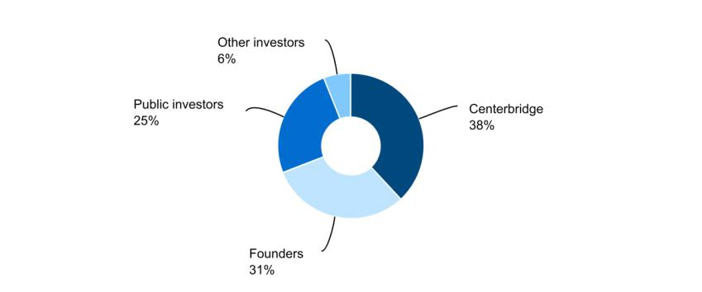

GoHealth, Inc. is subject to U.S. federal, state and local income taxes with respect to our allocable share of any taxable income of GoHealth Holdings, LLC and is taxed at the prevailing corporate tax rates. In addition to tax expenses, we also incur expenses related to our status as a public company, plus payment obligations under the Tax Receivable Agreement, which could be

GoHealth, Inc. | 2022 Form 10-Q | 23

significant. We intend to cause GoHealth Holdings, LLC to make distributions to us in an amount sufficient to allow us to pay these expenses and fund any payments due under the Tax Receivable Agreement.

Results of Operations

The following is our consolidated results of operations for the three months ended March 31, 2022 and 2021:

 |  |  | Three months ended Mar. 31,
(in thousands) |  |  | 2022 |  | 2021
Net revenues:
Commission |  | $ | 209,639 | $ | 173,981
Enterprise |  |  | 60,954 |  | 30,198
Net revenues |  |  | 270,593 |  | 204,179
Operating expenses:
Cost of revenue |  |  | 67,923 |  | 48,375
Marketing and advertising |  |  | 84,033 |  | 54,484
Customer care and enrollment |  |  | 78,455 |  | 47,094
Technology |  |  | 12,759 |  | 9,617
General and administrative |  |  | 29,217 |  | 19,685
Amortization of intangible assets |  |  | 23,514 |  | 23,514
Total operating expenses |  |  | 295,901 |  | 202,769
Income (loss) from operations |  |  | (25,308) |  | 1,410
Interest expense |  |  | 11,398 |  | 8,688
Other (income) expense, net |  |  | 63 |  | 13
Income (loss) before income taxes |  |  | (36,769) |  | (7,291)
Income tax expense (benefit) |  |  | 472 |  | (31)
Net income (loss) |  |  | (37,241) |  | (7,260)
Net income (loss) attributable to non-controlling interests |  |  | (23,758) |  | (5,173)
Net income (loss) attributable to GoHealth, Inc. |  | $ | (13,483) | $ | (2,087)
Non-GAAP financial measures:
EBITDA |  | $ | 577 | $ | 26,764
Adjusted EBITDA |  | $ | 11,073 | $ | 32,056
Adjusted EBITDA margin |  |  | 4.1 % |  | 15.7 %

The following are our components of net revenue and results thereof for the three months ended March 31, 2022 and 2021:

 |  |  | Three months ended Mar. 31, |  |  |  |  |  |  | % of Net Revenues
Commission net revenues |  |  | 2022 |  | 2021 |  | $ Change | % Change |  | 2022 | 2021
 |  | $ | 209,639 | $ | 173,981 | $ |  | 35,658 | 20.5 % | 77.5% | 85.2%

The increase for the three months ended March 31, 2022 compared to the prior year period was primarily attributable to increases in commission revenue from the sales of Medicare Advantage policies in both the Medicare—Internal and Medicare—External segments, driven by a 62% increase in total Medicare Advantage commissionable Approved Submissions.

 |  |  | Three months ended Mar. 31, |  |  |  |  |  |  | % of Net Revenues
Enterprise net revenues |  |  | 2022 |  | 2021 |  | $ Change | % Change |  | 2022 | 2021
 |  | $ | 60,954 | $ | 30,198 | $ |  | 30,756 | 101.8 % | 22.5% | 14.8%

The increase for the three months ended March 31, 2022 compared to the prior year period was primarily attributable to an increase of $18.8 million related to partner marketing and enrollment services and a $12.0 million increase in direct partner campaigns in our Medicare—Internal segment.

The following are our key components of operating expenses and results thereof for the three months ended March 31, 2022 and 2021:

 |  |  | Three months ended Mar. 31, |  |  |  |  |  |  |  | % of Net Revenues
Cost of revenue |  |  | 2022 | 2021 |  |  |  | $ Change |  | % Change | 2022 | 2021
 |  | $ | 67,923 | $ |  | 48,375 | $ | 19,548 |  | 40.4 % | 25.1% | 23.7%
 |  |  | GoHealth, Inc. |  |  | 2022 Form 10-Q
 |  |  |  |  |  |  |  |  | 24

The increase for the three months ended March 31, 2022 compared to the prior year period was primarily attributable to a 111% increase in commissionable Approved Submissions in the Medicare— External segment, which increased the amount of expense we recognized pursuant to our revenue-sharing agreements with external agents and other partners.

 |  |  | Three months ended Mar. 31, |  |  |  |  |  |  | % of Net Revenues
Marketing and advertising expense |  |  | 2022 |  | 2021 |  | $ Change | % Change |  | 2022 | 2021
 |  | $ | 84,033 | $ | 54,484 | $ |  | 29,549 | 54.2 % | 31.1% | 26.7%

The increase for the three months ended March 31, 2022 compared to the prior year period was primarily attributable to an increase in our advertising costs for the Medicare—Internal segment to generate more qualified prospects, which contributed to a 46% in Medicare—Internal commissionable Approved Submissions.

 |  |  | Three months ended Mar. 31, |  |  |  |  |  |  | % of Net Revenues
Customer care and enrollment |  |  | 2022 |  | 2021 |  | $ Change | % Change |  | 2022 | 2021
 |  | $ | 78,455 | $ | 47,094 | $ |  | 31,361 | 66.6 % | 29.0% | 23.1%

The increase for the three months ended March 31, 2022 compared to the prior year period was primarily attributable to the hiring of additional agents in the Medicare—Internal segment throughout 2021, particularly in the second and third quarters as we prepared for the annual enrollment period (“AEP”).

 |  |  | Three months ended Mar. 31, |  |  |  |  |  |  |  | % of Net Revenues
Technology expense |  |  | 2022 |  | 2021 |  | $ Change | % Change |  | 2022 |  | 2021
 |  | $ | 12,759 | $ | 9,617 | $ |  | 3,142 | 32.7 % | 4.7% |  | 4.7%

The increase for the three months ended March 31, 2022 compared to the prior year period was primarily attributable to the hiring of additional employees in our technology and data science teams, and the expansion of our business intelligence and analytics staffing in order to support the growth of the Medicare—Internal segment.

 |  | Three months ended Mar. 31, |  |  |  |  |  | % of Net Revenues
General and administrative expense |  | 2022 | 2021 |  | $ Change | % Change |  | 2022 |  | 2021
 |  |  | 29,217 | 19,685 | $ | 9,532 | 48.4 % | 10.8% |  | 9.6%

The increase for the three months ended March 31, 2022 compared to the prior year period was primarily attributable to professional and consulting fees, as well as investments in corporate infrastructure, such as legal, human resources, and finance.

 |  | Three months ended Mar. 31, |  |  |  |  |  |  | % of Net Revenues
Amortization of intangible assets |  | 2022 | 2021 |  | $ Change | % Change |  | 2022 |  | 2021
 |  | 23,514 | 23,514 | $ |  | — | — % | 8.7% |  | 11.5%

Amortization of intangible assets expense was $23.5 million for both the three months ended March 31, 2022 and 2021, and relates to the amortization of developed technology and customer relationships.

 |  | Three months ended Mar. 31, |  |  |  |  |  |  | % of Net Revenues
Interest expense |  | 2022 | 2021 |  | $ Change | % Change |  | 2022 |  | 2021
 |  |  | 11,398 | 8,688 | $ | 2,710 | 31.2 % | 4.2% |  | 4.3%

The increase for the three months ended March 31, 2022 compared to the prior year period was primarily attributable to additional debt outstanding on our Credit Facilities.

Non-GAAP Financial Measures

We use supplemental measures of our performance that are derived from our consolidated financial information, but which are not presented in our Consolidated Financial Statements prepared in accordance with GAAP. These non-GAAP financial measures include net income (loss) before interest expense, income tax (benefit) expense and depreciation and amortization expense, or EBITDA; Adjusted EBITDA and Adjusted EBITDA margin. Adjusted EBITDA is the primary financial performance measure used by management to evaluate its business and monitor its results of operations.

GoHealth, Inc. | 2022 Form 10-Q | 25

Adjusted EBITDA represents EBITDA as further adjusted for certain items summarized in the table below. Adjusted EBITDA margin represents Adjusted EBITDA divided by net revenues.

We use non-GAAP financial measures to supplement financial information presented on a GAAP basis. We believe that excluding certain items from our GAAP results allows management to better understand our consolidated financial performance from period to period and better project our future consolidated financial performance as forecasts are developed at a level of detail different from that used to prepare GAAP-based financial measures. Moreover, we believe these non-GAAP financial measures provide our stakeholders with useful information to help them evaluate our operating results by facilitating an enhanced understanding of our operating performance and enabling them to make more meaningful period to period comparisons. There are limitations to the use of the non-GAAP financial measures presented in this Quarterly Report on Form 10-Q. For example, our non-GAAP financial measures may not be comparable to similarly titled measures of other companies. Other companies, including companies in our industry, may calculate non-GAAP financial measures differently than we do, limiting the usefulness of those measures for comparative purposes.

The non-GAAP financial measures are not meant to be considered as indicators of performance in isolation from or as a substitute for net income (loss) prepared in accordance with GAAP, and should be read only in conjunction with financial information presented on a GAAP basis. Reconciliations of each of EBITDA and Adjusted EBITDA to its most directly comparable GAAP financial measure, net income (loss), are presented in the tables below in this Quarterly Report on Form 10-Q. We encourage you to review the reconciliations in conjunction with the presentation of the non-GAAP financial measures for each of the periods presented. In future periods, we may exclude similar items, may incur income and expenses similar to these excluded items and include other expenses, costs and non-recurring items.

The following table sets forth the reconciliations of GAAP net income (loss) to EBITDA and Adjusted EBITDA for the periods presented:

 |  |  | Three months ended Mar. 31,
Non-GAAP Financial Measures |  |  | 2022 |  | 2021
Net revenues |  | $ | 270,593 | $ | 204,179
Net income (loss) |  |  | (37,241) |  | (7,260)
Interest expense |  |  | 11,398 |  | 8,688
Income tax expense (benefit) |  |  | 472 |  | (31)
Depreciation and amortization expense |  |  | 25,948 |  | 25,367
EBITDA |  |  | 577 |  | 26,764
Share-based compensation expense (1) |  |  | 5,155 |  | 5,112
Severance costs (2) |  |  | 1,391 |  | —
Professional services (3) |  |  | 3,950 |  | —
Legal fees (4) |  |  | — |  | 180
Adjusted EBITDA |  | $ | 11,073 | $ | 32,056
Adjusted EBITDA Margin
Adjusted EBITDA Margin |  |  | 4.1 % |  | 15.7 %

- Represents non-cash share-based compensation expense relating to equity awards.

- Represents costs associated with the termination of employment and associated fees.

- Represents costs associated with non-recurring consulting fees.

- Represents non-recurring legal fees unrelated to our core operations.

 |  |  | Three months ended Mar. 31,
Adjusted EBITDA |  |  | 2022 |  | 2021 |  | $ Change | % Change
 |  | $ | 11,073 | $ | 32,056 | $ | (20,983) | (65.5)%

The decrease for the three months ended March 31, 2022 compared to the prior year period was primarily due to increases in agent costs associated with a larger agent workforce and increased marketing and advertising spend, which drove a 62% increase in total Medicare Advantage commissionable Approved Submissions over the prior year period.

Our Segments

We are organized under the following four reportable segments: (1) Medicare—Internal, (2) Medicare—External, (3) Individual and Family Plans (“IFP”) and Other—Internal and (4) IFP and Other—External. The basis for our segmentation is product type and distribution channel. We organize the segments by product type, Medicare and IFP and Other, as well as by distribution channel, internal and external, as further described below. In addition, we separately report other expenses (classified as “Corporate expenses” in our financial statements), the primary components of which are corporate overhead expenses and shared service expenses that have not been allocated to the operating segments. The segment results provided herein may not be comparable to other companies. We refer to the Medicare—Internal and Medicare—External segments collectively as the “Medicare segments” and the IFP and Other—Internal and IFP and Other—External segments as the “IFP and Other segments.”

GoHealth, Inc. | 2022 Form 10-Q | 26

 |  |  | Three months ended Mar. 31,
(in thousands) |  |  | 2022 |  |  | 2021
Net revenues:
Medicare—Internal |  | $ | 203,845 |  | $ | 157,353
Medicare—External |  |  | 61,486 |  |  | 39,500
IFP and Other—Internal |  |  | 4,200 |  |  | 3,975
IFP and Other—External |  |  | 1,062 |  |  | 3,351
Net revenues |  |  | 270,593 |  |  | 204,179
Segment profit (loss):
Medicare—Internal |  |  | 34,839 |  |  | 46,443
Medicare—External |  |  | (7,793) |  |  | (631)
IFP and Other—Internal |  |  | 590 |  |  | (729)
IFP and Other—External |  |  | (258) |  |  | 160
Segment profit (loss) |  |  | 27,378 |  |  | 45,243
Corporate expense |  |  | 29,172 |  |  | 20,319
Amortization of intangible assets |  |  | 23,514 |  |  | 23,514
Interest expense |  |  | 11,398 |  |  | 8,688
Other (income) expense, net |  |  | 63 |  |  | 13
Income (loss) before income taxes |  | $ | (36,769) |  | $ | (7,291)

Medicare-Internal Segment

The Medicare—Internal segment relates to sales of products and plans by GoHealth-employed agents offering qualified prospects plans from multiple carriers, GoHealth-employed agents offering qualified prospects plans on a carrier-specific basis, or sales of products and plans through our online platform without the assistance of our agents, which we refer to as DIY. In this segment, we sell Medicare Advantage, Medicare Supplement, Medicare prescription drug plans, and Medicare Special Needs Plans, or SNPs. We earn revenue in this segment through commissions paid by carriers based on sales we generated, as well as enrollment fees, hourly fees and other fees for services performed for specific carriers and other partners. The Medicare—Internal segment is our largest and fastest growing segment, and represented 127% of segment profits in 2022.

Medicare—Internal |  |  | Three months ended Mar. 31, |  |  |  |  |  | % of Net Revenues
Medicare—Internal |  |  | 2022 |  | 2021 |  | $ Change | % Change | 2022 | 2021
Net Revenues |  |  | 2022 |  | 2021
Net Revenues |  | $ | 203,845 | $ | 157,353 | $ | 46,492 | 29.5 % | 75.4% | 77.0%

The increase for the three months ended March 31, 2022 compared to the prior year period was primarily attributable to the hiring of additional agents and an increase in marketing costs to generate a greater number of prospects for a larger agent workforce, which drove a 46% increase in commissionable Approved Submissions.

Medicare—Internal |  |  | Three months ended Mar. 31, |  |  |  |  |  | % of Segment Profit (Loss)
Medicare—Internal |  |  | 2022 |  | 2021 |  | $ Change | % Change | 2022 | 2021
Segment Profit (Loss) |  |  | 2022 |  | 2021
 |  | $ | 34,839 | $ | 46,443 | $ | (11,604) | (25.0)% | 127.3% | 102.7%

The decrease for the three months ended March 31, 2022 compared to the prior year period was primarily due to (i) increased marketing and advertising costs, which contributed to a 46% increase in Medicare—Internal commissionable Approved Submissions and a 30% increase in net revenue, and (ii) increased customer care and enrollment costs attributable to the hiring, onboarding, and training of additional agents throughout 2021, particularly in the second and third quarters as we prepared for the AEP.

Medicare-External Segment

The Medicare—External segment relates to sales of products and plans under GoHealth’s carrier contracts using an independent, national network of agents or external agencies, which are not employed by GoHealth. These agents utilize our technology and platform to enroll consumers in health insurance plans and provide us with a means to earn a return on leads that otherwise may have not been addressed. In this segment, we sell Medicare Advantage, Medicare Supplement, Medicare prescription drug plans, and SNPs. We earn revenue in this segment through commissions paid by carriers as a result of policy sales, as well as sales of consumer leads to external agencies.

GoHealth, Inc. | 2022 Form 10-Q | 27

Medicare—External |  |  | Three months ended Mar. 31, |  |  |  |  |  | % of Net Revenues
Medicare—External |  |  | 2022 |  | 2021 |  | $ Change | % Change | 2022 | 2021
Net Revenues |  |  | 2022 |  | 2021
Net Revenues |  | $ | 61,486 | $ | 39,500 | $ | 21,986 | 55.7 % | 22.7% | 19.3%

The increase for the three months ended March 31, 2022 compared to the prior year period was primarily attributable to a 111% increase in commissionable Approved Submissions in the Medicare— External segment due to our ability to recruit and onboard additional external agents to enroll consumers in Medicare plans using our technology and platform.

Medicare—External |  |  | Three months ended Mar. 31, |  |  |  |  |  | % of Segment Profit (Loss)
Medicare—External |  |  | 2022 |  | 2021 |  | $ Change | % Change | 2022 | 2021
Segment Profit (Loss) |  |  | 2022 |  | 2021
Segment Profit (Loss) |  | $ | (7,793) | $ | (631) | $ | (7,162) | N/M | (28.5)% | (1.4)%

NM = Not meaningful

The increase in loss for the three months ended March 31, 2022 compared to the prior year period was primarily attributable to an increase in the amount of expense we recognized pursuant to our revenue-sharing agreements with external agents and other partners.

IFP and Other Segments

The IFP and Other—Internal segment relates to sales of products and plans by GoHealth-employed agents offering qualified prospects plans from multiple carriers, GoHealth-employed agents offering qualified prospects plans on a carrier-specific basis, or DIY. In this segment, we sell individual and family plans, dental plans, vision plans and other ancillary plans to individuals who are not Medicare-eligible. We earn revenue in this segment through commissions paid by carriers based on sales we generate, as well as enrollment fees, and hourly fees and other fees for services performed for specific carriers and other partners.

The IFP and Other—External segment relates to sales of products and plans under GoHealth’s carrier contracts using external agencies, who use agents that are not employed by GoHealth. These agents utilize our technology and platform to enroll consumers in health insurance plans. We also sell consumer leads generated by us to external agencies. In this segment, we sell individual and family plans, dental plans, vision plans and other ancillary plans to individuals who are not Medicare-eligible. We earn revenue in this segment through commissions paid by carriers as a result of policy sales, as well as sales of consumer leads to external agencies.

 |  |  | Three months ended Mar. 31, |  |  |  |  |  |  |  | % of Net Revenues
Net Revenues |  |  | 2022 |  | 2021 |  | $ Change | % Change |  | 2022 |  | 2021
IFP and Other—Internal |  | $ | 4,200 | $ | 3,975 | $ |  | 225 | 6 % | 1.6% |  | 1.9%
IFP and Other—External |  |  | 1,062 |  | 3,351 |  |  | (2,289) | (68)% | 0.4% |  | 1.6%

For the IFP and Other—Internal segment, the increase was driven by a change in product mix sold. For the IFP and Other—External segment, the decrease was primarily driven by a strategic shift towards higher margin Medicare products.

 |  | Three months ended Mar. 31, |  |  |  |  |  |  | % of Segment Profit (Loss)
Segment Profit (Loss) |  | 2022 |  | 2021 |  | $ Change | % Change |  | 2022 | 2021
IFP and Other—Internal |  | $ | 590 | $ | (729) | $ | 1,319 | N/M | 2.2% | (1.6)%
IFP and Other—External |  |  | (258) |  | 160 |  | (418) | (261)% | (1.0)% | 0.4%

NM = Not meaningful

For the IFP and Other—Internal segment, the increase was attributable to a reduction in operating costs driven by less investment in this segment, as we have implemented an overall strategic shift towards higher margin Medicare products. For the IFP and Other—External segment, the decrease was primarily driven by a change in product mix sold by external agencies, as well as an overall strategic shift towards higher margin Medicare products.

Key Business Performance and Operating Metrics

In addition to traditional financial metrics, we rely upon certain business and operating metrics to evaluate our business performance and facilitate our operations. Below are the most relevant business and operating metrics for each segment, except for EBITDA and Adjusted EBITDA, which are not presented on a segment basis. The business and operating metrics are organized to reflect the evolution of a policy from submission to recognition of commission revenue.

Submitted Policies

GoHealth, Inc. | 2022 Form 10-Q | 28

Medicare Segments

Submitted Policies represent completed applications that, with respect to each such application, the consumer has authorized us to submit to the carrier. The applicant may need to take additional actions, including providing subsequent information before the application is reviewed by the carrier.

The following table presents the number of Submitted Policies by product for the Medicare segments for the periods presented, split between those submissions that are commissionable (compensated through commissions received from carriers) and those that are non-commissionable (compensated via hourly fees and enrollment fees):

 |  | Three months ended Mar. 31,
Submitted Policies |  | 2022 | 2021
Commissionable
MA |  | 286,109 | 172,874
MS |  | 502 | 1,104
PDP |  | 6,525 | 2,593
Medicare commissionable Submitted Policies |  | 293,136 | 176,571
Non-commissionable
MA |  | 4,487 | 5,939
MS |  | 2,191 | 1,650
PDP |  | 829 | 885
Medicare non-commissionable Submitted Policies |  | 7,507 | 8,474
Total Submitted Policies
MA |  | 290,596 | 178,813
MS |  | 2,693 | 2,754
PDP |  | 7,354 | 3,478
Total Medicare commissionable and non-commissionable Submitted Policies |  | 300,643 | 185,045

The increase for the three months ended March 31, 2022 compared to the prior year period is attributable to an increase in agent headcount, driven by the hiring, onboarding, and training of additional agents throughout 2021, particularly in the second and third quarters as we prepared for AEP, and an increase in marketing costs to generate a greater number of prospects for a larger agent workforce.

IFP and Other Segments

Total Submitted Policies for the IFP and Other segments were 9,205 and 16,824 for the three months ended March 31, 2022 and 2021, respectively. The decrease is due to a change in strategy to prioritize agents and marketing and advertising spend in the Medicare segments instead of the IFP and Other segments.

Approved Submissions

Medicare Segments

Approved Submissions represent Submitted Policies approved by carriers for the identified product during the indicated period. Not all Approved Submissions will go in force, as some individuals we enroll may not ultimately pay their insurance premiums or may switch out of a policy within the disenrollment period during the first 90 days of the policy. In general, the relationship between Submitted Policies and Approved Submissions has been steady over time. Therefore, factors impacting the number of Submitted Policies also impact the number of Approved Submissions.

The following tables present the number of Approved Submissions by product relating to commissionable policies for each of the Medicare segments for the periods presented. Only commissionable policies are used to calculate our LTV.

GoHealth, Inc. | 2022 Form 10-Q | 29

 |  | Three months ended Mar. 31,
Approved Submissions |  | 2022 | 2021
Medicare-Internal
MA |  | 188,928 | 128,886
MS |  | 154 | 251
PDP |  | 2,999 | 2,284
Medicare-Internal commissionable Approved Submissions |  | 192,081 | 131,421
Medicare-External
MA |  | 87,948 | 42,241
MS |  | 216 | 731
PDP |  | 3,174 | 289
Medicare-External commissionable Approved Submissions |  | 91,338 | 43,261
Total commissionable Approved Submissions
MA |  | 276,876 | 171,127
MS |  | 370 | 982
PDP |  | 6,173 | 2,573
Total Medicare commissionable Approved Submissions |  | 283,419 | 174,682

The increase in Medicare—Internal commissionable Approved Submissions was attributable to an increase in agent headcount, driven by the hiring, onboarding, and training of additional agents throughout 2021, particularly in the second and third quarters as we prepared for AEP, and an increase in marketing costs to generate a greater number of prospects for a larger agent workforce.

The increase in Medicare—External commissionable Approved Submissions was attributable to our ability to recruit and onboard additional external agents to enroll consumers in Medicare plans.

LTV Per Approved Submission

Medicare Segments

Lifetime value of commissions per commissionable Approved Submission, or LTV per Approved Submission, represents (i) aggregate commissions estimated to be collected over the estimated life of all commissionable Approved Submissions for the relevant period based on multiple factors, including but not limited to, contracted commission rates, carrier mix and expected policy persistency with applied constraints, excluding revenue adjustments recorded in the period, but relating to performance obligations satisfied in prior periods, divided by (ii) the number of commissionable Approved Submissions for such period. LTV per Approved Submission is equal to the sum of the commission revenue due upon the initial sale of a policy, and when applicable, an estimate of future renewal commissions per commissionable Approved Submissions. The estimate of the future renewal commissions is determined by using the contracted renewal commission rates constrained by a persistency-adjusted renewal period. The persistency-adjusted renewal period is determined based on our historical experience and available industry and carrier historical data. Persistency-adjustments allow us to estimate renewal revenue only to the extent probable that a material reversal in revenue would not be expected to occur. These factors may result in varying values from period to period. LTV per Approved Submission represents commissions only from policies sold during the period, but excludes policies originally submitted in prior periods.

The following table presents the LTV per Approved Submission by product for the Medicare segments for the periods presented:

 |  |  | Three months ended Mar. 31,
LTV Per Approved Submission |  |  | 2022 |  | 2021
MA |  | $ | 756 | $ | 856
MS |  |  | 843 |  | 798
PDP |  |  | 203 |  | 215

The decrease in LTV Per Approved Submission for Medicare Advantage was primarily attributable to an increase in consumer shopping, resulting in lower persistency and an increased constraint added to the LTV for the three months ended March 31, 2022.

The changes in LTV Per Approved Submission for Medicare Supplement and prescription drug plans were primarily due to changes in carrier mix and an increased constraint added to the LTVs.

GoHealth, Inc. | 2022 Form 10-Q | 30

LTV/CAC

Medicare Segments

Lifetime value of commissions per consumer acquisition cost, or LTV/CAC, represents (i) aggregate commissions estimated to be collected over the estimated life of all commissionable Approved Submissions for the relevant period based on multiple factors, including but not limited to, contracted commission rates, carrier mix and expected policy persistency with applied constraints, excluding revenue adjustments recorded in the period, but relating to performance obligations satisfied in prior periods, divided by (ii) the cost to convert a qualified prospect into a Submitted Policy (comprised of cost of revenue, marketing and advertising expenses and customer care and enrollment expenses) less other non-commission carrier revenue for such period, or CAC. CAC is comprised of cost of revenue, marketing and advertising expenses and customer care and enrollment expenses less enterprise revenue, excluding cost of revenue adjustments recorded in the period, but relating to performance obligations satisfied in prior periods, and is presented on a per commissionable Approved Submission basis. The estimate of the future renewal commissions is determined by using the contracted renewal commission rates constrained by a persistency-adjusted renewal period. The persistency-adjusted renewal period is determined based on our historical experience and available industry and insurance carrier historical data. Persistency-adjustments allow us to estimate renewal revenue only to the extent probable that a material reversal in revenue would not be expected to occur. These factors may result in varying values from period to period.

The following are our LTV/CACs as well as our CACs, for our Medicare—Internal segment for the three months ended March 31, 2022 and 2021:

 |  | Three months ended Mar. 31,
 |  | 2022 |  | 2021
LTV/CAC |  |  | 1.5x |  | 1.5x
CAC |  | $ | 100.0 | $ | 73.6

LTV/CAC for the three months ended March 31, 2022 and 2021 was 1.5x. The hiring of additional agents and increased marketing and advertising spend to generate a greater number of prospects for a larger agent workforce drove a 29.5% increase in revenues within the Medicare—Internal segment and resulted in a flat LTV/CAC year-over-year.

Liquidity and Capital Resources

Overview

Our liquidity needs primarily include working capital and debt service requirements. At March 31, 2022, cash and cash equivalents totaled $129.6 million. We believe that our current sources of liquidity, which include cash and cash equivalents and funds available under the Credit Facilities, as described further below, will be sufficient to meet our projected operating and debt service requirements for at least the next 12 months. Short-term liquidity needs will primarily be funded through the Revolving Credit Facilities, as described further below, if necessary. As of March 31, 2022, the Company had $155.0 million outstanding under the Revolving Credit Facilities and had a remaining capacity of $45.0 million. To the extent that our current liquidity is insufficient to fund future activities, we may need to raise additional funds, which may include the sale of equity securities or through debt financing arrangements. The incurrence of additional debt financing would result in debt service obligations, and any future instruments governing such debt could provide for operating and financing covenants that could restrict our operations.

The following table presents a summary of cash flows for the three months ended March 31, 2022 and 2021 :

 |  |  | Three months ended Mar. 31,
(in thousands) |  |  | 2022 |  | 2021
Net cash provided by operating activities |  | $ | 54,486 | $ | 31,202
Net cash used in investing activities |  |  | (5,997) |  | (3,740)
Net cash (used in) provided by financing activities |  |  | (3,105) |  | 2,276

Operating Activities

Cash provided by operating activities primarily consists of net income (loss) adjusted for certain non-cash items including share-based compensation; depreciation and amortization; amortization of intangible assets; loss on extinguishment of debt; loss on sublease; change in the fair value of contingent consideration; goodwill impairment charges; noncash lease expense; amortization of debt discount and issuance costs and the effect of changes in working capital and other activities.

GoHealth, Inc. | 2022 Form 10-Q | 31

Collection of commissions receivable depends upon the timing of the receipt of commission payments. If there were to be a delay in receiving a commission payment from a carrier within a quarter, the operating cash flows for that quarter could be adversely impacted.

A significant portion of marketing and advertising expense is driven by the number of qualified prospects required to generate the insurance applications submitted to carriers. Marketing and advertising costs are expensed and generally paid as incurred and since commission revenue is recognized upon approval of a submission but commission payments are paid to us over time, there are working capital requirements to fund the upfront cost of acquiring new policies.

Net cash provided by operating activities was $54.5 million for the three months ended March 31, 2022, compared to $31.2 million for the three months ended March 31, 2021. The $23.3 million increase is primarily driven by a decrease in commissions receivable of $116.5 million, partially offset by an increase in net loss of $30.0 million, a decrease in commissions payable of $29.9 million, an increase in accounts receivable of $21.2 million, and other adjustments for non-cash items of $12.2 million.

Investing Activities

Net cash used in investing activities increased to $6.0 million for the three months ended March 31, 2022, from $3.7 million for the three months ended March 31, 2021. The increase was primarily driven by an increase in capitalized internal-use software related to new technology, software, and systems and purchases of property and equipment.

Financing Activities

Net cash used in financing activities was $3.1 million for the three months ended March 31, 2022, from $2.3 million cash provided by financing activities for the three months ended March 31, 2021. The change is primarily driven by the collection of the short-term advancement to NVX Holdings of $3.4 million during the three months ended March 31, 2021, as well as an increase in debt issuance cost payments of $1.7 million.

Credit Facilities

Term Loan Facilities

On September 13, 2019, in connection with the Acquisition, Norvax (“the Borrower”) entered into a first lien credit agreement (the “Credit Agreement”) which provided for a $300.0 million aggregate principal amount senior secured term loan facility (the “Initial Term Loan Facility”). During 2020, the Company entered into a series of amendments to the Credit Agreement to provide for, among other items as further described below, $117.0 million of incremental term loans (the “Incremental Term Loan Facility”).

On June 11, 2021, the Company entered into Amendment No. 5 to the Credit Agreement and Incremental Facility Agreement (“Amendment No. 5”). Amendment No. 5 creates a new class of incremental term loans (the “2021 Incremental Term Loans”) in an aggregate principal amount equal to $310.0 million, which was used to refinance $295.5 million of outstanding principal under the Initial Term Loan Facility, pay the related accrued interest and fund the prepayment premium. In connection with Amendment No. 5 and the refinancing of the Initial Term Loan, the Company recognized an $11.9 million loss on debt extinguishment, representing the 2% prepayment premium of $5.9 million and the write-down of deferred financing costs and debt discounts of $6.0 million. The Company incurred $1.7 million of debt issuance costs associated with Amendment No. 5, which are being amortized over the life of the debt to interest expense using the effective interest method.

On November 10, 2021, the Company entered into Amendment No. 6 to the Credit Agreement and Incremental Facility Agreement (“Amendment No. 6”). Amendment No. 6 provides $100.0 million of incremental term loans, or the “2021-2 Incremental Term Loans”. The Company incurred $2.5 million of debt issuance costs associated with Amendment No. 6, which are being amortized over the life of the debt to interest expense using the effective interest method.

The Company collectively refers to the Initial Term Loan Facility, the Incremental Term Loan Facility, and the 2021 Incremental Term Loans as the “Term Loan Facilities”.

As of March 31, 2022, the Company had a principal amount of $114.7 million, $307.7 million, and $99.7 million outstanding under the Incremental Term Loan Facility, the 2021 Incremental Term Loans, and the 2021-2 Incremental Term Loans, respectively. As of December 31, 2021, the Company had a principal amount of $115.0 million $308.4 million, and $100.0 million outstanding under the Incremental Term Loan Facility, the 2021 Incremental Term Loans, and the 2021-2 Incremental Term Loans, respectively. The Incremental Term Loan Facility effective interest rate was 7.5% at both March 31, 2022 and December 31, 2021. The 2021 Incremental Term Loans and the 2021-2 Incremental Term Loans effective interest rate was 7.5% and 6.0% at March 31, 2022 and December 31, 2021, respectively.

Borrowings under the Incremental Term Loan Facility are, at the option of the Borrower, either (i) alternate base rate (“ABR”) plus 5.50% per annum or (ii) LIBOR plus 6.50% per annum. The 2021 Incremental Term Loans from and after the 2021-2 Incremental

GoHealth, Inc. | 2022 Form 10-Q | 32

Term Loans Closing Date, or November 10, 2021, and the 2021-2 Incremental Term Loans, bear interest at either (i) alternate base rate (“ABR”) plus 4.00% per annum or (ii) LIBOR plus 5.00% per annum.

On March 14, 2022, the Company entered into Amendment No. 7 to the Credit Agreement and Incremental Facility Agreement (“Amendment No. 7”). Amendment No. 7 provides that (a) the 2021 Incremental Term Loans, from and after the Amendment No. 7 Effective Date, will bear interest at either (i) alternate base rate (“ABR”) plus 5.50% per annum or (ii) LIBOR plus 6.50% per annum and

- the 2021-2 Incremental Term Loans, from and after the Amendment No. 7 Effective Date, will bear interest at either (i) ABR plus 5.50% per annum or (ii) LIBOR plus 6.50% per annum. Amendment No. 7 further amended the Credit Agreement to remove testing of the Net Leverage Ratio for the December 31, 2021 period and increase the maximum permitted Net Leverage Ratio for future reporting periods through March 31, 2023. The Company incurred $1.7 million of debt issuance costs associated with Amendment No. 7, which are being amortized over the life of the debt to interest expense using the effective interest method.

The Term Loan Facilities are payable in quarterly installments in the principal amount of 0.25% of the original principal amount. The remaining unpaid balance on the Term Loan Facilities, together with all accrued and unpaid interest thereon, is due and payable on or prior to September 13, 2025.

Revolving Credit Facilities

The Credit Agreement provided for a $30.0 million aggregate principal amount senior secured revolving credit facility (the “Revolving Credit Facility”). During 2020, the Company entered into a series of amendments to the Credit Agreement to provide for $28.0 million of incremental revolving credit (the “Incremental Revolving Credit Facilities”).

On May 7, 2021, the Company entered into a fourth amendment to the Credit Agreement, which provided $142.0 million of incremental revolving credit (the “Incremental No. 4 Revolving Credit Facility”), for a total amount of $200.0 million.

The Company collectively refers to the Revolving Credit Facility, the Incremental Revolving Credit Facilities, and the Incremental No. 4 Revolving Credit Facility as the “Revolving Credit Facilities”.

Amendment No. 5, as described above, also separates the Revolving Credit Facilities into two classes of revolving commitments consisting of Class A Revolving Commitments in the amount of $30.0 million and Class B Revolving Commitments in the amount of $170.0 million.

Borrowings under the Class A Revolving Commitments bear interest at either ABR plus 5.50% per annum or LIBOR plus 6.50% per annum. Borrowings under the Class B Revolving Commitments bear interest at either ABR plus 3.00% per annum or LIBOR plus 4.00% per annum. The Borrower is required to pay a commitment fee of 0.50% per annum under the Revolving Credit Facilities.

The Company had $23.2 million outstanding under the Class A Revolving Credit Facilities and $131.8 million outstanding under the Class B Revolving Credit Facilities as of both March 31, 2022 and December 31, 2021. The Revolving Credit Facilities have a remaining capacity of $45.0 million in the aggregate as of March 31, 2022. The Class A Revolving Credit Facilities and Class B Revolving Credit Facilities effective interest rates at both March 31, 2022 and December 31, 2021 was 7.5% and 5.0%, respectively.

Outstanding borrowings under the Revolving Credit Facilities do not amortize and are due and payable on September 13, 2024.

Recent Accounting Pronouncements

For a discussion of new accounting pronouncements recently adopted and not yet adopted, see Note 1, “Description Of Business And Significant Accounting Policies,” to the Condensed Consolidated Financial Statements included elsewhere in this Quarterly Report on Form 10-Q.

Seasonality

The Medicare annual enrollment period occurs from October 15th to December 7th. As a result, we experience an increase in the number of submitted Medicare-related applications during the fourth quarter and an increase in expense related to the Medicare segments during the third and fourth quarters. Additionally, as a result of the annual Medicare Advantage open enrollment period that occurs from January 1st to March 31st, commission revenue is typically second-highest in our first quarter. The second and third quarters are known as special election periods, and are our seasonally smallest quarters. A significant portion of our marketing and advertising expenses is driven by the number of health insurance applications submitted through us. Marketing and advertising expenses are generally higher in the fourth quarter during the Medicare annual enrollment period, but because commissions from approved customers are paid to us over time, our operating cash flows could be adversely impacted by a substantial increase in marketing and advertising expenses as a result of a higher volume of applications submitted during the

GoHealth, Inc. | 2022 Form 10-Q | 33

fourth quarter or positively impacted by a substantial decline in marketing and advertising expenses as a result of lower volume of applications submitted during the fourth quarter.

Critical Accounting Policies and Estimates

The preparation of our Condensed Consolidated Financial Statements in conformity with GAAP requires management to make estimates and assumptions that affect the reported amounts of revenues, expenses, assets, and liabilities and disclosure of contingent assets and liabilities in our financial statements. We regularly assess these estimates; however, actual amounts could differ from those estimates. The most significant items involving management’s estimates include estimates of revenue recognition, commissions receivable, and commissions payable. The impact of changes in estimates is recorded in the period in which they become known.

An accounting policy is considered to be critical if the nature of the estimates or assumptions is material due to the levels of subjectivity and judgment necessary to account for highly uncertain matters or the susceptibility of such matters to change, and the effect of the estimates and assumptions on financial condition or operating performance. The accounting policies we believe to reflect our more significant estimates, judgments and assumptions that are most critical to understanding and evaluating our reported financial results are: (1) revenue recognition and commissions receivable, (2) share-based compensation, (3) intangible assets, (4) income taxes and (5) liabilities pursuant to TRAs.

Our critical accounting policies are described under the heading “Management’s Discussion and Analysis of Financial Condition and Results of Operations—Critical Accounting Policies” in our 2021 Form 10-K. During the three months ended March 31, 2022, there were no material changes to our critical accounting policies from those discussed in our 2021 Form 10-K, with the exception of our policy to test goodwill for impairment on an annual basis in the fourth quarter of each year, on November 30th, or whenever events or changes in circumstances indicate that the goodwill may be impaired. This change was driven by the annual goodwill impairment test conducted as of November 30, 2021, which resulted in the Company recognizing goodwill impairment charges of $386.6 million in the fourth quarter of 2021, representing the full amount of goodwill.

ITEM 3. QUANTITATIVE AND QUALITATIVE DISCLOSURES ABOUT MARKET RISK.

In the normal course of business, we are subject to market risks. Market risk represents the risk of loss that may impact our financial position due to adverse changes in financial market prices and rates. There have been no material changes to our market risk policies or our market risk-sensitive instruments and positions as described in our 2021 Form 10-K.

ITEM 4. CONTROLS AND PROCEDURES

Limitations on Effectiveness of Controls and Procedures

In designing and evaluating our disclosure controls and procedures, management recognizes that any controls and procedures, no matter how well designed and operated, can provide only reasonable assurance of achieving the desired control objectives. In addition, the design of disclosure controls and procedures must reflect the fact that there are resource constraints and that management is required to apply judgment in evaluating the benefits of possible controls and procedures relative to their costs. Also, projections of any evaluation of effectiveness to future periods are subject to the risk that controls may become inadequate because of changes in conditions, or that the degree of compliance with the policies or procedures may deteriorate. Because of the inherent limitations in a cost-effective control system, misstatements due to error or fraud may occur and not be detected.

Evaluation of Disclosure Controls and Procedures

Our management, with the participation of our chief executive officer and interim chief financial officer, evaluated, as of the end of the period covered by this Quarterly Report on Form 10-Q, the effectiveness of our disclosure controls and procedures (as defined in Rules 13a-15(e) and 15d-15(e) under the Exchange Act). Based on that evaluation, our chief executive officer and interim chief financial officer concluded that our disclosure controls and procedures were not effective as of March 31, 2022, because of the material weakness in internal control over financial reporting described below. A material weakness is a deficiency, or a combination of deficiencies, in internal control over financial reporting, such that there is a reasonable possibility that a material misstatement of our annual or interim financial statements will not be prevented or detected on a timely basis.

Based on this evaluation and those criteria, our management concluded that our internal control over financial reporting was ineffective as of March 31, 2022, because we identified a material weakness related to the ineffective design and operation of process level controls that addressed the completeness and accuracy of key financial data utilized in the recognition of commission revenue, including estimating the total constrained lifetime value of commission revenue and the related cost of revenue and balance sheet accounts, and the Company did not retain sufficient contemporaneous documentation to demonstrate the operation of review controls over commission revenue at a sufficient level of precision. We reviewed the results of our management’s assessment with our Audit Committee.

GoHealth, Inc. | 2022 Form 10-Q | 34

We continue to strengthen our internal control over financial reporting and are committed to ensuring that such controls are designed and operating effectively. We will be implementing process and control improvements to address the above material weakness that include, but are not limited to: i) establishing specific management review procedures to ensure completeness and accuracy of key financial data utilized in the recognition of commission revenue and the contemporaneous documentation of such reviews, ii) providing additional training related to validating the accuracy of data used in key review controls and the level of documentation required, and iii) investing in our corporate infrastructure to ensure adequate technology and resources to support our financial reporting process and internal control framework.

When fully implemented and operational, we believe the measures described above will remediate the control deficiencies that have led to the material weakness.

Notwithstanding the existence of the material weakness as described above, our management has concluded that the Condensed Consolidated Financial Statements included in this Quarterly Report on Form 10-Q fairly present, in all material respects, our financial position, results of operations and cash flows as of the dates, and for the periods presented, in conformity with U.S. GAAP.

Changes in Internal Control over Financial Reporting

Except for the material weakness identified above, there were no changes in our internal control over financial reporting identified in management’s evaluation pursuant to Rules 13a-15(d) or 15d-15(d) of the Exchange Act during the quarter ended March 31, 2022 that materially affected, or are reasonably likely to materially affect, our internal control over financial reporting.

GoHealth, Inc. | 2022 Form 10-Q | 35

PART II - Other Information

ITEM 1. LEGAL PROCEEDINGS.

Refer to Note 11, “Commitments And Contingencies,” of the Notes to Condensed Consolidated Financial Statements for information about legal proceedings.

ITEM 1A. RISK FACTORS.

Our operating results may be adversely impacted by factors that impact our estimate of LTV.

We recognize revenue at the time a Submitted Policy becomes an Approved Submission by applying the latest estimated LTV for that product. We estimate commission revenue for each product by using a portfolio approach to a group of approved customers that are organized based on a variety of attributes, which we refer to as “vintages.” We estimate the cash commissions we expect to collect for each approved customer vintage by evaluating various factors, including, but not limited to, commission rates, carriers, estimated average plan duration, the regulatory environment, and historic cancellations of health insurance plans offered by carriers with which we have a relationship. On a quarterly basis, we recompute LTV at a vintage level for all outstanding vintages, review and monitor changes in the data used to estimate LTV as well as the cash received for each vintage as compared to our original estimates. The fluctuations of cash received for each vintage and LTV may be significant and may or may not be indicative of the need to adjust LTVs for prior period vintages. Management analyzes these fluctuations and, to the extent we see changes in our estimates of the cash commission collections that we believe are indicative of an increase or decrease to prior period LTVs, we will adjust LTVs for the affected vintages at the time such determination is made. Changes in LTV may result in an increase or a decrease to revenue and a corresponding increase or decrease to net commissions receivable accordingly.

As we continue to evaluate our LTV estimation models and the process and controls related to the LTV estimation models, including to address the material weakness identified in Item 4 in this Quarterly Report on Form 10-Q and Item 9A “Controls and Procedures” of our 2021 Form 10-K, we have made and will make further changes based on a number of factors and such changes could result in significant further increases or decreases in revenue. LTVs are estimates and are based on a number of assumptions, which include, but are not limited to, estimates of the conversion rates of commissionable Approved Submissions into customers, forecasted average plan duration and forecasted commission rates we expect to receive per approved customer’s plan. These assumptions are based on historical trends and require significant judgment by our management in interpreting those trends. Changes in our historical trends will result in changes to our LTV estimates in future periods and, therefore, could adversely affect our revenue and financial results in those future periods. As a result, negative changes in the factors upon which we estimate LTVs, such as reduced conversion of commissionable Approved Submissions to customers, increased health insurance plan termination or a reduction in the lifetime commission amounts we expect to receive for selling the plan to a customer or other changes could harm our business, operating results and financial condition. We have seen, in the past few quarters, and continue to see some of these negative changes. In addition, if we ultimately receive commission payments that are less than the amount we estimated when we recognized commission revenues, we would need to write off the remaining commissions receivable balance, which could materially adversely impact our operating results and financial condition.

The forecasted average plan duration is another important factor in our estimation of LTV. We receive commissions from carriers for policies sold through us that go on to become customers of those carriers. When one of these plans is canceled, or if we otherwise do not remain the agent on the policy, we no longer receive the related commission payment. Our forecasted average plan duration and health insurance plan termination rates are calculated based on our historical data by plan type and for certain products, such as our Medicare Advantage products which constitute the majority of our revenue, and if we are unable to produce an accurate forecasted average plan duration, our business, operating results and financial condition may be adversely impacted. We have seen pressure, within the industry, on plan duration based upon increased customer churn. Additionally, from time to time, carriers may stop offering products in a geographic area. While in many cases, carriers will still support existing customers in those geographic areas, because they are no longer offering new plans, the retention of those customers may be adversely impacted, thereby impacting our expected LTVs.

Commission rates are also a factor in estimating our LTVs, which are impacted by a variety of factors, including the particular health insurance plans chosen by our customers, the carriers offering those plans, our customers’ states of residence, the laws and regulations in those jurisdictions, the average premiums of plans purchased through us and healthcare reform. Any reduction in our average commission revenue per customer could harm our business, operating results and financial condition.

Our management and independent auditors have identified a material weakness in our internal controls over financial reporting, and we may be unable to develop, implement and maintain appropriate controls in future periods, which may lead to errors or omissions in our financial statements.

We are subject to the NASDAQ rules and the rules and regulations established from time to time by the SEC. These rules and regulations require, among other things, that we establish and periodically evaluate procedures with respect to our internal control over financial reporting. In addition, the Sarbanes-Oxley Act and related rules and regulations require that management report annually on the effectiveness of our internal control over financial reporting and assess the effectiveness of our disclosure

GoHealth, Inc. | 2022 Form 10-Q | 36

controls and procedures on a quarterly basis. Maintaining and adapting our internal controls is expensive and is likely to place a considerable strain on our financial and management systems, processes and controls, as well as on our personnel.

As described in Item 9A “Controls and Procedures” of our 2021 Form 10-K, and Item 4 in this Quarterly Report on Form 10-Q, we concluded that our disclosure controls and procedures were not effective as of December 31, 2021 and March 31, 2022, and that we had, as of such dates, a material weakness in our internal control over financial reporting related to the ineffective design and operation of process level controls that addressed the completeness and accuracy of key financial data utilized in the recognition of commission revenue, including estimating the total constrained lifetime value of commission revenue and the related cost of revenue and balance sheet accounts, and the Company did not retain sufficient contemporaneous documentation to demonstrate the operation of review controls over commission revenue at a sufficient level of precision. A material weakness is a deficiency, or a combination of deficiencies, in internal control over financial reporting such that there is a reasonable possibility that a material misstatement of our annual or interim consolidated financial statements would not be prevented or detected on a timely basis. This material weakness identified in Item 9A of our 2021 Form 10-K did not result in any adjustments or restatements of our audited and unaudited consolidated financial statements or disclosures for any prior period previously reported by the Company. However, until the material weakness is remediated and our associated disclosure controls and procedures improved, or if additional material weaknesses or significant deficiencies in our internal control over financial reporting occur in the future, our future consolidated financial statements or other information filed with the SEC may contain material misstatements.

We are evaluating and developing a plan, which will include the implementation of appropriate processes and controls to remediate the material weakness described above. While we work towards the design and implementation of these processes and controls, we may rely significantly on manual procedures to assist us with meeting the objectives otherwise fulfilled by an effective control environment. The implementation of new procedures and controls could be costly and distract management from other activities. Prior to the complete remediation of this material weakness, there remains a risk that the transitional controls on which we currently rely will fail to be sufficiently effective, which could result in errors in our consolidated financial statements. If the new controls being implemented to address the material weakness and to strengthen the overall internal control are not designed or do not operate effectively, if we are unsuccessful in implementing or following these new processes or if we are otherwise unable to remediate this material weakness, it may result in untimely or inaccurate reporting of our financial condition or results of operations.

In addition, although we review and evaluate internal control systems to allow management to report on the sufficiency of our internal controls, we cannot assure you that we will not discover additional weaknesses in our internal control over financial reporting in the future. Any such additional weakness or failure to remediate the existing weakness could materially adversely affect our financial condition or ability to comply with applicable financial reporting requirements, which could result in violations of applicable securities laws and NASDAQ listing requirements, subject us to litigation and investigations, negatively affect investor confidence in our financial statements, and adversely impact our stock price and ability to access capital markets.

If our common stock’s closing bid price continues to remain below the minimum price of $1.00 per share, or if we fail to satisfy the NASDAQ rule concerning the composition of our audit committee, our common stock may be delisted from the NASDAQ.

Recently, the closing price of our common stock fell below $1.00 per share. If our common stock were to continue to trade below $1.00 per share, which is the minimum closing bid price required for continued listing on NASDAQ, for 30 consecutive business days, we will receive a notification letter from NASDAQ and will have 180 calendar days (subject to extension in some circumstances) to regain compliance with the minimum bid price rule (“Minimum Bid Price Rule”). To regain compliance, the closing bid price of our common stock must be at least $1.00 per share for a minimum of ten consecutive business days (or such longer period of time as the NASDAQ may require in some circumstances). Should we fail to regain compliance with the Minimum Bid Price Rule, we may consider a reverse stock split (or combination) of our outstanding common stock.

On April 29, 2022, we received notification from NASDAQ regarding our noncompliance with NASDAQ Listing Rule 5605(c)(2) (“Rule 5605”), which requires that our audit committee be comprised of a minimum of three independent directors. Our noncompliance occurred as the result of the resignation of one of our directors, Anita Pramoda, who was one of the three members of our audit committee. In accordance with NASDAQ Listing Rule 5605(c)(4), we have a cure period in order to regain compliance with Rule 5605 lasting until the date that is 180 days following the event that caused the vacancy. We intend to appoint a third independent director to our board of directors and audit committee, and thereby regain compliance Rule 5605, prior to the end of the cure period.

If we fail to effect a reverse stock split which allows us to regain compliance with the Minimum Bid Price Rule or otherwise fail to achieve compliance with the Minimum Bid Price Rule, or if we fail to regain compliance with Rule 5605 prior to the expiration of the cure period, our stock may be delisted. Delisting from the NASDAQ Global Select Market or any NASDAQ market could make trading our common stock more difficult for investors, potentially leading to declines in our share price and liquidity. In addition, without a NASDAQ market listing, stockholders may have a difficult time getting a quote for the sale or purchase of our stock, the sale or purchase of our stock would likely be made more difficult and the trading volume and liquidity of our stock could decline. Delisting from NASDAQ could also result in negative publicity and make it more difficult for us to raise additional capital. The absence of such a listing may adversely affect the acceptance of our common stock as currency or the value accorded by other parties. Further, if we are delisted, we would also incur additional costs under state blue sky laws in connection with any sales of our securities. These requirements could severely limit the market liquidity of our common stock and the ability of our stockholders to sell our common stock in the secondary market. We cannot assure you that our common stock, if delisted from NASDAQ, will be listed on another national securities exchange or quoted on an over-the counter quotation system. If our common stock is delisted, it may come within the definition of “penny stock” as defined in the Securities Exchange Act of 1934 as

GoHealth, Inc. | 2022 Form 10-Q | 37

amended (the “Exchange Act”) and would be covered by Rule 15g-9 of the Exchange Act. That Rule imposes additional sales practice requirements on broker-dealers who sell securities to persons other than established customers and accredited investors.

With the exception of the risk factor noted above, there have been no material changes to the risk factors set forth in our 2021 Form 10-K. Before investing in our Class A common stock, we recommend that investors carefully consider the risks described in the 2021 Form 10-K filed with the SEC, including those under the heading “Item 1A. Risk Factors.” Realization of any of these risks could have a material adverse effect on our financial condition or results of operations. Additional risks and uncertainties not currently known to us or that we deem to be immaterial could also materially adversely affect our business, financial condition, or results of operations.

ITEM 2. UNREGISTERED SALES OF EQUITY SECURITIES AND USE OF PROCEEDS.

None.

ITEM 3. DEFAULTS UPON SENIOR SECURITIES.

None.

ITEM 4. MINE SAFETY DISCLOSURES.

Not applicable.

ITEM 5. OTHER INFORMATION.

None.

GoHealth, Inc. | 2022 Form 10-Q | 38

ITEM 6. EXHIBITS.

Exhibit Index

Exhibit
Number |  |  |  |  | Description
3.1 |  |  |  | Amended and Restated Certificate of Incorporation of GoHealth, Inc.
3.2 |  |  |  | Amended and Restated Bylaws of GoHealth, Inc.
4.1 |  |  |  | Specimen Stock Certificate evidencing the shares of Class A common stock.
10.1 |  | Amendment No. 7 to the Credit Agreement and Incremental Facility Agreement, dated as of March
 |  | 14, 2022, among Norvax, LLC, as borrower, Blizzard Midco, LLC, as a guarantor, the other
 |  | guarantors party thereto, Owl Rock Capital Corporation, as administrative agent, collateral |  |  |  |  |  |  |  |  |  |  |  | agent
 |  | and swingline lender and the other lenders from time to time party thereto.
10.2# |  | Amended and Restated Employment Agreement, dated July 7, 2020, by and among GoHealth, Inc.,
 |  | GoHealth Holdings, LLC, and Brandon Cruz.
10.3# |  | Employment Agreement, dated June 3, 2020, by and among GoHealth, Inc., GoHealth Holdings,
 |  | LLC, and Brian Farley.
31.1 |  | Certification of Chief Executive Officer pursuant to Exchange Act Rule 13a-14(a).
31.2 |  | Certification of Chief Financial Officer pursuant to Exchange Act Rule 13a-14(a).
32.1 |  | Certification of Principal Executive Officer pursuant to 18 U.S.C. Section 1350.
32.2 |  | Certification of Chief Financial Officer pursuant to 18 U.S.C. Section 1350.
101.INS |  | Inline XBRL Instance Document – the instance document does not appear in the Interactive Data
 |  | File because its XBRL tags are embedded within the Inline XBRL document.
101.SCH |  | Inline XBRL Taxonomy Extension Schema Document
101.CAL |  | Inline XBRL Taxonomy Extension Calculation Linkbase Document
101.DEF |  | Inline XBRL Taxonomy Extension Definition Linkbase Document
101.LAB |  | Inline XBRL Taxonomy Extension Label Linkbase Document
101.PRE |  | Inline XBRL Taxonomy Extension Presentation Linkbase Document

  - Cover Page Interactive Data File (formatted as Inline XBRL and contained in Exhibit 101)

* Filed herewith.

- Furnished herewith.

- Indicates management contract or compensatory plan.

Incorporated by Reference

 |  |  |  |  |  | Filing
Form |  | File No. |  | Exhibit |  | Date
10-Q |  | 01-39390 |  | 3.1 |  | 8/20/2020
10-Q |  | 01-39390 |  | 3.2 |  | 8/20/2020
S-1 |  | 333-239287 |  | 4.1 |  | 6/19/2020
8-K |  | 001-39390 |  | 10.1 |  | 3/16/2022

Filed/

Furnished

Herewith

*

*

*

*

**

**

*

*

*

*

*

*

*

GoHealth, Inc. | 2022 Form 10-Q | 39

SIGNATURES

Pursuant to the requirements of Section 13 or 15(d) of the Securities Exchange Act of 1934, the Registrant has duly caused this report to be signed on its behalf by the undersigned thereunto duly authorized.

GoHealth, Inc.

(Registrant)

Date: May 10, 2022 By: /s/ Clinton P. Jones

Clinton P. Jones

Chief Executive Officer

(Principal Executive Officer)

Date: May 10, 2022 By: /s/ Travis J. Matthiesen

Travis J. Matthiesen

Interim Chief Financial Officer

(Principal Financial and Accounting Officer)

GoHealth, Inc. | 2022 Form 10-Q | 40

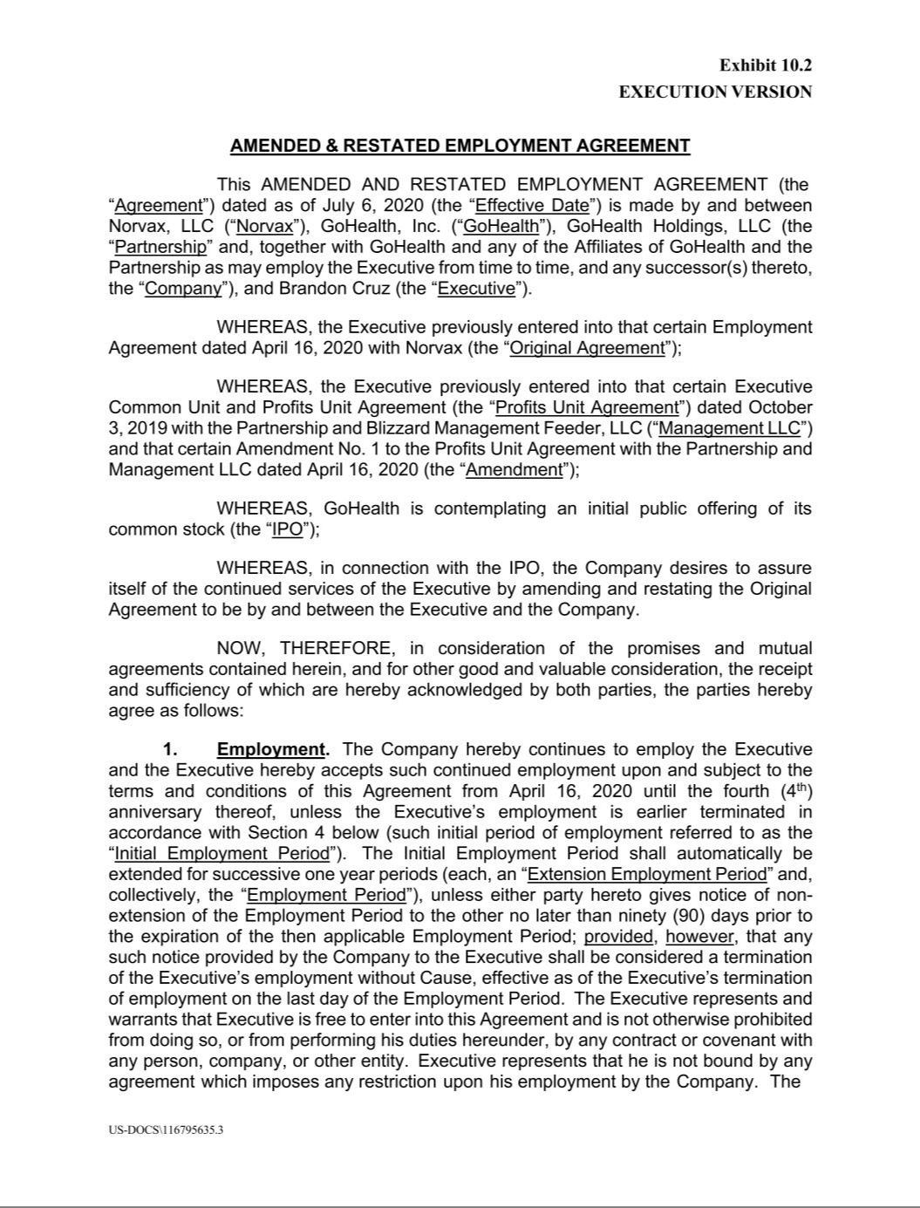

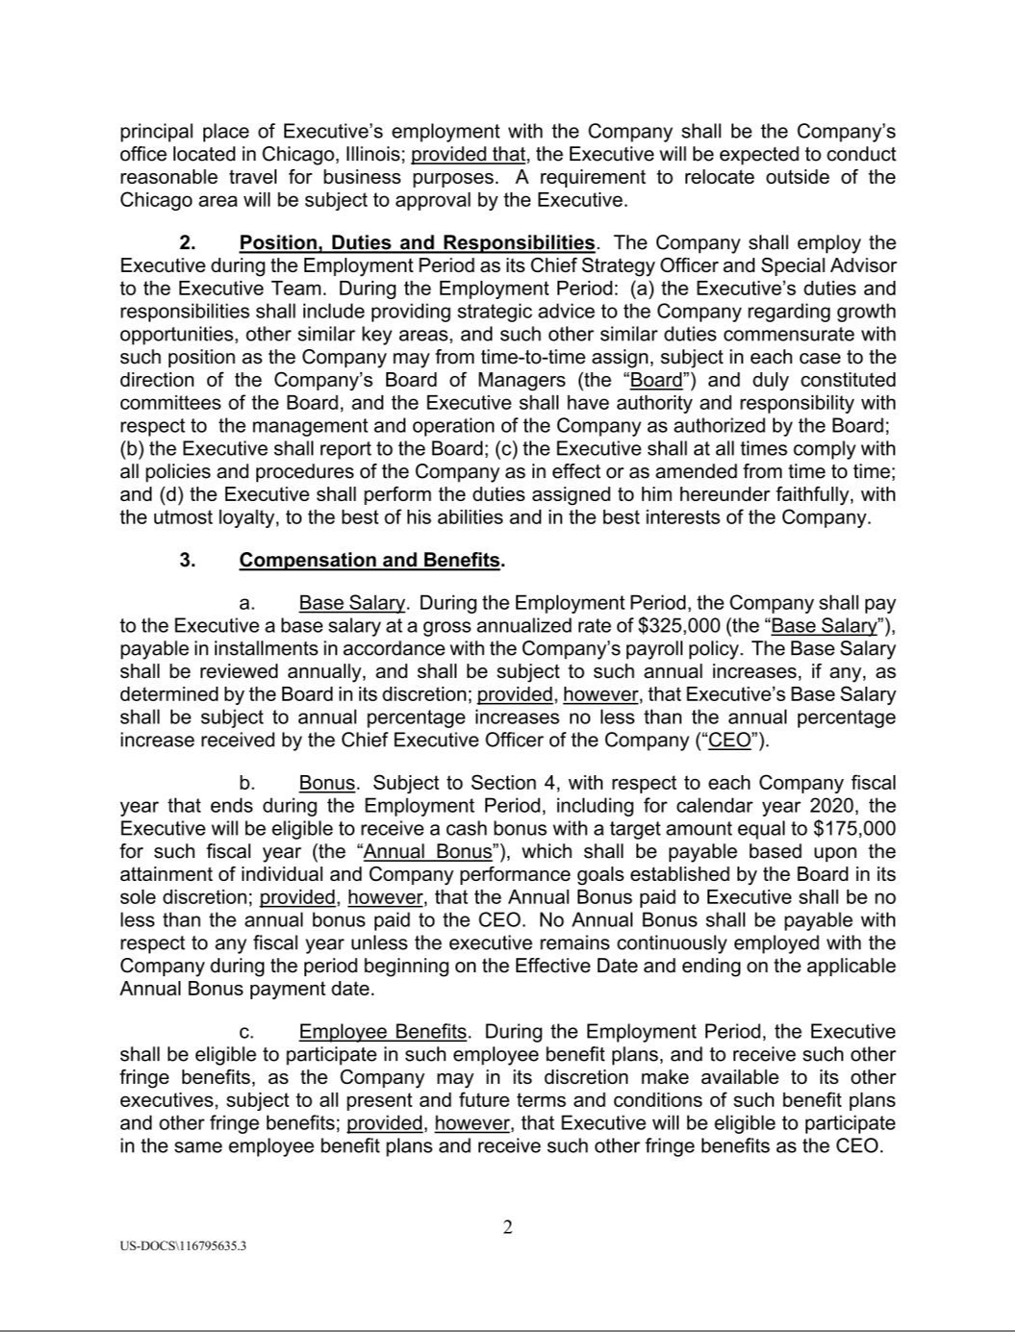

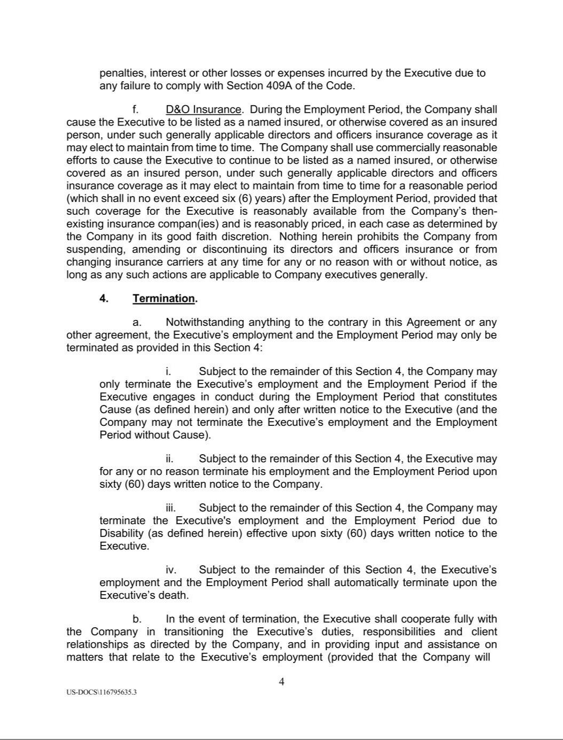

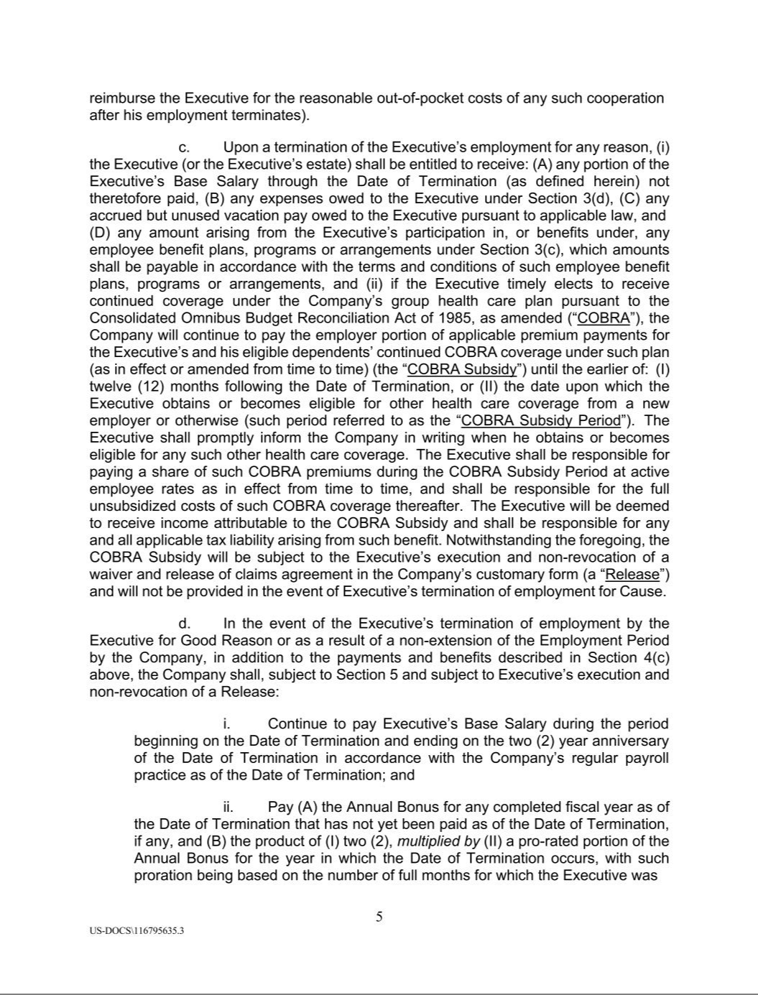

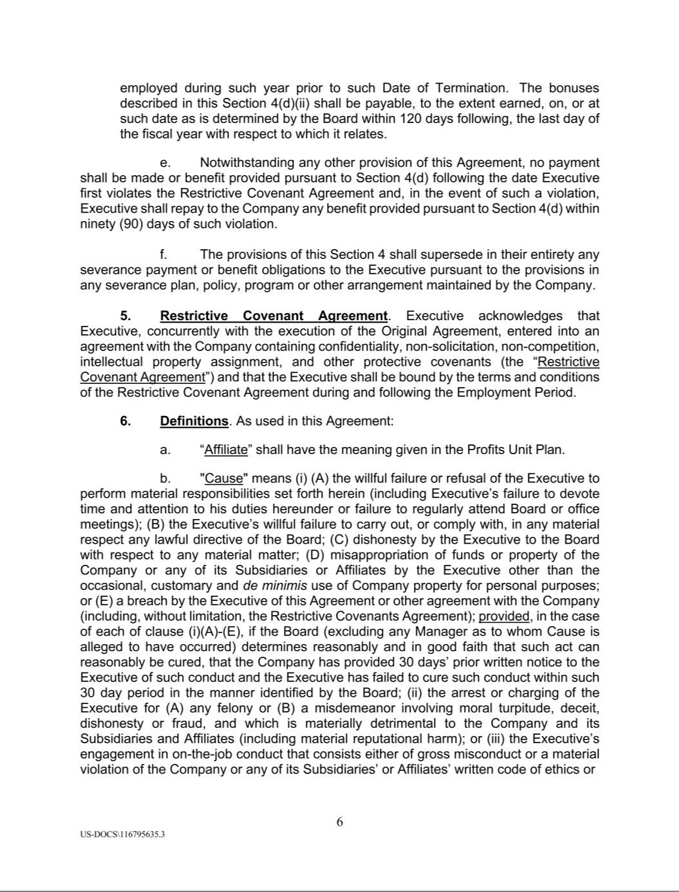

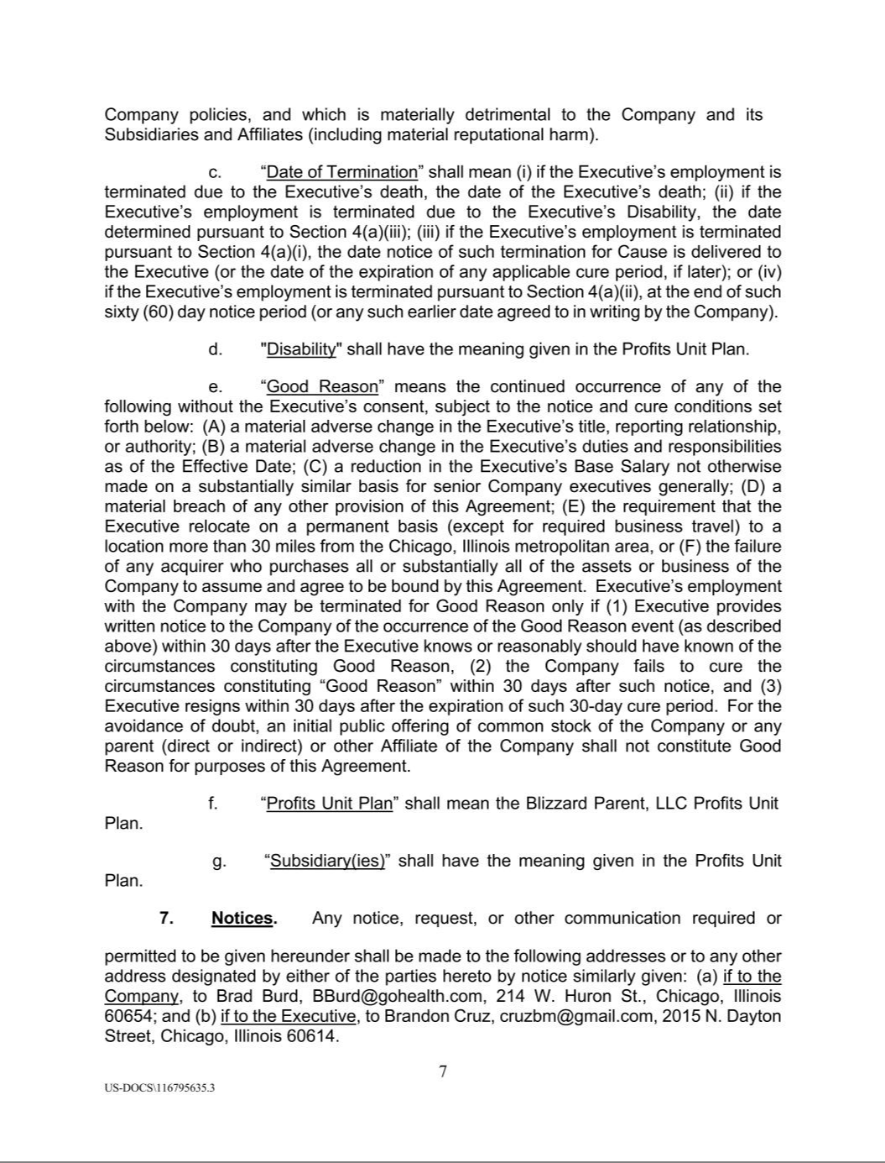

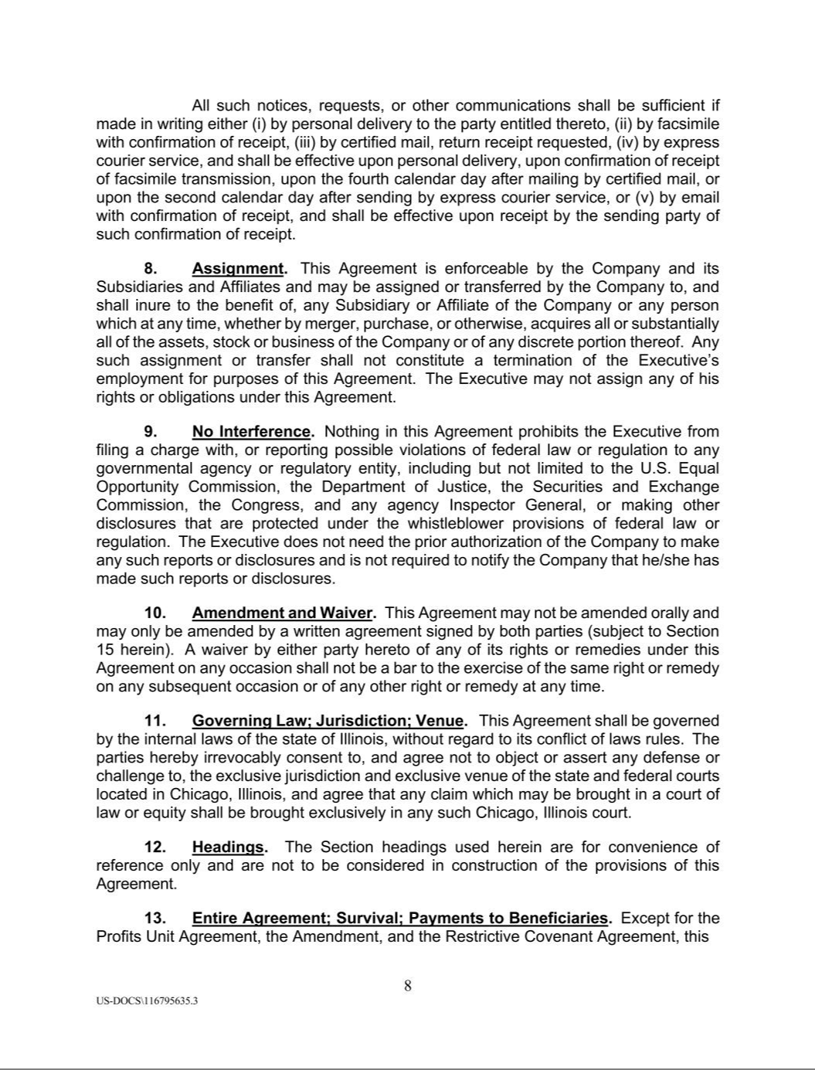

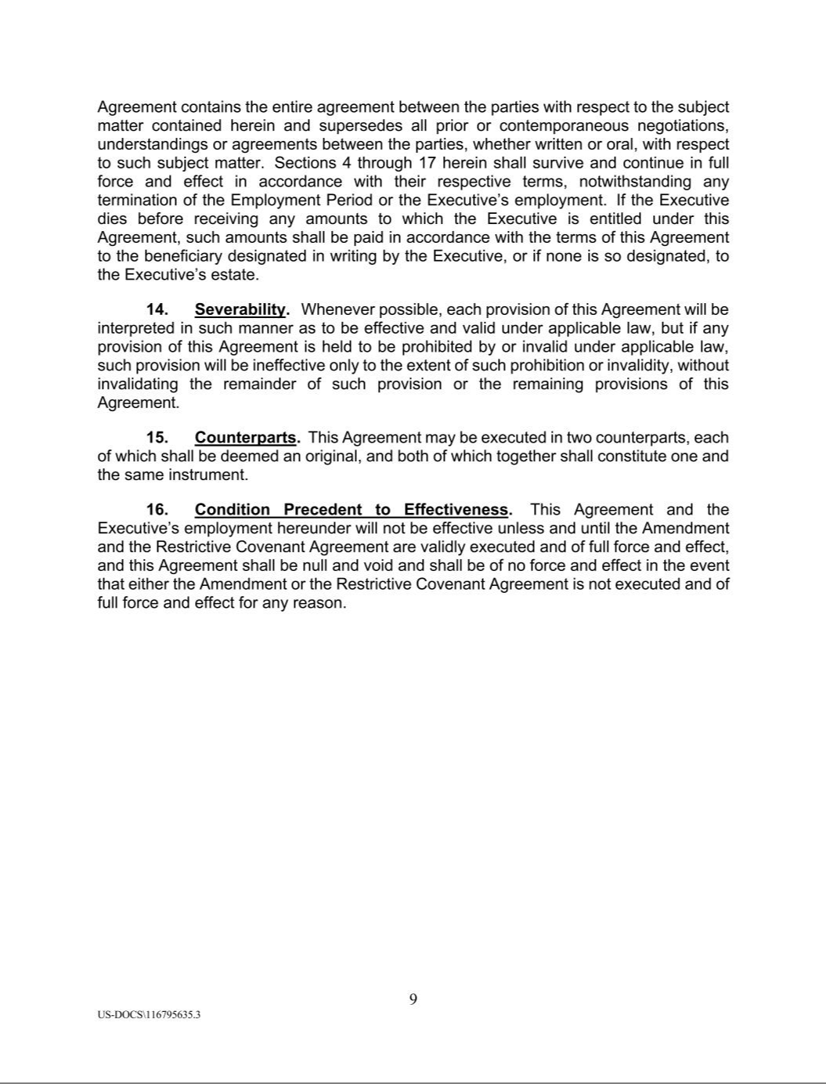

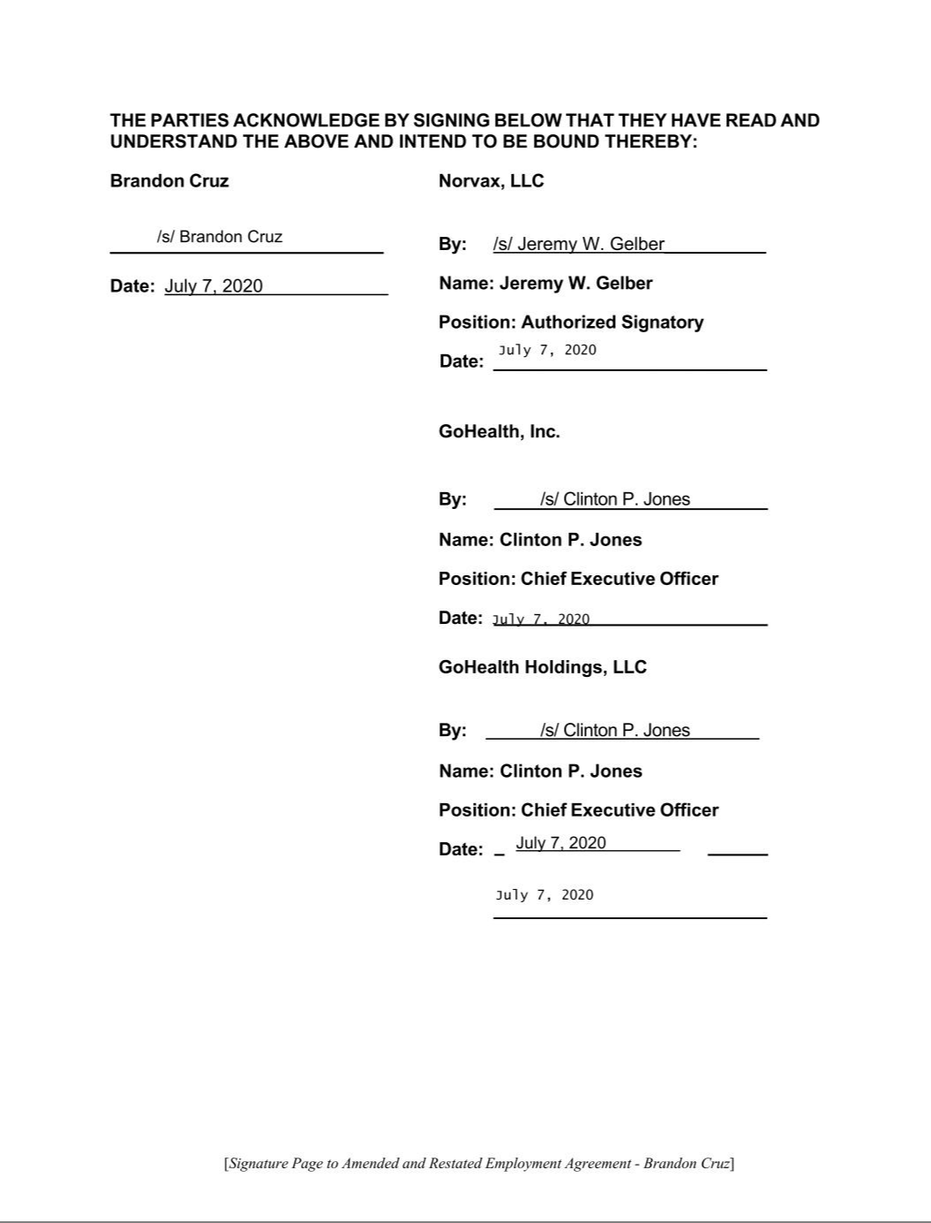

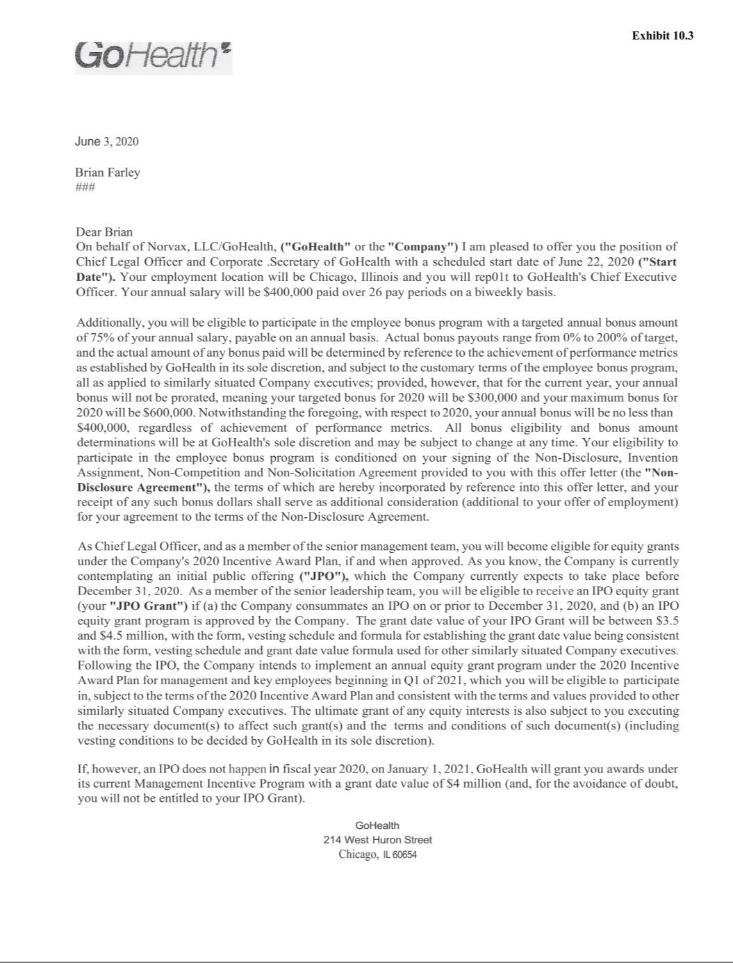

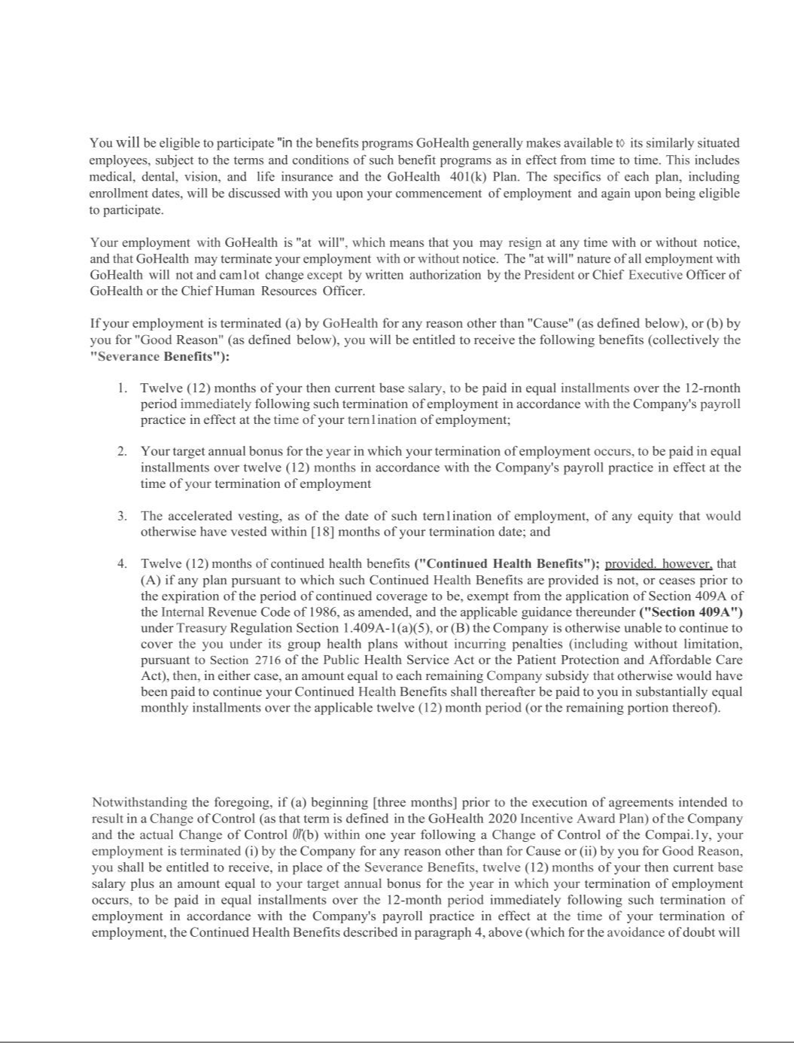

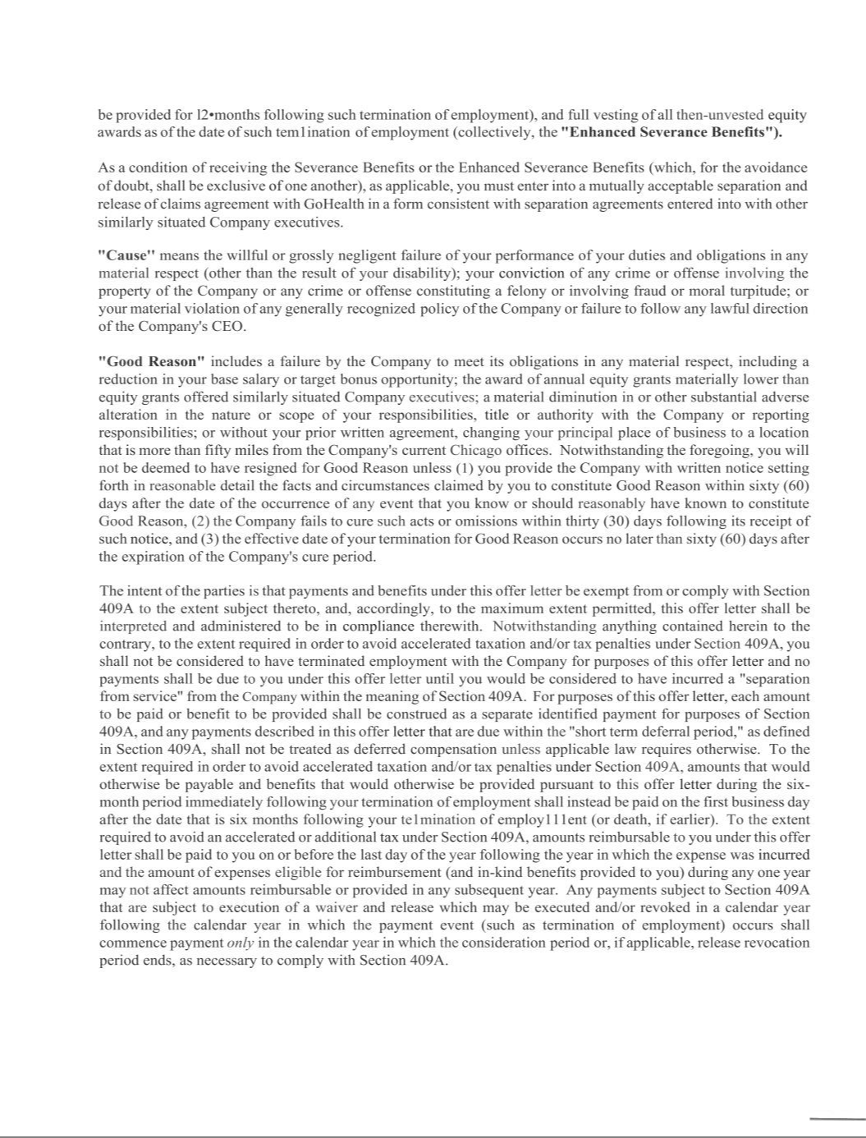

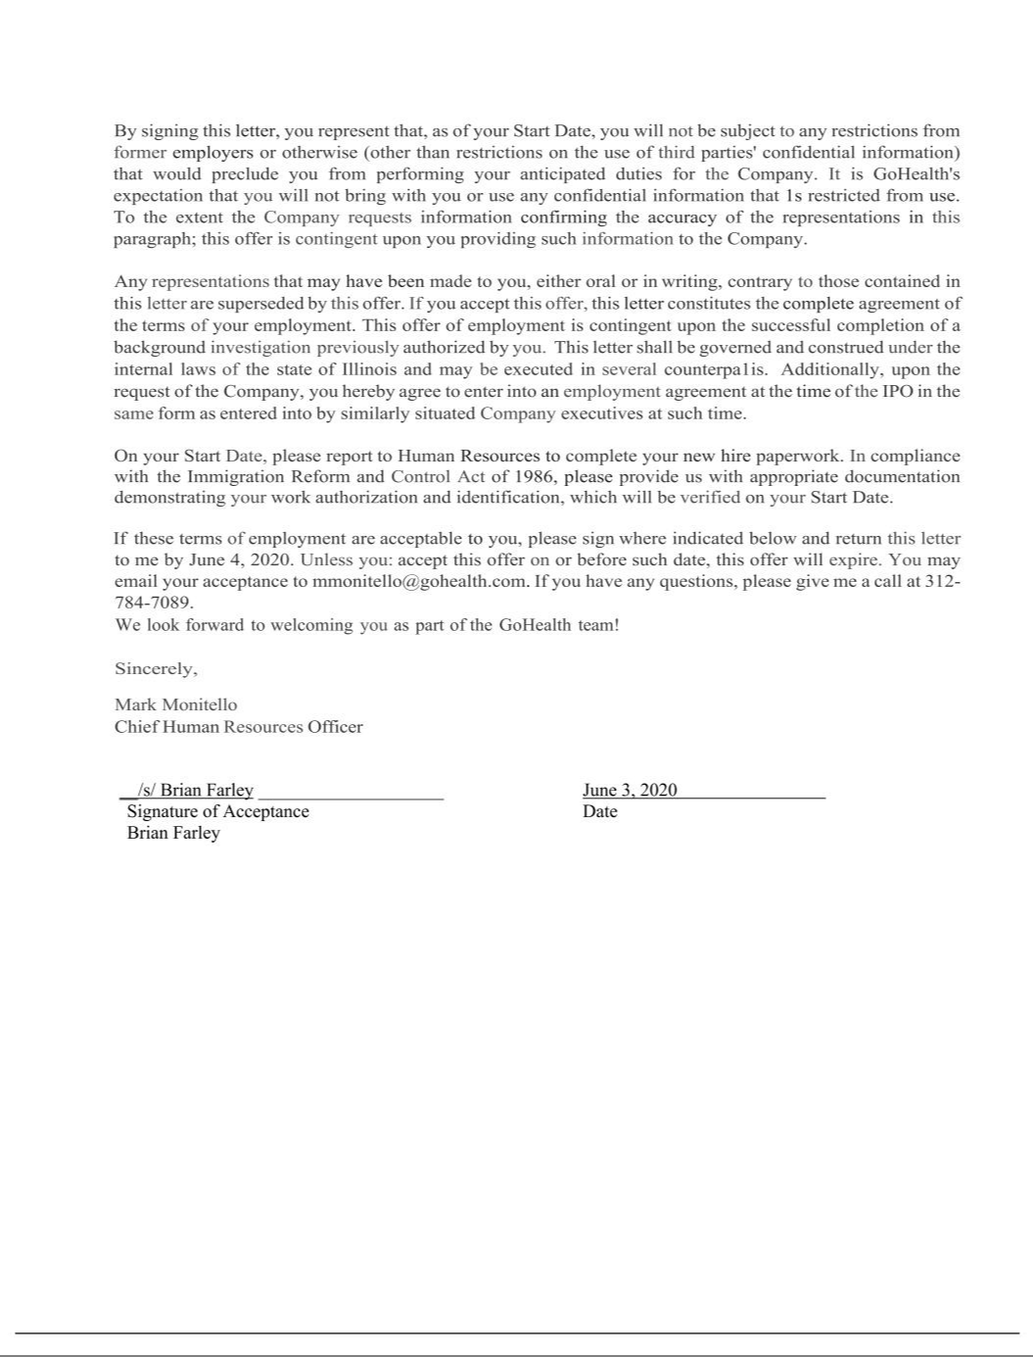

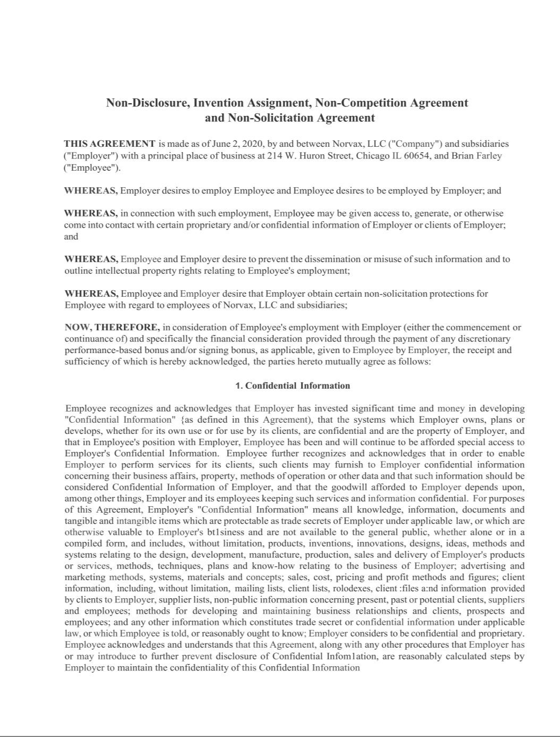

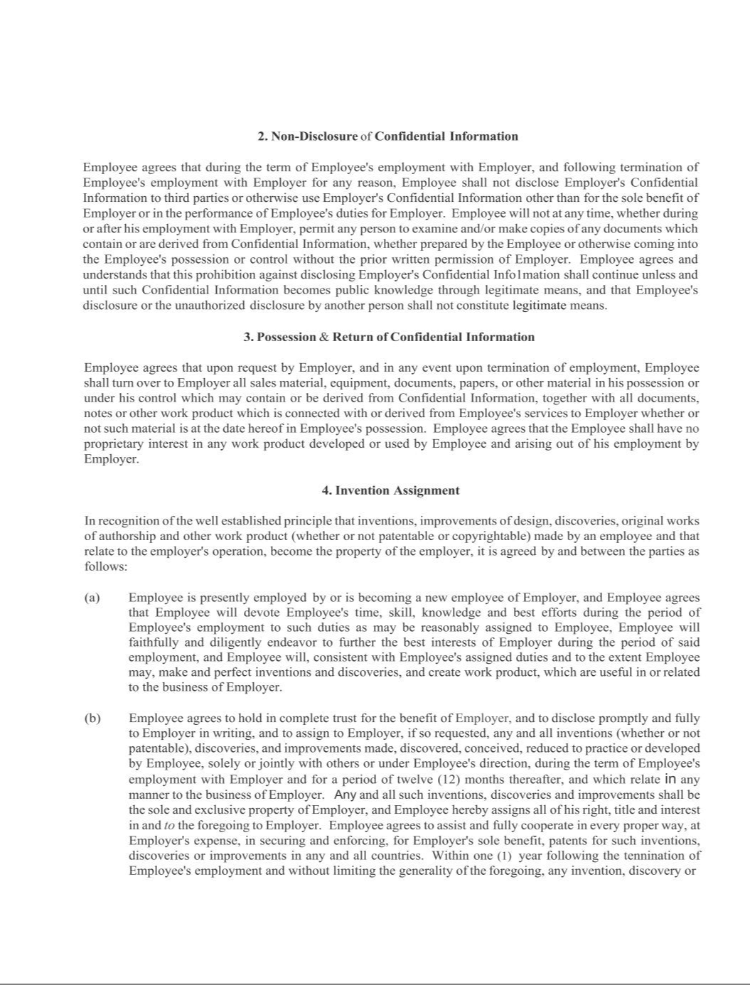

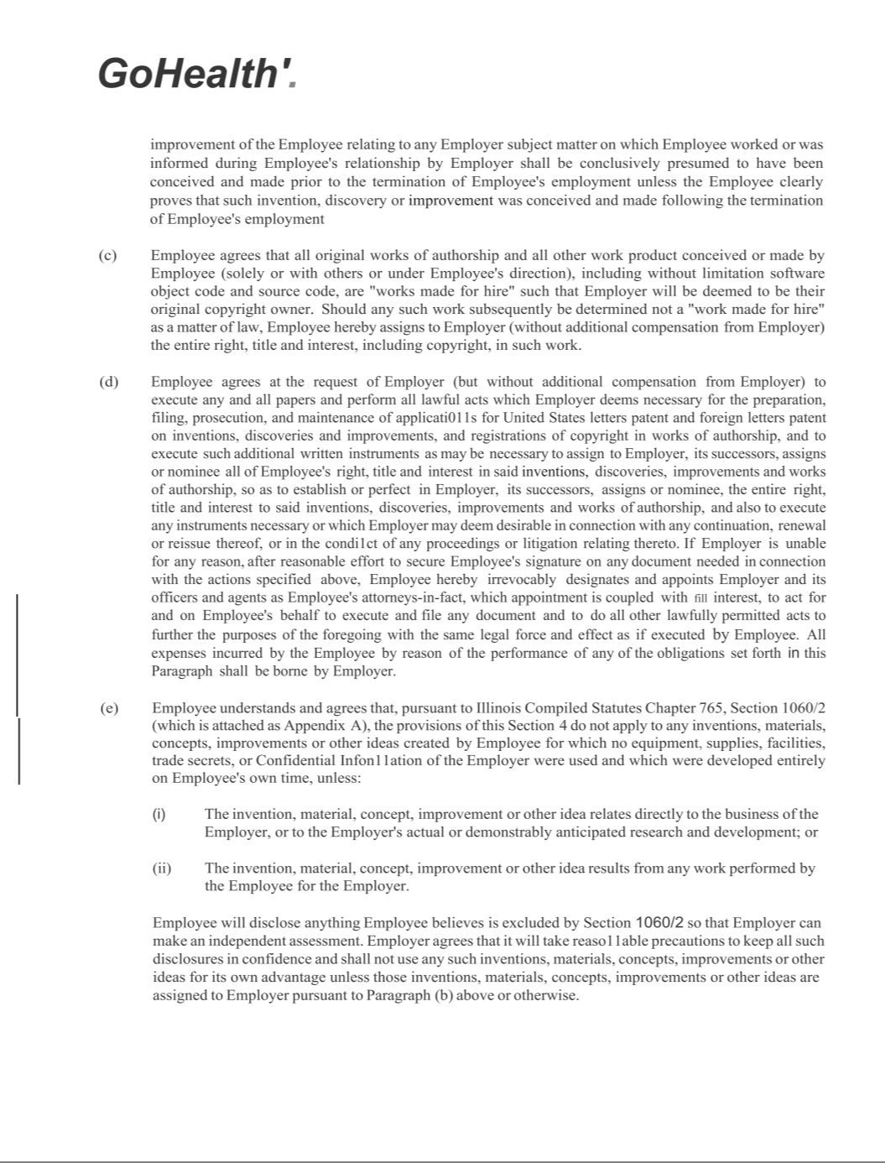

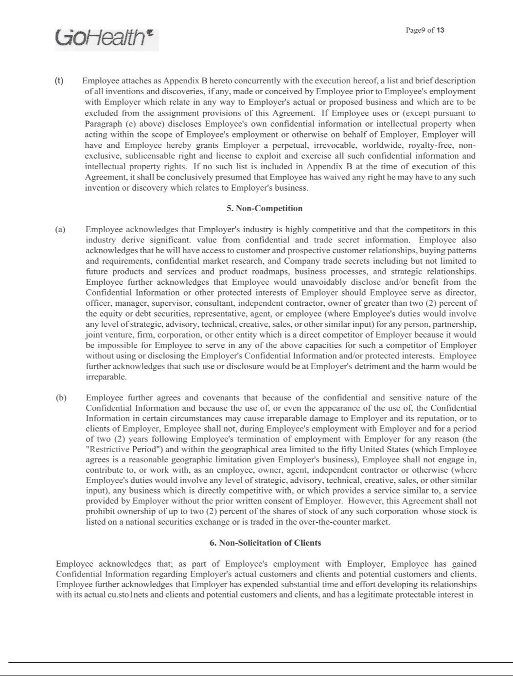

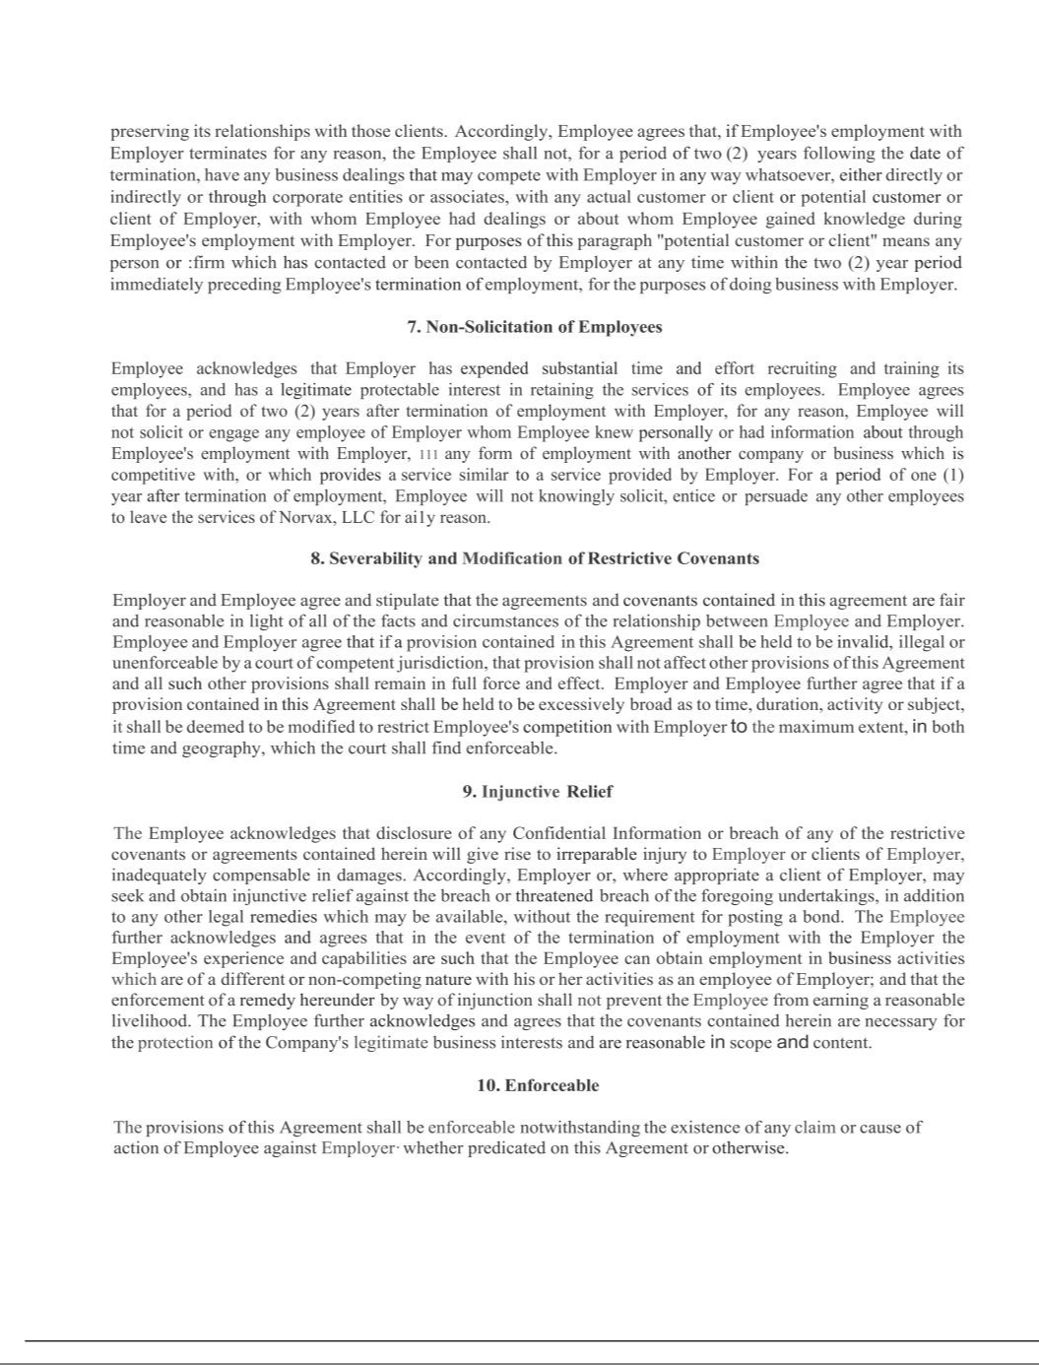

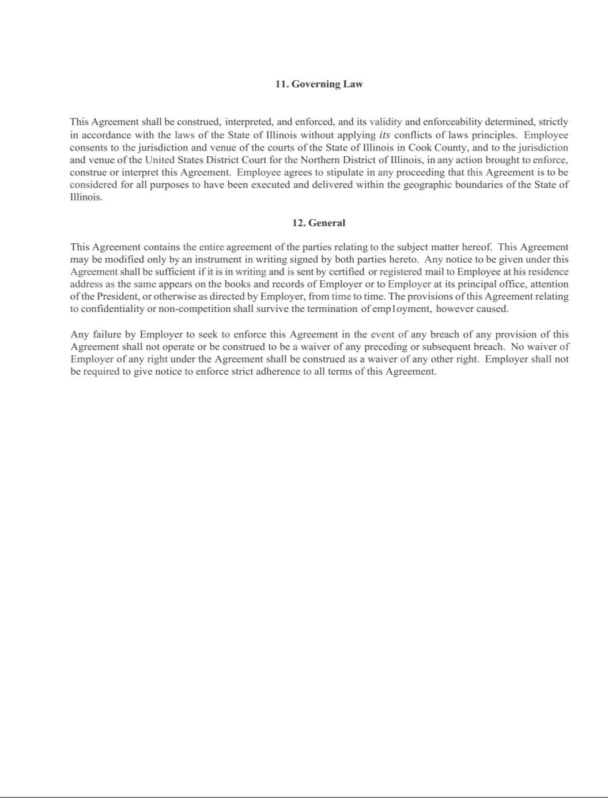

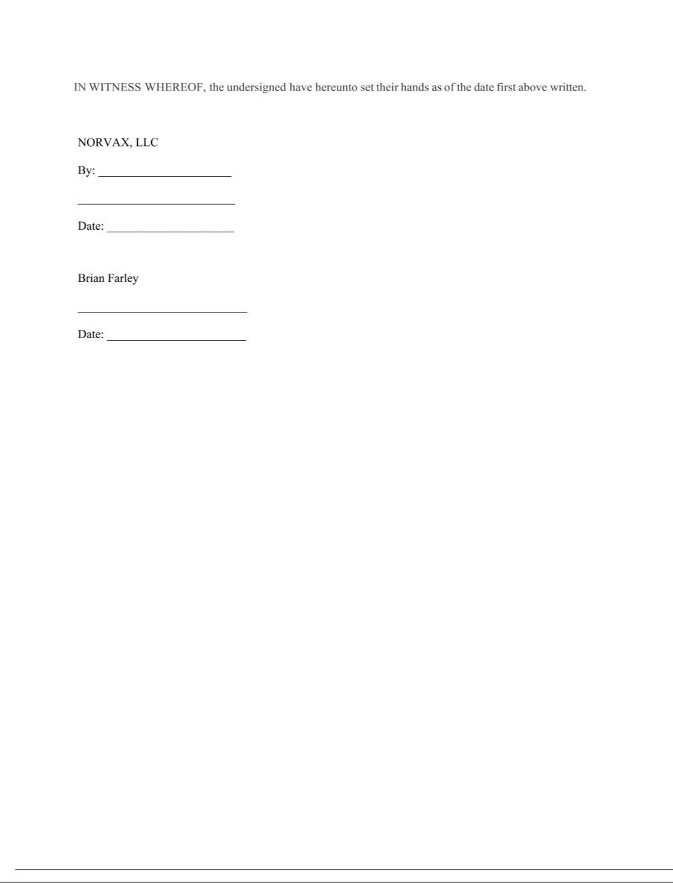

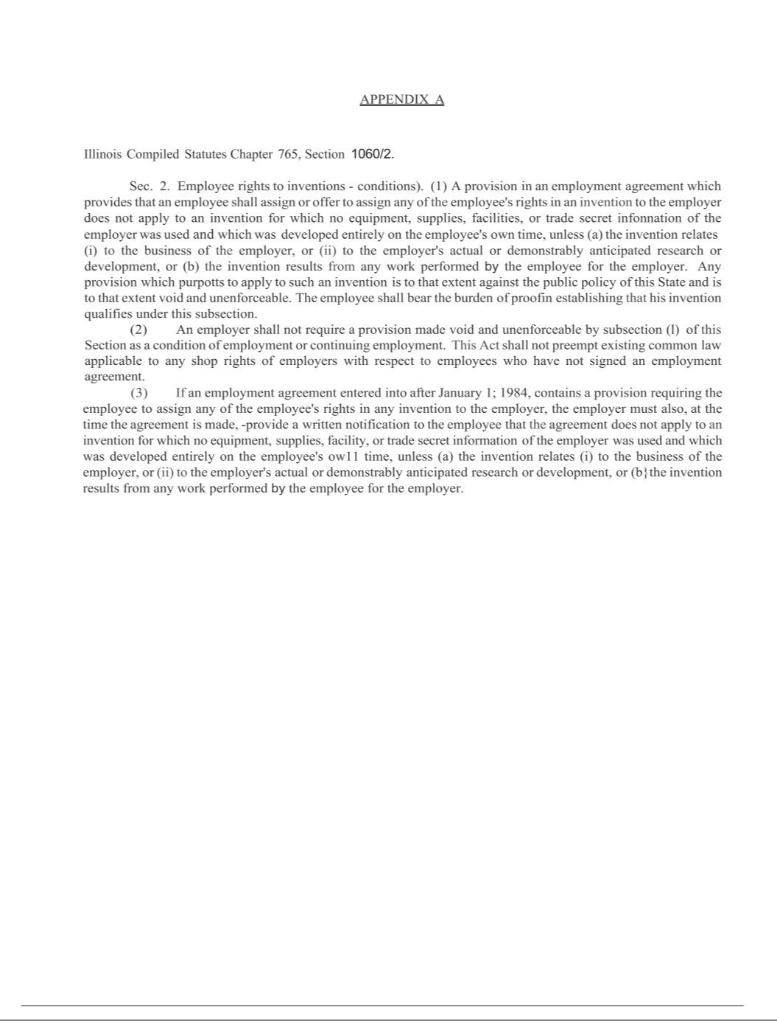

Exhibit 31.1

Certification

I, Clinton P. Jones, certify that:

- I have reviewed this Quarterly Report on Form 10-Q of GoHealth, Inc.;

- Based on my knowledge, this report does not contain any untrue statement of a material fact or omit to state a material fact necessary to make the statements made, in light of the circumstances under which such statements were made, not misleading with respect to the period covered by this report;

- Based on my knowledge, the financial statements, and other financial information included in this report, fairly present in all material respects the financial condition, results of operations and cash flows of the registrant as of, and for, the periods presented in this report;

- The registrant’s other certifying officer(s) and I are responsible for establishing and maintaining disclosure controls and procedures (as defined in Exchange Act Rules 13a-15(e) and 15d-15(e)) for the registrant and have:

  - Designed such disclosure controls and procedures, or caused such disclosure controls and procedures to be designed under our supervision, to ensure that material information relating to the registrant, including its consolidated subsidiaries, is made known to us by others within those entities, particularly during the period in which this report is being prepared;

  - [omitted];

  - Evaluated the effectiveness of the registrant’s disclosure controls and procedures and presented in this report our conclusions about the effectiveness of the disclosure controls and procedures, as of the end of the period covered by this report based on such evaluation; and

  - Disclosed in this report any change in the registrant’s internal control over financial reporting that occurred during the registrant’s most recent fiscal quarter (the registrant’s fourth fiscal quarter in the case of an annual report) that has materially affected, or is reasonably likely to materially affect, the registrant’s internal control over financial reporting; and

- The registrant’s other certifying officer(s) and I have disclosed, based on our most recent evaluation of internal control over financial reporting, to the registrant’s auditors and the audit committee of the registrant’s board of directors (or persons performing the equivalent functions):

  - All significant deficiencies and material weaknesses in the design or operation of internal control over financial reporting which are reasonably likely to adversely affect the registrant’s ability to record, process, summarize and report financial information; and

  - Any fraud, whether or not material, that involves management or other employees who have a significant role in the registrant’s internal control over financial reporting.

Date: May 10, 2022 By: /s/ Clinton P. Jones

Clinton P. Jones

Chief Executive Officer

(Principal Executive Officer)

Exhibit 31.2

Certification

I, Travis J. Matthiesen, certify that:

- I have reviewed this Quarterly Report on Form 10-Q of GoHealth, Inc.;

- Based on my knowledge, this report does not contain any untrue statement of a material fact or omit to state a material fact necessary to make the statements made, in light of the circumstances under which such statements were made, not misleading with respect to the period covered by this report;

- Based on my knowledge, the financial statements, and other financial information included in this report, fairly present in all material respects the financial condition, results of operations and cash flows of the registrant as of, and for, the periods presented in this report;

- The registrant’s other certifying officer(s) and I are responsible for establishing and maintaining disclosure controls and procedures (as defined in Exchange Act Rules 13a-15(e) and 15d-15(e)) for the registrant and have:

  - Designed such disclosure controls and procedures, or caused such disclosure controls and procedures to be designed under our supervision, to ensure that material information relating to the registrant, including its consolidated subsidiaries, is made known to us by others within those entities, particularly during the period in which this report is being prepared;

  - [omitted];

  - Evaluated the effectiveness of the registrant’s disclosure controls and procedures and presented in this report our conclusions about the effectiveness of the disclosure controls and procedures, as of the end of the period covered by this report based on such evaluation; and

  - Disclosed in this report any change in the registrant’s internal control over financial reporting that occurred during the registrant’s most recent fiscal quarter (the registrant’s fourth fiscal quarter in the case of an annual report) that has materially affected, or is reasonably likely to materially affect, the registrant’s internal control over financial reporting; and

- The registrant’s other certifying officer(s) and I have disclosed, based on our most recent evaluation of internal control over financial reporting, to the registrant’s auditors and the audit committee of the registrant’s board of directors (or persons performing the equivalent functions):

  - All significant deficiencies and material weaknesses in the design or operation of internal control over financial reporting which are reasonably likely to adversely affect the registrant’s ability to record, process, summarize and report financial information; and

  - Any fraud, whether or not material, that involves management or other employees who have a significant role in the registrant’s internal control over financial reporting.

Date: May 10, 2022 By: /s/ Travis J. Matthiesen

Travis J. Matthiesen

Interim Chief Financial Officer

(Principal Financial and Accounting Officer)

Exhibit 32.1

Certification Pursuant to

18 U.S.C. Section 1350, as Adopted Pursuant to

Section 906 of the Sarbanes-Oxley Act of 2002

In connection with the Quarterly Report on Form 10-Q of GoHealth, Inc. (the “Company”) for the period ended March 31, 2022 as filed with the Securities and Exchange Commission on the date hereof (the “Report”), I certify, pursuant to 18 U.S.C. § 1350, as adopted pursuant to § 906 of the Sarbanes-Oxley Act of 2002, that:

- The Report fully complies with the requirements of section 13(a) or 15(d) of the Securities Exchange Act of 1934, as amended; and

- The information contained in the Report fairly presents, in all material respects, the financial condition and results of operations of the Company.

Date: May 10, 2022 By: /s/ Clinton P. Jones

Clinton P. Jones

Chief Executive Officer

(Principal Executive Officer)

Exhibit 32.2

Certification Pursuant to

18 U.S.C. Section 1350, as Adopted Pursuant to

Section 906 of the Sarbanes-Oxley Act of 2002

In connection with the Quarterly Report on Form 10-Q of GoHealth, Inc. (the “Company”) for the period ended March 31, 2022 as filed with the Securities and Exchange Commission on the date hereof (the “Report”), I certify, pursuant to 18 U.S.C. § 1350, as adopted pursuant to § 906 of the Sarbanes-Oxley Act of 2002, that:

- The Report fully complies with the requirements of section 13(a) or 15(d) of the Securities Exchange Act of 1934, as amended; and

- The information contained in the Report fairly presents, in all material respects, the financial condition and results of operations of the Company.

Date: May 10, 2022 By: /s/ Travis J. Matthiesen

Travis J. Matthiesen

Interim Chief Financial Officer

(Principal Financial and Accounting Officer)

