UNITED STATES

SECURITIES AND EXCHANGE COMMISSION

WASHINGTON, DC 20549

FORM 10-Q

(Mark One)

- QUARTERLY REPORT PURSUANT TO SECTION 13 OR 15(d) OF THE SECURITIES EXCHANGE ACT OF 1934

For the quarterly period ended March 31, 2024

OR

- TRANSITION REPORT PURSUANT TO SECTION 13 OR 15(d) OF THE SECURITIES EXCHANGE ACT OF 1934

For the transition period from to

Commission File Number: 001-39390


GoHealth, Inc.

(Exact name of registrant as specified in its charter)

_________________________

Delaware

85-0563805

(State or other jurisdiction of incorporation or organization)

(I.R.S. Employer Identification No.)

222 W Merchandise Mart Plaza, Suite 1750

Chicago, Illinois

60654

(Address of principal executive offices)

(Zip Code)

(312) 386-8200

(Registrant’s telephone number, including area code)

N/A

(Former name, former address and former fiscal year, if changed since last report)

_________________________

Securities registered pursuant to Section 12(b) of the Act:
 |  |  |  | Name of each exchange
Title of each class |  | Trading Symbol(s) |  | on which registered
Class A Common Stock, |  | GOCO |  | The Nasdaq Global Market
$0.0001 par value per share

Indicate by check mark whether the registrant (1) has filed all reports required to be filed by Section 13 or 15(d) of the Securities Exchange Act of 1934 during the preceding 12 months (or for such shorter period that the registrant was required to file such reports), and (2) has been subject to such filing requirements for the past 90 days. Yes ☒ No ☐

Indicate by check mark whether the registrant has submitted electronically every Interactive Data File required to be submitted pursuant to Rule 405 of Regulation S-T (§232.405 of this chapter) during the preceding 12 months (or for such shorter period that the registrant was required to submit such files). Yes ☒ No ☐

Indicate by check mark whether the registrant is a large accelerated filer, an accelerated filer, a non-accelerated filer, a smaller reporting company, or an emerging growth company. See the definitions of “large accelerated filer,” “accelerated filer,” “smaller reporting company,” and “emerging growth company” in Rule 12b-2 of the Exchange Act.

Large accelerated filer | ☐ | Accelerated filer | ☒
Non-accelerated filer | ☐ | Smaller reporting company | ☒
 |  | Emerging growth company | ☐

If an emerging growth company, indicate by check mark if the registrant has elected not to use the extended transition period for complying with any new or revised financial accounting standards provided pursuant to Section 13(a) of the Exchange Act. ☐

Indicate by check mark whether the registrant is a shell company (as defined in Rule 12b-2 of the Exchange Act). Yes ☐ No ☒

As of May 1, 2024, the registrant had 9,946,669 shares of Class A common stock, $0.0001 par value per share, outstanding and 12,781,528 shares of Class B common stock, $0.0001 par value per share, outstanding.

 |  |  |  |  |  |  |  |  |  |  |  | TABLE OF CONTENTS
 |  |  |  |  |  |  |  |  |  |  |  |  |  |  |  |  |  |  |  |  | PAGE
 |  |  |  |  |  |  |  |  |  |  | PART I - FINANCIAL INFORMATION
ITEM 1. | FINANCIAL STATEMENTS. |  |  |  |  |  |  |  |  |  |  |  |  |  |  |  |  |  |  |  | 4
 | CONDENSED CONSOLIDATED FINANCIAL STATEMENTS |  |  |  |  |  |  |  |  |  |  |  |  |  |  |  |  |  |  |  | 4
 |  | CONDENSED CONSOLIDATED STATEMENTS OF OPERATIONS |  |  |  |  |  |  |  |  |  |  |  |  |  |  |  |  |  |  | 4
 |  | CONDENSED CONSOLIDATED STATEMENTS OF COMPREHENSIVE INCOME (LOSS) |  |  |  |  |  |  |  |  |  |  |  |  |  |  |  |  |  |  | 5
 |  | CONDENSED CONSOLIDATED BALANCE SHEETS |  |  |  |  |  |  |  |  |  |  |  |  |  |  |  |  |  |  | 6
 |  | CONDENSED CONSOLIDATED STATEMENTS OF CHANGES IN STOCKHOLDERS’ EQUITY |  |  |  |  |  |  |  |  |  |  |  |  |  |  |  |  |  |  | 7
 |  | CONDENSED CONSOLIDATED STATEMENTS OF CASH FLOWS |  |  |  |  |  |  |  |  |  |  |  |  |  |  |  |  |  |  | 8
 |  | NOTES TO CONDENSED CONSOLIDATED FINANCIAL STATEMENTS |  |  |  |  |  |  |  |  |  |  |  |  |  |  |  |  |  |  | 9
ITEM 2. | MANAGEMENT’S DISCUSSION AND ANALYSIS OF FINANCIAL CONDITIONS AND RESULTS OF OPERATIONS. |  |  |  |  |  |  |  |  |  |  |  |  |  |  |  |  |  |  |  | 23
ITEM 3. | QUANTITATIVE AND QUALITATIVE DISCLOSURES ABOUT MARKET RISK. |  |  |  |  |  |  |  |  |  |  |  |  |  |  |  |  |  |  |  | 32
ITEM 4. | CONTROLS AND PROCEDURES. |  |  |  |  |  |  |  |  |  |  |  |  |  |  |  |  |  |  |  | 32
 |  |  |  |  |  |  |  |  |  |  |  | PART II - OTHER INFORMATION
ITEM 1. | LEGAL PROCEEDINGS. |  |  |  |  |  |  |  |  |  |  |  |  |  |  |  |  |  |  |  | 33
ITEM 1A. | RISK FACTORS. |  |  |  |  |  |  |  |  |  |  |  |  |  |  |  |  |  |  |  | 33
ITEM 2. | UNREGISTERED SALES OF EQUITY SECURITIES AND USE OF PROCEEDS. |  |  |  |  |  |  |  |  |  |  |  |  |  |  |  |  |  |  |  | 33
ITEM 3. | DEFAULTS UPON SENIOR SECURITIES. |  |  |  |  |  |  |  |  |  |  |  |  |  |  |  |  |  |  |  | 33
ITEM 4. | MINE SAFETY DISCLOSURES. |  |  |  |  |  |  |  |  |  |  |  |  |  |  |  |  |  |  |  | 33
ITEM 5. | OTHER INFORMATION. |  |  |  |  |  |  |  |  |  |  |  |  |  |  |  |  |  |  |  | 33
ITEM 6. | EXHIBITS. |  |  |  |  |  |  |  |  |  |  |  |  |  |  |  |  |  |  |  | 34
 | SIGNATURES |  |  |  |  |  |  |  |  |  |  |  |  |  |  |  |  |  |  |  | 35

CAUTIONARY NOTE REGARDING FORWARD-LOOKING STATEMENTS

This Quarterly Report on Form 10-Q contains forward-looking statements within the meaning of Section 27A of the Securities Act of 1933, as amended, (the “Securities Act”) and Section 21E of the Securities Exchange Act of 1934, as amended (the “Exchange Act”). These forward-looking statements are made in reliance upon the safe harbor provision of the Private Securities Litigation Reform Act of 1995. All statements other than statements of historical facts contained in this Quarterly Report on Form 10-Q may be forward-looking statements. Statements regarding our future results of operations and financial position, business strategy and plans and objectives of management for future operations, including, among others, statements regarding our expected growth, future capital expenditures and debt service obligations, are forward-looking statements.

In some cases, you can identify forward-looking statements by terms such as “may,” “will,” “should,” “aims,” “expects,” “plans,” “anticipates,” “could,” “intends,” “targets,” “projects,” “contemplates,” “believes,” “estimates,” “predicts,” “potential,” “likely,” “future” or “continue” or the negative of these terms or other similar expressions. The forward-looking statements in this Quarterly Report on Form 10-Q are only predictions, projections and other statements about future events that are based on current expectations and assumptions. Accordingly, we caution you that any such forward-looking statements are not guarantees of future performance and are subject to risks, assumptions and uncertainties that are difficult to predict. Although we believe that the expectations reflected in these forward-looking statements are reasonable as of the date made, actual results may prove to be materially different from the results expressed or implied by the forward-looking statements.

These forward-looking statements speak only as of the date of this Quarterly Report on Form 10-Q and are subject to a number of important factors that could cause actual results to differ materially from those in the forward-looking statements, including the factors described in the sections titled “Summary Risk Factors,” “Risk Factors” and “Management’s Discussion and Analysis of Financial Condition and Results of Operations” in our Annual Report on Form 10-K for the fiscal year ended December 31, 2023 (“2023 Annual Report on Form 10-K”) and in our other filings with the Securities and Exchange Commission.

You should read this Quarterly Report on Form 10-Q and the documents that we reference in this Quarterly Report on Form 10-Q completely and with the understanding that our actual future results may be materially different from what we expect. We qualify all of our forward-looking statements by these cautionary statements. Except as required by applicable law, we do not plan to publicly update or revise any forward-looking statements contained herein, whether as a result of any new information, future events, changed circumstances or otherwise.

CERTAIN DEFINITIONS

As used in this Quarterly Report on Form 10-Q, unless the context otherwise requires:

- “We,” “us,” “our,” the “Company,” “GoHealth” and similar references refer to GoHealth, Inc., and unless otherwise stated, all of its direct and indirect subsidiaries, including GoHealth Holdings, LLC (“GHH, LLC”).

- “Blocker Company” refers to an entity affiliated with Centerbridge that was an indirect owner of LLC Interests in GHH, LLC prior to the Transactions and is taxable as a corporation for U.S. federal income tax purposes.

- “Blocker Shareholders” refer to entities affiliated with Centerbridge, the owners of the Blocker Company prior to the Transactions, who exchanged their interests in the Blocker Company for shares of our Class A common stock and cash in connection with the consummation of the Transactions.

- “Centerbridge” refers to certain investment funds and other entities affiliated with CCP III Cayman GP Ltd., a Cayman Islands exempted company over which CCP III Cayman GP Ltd. has voting control (including any such fund or entity formed to hold shares of Class A common stock for the Blocker Shareholders).

- “Continuing Equity Owners” refer collectively to direct or indirect holders of LLC Interests and our Class B common stock immediately following consummation of the Transactions, including Centerbridge, NVX Holdings, our Founders, the Former Profits Unit Holders and certain executive officers, employees and other minority investors and their respective permitted transferees who may, following the consummation of our IPO, exchange at each of their respective options (subject in certain circumstances to time-based vesting requirements and certain other restrictions), in whole or in part from time to time, their LLC Interests (along with an equal number of shares of Class B common stock (and such shares shall be immediately cancelled)) for, at our election (determined solely by our independent directors (within the meaning of the listing rules of The Nasdaq Global Market (the “Nasdaq Rules”) who are disinterested)), cash or newly-issued shares of our Class A common stock.

- “Founders” refer to Brandon M. Cruz, our Co-Founder and Co-Chairman of the Board of Directors and Clinton P. Jones, our Co-Founder and Co-Chairman of the Board of Directors.

- “Former Profits Unit Holders” refers collectively to certain of our directors and certain current and former officers and employees, in each case, who directly or indirectly held existing vested and unvested profits units, which were

GoHealth, Inc. | 2024 Form 10-Q | 1

comprised of profits units that have time-based vesting conditions and profits units that have performance-based vesting conditions, of GHH, LLC pursuant to GHH, LLC’s existing profits unit plan and who received LLC Interests in exchange for their profits units in connection with the Transactions. LLC Interests received in exchange for unvested profits units remain subject to their existing time-based vesting requirements. Profits units with performance-based vesting conditions fully vested as such conditions were met in connection with our IPO.

- “GHH, LLC Agreement” refers to GHH, LLC’s amended and restated limited liability company agreement, as further amended, which became effective substantially concurrently with or prior to the consummation of our IPO.

- “LLC Interests” refer to the common units of GHH, LLC, including those that we purchased with a portion of the net proceeds from our IPO.

- “Norvax” refers to Norvax, LLC, a Delaware limited liability company and a subsidiary of GHH, LLC.

- “NVX Holdings” refers to NVX Holdings, Inc., a Delaware corporation that is controlled by the Founders.

- “Transactions” refer to our IPO and certain organizational transactions that were effected in connection with our IPO, and the application of the net proceeds therefrom.

GoHealth, Inc. is a holding company and the sole managing member of GHH, LLC, and its principal asset consists of LLC Interests.

KEY TERMS AND PERFORMANCE INDICATORS; NON-GAAP FINANCIAL MEASURES

Throughout this Quarterly Report on Form 10-Q, we use a number of key terms and provide a number of key performance indicators used by management. We define these terms and key performance indicators as follows:

- “Adjusted EBITDA” represents, as applicable for the period, EBITDA as further adjusted for certain items discussed in Item 2. “Management’s Discussion and Analysis of Financial Condition and Results of Operations.”

- “Adjusted EBITDA Margin” refers to Adjusted EBITDA divided by net revenues.

- “Adjusted Gross Margin per Submission” refers to Sales per Submission less Cost per Submission.

- “Cash Adjusted EBITDA” refers to Adjusted EBITDA plus a decrease or less an increase in the period over period change in net contract assets.

- “Cost of Submission” refers to the aggregate cost to convert prospects into Submissions during a particular period. Cost of Submission is comprised of revenue share, marketing and advertising expenses and consumer care and enrollment expenses, excluding share-based compensation expense, the impact of revenue adjustments recorded in the period, but relating to performance obligations satisfied in prior periods and such expenses related to Non-Encompass BPO Services.

- “Cost per Submission” refers to (x) the aggregate cost to convert prospects into Submissions for a particular period (comprised of revenue share, marketing and advertising expenses and consumer care and enrollment expenses, excluding share-based compensation expense and such expenses related to Non-Encompass BPO Services) divided by (y) number of Submissions for such period.

- “EBITDA” represents net income (loss) before interest expense, income tax expense (benefit) and depreciation and amortization expense.

- “LTV” refers to the Lifetime Value of Commissions, which we define as aggregate commissions estimated to be collected over the estimated life of all commissionable Submissions for the relevant period based on multiple factors, including but not limited to, contracted commission rates, health plan partner mix and expected policy persistency with applied constraints.

- “Non-Encompass BPO Services” refer to programs in which GoHealth-employed agents are dedicated to certain health plans and agencies we partner with outside of the Encompass operating model.

- “Sales per Submission” refers to (x) the sum of (i) aggregate commissions estimated to be collected over the estimated life of all commissionable Submissions for the relevant period based on multiple factors, including but not limited to, contracted commission rates, health plan partner mix and expected policy persistency with applied constraints, excluding revenue adjustments recorded in the period, but relating to performance obligations satisfied in prior periods,

GoHealth, Inc. | 2024 Form 10-Q | 2

(ii) non-agency revenue, and (iii) partner marketing and other revenue, divided by (y) the number of Submissions for such period.

- “Sales/Cost of Submission” refers to (x) the sum of (i) aggregate commissions estimated to be collected over the estimated life of all commissionable Submissions for the relevant period based on multiple factors, including but not limited to, contracted commission rates, health plan partner mix and expected policy persistency with applied constraints, excluding revenue adjustments recorded in the period, but relating to performance obligations satisfied in prior periods, (ii) non-agency revenue and (iii) partner marketing and other revenue, divided by (y) the aggregate cost to convert prospects into Submissions (comprised of revenue share, marketing and advertising expenses and consumer care and enrollment expenses, excluding share-based compensation expense) for such period. Sales and Cost of Submission exclude amounts related to Non-Encompass BPO Services.

- “Submission” refers to either (i) a completed application with our licensed agent that is submitted to the health plan partner and subsequently approved by the health plan partner during the indicated period, excluding applications through our Non-Encompass BPO Services or (ii) a transfer by our agent to the health plan partner through the Encompass operating model during the indicated period.

We use supplemental measures of our performance that are derived from our consolidated financial information, but which are not presented in our Condensed Consolidated Financial Statements prepared in accordance with U.S. generally accepted accounting principles (“GAAP”). These non-GAAP financial measures include EBITDA, Adjusted EBITDA and Adjusted EBITDA Margin. Adjusted EBITDA is the primary financial performance measure used by management to evaluate the business and monitor the results of operations. Sales per Submission, Cost per Submission and Adjusted Gross Margin per Submission are also presented on a non-GAAP basis and are key operating metrics used by management to understand the Company’s underlying financial performance and trends.

We use non-GAAP financial measures to supplement financial information presented on a GAAP basis. We believe that excluding certain items from our GAAP results allows management to better understand our consolidated financial performance from period to period and better project our future consolidated financial performance as forecasts are developed at a level of detail different from that used to prepare GAAP-based financial measures. Moreover, we believe these non-GAAP financial measures provide our stakeholders with useful information to help them evaluate our operating results by facilitating an enhanced understanding of our operating performance and enabling them to make more meaningful period to period comparisons. Adjusted EBITDA is used as a basis for certain compensation programs sponsored by the Company. There are limitations to the use of the non-GAAP financial measures presented in this Quarterly Report on Form 10-Q. For example, our non-GAAP financial measures may not be comparable to similarly titled measures of other companies. Other companies, including companies in our industry, may calculate non-GAAP financial measures differently than we do, limiting the usefulness of those measures for comparative purposes.

The non-GAAP financial measures are not meant to be considered as indicators of performance in isolation from or as a substitute for the most directly comparable financial measures prepared in accordance with GAAP and should be read only in conjunction with financial information presented on a GAAP basis. Reconciliations of each of EBITDA, Adjusted EBITDA, Sales per Submission, Cost per Submission and Adjusted Gross Margin per Submission to its most directly comparable GAAP financial measure are presented in the tables within Item 2. “Management’s Discussion and Analysis of Financial Condition and Results of Operations” of this Quarterly Report on Form 10-Q. We encourage you to review the reconciliations in conjunction with the presentation of the non-GAAP financial measures for each of the periods presented. In future periods, we may exclude similar items, may incur income and expenses similar to these excluded items and may include other expenses, costs and non-routine items.

GoHealth, Inc. | 2024 Form 10-Q | 3

PART I - Financial Information

ITEM 1. FINANCIAL STATEMENTS.

CONDENSED CONSOLIDATED FINANCIAL STATEMENTS

GOHEALTH, INC.

CONDENSED CONSOLIDATED STATEMENTS OF OPERATIONS

(in thousands, except per share amounts, unaudited)

 | Three months ended Mar. 31,
 | 2024 |  |  | 2023
Net revenues |  | 185,600 |  |  | 183,158
Operating expenses:
Revenue share |  | 38,013 |  |  | 45,462
Marketing and advertising |  | 52,775 |  |  | 45,743
Consumer care and enrollment |  | 47,861 |  |  | 42,027
Technology |  | 10,550 |  |  | 9,543
General and administrative |  | 16,919 |  |  | 22,618
Amortization of intangible assets |  | 23,514 |  |  | 23,514
Total operating expenses |  | 189,632 |  |  | 188,907
Income (loss) from operations |  | (4,032) |  |  | (5,749)
Interest expense |  | 17,951 |  |  | 16,891
Other (income) expense, net |  | (566) |  |  | (53)
Income (loss) before income taxes |  | (21,417) |  |  | (22,587)
Income tax (benefit) expense |  | (71) |  |  | (44)
Net income (loss) |  | (21,346) |  |  | (22,543)
Net income (loss) attributable to non-controlling interests |  | (12,130) |  |  | (13,364)
Net income (loss) attributable to GoHealth, Inc. | $ | (9,216) |  | $ | (9,179)
Net loss per share (Note 7):
Net income (loss) per share of Class A common stock — basic and diluted | $ | (1.04) |  | $ | (1.12)
Weighted-average shares of Class A common stock outstanding — basic and diluted |  | 9,715 |  |  | 8,965

The accompanying Notes are an integral part of these Condensed Consolidated Financial Statements.

GoHealth, Inc. | 2024 Form 10-Q | 4

GOHEALTH, INC.

CONDENSED CONSOLIDATED STATEMENTS OF COMPREHENSIVE INCOME (LOSS)

(in thousands, unaudited)

 |  |  |  |  | Three months ended Mar. 31,
 |  |  |  |  | 2024 |  |  | 2023
Net income (loss) |  |  | $ |  | (21,346) |  | $ | (22,543)
Other comprehensive income (loss):
Foreign currency translation adjustments |  |  |  |  | (5) |  |  | 5
Comprehensive income (loss) |  |  |  |  | (21,351) |  |  | (22,538)
Comprehensive income (loss) attributable to non-controlling interests |  |  |  |  | (12,133) |  |  | (13,361)
Comprehensive income (loss) attributable to GoHealth, Inc. |  |  | $ |  | (9,218) |  | $ | (9,177)
The accompanying Notes are an integral part of these Condensed Consolidated Financial Statements.
GoHealth, Inc. |  | 2024 Form 10-Q
GoHealth, Inc. |  | 2024 Form 10-Q | 5

GOHEALTH, INC.

CONDENSED CONSOLIDATED BALANCE SHEETS

(in thousands, except per share amounts, unaudited)

 | Mar. 31, 2024 |  |  |  | Dec. 31, 2023
Assets
Current assets:
Cash and cash equivalents | $ | 97,818 |  | $ | 90,809
Accounts receivable, net of allowance for doubtful accounts of $6 in 2024 and $27 in 2023 |  | 9,226 |  |  | 250
Commissions receivable - current |  | 269,799 |  |  | 336,215
Prepaid expense and other current assets |  | 20,254 |  |  | 49,166
Total current assets |  | 397,097 |  |  | 476,440
Commissions receivable - non-current |  | 573,328 |  |  | 575,482
Operating lease ROU asset |  | 21,008 |  |  | 21,995
Other long-term assets |  | 2,118 |  |  | 2,256
Property, equipment, and capitalized software, net |  | 28,667 |  |  | 26,843
Intangible assets, net |  | 373,040 |  |  | 396,554
Total assets | $ | 1,395,258 |  | $ | 1,499,570
Liabilities, Redeemable Convertible Preferred Stock and Stockholders’ Equity
Current liabilities:
Accounts payable | $ | 5,773 |  | $ | 17,705
Accrued liabilities |  | 66,595 |  |  | 86,254
Commissions payable - current |  | 94,896 |  |  | 118,732
Short-term operating lease liability |  | 5,309 |  |  | 5,797
Deferred revenue |  | 38,723 |  |  | 52,403
Current portion of long-term debt |  | 75,000 |  |  | 75,000
Other current liabilities |  | 13,707 |  |  | 14,122
Total current liabilities |  | 300,003 |  |  | 370,013
Non-current liabilities:
Commissions payable - non-current |  | 201,653 |  |  | 203,255
Long-term operating lease liability |  | 38,198 |  |  | 39,547
Long-term debt, net of current portion |  | 410,324 |  |  | 422,705
Other non-current liabilities |  | 9,247 |  |  | 9,095
Total non-current liabilities |  | 659,422 |  |  | 674,602
Commitments and Contingencies (Note 11)
Series A redeemable convertible preferred stock — $0.0001 par value; 50 shares authorized; 50 shares issued and outstanding as of both March 31, 2024 and December 31, |  | 50,193 |  |  | 49,302
2023. Liquidation preference of $51.9 million and $50.9 million as of March 31, 2024 and December 31, 2023, respectively.
Stockholders’ equity:
Class A common stock – $0.0001 par value; 1,100,000 shares authorized; 10,160 and 9,823 shares issued; 9,898 and 9,651 shares outstanding as of March 31, 2024 and |  | 1 |  |  | 1
December 31, 2023, respectively.
Class B common stock – $0.0001 par value; 615,987 and 616,018 shares authorized; 12,783 and 12,814 shares issued and outstanding as of March 31, 2024 and December |  | 1 |  |  | 1
31, 2023, respectively.
Preferred stock – $0.0001 par value; 20,000 shares authorized (including 50 shares of Series A redeemable convertible preferred stock authorized and 200 shares of Series |  | — |  |  | —
A-1 convertible preferred stock authorized); 50 shares issued and outstanding as of both March 31, 2024 and December 31, 2023.
Series A-1 convertible preferred stock— $0.0001 par value; 200 shares authorized; no shares issued and outstanding as of both March 31, 2024 and December 31, 2023. |  | — |  |  | —
Treasury stock – at cost; 262 and 173 shares of Class A common stock as of March 31, 2024 and December 31, 2023, respectively. |  | (3,582) |  |  | (2,640)
Additional paid-in capital |  | 659,080 |  |  | 654,059
Accumulated other comprehensive income (loss) |  | (129) |  |  | (127)
Accumulated deficit |  | (429,496) |  |  | (420,280)
Total stockholders’ equity attributable to GoHealth, Inc. |  | 225,875 |  |  | 231,014
Non-controlling interests |  | 159,765 |  |  | 174,639
Total stockholders’ equity |  | 385,640 |  |  | 405,653
Total liabilities, redeemable convertible preferred stock and stockholders’ equity | $ | 1,395,258 |  | $ | 1,499,570

The accompanying Notes are an integral part of these Condensed Consolidated Financial Statements.

GoHealth, Inc. | 2024 Form 10-Q | 6

Balance at Jan. 1, 2024 Net income (loss)

Issuance of Class A common shares related to share-based compensation plans

Share-based compensation expense Foreign currency translation adjustments
Class A common shares repurchased for employee tax withholdings

Dividends accumulated on Series A redeemable convertible preferred stock

Forfeitures of Time-Vesting Units Redemption of LLC Interests Balance at Mar. 31, 2024

Balance at Jan. 1, 2023 Net income (loss)

Issuance of Class A common shares related to share-based compensation plans

Share-based compensation expense Foreign currency translation adjustments
Class A common shares repurchased for employee tax withholdings

Dividends accumulated on Series A redeemable convertible preferred stock

Forfeitures of Time-Vesting Units Redemption of LLC Interests Balance at Mar. 31, 2023

GOHEALTH, INC.

CONDENSED CONSOLIDATED STATEMENTS OF CHANGES IN STOCKHOLDERS’ EQUITY

(in thousands, unaudited)

Three months ended Mar. 31, 2024

 |  | Class A Common Stock |  |  |  |  |  |  |  |  | Class B Common Stock |  |  |  |  |  |  |  |  | Treasury Stock
 |  | Shares |  |  |  | Amount |  |  |  |  | Shares |  |  |  | Amount |  |  |  |  | Shares |  |  |  |  | Amount |  |  |  |  | Additional Paid-In |  |  |  |  | Accumulated Deficit |  |  |  |  | Accumulated Other |  |  |  |  | Non-Controlling |  |  | Stockholders’ Equity
 |  |  |  |  |  |  |  |  |  |  |  |  |  |  |  |  |  |  |  |  |  |  |  |  |  |  |  |  |  | Capital |  |  |  |  |  |  |  |  | Comprehensive Income |  |  |  |  |  | Interest
 |  |  |  |  |  |  |  |  |  |  |  |  |  |  |  |  |  |  |  |  |  |  |  |  |  |  |  |  |  |  |  |  |  |  |  |  |  |  |  | (Loss)
 |  | 9,823 |  | $ |  |  | 1 |  |  |  | 12,814 |  | $ |  |  | 1 |  |  |  | (173) |  | $ |  |  | (2,640) |  | $ |  |  | 654,059 |  | $ |  |  | (420,280) |  | $ |  |  | (127) |  | $ |  |  | 174,639 |  | $ | 405,653
 |  |  |  |  |  |  |  |  |  |  |  |  |  |  |  |  |  |  |  |  |  |  |  |  |  |  |  |  |  |  |  |  |  |  | (9,216) |  |  |  |  |  |  |  |  |  | (12,130) |  |  | (21,346)
 |  | 307 |  |  |  |  | — |  |  |  |  |  |  |  |  |  |  |  |  |  |  |  |  |  |  |  |  |  |  | — |  |  |  |  |  |  |  |  |  |  |  |  |  |  |  |  |  | —
 |  |  |  |  |  |  |  |  |  |  |  |  |  |  |  |  |  |  |  |  |  |  |  |  |  |  |  |  |  | 3,172 |  |  |  |  |  |  |  |  |  |  |  |  |  |  |  |  |  | 3,172
 |  |  |  |  |  |  |  |  |  |  |  |  |  |  |  |  |  |  |  |  |  |  |  |  |  |  |  |  |  |  |  |  |  |  |  |  |  |  |  | (2) |  |  |  |  | (3) |  |  | (5)
 |  |  |  |  |  |  |  |  |  |  |  |  |  |  |  |  |  |  |  | (89) |  |  |  |  | (942) |  |  |  |  |  |  |  |  |  |  |  |  |  |  |  |  |  |  |  |  |  |  | (942)
 |  |  |  |  |  |  |  |  |  |  |  |  |  |  |  |  |  |  |  |  |  |  |  |  |  |  |  |  |  | (892) |  |  |  |  |  |  |  |  |  |  |  |  |  |  |  |  |  | (892)
 |  |  |  |  |  |  |  |  |  |  | (1) |  |  |  |  | — |  |  |  |  |  |  |  |  |  |  |  |  |  |  |  |  |  |  |  |  |  |  |  |  |  |  |  |  |  |  |  | —
 |  | 30 |  |  |  |  | — |  |  |  | (30) |  |  |  |  | — |  |  |  |  |  |  |  |  |  |  |  |  |  | 2,741 |  |  |  |  |  |  |  |  |  |  |  |  |  |  | (2,741) |  |  | —
 |  | 10,160 |  |  |  | $ | 1 |  |  |  | 12,783 |  |  |  | $ | 1 |  |  |  | (262) |  |  |  | $ | (3,582) |  |  |  | $ | 659,080 |  |  |  | $ | (429,496) |  |  |  | $ | (129) |  |  |  | $ | 159,765 |  | $ | 385,640
 |  |  |  |  |  |  |  |  |  |  |  |  |  |  |  |  |  |  |  |  |  |  |  |  | Three months ended Mar. 31, 2023
 |  | Class A Common Stock |  |  |  |  |  |  |  |  | Class B Common Stock |  |  |  |  |  |  |  |  | Treasury Stock
 |  | Shares |  |  |  | Amount |  |  |  |  | Shares |  |  |  | Amount |  |  |  |  | Shares |  |  |  |  | Amount |  |  |  |  | Additional Paid-In |  |  |  | Accumulated Deficit |  |  |  |  |  | Accumulated Other |  |  |  |  | Non-Controlling |  |  | Stockholders’ Equity
 |  |  |  |  |  |  |  |  |  |  |  |  |  |  |  |  |  |  |  |  |  |  |  |  |  |  |  |  |  | Capital |  |  |  |  |  |  |  | Comprehensive Income |  |  |  |  |  |  | Interest
 |  |  |  |  |  |  |  |  |  |  |  |  |  |  |  |  |  |  |  |  |  |  |  |  |  |  |  |  |  |  |  |  |  |  |  |  |  |  |  | (Loss)
 |  | 8,963 |  | $ |  |  | 1 |  |  |  | 13,054 |  | $ |  |  | 1 |  |  |  | (13) |  | $ |  |  | (345) |  | $ |  |  | 626,269 |  | $ |  |  | (357,023) |  | $ |  |  | (144) |  | $ |  |  | 273,640 |  | $ | 542,399
 |  |  |  |  |  |  |  |  |  |  |  |  |  |  |  |  |  |  |  |  |  |  |  |  |  |  |  |  |  |  |  |  |  |  | (9,179) |  |  |  |  |  |  |  |  |  | (13,364) |  |  | (22,543)
 |  | 38 |  |  |  |  | — |  |  |  |  |  |  |  |  |  |  |  |  |  |  |  |  |  |  |  |  |  |  | — |  |  |  |  |  |  |  |  |  |  |  |  |  |  |  |  |  | —
 |  |  |  |  |  |  |  |  |  |  |  |  |  |  |  |  |  |  |  |  |  |  |  |  |  |  |  |  |  | 4,444 |  |  |  |  |  |  |  |  |  |  |  |  |  |  |  |  |  | 4,444
 |  |  |  |  |  |  |  |  |  |  |  |  |  |  |  |  |  |  |  |  |  |  |  |  |  |  |  |  |  |  |  |  |  |  |  |  |  |  |  | 2 |  |  |  |  | 3 |  |  | 5
 |  |  |  |  |  |  |  |  |  |  |  |  |  |  |  |  |  |  |  | (7) |  |  |  |  | (114) |  |  |  |  |  |  |  |  |  |  |  |  |  |  |  |  |  |  |  |  |  |  | (114)
 |  |  |  |  |  |  |  |  |  |  |  |  |  |  |  |  |  |  |  |  |  |  |  |  |  |  |  |  |  | (892) |  |  |  |  |  |  |  |  |  |  |  |  |  |  |  |  |  | (892)
 |  |  |  |  |  |  |  |  |  |  | (1) |  |  |  |  | — |  |  |  |  |  |  |  |  |  |  |  |  |  |  |  |  |  |  |  |  |  |  |  |  |  |  |  |  |  |  |  | —
 |  | 1 |  |  |  |  | — |  |  |  | (1) |  |  |  |  | — |  |  |  |  |  |  |  |  |  |  |  |  |  | 495 |  |  |  |  |  |  |  |  |  |  |  |  |  |  | (495) |  |  | —
 |  | 9,002 |  | $ |  |  | 1 |  |  |  | 13,052 |  | $ |  |  | 1 |  |  |  | (20) |  | $ |  |  | (459) |  |  |  |  | 630,316 |  | $ |  |  | (366,202) |  | $ |  |  | (142) |  | $ |  |  | 259,784 |  | $ | 523,299

The accompanying Notes are an integral part of these Condensed Consolidated Financial Statements.

GoHealth, Inc. | 2024 Form 10-Q | 7

GOHEALTH, INC.

CONDENSED CONSOLIDATED STATEMENTS OF CASH FLOWS

(in thousands, unaudited)

 |  |  |  |  | Three months ended Mar. 31,
 |  |  |  |  | 2024 |  |  | 2023
Operating Activities
Net income (loss) |  |  | $ |  | (21,346) |  | $ | (22,543)
Adjustments to reconcile net income (loss) to net cash provided by (used in) operating activities:
Share-based compensation |  |  |  |  | 1,783 |  |  | 4,444
Depreciation and amortization |  |  |  |  | 2,732 |  |  | 2,753
Amortization of intangible assets |  |  |  |  | 23,514 |  |  | 23,514
Amortization of debt discount and issuance costs |  |  |  |  | 1,262 |  |  | 873
Non-cash lease expense |  |  |  |  | 988 |  |  | 1,108
Other non-cash items |  |  |  |  | (67) |  |  | (263)
Changes in assets and liabilities:
Accounts receivable |  |  |  |  | (8,955) |  |  | (21,231)
Commissions receivable |  |  |  |  | 68,616 |  |  | 94,645
Prepaid expenses and other assets |  |  |  |  | 28,992 |  |  | 33,463
Accounts payable |  |  |  |  | (11,932) |  |  | (3,863)
Accrued liabilities |  |  |  |  | (33,242) |  |  | (22,355)
Deferred revenue |  |  |  |  | (13,680) |  |  | (24,918)
Commissions payable |  |  |  |  | (25,438) |  |  | (45,706)
Operating lease liabilities |  |  |  |  | (1,838) |  |  | (3,285)
Other liabilities |  |  |  |  | 1,123 |  |  | 3,843
Net cash provided by (used in) operating activities |  |  |  |  | 12,512 |  |  | 20,479
Investing Activities
Purchases of property, equipment and software |  |  |  |  | (4,556) |  |  | (2,226)
Net cash provided by (used in) investing activities |  |  |  |  | (4,556) |  |  | (2,226)
Financing Activities
Repayment of borrowings |  |  |  |  | — |  |  | (1,391)
Payment of preferred stock dividends |  |  |  |  | — |  |  | (892)
Repurchase of shares to satisfy employee tax withholding obligations |  |  |  |  | (942) |  |  | (114)
Net cash provided by (used in) financing activities |  |  |  |  | (942) |  |  | (2,397)
Effect of exchange rate changes on cash and cash equivalents |  |  |  |  | (5) |  |  | 5
Increase (decrease) in cash and cash equivalents |  |  |  |  | 7,009 |  |  | 15,861
Cash and cash equivalents at beginning of period |  |  |  |  | 90,809 |  |  | 16,464
Cash and cash equivalents at end of period |  |  |  | $ | 97,818 |  | $ | 32,325
Supplemental Disclosure of Cash Flow Information
Non-cash investing and financing activities:
Purchases of property, equipment and software included in accounts payable |  |  | $ |  | — |  | $ | 124
The accompanying Notes are an integral part of these Condensed Consolidated Financial Statements.
GoHealth, Inc. |  | 2024 Form 10-Q
GoHealth, Inc. |  | 2024 Form 10-Q | 8

GOHEALTH, INC.

NOTES TO CONDENSED CONSOLIDATED FINANCIAL STATEMENTS

(In thousands, except per share amounts, unaudited)

- DESCRIPTION OF BUSINESS AND SIGNIFICANT ACCOUNTING POLICIES Description of Business

GoHealth is a leading health insurance marketplace and Medicare-focused digital health company whose purpose is to compassionately ensure consumers’ peace of mind when making healthcare decisions so they can focus on living life. With a widely scalable end-to-end platform and substantial presence in the Medicare landscape, we believe we are uniquely positioned as a trusted partner to the 65 million Medicare-eligible Americans, as well as the 11,000 Americans becoming eligible each day, as they navigate one of life's most important purchasing decisions. For many of these consumers, enrolling in a health insurance plan is confusing and difficult, and seemingly small differences between health plans may lead to significant out-of-pocket costs or lack of access to critical providers and medicines. We aim to simplify the process by offering education, comparison guidance, transparency and choice. This includes providing a large selection of leading health plan choices, advice informed by consumers’ specific needs, transparency of health plan benefits and fit, assistance accessing available government subsidies and a high-touch consumer care team. We partner with health plans across the nation that provide access to high quality health plans across all 50 states.

We primarily offer Medicare plans, including, but not limited to, Medicare Advantage, Medicare Supplement and prescription drug plans. Our proprietary technology platform leverages modern machine-learning algorithms, powered by over two decades of insurance purchasing behavior, to reimagine the process of matching a health plan to a consumer’s specific needs. Our unbiased, technology-driven marketplace coupled with highly skilled licensed agents has facilitated the enrollment of millions of consumers in Medicare plans since GoHealth’s inception. Health plan partners benefit from our platform by gaining access to the large and rapidly growing Medicare-eligible population. We believe health plan partners utilize our large-scale data, technology and efficient marketing processes to maximize scale and reduce their cost of submission, compared to health plan partner-employed agent workforces.

We believe our streamlined, consumer-centric Encompass operating model drives both high quality enrollments and a strong consumer experience. Our consumer-centric approach positions us to be a trusted, high-quality enrollment partner for both consumers and health plan partners.

Basis of Presentation and Significant Accounting Policies

The Company was incorporated in Delaware on March 27, 2020 for the purpose of facilitating an initial public offering (the “IPO”) and other related transactions in order to carry on the business of GHH, LLC, a Delaware limited liability company, and its controlled subsidiaries (collectively, “GHH, LLC”). Following the IPO and pursuant to a reorganization into a holding company structure, the Company is a holding company and its principal asset is a controlling equity interest in GHH, LLC. As the sole managing member of GHH, LLC, the Company operates and controls all of the business and affairs of GHH, LLC, and through GHH, LLC and its subsidiaries, conducts its business. As a result, the Company consolidates GHH, LLC’s financial results in its Condensed Consolidated Financial Statements and reports non-controlling interests for the economic interest in GHH, LLC held by the Continuing Equity Owners.

The accompanying Condensed Consolidated Financial Statements have been prepared in accordance with GAAP for interim financial information, but do not include all information and footnote disclosures required under GAAP for annual financial statements. The accompanying Condensed Consolidated Financial Statements and related notes should be read in conjunction with the audited Consolidated Financial Statements and related notes included in the Company’s 2023 Annual Report on Form 10-K, which was filed with the Securities and Exchange Commission on March 14, 2024. In the opinion of management, the interim Condensed Consolidated Financial Statements include all adjustments, consisting only of normal recurring adjustments, necessary for the fair presentation of the Company’s financial position, results of operations and cash flows as of the dates and for the periods presented. All intercompany transactions and balances are eliminated in consolidation.

“Consumer care and enrollment” on the Condensed Consolidated Statements of Operations, previously referred to as “customer care and enrollment” reflects a name change only and does not require any financial information to be reclassified from previous periods.

There have been no material changes to the Company’s significant accounting policies from those disclosed in the notes to the Company’s audited Consolidated Financial Statements as of and for the year ended December 31, 2023, which were included in the Company’s 2023 Annual Report on Form 10-K.

Use of Estimates

GoHealth, Inc. | 2024 Form 10-Q | 9

The preparation of the Condensed Consolidated Financial Statements in conformity with GAAP requires management to make certain estimates, judgments and assumptions that affect the reported amounts of assets and liabilities at the date of the Condensed Consolidated Financial Statements and the reported amounts of revenues and expenses during the reporting periods. The Company bases its estimates on historical experience and various other assumptions that management believes are reasonable under the circumstances, the results of which form the basis for making judgments about carrying values of assets and liabilities that are not readily apparent from other sources. Actual results could differ from those estimates.

Seasonality

The Medicare annual enrollment period (“AEP”) occurs from October 15th to December 7th. As a result, and in general, we experience an increase in the number of Submissions during the fourth quarter and an increase in expense related to the Medicare Submissions during the third and fourth quarters. Additionally, as a result of the annual Medicare Advantage open enrollment period that occurs from January 1st to March 31st, Medicare Submissions are typically second-highest in our first quarter. The second and third quarters are known as special election periods, during which Medicare Submissions are typically lowest. A significant portion of our marketing and advertising expenses is driven by the number of health insurance applications submitted through us. Marketing and advertising expenses are generally higher in the fourth quarter during AEP, but because commissions from approved consumers are paid to us over time, our operating cash flows could be adversely impacted by a substantial increase in marketing and advertising expenses as a result of a higher volume of Submissions during the fourth quarter or positively impacted by a substantial decline in marketing and advertising expenses as a result of lower volume of Submissions during the fourth quarter.

Segment Information

Operating segments are identified as components of an enterprise about which separate discrete financial information is available and reviewed regularly by the chief operating decision-maker (“CODM”). The Company’s CODM is its Chief Executive Officer who reviews financial information together with certain operating metrics principally to make decisions about how to allocate resources and to measure the Company’s performance. The Company has one operating and reportable segment.

Recent Accounting Pronouncements

In November 2023, the Financial Accounting Standards Board (the “FASB”) issued ASU 2023-07, Segment Reporting (Topic 280): Improvements to Reportable Segment Disclosures (“ASU 2023-07”), which aims to improve reportable segment disclosure requirements, primarily through enhanced disclosures about significant segment expenses. The amendments in ASU 2023-07 do not change how a public entity identifies its operating segments, aggregates those operating segments or applies the quantitative thresholds to determine its reportable segments. ASU 2023-07 is effective for fiscal years beginning after December 15, 2023, and for interim periods beginning after December 15, 2024, with early adoption permitted. The Company is currently assessing the impact on our related disclosures.

In December 2023, the FASB issued ASU 2023-09, Income Taxes (Topic 740): Improvements to Income Tax Disclosures ("ASU 2023-09"). ASU 2023-09 enhanced annual disclosures regarding the income tax rate reconciliation and income taxes paid information. For public business entities, ASU 2023-09 is effective for annual periods beginning after December 15, 2024. The Company is currently assessing the impact on our related disclosures.

2. FAIR VALUE MEASUREMENTS

The Company defines fair value as the price that would be received for an asset or paid to transfer a liability (an exit price) in the principal or most advantageous market for the asset or liability in an orderly transaction between market participants on the measurement date. Valuation techniques the Company uses to measure fair value maximize the use of observable inputs and minimize the use of unobservable inputs. The Company has applied the provisions of fair value accounting for purposes of computing the fair value of financial instruments for disclosure purposes as presented below.

Level 1 Inputs

Level 2 Inputs

Level 3 Inputs

Fair Value Measurements

Unadjusted quoted prices in active markets for identical assets or liabilities.

Unadjusted quoted prices in active markets for similar assets or liabilities; unadjusted quoted prices for identical or similar assets or liabilities in markets that are not active; inputs other than quoted prices that are observable for the asset or liability.
Unobservable inputs for the asset or liability.

The carrying amount of certain financial instruments, including cash and cash equivalents, accounts receivable, unbilled receivables, accounts payable and accrued expenses approximate fair value due to the short maturity of these instruments. The carrying value of debt approximates fair value due to the variable nature of interest rates.

GoHealth, Inc. | 2024 Form 10-Q | 10

As part of the Company’s continued cost savings initiatives, the Company is actively looking to terminate or sublease certain office spaces and call centers. These actions resulted in operating lease impairment charges of $2.7 million during the second fiscal quarter of 2023. The Company recorded no operating lease impairment charges for the three months ended March 31, 2024 and 2023. The Company continues to evaluate its portfolio of properties, and thus it is possible that impairments could be identified in future periods, and such amounts could be material. The operating lease impairment charges reduce the carrying value of the associated right-of-use (“ROU”) assets and leasehold improvements to the estimated fair values. The fair values are estimated using a discounted cash flows approach based on forecasted future cash flows expected to be derived from the property based on current sublease market rent, which is considered a level 3 input in the fair value hierarchy, and other key assumptions such as future sublease market conditions and the discount rate.

During the twelve months ended December 31, 2023, the Company recorded indefinite-lived trade names impairment charges of $10.0 million. The Company recorded no indefinite-lived trade names impairment charges for the three months ended March 31, 2024 and 2023. Determination of the fair value of the indefinite-lived trade names involves estimates and assumptions which are considered a level 3 input in the fair value hierarchy. For more information, refer to Note 3 “Intangible Assets, Net.”

- INTANGIBLE ASSETS, NET Intangible Assets

Fourth Quarter 2023 Indefinite-Lived Intangible Asset Impairment Charges

In connection with its annual indefinite-lived impairment test performed as of November 30, 2023, the Company determined that the fair value of its indefinite-lived trade names no longer exceeded their carrying value. As a result, during the twelve months ended December 31, 2023, the Company recorded indefinite-lived trade names impairment charges of $10.0 million to write down the carrying value of the indefinite-lived trade names to their fair value of $73.0 million. Determination of fair value involves utilizing the relief-from-royalty under the income approach which contains significant estimates and assumptions including, among others, revenue projections as well as selecting appropriate royalty and discount rates, which are considered level 3 inputs in the fair value hierarchy. The indefinite-lived trade names impairment charge was a result of an increase in the discount rate driven by changes in forecast assumptions from the prior year. While the Company believes the judgments and assumptions are reasonable, different assumptions could change the estimated fair value and, therefore, additional impairments could be required. Weakening industry or economic trends, disruptions to the Company's business, changes in discount rate assumptions, unexpected significant changes or planned changes in the use of the assets or in the Company’s entity structure are all factors which may adversely impact the assumptions used in the valuation.

There was no impairment of intangible assets for the three months ended March 31, 2024 and 2023.

The gross carrying amounts, accumulated amortization and net carrying amounts of the Company’s definite-lived amortizable intangible assets, as well as its indefinite-lived intangible trade names, are as follows:

 |  |  |  |  |  |  |  | Mar. 31, 2024
(in thousands) |  |  |  | Gross Carrying Amount |  |  |  | Accumulated Amortization |  |  | Net Carrying Amount
Developed technology | $ |  |  | 496,000 |  |  | $ | 322,400 |  | $ | 173,600
Customer relationships |  |  |  | 232,000 |  |  |  | 105,560 |  |  | 126,440
Total intangible assets subject to amortization | $ |  |  | 728,000 |  |  | $ | 427,960 |  | $ | 300,040
Indefinite-lived trade names
Indefinite-lived trade names |  |  |  |  |  |  |  |  |  |  | 73,000
Total intangible assets |  |  |  |  |  |  |  |  |  | $ | 373,040
 |  |  |  |  |  |  |  | Dec. 31, 2023
(in thousands) |  |  |  | Gross Carrying Amount |  |  |  | Accumulated Amortization |  |  | Net Carrying Amount
Developed technology | $ |  |  | 496,000 |  |  | $ | 304,686 |  | $ | 191,314
Customer relationships |  |  |  | 232,000 |  |  |  | 99,760 |  |  | 132,240
Total intangible assets subject to amortization | $ |  |  | 728,000 |  |  | $ | 404,446 |  | $ | 323,554
Indefinite-lived trade names
Indefinite-lived trade names |  |  |  |  |  |  |  |  |  |  | 73,000
Total intangible assets |  |  |  |  |  |  |  |  |  | $ | 396,554
As of March 31, 2024, expected amortization expense related to intangible assets for each of the five succeeding years is as follows:
GoHealth, Inc. |  | 2024 Form 10-Q
GoHealth, Inc. |  |  |  |  | 11

(in thousands) |  | Developed Technology |  |  | Customer Relationships |  |  | Total
Remainder of 2024 | $ | 53,143 |  | $ | 17,400 |  | $ | 70,543
2025 |  | 70,857 |  |  | 23,200 |  |  | 94,057
2026 |  | 49,600 |  |  | 23,200 |  |  | 72,800
2027 |  | — |  |  | 23,200 |  |  | 23,200
2028 |  | — |  |  | 23,200 |  |  | 23,200
Thereafter |  | — |  |  | 16,240 |  |  | 16,240
Total | $ | 173,600 |  | $ | 126,440 |  | $ | 300,040

4. LONG-TERM DEBT

The Company’s long-term debt consisted of the following:

(in thousands) |  | Mar. 31, 2024 |  |  | Dec. 31, 2023
Term Loan Facilities | $ | 502,796 |  | $ | 502,796
Less: Unamortized debt discount and issuance costs |  | (17,472) |  |  | (5,091)
Total debt | $ | 485,324 |  | $ | 497,705
Less: Current portion of long-term debt
Less: Current portion of long-term debt |  | (75,000) |  |  | (75,000)
Total long-term debt | $ | 410,324 |  | $ | 422,705

Maturities of long-term debt for each of the next five years is as follows:

(in thousands)
Remainder of 2024 | $ | 75,000
2025 |  | 427,796
2026 |  | —
2027 |  | —
2028 |  | —
Thereafter |  | —
Total | $ | 502,796

Term Loan Facilities

During 2019, Norvax (the “Borrower”) entered into a first lien credit agreement (as amended from time to time, the “Credit Agreement”) which provided for, among other items as further described below, (i) $117.0 million of incremental term loans (the “Incremental Term Loan Facility”), (ii) a new class of incremental term loans (the “2021 Incremental Term Loans”) in an aggregate principal amount equal to $310.0 million and (iii) a new class of incremental term loans (the “2021-2 Incremental Term Loans”) in an aggregate principal amount equal to $100.0 million. The Company collectively refers to the Initial Term Loan Facility, the Incremental Term Loan Facility, the 2021 Incremental Term Loans and the 2021-2 Incremental Term Loans as the “Term Loan Facilities.”

The Term Loan Facilities all bear interest at either (i) ABR plus 6.5% per annum or (ii) SOFR plus 7.5% per annum. Per Amendment No. 11 to the Credit Agreement (“Amendment No. 11”), as further described below, after August 31, 2024 the Term Loan Facilities all bear interest at either ABR plus 7.0% or SOFR plus 8.0%.

On March 12, 2024, the Borrower entered into Amendment No. 11. Prior to Amendment No. 11, the Revolving Credit Facilities (as defined below) were separated into two classes of revolving commitments consisting of Class A Revolving Commitments in the amount of $30.0 million (the “Class A Revolving Commitments”) and Class B Revolving Commitments in the amount of $170.0 million (the “Class B Revolving Commitments”), each maturing on September 13, 2024. In connection with Amendment No. 11, each existing lender under the Class A Revolving Commitments and the Class B Revolving Commitments received the option to extend the maturity of their respective commitments through June 30, 2025. Under the terms of Amendment No. 11, the lenders consenting to the extension formed a new tranche of Class A Revolving Commitments (the “New Class A Revolving Commitments”) and the non-consenting lenders remain part of the existing Class B Revolving Commitments (the “Remaining Class B Revolving Commitments”). Each consenting lender received a 50.0% commitment reduction, resulting in a total of $88.5 million available to the Borrower under the New Class A Revolving Commitments, with $23.0 million remaining available to the Borrower under the Remaining Class B Revolving Commitments. The New Class A Revolving Commitments mature on June 30, 2025 and bear interest at either ABR plus 5.5% per annum or SOFR plus 6.5% per annum. The Remaining Class B Revolving Commitments continue to mature on September 13, 2024 and bear interest at either ABR plus 3.0% per annum or SOFR plus 4.0% per annum. In addition, Amendment No. 11 amended the Credit Agreement to, among other things, (i) increase the interest rate applicable to the Term Loan Facilities after August 31, 2024 to either ABR plus 7.0% or SOFR plus 8.0%, (ii)

GoHealth, Inc. | 2024 Form 10-Q | 12

modify the financial covenant testing to be based on a Net Cash Leverage Ratio, as defined in Amendment No. 11, for reporting periods from December 31, 2023 and onwards, (iii) require the Borrower to repay $50.0 million and $25.0 million in borrowings under the Term Loan Facilities by April 12, 2024 and October 15, 2024, respectively together with applicable consent fees and (iv) modify the permitted usage of certain of the baskets available under the Credit Agreement. Finally, Amendment No. 11 provides that if the Borrower undertakes a securitization transaction prior to the maturity of the New Class A Revolving Commitments, the New Class A Revolving Commitments will further be reduced by 50.0%.

As of both March 31, 2024 and December 31, 2023, the Borrower had a principal amount of $110.4 million, $296.3 million and $96.1 million outstanding under the Incremental Term Loan Facility, the 2021 Incremental Term Loans, and the 2021-2 Incremental Term Loans, respectively. The effective interest rate of the Term Loan Facilities was 12.9% at March 31, 2024 and 13.0% at December 31, 2023.

The remaining unpaid balance on the Term Loan Facilities, together with all accrued and unpaid interest thereon, is due and payable on or prior to September 13, 2025.

Revolving Credit Facilities

In addition, the Credit Agreement provides for senior secured revolving credit facilities (collectively, the “Revolving Credit Facilities”). As described above, prior to Amendment No. 11 the Revolving Credit Facilities were separated into two classes of revolving commitments consisting of Class A Revolving Commitments in the amount of $30.0 million and Class B Revolving Commitments in the
amount of $170.0 million, each maturing on September 13, 2024. Effective March 12, 2024, Amendment No. 11 changed the two classes of revolving commitments resulting in a total of $88.5 million remaining available to the Borrower under the New Class A Revolving Commitments, and $23.0 million remaining available to the Borrower under the Remaining Class B Revolving Commitments. The New Class A Revolving Commitments mature on June 30, 2025 and bear interest at either ABR plus 5.5% per annum or SOFR plus 6.5% per annum. The Remaining Class B Revolving Commitments

continue to mature on September 13, 2024 and bear interest at either ABR plus 3.0% per annum or SOFR plus 4.0% per annum. The Borrower is required to pay a commitment fee of 0.5% per annum under the Revolving Credit Facilities.

The Borrower had no amounts outstanding under the Revolving Credit Facilities as of both March 31, 2024 and December 31, 2023. The Revolving Credit Facilities have a remaining capacity of $111.5 million and $200.0 million in the aggregate as of March 31, 2024 and December 31, 2023, respectively.

Voluntary Prepayment

The Borrower may voluntarily prepay outstanding borrowings under the Term Loan Facilities at any time in whole or in part without premium or penalty; provided, that, with respect to voluntary prepayments of the Term Loan Facilities and in certain other circumstances, the Borrower may have to pay a prepayment premium.

Mandatory Prepayments

As described above, Amendment No. 11 requires the Borrower to repay $50.0 million and $25.0 million in borrowings under the Term Loan Facilities by April 12, 2024 and October 15, 2024, respectively. The Borrower is also required to pay consent fees on April 12, 2024 and August 30, 2024 in the amount of 2.0% and 1.0%, respectively, of the aggregate principal balance of Term Loan Facilities outstanding after any mandatory prepayments. Subject to these terms, the Borrower paid $50.0 million and $9.1 million on April 4, 2024 related to the Term Loan Facilities repayment and the required consent fees, respectively.

The Credit Agreement requires the Borrower to repay amounts equal to 100.0% of the net cash proceeds of certain asset sales or other dispositions of property (including insurance and condemnation proceeds); provided, that, in the case of any prepayment events required in connection with certain dispositions and casualty events, if the net proceeds therefrom are invested (or committed to be invested) within twelve months after the receipt of such net proceeds, then no prepayment shall be required except to the extent such net proceeds have not been so invested (or committed to be invested) by the end of such 12-month period.

The Credit Agreement requires 100.0% of the net proceeds from the issuance or incurrence of certain indebtedness to be applied to prepay the term loans under the Term Loan Facilities, except to the extent the indebtedness constitutes refinancing indebtedness.

Guarantees and Security

The Borrower’s obligations under the Term Loan Facilities and Revolving Credit Facilities are guaranteed by Blizzard Midco, LLC and certain of the Borrower’s subsidiaries. All obligations under the Credit Agreement are secured by a first priority lien on substantially all of the assets of the Borrower, including a pledge of all of the equity interests of its subsidiaries.

Covenants and Other Matters

GoHealth, Inc. | 2024 Form 10-Q | 13

The Credit Agreement contains a number of covenants that, among other things and subject to certain exceptions, restrict the Borrower’s and its restricted subsidiaries’ ability to incur indebtedness; incur certain liens; consolidate, merge or sell or otherwise dispose of assets; make investments, loans, advances, guarantees and acquisitions; pay dividends or make other distributions on equity interests or redeem, repurchase or retire equity interests; enter into transactions with affiliates; alter the business conducted by the Borrower and subsidiaries; change their fiscal year; and amend or modify governing documents. In addition, the Credit Agreement contains financial and non-financial covenants including a financial covenant based on a Total Net Cash Leverage Ratio, which is defined as the ratio of consolidated total net debt as of the last day of the testing period to consolidated Cash EBITDA for the period. The Total Net Cash Leverage Ratio must be below 4.50:1.00 for the period ending March 31, 2024 after which the Total Net Cash Leverage Ratio covenant will increase to 4.75:1.00 for the periods ending June 30, 2024 and September 30, 2024. For the period ending December 31, 2024 the Total Net Cash Leverage Ratio covenant will decrease to 3.50:1.00 before decreasing further to 2.75:1.00 on March 31, 2025 until the maturity of the Credit Agreement. The Borrower is in compliance with all covenants as of March 31, 2024.

The Credit Agreement also contains certain customary representations and warranties and affirmative covenants, and certain reporting obligations. In addition, the lenders under the Credit Facilities will be permitted to accelerate all outstanding borrowings and other obligations, terminate outstanding commitments and exercise other specified remedies upon the occurrence of certain events of default (subject to certain grace periods and exceptions), which include, among other things, payment defaults, breaches of representations and warranties, covenant defaults, certain cross-defaults and cross-accelerations to other indebtedness, certain events of bankruptcy and insolvency, certain judgments and changes of control. Subject to certain limited exceptions, substantially all of the Borrower’s assets are restricted from distribution.

5. STOCKHOLDERS' EQUITY

In connection with the Company’s IPO in July 2020, the Company’s board of directors (the “Board of Directors”) approved an amended and restated certificate of incorporation and amended and restated bylaws. The amended and restated certificate of incorporation authorizes the issuance of up to 1,100,000,000 shares of Class A common stock, 690,000,000 shares of Class B common stock and 20,000,000 shares of preferred stock, each having a par value of $0.0001 per share. The number of shares of Class B common stock authorized is reduced for redemptions and forfeitures as they occur.

The Company’s amended and restated certificate of incorporation and the GHH, LLC Agreement require the Company and GHH, LLC at all times to maintain a one-to-one ratio between the number of shares of Class A common stock issued by the Company and the number of LLC Interests owned by the Company, except as otherwise determined by the Company. Additionally, the Company’s amended and restated certificate of incorporation and the GHH, LLC Agreement require that the Company and GHH, LLC at all times maintain a one-to-one ratio between the number of shares of Class B common stock owned by the Continuing Equity Owners and their respective permitted transferees and the number of LLC Interests owned by the Continuing Equity Owners and their respective permitted transferees, except as otherwise determined by the Company. Only the Continuing Equity Owners and the permitted transferees of Class B common stock are permitted to hold shares of Class B common stock. Shares of Class B common stock are transferable for shares of Class A common stock only together with an equal number of LLC Interests.

Holders of shares of the Company’s Class A common stock are entitled to one vote for each share held of record on all matters submitted to a vote of stockholders. Each share of Class B common stock entitles its holders to one vote per share on all matters presented to the Company’s stockholders generally. Holders of shares of Class B common stock will vote together with holders of the Company’s Class A common stock as a single class on all matters presented to the Company’s stockholders for their vote or approval, except for certain amendments to the Company’s amended and restated certificate of incorporation or as otherwise required by applicable law or the amended and restated certificate of incorporation. Holders of the Class B common stock are not entitled to participate in any dividends declared by the Board of Directors. Under the terms of the Company’s amended and restated certificate of incorporation, the Company’s Board of Directors is authorized to direct the Company to issue shares of preferred stock in one or more series without stockholder approval. The Company’s Board of Directors has the discretion to determine the rights, preferences, privileges and restrictions, including voting rights, dividend rights, conversion rights, redemption privileges and liquidation preferences, of each series of preferred stock.

The Continuing Equity Owners may, subject to certain exceptions, from time to time at each of their options require GHH, LLC to redeem all or a portion of their LLC Interests in exchange for, at the Company’s election (determined by at least two of the Company’s independent directors who are disinterested), newly-issued shares of Class A common stock on a one-for-one basis, or to the extent there is cash available from a secondary offering, a cash payment equal to a volume weighted average market price of one share of the Company’s Class A common stock for each LLC Interest so redeemed, in each case, in accordance with the terms of the GHH, LLC Agreement.

The weighted average ownership percentages for the applicable reporting periods are used to attribute net income (loss) and other comprehensive income (loss) to the Company and the non-controlling interest holders. Non-controlling interest represents the economic interest in GHH, LLC held directly or indirectly by the Continuing Equity Owners. The non-controlling interest holders' weighted average ownership percentages for the three months ended March 31, 2024 and 2023 were 56.8% and 59.3%, respectively.

GoHealth, Inc. | 2024 Form 10-Q | 14

Upon the Company’s dissolution or liquidation, after payment in full of all amounts required to be paid to creditors and to the holders of preferred stock having liquidation preferences, if any, holders of Class A common stock and Class B common stock will be entitled to receive ratable portions of the Company’s remaining assets available for distribution; provided, that the holders of Class B common stock shall not be entitled to receive more than $0.0001 per share of Class B common stock and upon receiving such amount, shall not be entitled to receive any of the Company’s other assets or funds with respect to such shares of Class B common stock.

Redeemable Convertible Preferred Stock

On September 23, 2022 (the “Closing Date”), the Company issued 50,000 shares of the Company’s Series A Convertible Perpetual Preferred Stock (the “Issuance”), par value $0.0001 per share (the “Series A redeemable convertible preferred stock”), to Anthem Insurance Companies, Inc. and GH 22 Holdings, Inc. (the “Purchasers”) for an aggregate purchase price of $50.0 million, at $1,000 per share of the Series A redeemable convertible preferred stock.

The Company is authorized to issue 20,000,000 shares of preferred stock with a par value of $0.0001 per share as of both March 31, 2024 and December 31, 2023, which had not been designated to any specific classes of preferred stock prior to the Closing Date. On the Closing Date, the Company designated and authorized the issuance of 50,000 shares under the Series A redeemable convertible preferred stock and 200,000 shares under the Series A-1 Convertible Non-Voting Perpetual Preferred Stock (the “Series A-1 convertible preferred stock”).

The Series A redeemable convertible preferred stock ranks senior to the shares of the Company’s Class A common stock and Class B common stock with respect to dividend rights and rights on the distribution of assets on any voluntary or involuntary liquidation, dissolution or winding up of the affairs of the Company. The Series A redeemable convertible preferred stock has an initial liquidation preference of $1,000 per share, which shall increase by accumulated quarterly dividends that are not paid in cash (“compounded dividends”). Dividends on each share of Series A redeemable convertible preferred stock shall accrue at an annual rate equal to 7%. Holders of Series A-1 convertible preferred stock are only entitled to dividends if the Company declares such dividends. For the three months ended March 31, 2024, the Company accrued $0.9 million of dividends relating to the Series A redeemable convertible preferred stock that were not paid in cash. The accrued dividends are included in temporary equity on the Condensed Consolidated Balance Sheets. For the three months ended March 31, 2023, the Company paid in cash $0.9 million of dividends relating to the Series A redeemable convertible preferred stock.

The Series A redeemable convertible preferred stock is convertible in full at the option of the holders into the number of shares of Class A common stock equal to the quotient of (a) the sum of (i) the liquidation preference (reflecting increases for compounded dividends) plus (ii) the accrued dividends with respect to each share of convertible preferred stock as of the applicable conversion date divided by (b) the conversion price ($9.60 as of March 31, 2024 and subject to adjustment based on certain changes to the Company’s Class A common stock) as of the applicable conversion date. Notwithstanding the foregoing, a holder of Series A redeemable convertible preferred stock may elect to receive upon conversion, in lieu of the shares of Class A common stock otherwise deliverable, one share of Series A-1 convertible preferred stock for every 1,000 shares of Class A common stock otherwise deliverable upon conversion. The Series A-1 convertible preferred stock will be essentially a substitute for the Class A common stock in the form of non-voting preferred stock.

The terms of the Series A redeemable convertible preferred stock and Series A-1 convertible preferred stock contain certain anti-dilution adjustments. Subject to certain conditions, at any time after the third anniversary of the Closing Date, if the volume weighted average price per share of Class A common stock on Nasdaq is equal to or greater than 150.0% of the then-applicable conversion price for each of at least twenty (20) trading days, whether or not consecutive, in any period of thirty (30) consecutive trading days ending on and including the trading day immediately before the Company provides the holders with notice of its election to convert all or a portion of the Series A redeemable convertible preferred stock into the relevant number of shares of Class A common stock or Series A-1 convertible preferred stock (at the election of the holder), the Company may elect to convert all or a portion of the Series A redeemable convertible preferred stock into the relevant number of shares of Class A common stock or Series A-1 convertible preferred stock.

In the event of any voluntary or involuntary liquidation, dissolution or winding up of the affairs of the Company, the holders of shares of Series A-1 convertible preferred stock (if issued upon conversion of the Series A redeemable convertible preferred stock) will be entitled, out of assets legally available therefor, and subject to the rights of the holders of any senior stock (including the Series A redeemable convertible preferred stock) or parity stock (including the Class A and Class B common stock) and the rights of the Company’s existing and future creditors, to receive an aggregate amount per share equal to 1,000 (as may be adjusted) times the aggregate amount to be distributed per share to holders of shares of Class A common stock. Each holder of a whole share of Series A-1 convertible preferred stock (if issued upon conversion of the Series A redeemable convertible preferred stock) shall be entitled to receive when, as and if declared by the Company’s Board of Directors out of funds legally available for the purpose, an amount per share equal to 1,000 (as may be adjusted) times the aggregate per share amount of all cash dividends, and 1,000 (as may be adjusted) times the aggregate per share amount (payable in kind) of all non-cash dividends or other distributions other than a dividend payable in shares of Class A common stock or a subdivision of the outstanding shares of Class A common stock (by reclassification or otherwise), declared on each share of Class A common stock since the first issuance of any share of Series A-1 convertible preferred stock. Each holder of Series A-1 convertible preferred

GoHealth, Inc. | 2024 Form 10-Q | 15

stock (if issued upon conversion of the Series A redeemable convertible preferred stock) will have the right, at such holder’s option, to convert in full each share of such holder’s Series A-1 convertible preferred stock at such time into the number of shares of Class A common stock based upon a conversion ratio of 1,000 shares of Class A common stock for each share of Series A-1 convertible preferred stock (such ratio being subject to adjustment).

Under the Certificate of Designations, holders of the Series A redeemable convertible preferred stock are entitled to vote with the holders of the Class A common stock on an as-converted basis on all matters submitted to a vote of the holders of the Class A common stock. Notwithstanding the foregoing: (1) the lead Purchaser’s voting rights shall not exceed 9.99% of the voting rights associated with the issued and outstanding shares of capital stock of the Company at any time; and (2) the voting rights of the Purchasers holding Series A redeemable convertible preferred stock, voting on an as-converted basis with the holders of the Class A common stock and the holders of any other class or series of capital stock of the Company then entitled to vote, shall be capped at the maximum amount that would not result in requiring shareholder approval for the exercise of such voting rights pursuant to the Nasdaq Rules. The Series A-1 convertible preferred stock is not entitled to vote with the Class A common stock on matters submitted to a vote of the holders of the Class A common stock and will have no voting rights except as required by applicable law.

In addition, holders of the preferred stock are entitled to a separate class vote with respect to, among other things, amendments to the Company’s organizational documents that materially, adversely and disproportionately affect the Series A redeemable convertible preferred stock, authorizations or issuances by the Company of securities that are senior to or pari passu with the Series A redeemable convertible preferred stock and issuing any debt security (for the avoidance of doubt, excluding any draws under the Company’s Existing Credit Agreement referenced in the Certificate of Designations), if the Company’s Consolidated Total Net Debt (as defined in the Certificate of Designations) following such action would exceed four times the Company’s Consolidated EBITDA (as defined in the Certificate of Designations) for the Company’s most recently completed four consecutive fiscal quarters.

At any time following the fifth anniversary of the Closing Date, the Company may redeem the Series A redeemable convertible preferred stock, in whole or in part, for a per share amount in cash equal to the liquidation preference (reflecting increases for compounded dividends) thereof plus all accrued dividends as of the applicable redemption date. Upon certain change of control events involving the Company, (i) a holder of the Series A redeemable convertible preferred stock may, so long as such payment would not otherwise result in a breach of, or event of default under, then-existing credit agreements, indentures or other financing arrangements, require the Company to purchase and (ii) subject to a holder’s right to convert its shares of Series A redeemable convertible preferred stock into Class A common stock or Series A-1 convertible preferred stock at the then-current conversion price, the Company may elect to purchase, all or a portion of such holder’s shares of Series A redeemable convertible preferred stock that have not been so converted, in each case at a purchase price per share of Series A redeemable convertible preferred stock, payable in cash, equal to (i) if the change of control effective date occurs at any time prior to the fifth anniversary of the Closing Date, 160.0% of a Purchaser’s original investment amount and (ii) if the change of control effective date occurs on or after the fifth anniversary of the Closing Date, the liquidation preference (reflecting increases for compounded dividends) of such share of Series A redeemable convertible preferred stock plus the accrued dividends in respect of such share of Series A redeemable convertible preferred stock as of the change of control purchase date.

The Purchasers have entered into a customary registration rights agreement with respect to shares of Class A common stock held by the Purchasers issued upon any future conversion of the Series A redeemable convertible preferred stock or Series A-1 convertible preferred stock.

In connection with the Issuance, the Company, as the managing member of GHH, LLC, caused GHH, LLC (i) to issue to the Company, in exchange for the proceeds from the Issuance, Series A preferred units and (ii) to authorize another series of preferred units, in each case having an aggregate liquidation preference and having terms substantially economically equivalent to the aggregate liquidation preference and the economic terms of the Series A redeemable convertible preferred stock and the Series A-1 convertible preferred stock, respectively, and entered into Amendment No. 2 to the GHH, LLC Agreement to effectuate the same.

The Company classifies the Series A redeemable convertible preferred stock and Series A-1 convertible preferred stock outside of permanent equity as temporary equity since the redemption of such shares is not solely within the Company’s control. The Company does not remeasure the redeemable convertible preferred stock because it is not currently redeemable and not probable of becoming redeemable. The redeemable convertible preferred stock was recorded at fair value upon issuance, net of issuance costs of $1.6 million.

6. SHARE-BASED COMPENSATION PLANS

The following table summarizes share-based compensation expense by operating function for the periods presented:

GoHealth, Inc. | 2024 Form 10-Q | 16

 |  | Three months ended Mar. 31,
(in thousands) |  | 2024 |  |  | 2023
Marketing and advertising | $ | 76 |  | $ | 66
Consumer care and enrollment |  | 324 |  |  | 604
Technology |  | 239 |  |  | 767
General and administrative⁽¹⁾ |  | 1,144 |  |  | 5,147
Total share-based compensation expense | $ | 1,783 |  | $ | 6,584

(1) For the three months ended March 31, 2024 and 2023, share-based compensation expense includes expense related to the stock appreciation rights (“SARs”), which are liability classified awards.

7. NET LOSS PER SHARE

Basic loss per share is computed by dividing net loss attributable to common stockholders by the weighted-average number of shares of Class A common stock outstanding during the period. Diluted loss per share is computed giving effect to all potentially dilutive shares. Diluted loss per share for all periods presented is the same as basic loss per share as the inclusion of potentially issuable shares would be antidilutive.

A reconciliation of the numerator and denominator used in the calculation of basic and diluted net loss per share of Class A common stock is as follows:

 |  | Three months ended Mar. 31,
(in thousands, except per share amounts) |  | 2024 |  |  | 2023
Numerator:
Net loss | $ | (21,346) |  | $ | (22,543)
Less: Net loss attributable to non-controlling interests |  | (12,130) |  |  | (13,364)
Net loss attributable to GoHealth, Inc. |  | (9,216) |  |  | (9,179)
Less: Dividends accumulated on redeemable convertible preferred stock |  | 892 |  |  | 892
Net loss attributable to common stockholders |  | (10,108) |  |  | (10,071)
Denominator:
Weighted-average shares of Class A common stock outstanding—basic and diluted |  | 9,715 |  |  | 8,965
Net loss per share of Class A common stock—basic and diluted | $ | (1.04) |  | $ | (1.12)

The following number of shares were excluded from the calculation of diluted loss per share because the effect of including such potentially dilutive shares would have been antidilutive:

 | Mar. 31,
(in thousands) | 2024 | 2023
Class A common stock issuable pursuant to equity awards | 1,671 | 2,145
Class A common stock issuable pursuant to conversion of redeemable convertible preferred stock | 3,989 | 3,873
Class B common stock | 12,783 | 13,053

Shares of Class B common stock do not share in earnings and are not participating securities. Accordingly, separate presentation of loss per share of Class B common stock under the two-class method has not been presented. Shares of Series A redeemable convertible preferred stock are not participating securities as holders receive a contractual dividend. Accordingly, separate presentation of loss per share of Series A redeemable convertible preferred stock under the two-class method has not been presented.

8. INCOME TAXES

The Company is taxed as a corporation for income tax purposes and is subject to federal, state and local taxes on the income allocated to it from GHH, LLC based upon the Company’s economic interest in GHH, LLC. The Company is the sole managing member of GHH, LLC and, as a result, consolidates the financial results of GHH, LLC. GHH, LLC is a limited liability company taxed as a partnership for income tax purposes, and the subsidiaries of GHH, LLC are limited liability companies for income tax purposes except for a foreign subsidiary, which is treated as a foreign disregarded entity. As a partnership, GHH, LLC does not pay any federal income taxes, as income or loss is included in the tax returns of the individual members. Prior to April 1, 2023, certain of the Company’s wholly-owned entities were taxed as corporations and subject to federal and state income taxes in the jurisdictions in which they operated. Additionally, the Company’s foreign subsidiary is subject to foreign income taxes in the jurisdiction in which it operates. The accruals for such taxes are included in the Condensed Consolidated Financial Statements.

GoHealth, Inc. | 2024 Form 10-Q | 17

The Company’s effective tax rate for the three months ended March 31, 2024 and 2023 was 0.33% and 0.19%, respectively. The effective tax rate for each period is lower than the statutory tax rate primarily due to the effect of loss entities for which the Company excludes from its effective tax rate calculation and loss attributable to non-controlling interests.

Tax Receivable Agreement

In connection with the IPO, the Company entered into a Tax Receivable Agreement with GHH, LLC, the Continuing Equity Owners and the Blocker Shareholders that will provide for the payment by the Company to the Continuing Equity Owners and the Blocker Shareholders of 85% of the amount of tax benefits, if any, that the Company actually realizes (or in some circumstances is deemed to realize). The amounts payable under the Tax Receivable Agreement will vary depending upon a number of factors, including the amount, character and timing of the taxable income of the Company in the future. As of both March 31, 2024 and December 31, 2023 the liability related to the Tax Receivable Agreement was $0.8 million. Should the Company determine that any additional Tax Receivable Agreement liability is considered probable at a future date based on new information, any changes will be recorded within earnings at that time.

9. REVENUE

Revenue Recognition for Variable Consideration

The Company’s variable consideration includes the expected amount of initial commissions received from the health plan partners and any renewal commissions to be paid on such placement as long as the policyholder remains with the same insurance product, also known as the total estimated LTV of the policy. The consideration is variable based on the estimated amount of time a policy will remain in force, which is based on historical experience or health plan partner experience to the extent available, industry data, and expectations as to future retention rates. Additionally, the Company considers the application of a constraint and only recognizes the amount of variable consideration that it believes is probable that it will be entitled to receive and will not be subject to a significant revenue reversal in the future.

On a quarterly basis, the Company re-estimates LTV at a vintage level for outstanding vintages, which takes into account cash received as compared to the original estimates and reviews and monitors changes in the data used to estimate LTV. Changes in LTV may result in an increase or a decrease to revenue and a corresponding change to commissions receivable. The Company analyzes these differences and to the extent the Company believes differences in the estimates are indicative of a change to prior period LTVs, the Company will adjust revenue for the affected vintages at the time such determination is made and when it is probable that a significant reversal in the amount of cumulative revenue recognized will not occur. For the three months ended March 31, 2024 and 2023, the Company recorded no revenue adjustments.

Disaggregation of Revenue

The table below depicts the disaggregation of revenue and is consistent with how the Company evaluates its financial performance:

 |  | Three months ended Mar. 31,
(in thousands) |  | 2024 |  |  | 2023
Medicare Revenue
Agency Revenue
Commission Revenue⁽¹⁾ | $ | 79,733 |  | $ | 97,531
Partner Marketing and Other Revenue |  | 19,391 |  |  | 27,124
Total Agency Revenue |  | 99,124 |  |  | 124,655
Non-Agency Revenue |  | 85,902 |  |  | 44,972
Total Medicare Revenue |  | 185,026 |  |  | 169,627
Other Revenue
Non-Encompass BPO Services Revenue |  | — |  |  | 6,794
Other Revenue |  | 574 |  |  | 6,737
Total Other Revenue |  | 574 |  |  | 13,531
Total Net Revenues | $ | 185,600 |  | $ | 183,158

- Commission revenue excludes commissions generated through the Company’s Non-Encompass BPO Services as well as from the sale of individual and family plan insurance products.

Medicare Revenue: The primary services provided by the Company relate to the sale and administration of Medicare insurance products through either the agency model or the non-agency model. The agency model refers to the commission revenue and partner marketing revenue the Company receives when GoHealth agents or the Company’s independent network of outsourced agents enroll the consumer and submit the policy application to the health plan partner, becoming the agent of record. The Company recognizes commission revenue from the sale of insurance products at the point when health plan partners approve an

GoHealth, Inc. | 2024 Form 10-Q | 18

insurance application produced by the Company. The Company records as commission revenue the expected amount of initial commissions received from the health plan partners and any renewal commissions to be paid on such placement as long as the policyholder remains with the same insurance product, which represents the LTV it expects to receive for selling the product after the health plan partner approves an application. As part of its estimation process, the Company constrains revenue such that the amount of revenue recognized is the amount the Company believes is probable will not result in a significant reversal in the future. The Company records partner marketing services over time based on delivering call volumes or providing marketing services.

Non-agency revenue refers to services provided by the Company that support enrollment and engagement activities in which the Company is not the agent of record. The non-agency model moves away from the agency structure in that cash is collected in advance or in close proximity to the point in time revenue is recognized. Non-agency revenue includes enrollment and engagement services through Encompass Connect and Encompass Engage. Encompass Connect is designed to provide enrollment related services to our participating partners. The Company is compensated for generating and transferring leads to the health plan partners, at which time the health plan partner representative will enroll and submit the application, becoming the agent of record. Revenue is recognized at the point in time the lead is transferred. Encompass Engage includes post-enrollment member outreach and engagement services, including facilitating an onboarding experience customized to a member’s plan and health needs. The Company recognizes Encompass Engage revenue at the point in time that the service is provided based on member retention and providing post-enrollment services.

Other Revenue: Other revenue is comprised of Non-Encompass BPO Services, which refers to programs in which GoHealth-employed agents are dedicated to certain health plans and agencies we partner with outside of the Encompass model. These services include commission revenue and partner marketing revenue that is directly attributable to Non-Encompass BPO Services. The remaining revenue relates primarily to revenue generated from the sale of individual and family plan insurance products and ancillary services.

Contract Assets and Liabilities

The Company records contract assets and contract liabilities from contracts with customers as it relates to commissions receivable, commissions payable and deferred revenue. Commissions receivable represents estimated variable consideration for commissions to be received from health plan partners for performance obligations that have been satisfied. Commissions payable represents estimated commissions to be paid to the Company’s external agents and other partners.

The Company had unbilled receivables for performance-based enrollment fees and non-agency revenue as of March 31, 2024 and December 31, 2023 of $8.8 million and $36.0 million, respectively, which are recorded in prepaid expenses and other current assets on the Condensed Consolidated Balance Sheets. In addition, the Company had accrued payments for revenue share as of March 31, 2024 and December 31, 2023 of $12.7 million and $14.8 million, respectively, which are recorded in accrued liabilities. There are no other contract assets or contract liabilities recorded by the Company.

Deferred revenue includes amounts collected for partner marketing services and non-agency revenue in advance of the Company satisfying its performance obligations for such customers. The decrease in deferred revenue during the three months ended March 31, 2024 compared to December 31, 2023 was primarily due to less cash received as of March 31, 2024 compared to December 31, 2023 for marketing, administrative and enrollment fees in advance of performing such services that the Company expects to satisfy within the next twelve months. During the three months ended March 31, 2024 and 2023, the Company recognized revenue that was recorded in deferred revenue on the Condensed Consolidated Balance Sheets at the beginning of the respective fiscal year of $34.9 million and $40.5 million, respectively.

Commissions Receivable

Commissions receivable activity is summarized as follows:

Three months ended Mar. 31,

(in thousands) |  | 2024 |  |  | 2023
Beginning balance | $ | 911,697 |  | $ | 1,031,433
Commission revenue(1) |  | 81,162 |  |  | 98,265
Cash receipts |  | (149,777) |  |  | (192,910)
Allowance for credit loss |  | 45 |  |  | 16
Ending balance | $ | 843,127 |  | $ | 936,804
Less: Commissions receivable - current |  | 269,799 |  |  | 292,943
Commissions receivable - non-current | $ | 573,328 |  | $ | 643,861

- Commission revenue excludes commissions generated through the Company’s Non-Encompass BPO Services as well as from the sale of individual and family plan insurance products.

GoHealth, Inc. | 2024 Form 10-Q | 19

The Company’s contracts with health plan partners expose it to credit risk because a financial loss could be incurred if the counterparty does not fulfill its financial obligation. While the Company is exposed to credit losses due to the potential non-performance of its counterparties, the Company considers this risk to be remote. The Company estimates the allowance for credit losses using available information from internal and external sources related to historical experiences, current conditions and forecasts. Estimates of loss are determined by using historical collections data as well as historical information obtained through research and review of other peer companies. The estimated exposure of default is determined by applying these internal and external factors to the commission receivable balances. The Company estimates the maximum credit risk in determining the commissions receivable amount recorded on the Condensed Consolidated Balance Sheets.

Significant Customers

The following table presents health plan partners representing 10% or more of the Company’s total revenue for the periods indicated:

Three months ended Mar. 31,

 | 2024 |  | 2023
Aetna |  | 29.9 % | 6.1 %
Elevance Health |  | 22.7 % | 17.9 %
Humana |  | 17.5 % | 37.8 %
United |  | 16.0 % | 20.4 %

Concentration of Credit Risk

The Company does not require collateral or other security in granting credit. As of March 31, 2024, three customers each represented 10% or more of the Company’s total accounts receivable and unbilled receivables and, in aggregate, represented 93.3%, or $16.8 million, of the combined total. As of December 31, 2023, three customers each represented 10% or more of the Company’s total accounts receivable and unbilled receivables and, in aggregate, represented 88.3%, or $32.1 million, of the combined total. Unbilled receivables are included in prepaid expense and other current assets on the Condensed Consolidated Balance Sheets.

10. LEASES

The Company has entered into operating agreements with lease periods expiring between 2024 and 2032. Lease expense for operating lease payments is recognized on a straight-line basis over the lease term.

Components of lease expense are as follows, all recorded within operating expenses in the Condensed Consolidated Statement of Operations:

 |  | Three months ended Mar. 31,
(in thousands) |  | 2024 |  |  | 2023
Operating lease cost |  | 1,946 |  |  | 2,092
Short-term lease cost⁽¹⁾ |  | 21 |  |  | 19
Variable lease cost⁽²⁾ |  | 162 |  |  | 123
Sublease income |  | (507) |  |  | (388)
Total net lease expense | $ | 1,622 |  | $ | 1,846

- Includes costs related to leases, which at the commencement date, have a lease term of 12 months or less.

- Includes costs incurred by the Company for the right to use an underlying asset that vary because of changes in facts or circumstances occurring after the commencement date, other than the passage of time.

As part of the Company’s continued cost savings initiatives, the Company is actively looking to terminate or sublease certain office spaces and call centers. These actions resulted in no operating lease impairment charges for the three months ended March 31, 2024 and 2023. Refer to Note 2. “Fair Value Measurements” for further details.

As of March 31, 2024, future minimum lease payments for operating leases consisted of the following:

GoHealth, Inc. | 2024 Form 10-Q | 20

(in thousands) |  | Operating Leases
Remainder of 2024 | $ | 6,904
2025 |  | 8,846
2026 |  | 7,762
2027 |  | 8,008
2028 |  | 7,033
Thereafter |  | 20,445
Total lease payments | $ | 58,998
Less: Imputed interest
Less: Imputed interest |  | (15,491)
Present value of lease liabilities | $ | 43,507

Supplemental cash flow information related to leases are as follows:

 |  | Three months ended Mar. 31,
(in thousands) |  | 2024 |  | 2023
Cash paid for amounts included in the measurement of lease liabilities:
Operating cash flows from operating leases | $ | 2,763 | $ | 3,343

The weighted average remaining operating lease term and discount rate are as follows:

Mar. 31,

 | 2024 |  | 2023
Weighted average remaining lease term (in years) |  | 7.0 years | 7.6 years
Weighted average discount rate |  | 9.0 % | 8.1 %

- COMMITMENTS AND CONTINGENCIES Legal Proceedings

In September 2020, three purported securities class action complaints were filed in the U.S. District Court for the Northern District of Illinois against the Company, certain of its officers and directors, and certain underwriters, private equity firms and investment vehicles alleging that the Registration Statement filed in connection with the IPO was negligently prepared and, as a result, contained untrue statements of material fact, omitted material facts necessary to make the statements contained therein not misleading and failed to make necessary disclosures required under the rules and regulations governing its preparation, including the Securities Act of 1933 (the “Securities Class Action”). Compensatory damages and reasonable costs and expenses incurred in the Securities Class Action were sought by the plaintiffs. On December 10, 2020, the court in the earliest filed action consolidated the three complaints, appointed lead plaintiffs and lead counsel for the consolidated action, and captioned the consolidated action “In re GoHealth, Inc. Securities Litigation.” On February 25, 2021, lead plaintiffs filed a consolidated complaint. On April 26, 2021, the Company and officer and director defendants filed a motion to dismiss the complaint. On April 5, 2022, that motion was denied. On May 31, 2022, the Company and officer and director defendants filed an answer to the consolidated complaint and, on June 21, 2022, they filed an amended answer. On September 23, 2022, lead plaintiffs filed a motion for class certification, which has not been decided. In December 2023, the parties notified the court that they had reached an agreement in principle to settle the Securities Class Action. On February 7, 2024, the plaintiffs filed an application with the court seeking preliminary approval of the parties’ proposed settlement, which application was granted by the court on February 27, 2024. The terms of the parties’ proposed settlement agreement are contained in the settlement documents filed with the court on February 7, 2024. The settlement, if finally approved by the Court, will fully resolve the Securities Class Action. A hearing for final approval of the settlement is scheduled for May 22, 2024.

On May 19, 2021, a derivative action (the “Derivative Action”) was filed in the U.S. District Court for the Northern District of Illinois, purportedly on behalf of the Company and against certain of the Company’s officers and directors, alleging breaches of fiduciary duty and other claims, based on substantially the same factual allegations as in the Securities Class Action. On June 6, 2022, the Derivative Action was stayed pursuant to the parties’ stipulation. The proposed settlement in the Securities Class Action will not resolve the Derivative Action. The Company is contesting the Derivative Action, but may pursue settlement negotiations, as it deems appropriate.

Although outcomes of these cases are uncertain until final disposition, the Company establishes an accrual for such matters when a loss is deemed to be probable and reasonably estimable. The Company previously disclosed that it recorded a $12.0 million accrual for the Securities Class Action and the Derivative Action. On March 13, 2024, the Company paid $10.5 million toward the Securities Class Action settlement. This payment was the remaining amount of the retention amount for which the Company was responsible under its applicable directors and officers liability insurance policies. The Company does not expect to

GoHealth, Inc. | 2024 Form 10-Q | 21

make any further contribution to the settlement amount in the Securities Class Action. The remaining settlement amount was paid by the Company’s insurance carriers under the applicable insurance policies and pursuant to the terms of the proposed settlement. It is possible that actual future losses related to the Securities Class Action, to the extent the Court does not approve the proposed settlement, or the Derivative Action, will exceed the current accrual level.

12. RELATED PARTY TRANSACTIONS

The Company is party to various lease agreements with 214 W Huron LLC, 220 W Huron Street Holdings LLC, 215 W Superior LLC and Wilson Tech 5, LLC, each of which is controlled by significant shareholders of the Company, to lease its former corporate offices in Chicago, Illinois and offices in Lindon, Utah. The Company pays rent, operating expenses, maintenance and utilities under the terms of the leases. For both the three months ended March 31, 2024 and 2023 the Company made aggregate lease payments of $1.5 million.

On January 1, 2020, the Company entered into a non-exclusive aircraft dry lease agreement with an entity wholly-owned and controlled by certain significant shareholders of the Company. The agreement allows the Company to use an aircraft owned by this entity for business and on an as-needed basis. The agreement has no set term and is terminable without cause by either party upon 30 days’ prior written notice. Under the agreement, the Company is required to pay $6,036.94 per flight hour for use of the aircraft. For the three months ended March 31, 2024 and 2023 the Company recorded no expense under the lease. The lease will terminate in the second quarter of fiscal year 2024.

13. RESTRUCTURING COSTS

During the second and third quarters of fiscal year 2022, the Company implemented restructuring initiatives as part of its strategic transformation to drive efficiency and optimize costs. On June 3, 2022, the Board approved the separation and replacement of key management roles, including Chief Operating Officer, Chief Financial Officer, Chief Strategy Officer, and President. On August 9, 2022, the Company eliminated 828 full-time positions, representing approximately 23.7% of the workforce, primarily within the consumer care and enrollment group. The majority of the restructuring charges incurred relate to employee termination benefits and will be settled in cash through the second quarter of 2024. The restructuring activities related to this plan were materially complete as of December 31, 2022. The Company evaluates restructuring charges in accordance with ASC 420 Exit or Disposal Cost Obligations and ASC 712 Compensation—Nonretirement Post-Employment Benefits.

The Company incurred no restructuring and other related charges during the three months ended March 31, 2024 and 2023.

The following table provides the changes in the Company’s restructuring and other related charges that will be settled in cash, included in accrued liabilities on the Condensed Consolidated Balance Sheets:

 |  |  |  |  | Mar. 31,
(in thousands) |  |  |  |  | 2024 |  |  | 2023
Beginning balance |  |  | $ |  | 645 |  | $ | 2,083
Charges incurred |  |  |  |  | — |  |  | —
Cash paid |  |  |  |  | (281) |  |  | (379)
Ending balance |  |  | $ |  | 364 |  | $ | 1,704
GoHealth, Inc. |  | 2024 Form 10-Q
GoHealth, Inc. |  | 2024 Form 10-Q | 22

ITEM 2. MANAGEMENT’S DISCUSSION AND ANALYSIS OF FINANCIAL CONDITIONS AND RESULTS OF OPERATIONS.

This section presents management’s perspective on our financial condition and results of operations. The following discussion and analysis is intended to highlight and supplement data and information presented elsewhere in this Quarterly Report on Form 10-Q, including the Condensed Consolidated Financial Statements and related Notes, and should be read in conjunction with the accompanying tables. To the extent that this discussion describes prior performance, the descriptions relate only to the periods listed, which may not be indicative of our future financial outcomes. In addition to historical information, this discussion contains forward-looking statements that involve risks, uncertainties and assumptions that could cause results to differ materially from management’s expectations. Factors that could cause such differences are discussed in the section titled “Cautionary Note Regarding Forward-Looking Statements” in this Quarterly Report on Form 10-Q, and the sections titled “Cautionary Note Regarding Forward-Looking Statements,” “Summary Risk Factors” and “Risk Factors” in our 2023 Annual Report on Form 10-K. The risks and uncertainties described in our 2023 Annual Report on Form 10-K are not the only risks and uncertainties we face. Additional risks and uncertainties not presently known to us or that we currently deem immaterial may also materially adversely affect our business, financial condition, or results of operations. We assume no obligation to update any of these forward-looking statements.

Unless otherwise noted, all dollars are in thousands. In certain cases, numbers and percentages in the tables below may not foot due to rounding.

Overview

We are a leading health insurance marketplace and Medicare-focused digital health company whose purpose is to compassionately ensure consumers’ peace of mind when making healthcare decisions so they can focus on living life. With a widely scalable end-to-end platform and substantial presence in the Medicare landscape, we believe we are uniquely positioned as a trusted partner to the 65 million Medicare-eligible Americans, as well as the 11,000 Americans becoming eligible each day, as they navigate one of life's most important purchasing decisions. For many of these consumers, enrolling in a health insurance plan is confusing and difficult and seemingly small differences between health plans may lead to significant out-of-pocket costs or lack of access to critical providers and medicines. We aim to simplify the process by offering education, comparison guidance, transparency and choice. This includes providing a large selection of leading health plan choices, advice informed by consumers’ specific needs, transparency of health plan benefits and fit, assistance accessing available government subsidies and a high-touch consumer care team. We partner with health plans across the nation that provide access to high quality health plans across all 50 states.

Update on Business Trends and Strategy

GoHealth has evolved from a traditional Medicare enrollment company to a Medicare engagement company, focusing on forging high-quality relationships with our consumers. This shift emphasizes a more integrated and interactive approach to consumer care and reflects how our Encompass operating model, which is now operating at scale with all key health plan partners, puts the consumer at the center of all our activities including how we market, support enrollment activities, provide administrative services, utilize our proprietary technology and ultimately deliver a high-quality solution to those we serve. We believe our end-to-end Encompass model offers a differentiated way for Medicare beneficiaries to navigate the complex Medicare Advantage plan selection process and begin to utilize their new plan benefits with greater confidence.

The Encompass operating model supports all Medicare services, including agency and non-agency revenue. Agency revenue refers to the commission revenue and partner marketing and other revenue we receive when GoHealth agents or our independent network of outsourced agents enroll the consumer and submit the policy application to the health plan partner, becoming the agent of record. Non-agency revenue refers to services we provide that support enrollment and engagement activities in which GoHealth is not the agent of record. During the second quarter of 2023 we began offering these enrollment and engagement services to our external partners, which we refer to as our vConnect program. The non-agency model moves away from the agency structure in that cash is collected in advance or in close proximity to the point in time revenue is recognized.

The enrollment and engagement services offered through our non-agency model are strategically designed to enhance the consumer experience, reflecting our focus on building trusted, long-term relationships with our consumers. The growth of non-agency revenue period over period is a reflection of our evolution from a traditional Medicare enrollment company to a Medicare engagement company. For the three months ended March 31, 2024, non-agency revenue increased by $40.9 million compared to the prior year period. Non-agency revenue grew from 27% of total Medicare revenue for the three months ended March 31, 2023 to 46% of total Medicare revenue for the three months ended March 31, 2024.

We continue to refine our Encompass operating model through investments in technology. Last year, we introduced PlanFit CheckUp, utilizing analytics from nearly thirty million consumer touchpoints and machine learning to help our licensed agents accurately match consumers with the best Medicare plans for their needs. PlanFit CheckUp enables consumers to regularly assess the appropriateness of their current plan through a data-driven customized process, guided by the trusted expertise of a licensed GoHealth agent. In addition to further developing PlanFit Checkups, we are investing in technologies like Customer 360.

GoHealth, Inc. | 2024 Form 10-Q | 23

Customer 360 provides a unified view of the consumer across every touchpoint to ensure high-quality, personalized service at every point of the consumer journey.

In the 2023 AEP we observed a unique set of market dynamics where for the first time in recent years the health plans on average made very little change to benefits, with many reducing benefits for the average Medicare consumer. As a result we observed higher shopping but lower switching. In response to these observed market dynamics, we enhanced our targeted marketing efforts to identify consumers in need of new health plan options.

The introduction of the Centers for Medicare and Medicaid Services (“CMS”) Final 2025 Marketing Rule in April 2024 has implications for Medicare Advantage plans, potentially affecting benefit structures and necessitating more dynamic consumer shopping behaviors. As the landscape becomes more complex, we believe GoHealth’s role as a reliable guide becomes increasingly critical. We are analyzing the implications of the CMS Final Rule with our health plan partners and closely monitoring its effects on the Medicare landscape. Further discussion of how changes and developments in the laws and regulations governing the health insurance markets in the U.S. could materially affect our business, operating results, financial condition and qualified prospects is included under the heading “Item 1A. Risk Factors” in our 2023 Annual Report on Form 10-K.

Additionally, the Company made the strategic decision to exit its Non-Encompass BPO Services, or services in which we dedicate certain agents to specific health plan partners and agencies outside of the Encompass model, to focus on our core business. The exit was completed during the second quarter of 2023. During the three months ended March 31, 2024 and 2023, Non-Encompass BPO Services contributed zero and $6.8 million of net revenue, respectively.

Ownership

GoHealth, Inc. is the sole managing member of GHH, LLC. Although we have a minority economic interest in GHH, LLC, we have the sole voting interest in, and control of the business and affairs of, GHH, LLC and its direct and indirect subsidiaries. As a result, GoHealth, Inc. consolidates GHH, LLC and records significant non-controlling interest in a consolidated entity in GoHealth, Inc.’s Condensed Consolidated Financial Statements for the economic interest in GHH, LLC held directly or indirectly by the Continuing Equity Owners. The weighted average ownership percentages for the applicable reporting periods are used to attribute net income (loss) and other comprehensive income (loss) to the Company and the non-controlling interest holders. The non-controlling interest holders' weighted average ownership percentage for the three months ended March 31, 2024 and 2023 was 56.8% and 59.3%, respectively.

The percentage ownership of total shares of Class A and Class B common stock issued and outstanding as of March 31, 2024, is as follows:
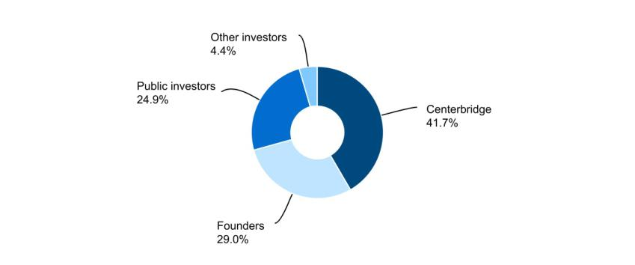

The percentage of ownership noted above is inclusive of only Class A and Class B common stock issued and outstanding. It does not include the Series A redeemable convertible preferred stock or the impact of any conversion of such, should a conversion occur. For more information on the Series A redeemable convertible preferred stock, please refer to Note 5. “Stockholders' Equity” of the Notes to Condensed Consolidated Financial Statements.

GoHealth, Inc. is subject to U.S. federal, state and local income taxes with respect to our allocable share of any taxable income of GHH, LLC and is taxed at the prevailing corporate tax rates. In addition to tax expenses, we also incur expenses related to our status as a public company, plus payment obligations under the Tax Receivable Agreement (“TRA”), which could be significant. We intend to cause GHH, LLC to make distributions to us in an amount sufficient to allow us to pay these expenses and fund any payments due under the TRA.

GoHealth, Inc. | 2024 Form 10-Q | 24

Results of Operations

The following is our consolidated results of operations for the three months ended March 31, 2024 and 2023:

 |  |  | Three months ended Mar. 31,
(in thousands) |  |  | 2024 |  | 2023
Net revenues |  |  | 185,600 |  | 183,158
Operating expenses:
Revenue share |  |  | 38,013 |  | 45,462
Marketing and advertising |  |  | 52,775 |  | 45,743
Consumer care and enrollment |  |  | 47,861 |  | 42,027
Technology |  |  | 10,550 |  | 9,543
General and administrative |  |  | 16,919 |  | 22,618
Amortization of intangible assets |  |  | 23,514 |  | 23,514
Total operating expenses |  |  | 189,632 |  | 188,907
Income (loss) from operations |  |  | (4,032) |  | (5,749)
Interest expense |  |  | 17,951 |  | 16,891
Other (income) expense, net |  |  | (566) |  | (53)
Income (loss) before income taxes |  |  | (21,417) |  | (22,587)
Income tax (benefit) expense |  |  | (71) |  | (44)
Net income (loss) |  |  | (21,346) |  | (22,543)
Net income (loss) attributable to non-controlling interests |  |  | (12,130) |  | (13,364)
Net income (loss) attributable to GoHealth, Inc. |  | $ | (9,216) | $ | (9,179)
Non-GAAP financial measures:
EBITDA |  | $ | 22,780 | $ | 20,571
Adjusted EBITDA |  | $ | 26,894 | $ | 28,778
Adjusted EBITDA margin |  |  | 14.5 % |  | 15.7 %

The following is our net revenues for the three months ended March 31, 2024 and 2023:

 |  |  | Three months ended Mar. 31,
Net Revenues |  |  | 2024 |  |  | 2023 |  |  | $ Change |  | % Change
 |  | $ | 185,600 |  | $ | 183,158 |  | $ | 2,442 |  | 1.3 %

The increase for the three months ended March 31, 2024 compared to the prior year period was primarily attributable to an increase in non-agency revenue, which includes the enrollment and engagement services offered through the Encompass Connect and Encompass Engage programs, partially offset by a decrease in agency revenue driven by a decline in Submissions for which GoHealth is the agent of record. The increase was further offset by a decrease in revenues associated with the strategic decision to exit our Non-Encompass BPO Services, which was completed during the second quarter of 2023.

The following are our key components of operating expenses and results thereof for the three months ended March 31, 2024 and 2023:

 |  |  | Three months ended Mar. 31, |  |  |  |  |  |  |  |  |  |  |  | % of Net Revenues
Revenue share |  |  | 2024 |  |  | 2023 |  |  | $ Change |  |  | % Change |  |  | 2024 | 2023
 |  | $ | 38,013 |  | $ | 45,462 |  | $ |  | (7,449) |  |  | (16.4)% |  | 20.5% | 24.8%

The decrease for the three months ended March 31, 2024 compared to the prior year period was primarily driven by a decrease in Submissions generated by our independent network of outsourced agents, which decreased the amount of expense we recognized pursuant to our revenue-sharing agreements with our external partners. The decrease was partially offset by the launch of the vConnect program during the second quarter of 2023, which includes revenue-sharing components.

 |  |  | Three months ended Mar. 31, |  |  |  |  |  |  |  |  |  |  |  | % of Net Revenues
Marketing and advertising expense |  |  | 2024 |  | 2023 |  |  |  |  | $ Change |  |  | % Change |  | 2024 | 2023
 |  | $ | 52,775 |  | $ |  | 45,743 |  | $ | 7,032 |  |  | 15.4 % |  | 28.4% | 25.0%
 |  |  | GoHealth, Inc. |  |  |  | 2024 Form 10-Q
 |  |  |  |  |  |  |  |  |  |  | 25

The increase for the three months ended March 31, 2024 compared to the prior year period was primarily attributable to enhancements in our targeted marketing efforts to identify consumers in need of new health plan options as well as an intentional pullback on marketing and advertising spend during the prior year period, partially offset by a decline in payments to our external marketing partners.

 |  |  | Three months ended Mar. 31, |  |  |  |  |  |  |  |  |  |  |  | % of Net Revenues
Consumer care and enrollment |  |  | 2024 |  |  | 2023 |  |  | $ Change |  |  | % Change |  |  | 2024 | 2023
 |  | $ | 47,861 |  | $ | 42,027 |  | $ |  | 5,834 |  |  | 13.9 % |  | 25.8% | 22.9%

The increase for the three months ended March 31, 2024 was primarily attributable to an increased agent headcount compared to the prior year period.

 |  |  | Three months ended Mar. 31, |  |  |  |  |  |  |  |  |  |  |  |  | % of Net Revenues
Technology expense |  |  | 2024 |  |  | 2023 |  |  | $ Change |  |  | % Change |  |  | 2024 |  | 2023
 |  | $ | 10,550 |  | $ | 9,543 |  | $ |  | 1,007 |  |  | 10.6 % |  | 5.7% |  | 5.2%

The increase for the three months ended March 31, 2024 was primarily attributable to an increased headcount in our technology support functions compared to the prior year period as we continue to invest in and enhance our technology to drive overall efficiency in our Encompass workflow and improve the consumer experience.

 |  | Three months ended Mar. 31, |  |  |  |  |  |  |  |  |  |  |  | % of Net Revenues
General and administrative expense |  | 2024 | 2023 |  |  |  |  |  | $ Change |  | % Change |  | 2024 |  | 2023
 |  |  | 16,919 |  |  | 22,618 |  | $ | (5,699) |  | (25.2)% |  | 9.1% |  | 12.3%

The decrease for the three months ended March 31, 2024 compared to the prior year period was primarily attributable to a decrease in share-based compensation expense and a reduction of expenses related to legal fees.

 |  | Three months ended Mar. 31, |  |  |  |  |  |  |  |  |  |  | % of Net Revenues
Amortization of intangible assets |  | 2024 |  | 2023 |  |  | $ Change |  |  | % Change |  |  | 2024 | 2023
 |  | 23,514 |  | 23,514 |  | $ |  | — |  |  | — % |  | 12.7% | 12.8%

Amortization of intangible assets expense was $23.5 million for the three months ended March 31, 2024 and 2023. Amortization of intangible assets expense relates to the amortization of developed technology and customer relationships.

 |  | Three months ended Mar. 31, |  |  |  |  |  |  |  |  |  |  |  |  | % of Net Revenues
Interest expense |  | 2024 | 2023 |  |  |  |  | $ Change |  |  | % Change |  |  | 2024 |  | 2023
 |  |  | 17,951 |  |  | 16,891 |  | $ | 1,060 |  |  | 6.3 % |  | 9.7% |  | 9.2%

The increase for the three months ended March 31, 2024 compared to the prior year period was primarily attributable to an increase in interest rates on our Term Loan Facilities.

Non-GAAP Financial Measures

We use supplemental measures of our performance that are derived from our consolidated financial information but which are not presented in our Condensed Consolidated Financial Statements prepared in accordance with GAAP. These non-GAAP financial measures include net income (loss) before interest expense, income tax (benefit) expense and depreciation and amortization expense, or EBITDA; Adjusted EBITDA; Adjusted EBITDA margin; Cash Adjusted EBITDA; Sales per Submission; Cost per Submission and Adjusted Gross Margin per Submission. Adjusted EBITDA is the primary financial performance measure used by management to evaluate the business and to monitor its results of operations. Cash Adjusted EBITDA is used by management to assess Adjusted EBITDA excluding the effect of LTV estimates period over period. Sales per Submission, Cost per Submission and Adjusted Gross Margin per Submission are key operating metrics used by management to understand the Company’s underlying financial performance and trends.

Adjusted EBITDA represents, as applicable for the period, EBITDA as further adjusted for certain items summarized in the table furnished below. Adjusted EBITDA margin represents Adjusted EBITDA divided by net revenues. Cash Adjusted EBITDA represents Adjusted EBITDA plus a decrease or less an increase in the period over period change in our net contract assets. Sales per Submission represents Medicare Revenue per Submission as further adjusted for certain items summarized in the table furnished below within the Key Business Performance and Operating Metrics section. Cost per Submission represents Operating Expense per Submission as further adjusted for certain items summarized in the table furnished below within the Key

GoHealth, Inc. | 2024 Form 10-Q | 26

Business Performance and Operating Metrics section. Adjusted Gross Margin per Submission represents Sales per Submission less Cost per Submission.

We use non-GAAP financial measures to supplement financial information presented on a GAAP basis. We believe that excluding certain items from our GAAP results allows management to better understand our consolidated financial performance from period to period and better project our future consolidated financial performance as forecasts are developed at a level of detail different from that used to prepare GAAP-based financial measures. Moreover, we believe these non-GAAP financial measures provide our stakeholders with useful information to help them evaluate our operating results by facilitating an enhanced understanding of our operating performance and enabling them to make more meaningful period to period comparisons. Adjusted EBITDA is used as a basis for certain compensation programs sponsored by the Company. There are limitations to the use of the non-GAAP financial measures presented in this Quarterly Report on Form 10-Q. For example, our non-GAAP financial measures may not be comparable to similarly titled measures of other companies. Other companies, including companies in our industry, may calculate non-GAAP financial measures differently than we do, limiting the usefulness of those measures for comparative purposes.

The non-GAAP financial measures are not meant to be considered as indicators of performance in isolation from or as a substitute for the most directly comparable measures prepared in accordance with GAAP, and should be read only in conjunction with financial information presented on a GAAP basis. Reconciliations of each of EBITDA, Adjusted EBITDA, Cash Adjusted EBITDA, Sales per Submission, Cost per Submission and Adjusted Gross Margin per Submission to its most directly comparable GAAP financial measure are presented in the tables below in this Quarterly Report on Form 10-Q. We encourage you to review the reconciliations in conjunction with the presentation of the non-GAAP financial measures for each of the periods presented. In future periods, we may exclude similar items, may incur income and expenses similar to these excluded items and may include other expenses, costs and non-routine items.

The following table sets forth the reconciliations of GAAP net income (loss) to EBITDA and Adjusted EBITDA for the periods presented:

 |  |  | Three months ended Mar. 31,
Non-GAAP Financial Measures |  |  | 2024 |  |  | 2023
Net revenues |  | $ | 185,600 |  | $ | 183,158
Net income (loss) |  |  | (21,346) |  |  | (22,543)
Interest expense |  |  | 17,951 |  |  | 16,891
Income tax expense (benefit) |  |  | (71) |  |  | (44)
Depreciation and amortization expense |  |  | 26,246 |  |  | 26,267
EBITDA |  |  | 22,780 |  |  | 20,571
Share-based compensation expense (benefit)(1) |  |  | 1,783 |  |  | 6,584
Legal fees(2) |  |  | 503 |  |  | 1,623
Severance costs(3) |  |  | 1,828 |  |  | —
Adjusted EBITDA |  | $ | 26,894 |  | $ | 28,778
Adjusted EBITDA Margin
Adjusted EBITDA Margin |  |  | 14.5 % |  |  | 15.7 %

- Represents non-cash share-based compensation expense (benefit) relating to equity awards as well as share-based compensation expense (benefit) relating to liability classified awards that will be settled in cash.

- Represents legal fees, settlement accruals and other expenses related to certain litigation, Credit Agreement amendments and other non-routine legal or regulatory matters as described in Note 4. “Long-Term Debt” and Note 11. “Commitments And Contingencies” of the Notes to Condensed Consolidated Financial Statements.
- Represents severance costs and associated fees associated with a reduction in workforce.

 |  |  | Three months ended Mar. 31, |  |  |  |  |  |  |  | % of Net Revenues
Adjusted EBITDA |  |  | 2024 |  | 2023 |  | $ Change | % Change |  |  | 2024 | 2023
 |  | $ | 26,894 | $ | 28,778 | $ | (1,884) |  | 6.5 % |  |  | 14.5 % | 15.7 %

The decrease for the three months ended March 31, 2024 compared to the prior year period was primarily due to investments in targeted marketing and other operating expenses, partially offset by a decrease in revenue share and an increase in net revenues.

GoHealth, Inc. | 2024 Form 10-Q | 27

The following table sets forth the reconciliations of Adjusted EBITDA to Cash Adjusted EBITDA for the periods presented:

 |  |  |  |  |  |  |  | Three months ended Mar. 31,
(in thousands) |  |  |  |  |  |  | 2024 |  |  |  |  | 2023
Adjusted EBITDA |  |  |  |  |  |  | $ | 26,894 |  | $ |  | 28,778
Beginning commissions receivable |  |  |  |  |  |  |  | 911,697 |  |  |  | 1,031,433
Beginning commissions payable |  |  |  |  |  |  |  | (321,987) |  |  |  | (375,141)
Beginning net contract assets |  |  |  |  |  |  |  | 589,710 |  |  |  | 656,292
Ending commissions receivable |  |  |  |  |  |  |  | 843,127 |  |  |  | 936,804
Ending commissions payable |  |  |  |  |  |  |  | (296,549) |  |  |  | (329,435)
Ending net contract assets |  |  |  |  |  |  |  | 546,578 |  |  |  | 607,369
(Increase)/decrease in contract assets |  |  |  |  |  |  |  | 43,132 |  |  |  | 48,923
Cash Adjusted EBITDA |  |  |  |  |  |  | $ | 70,026 |  |  | $ | 77,701
 |  | Three months ended Mar. 31, |  |  |  |  |  |  |  | % of Net Revenues
Cash Adjusted EBITDA |  | 2024 |  | 2023 |  | $ Change | % Change |  | 2024 |  |  | 2023
 | $ | 70,026 | $ | 77,701 | $ | (7,675) | 9.9 % |  |  | 37.7 % |  | 42.4 %

Cash Adjusted EBITDA decreased compared to the prior year period because of a decrease in Adjusted EBITDA, as described above, and a decrease in cash collected from our net contract assets as we continue to earn more non-agency revenue relative to agency revenue.

Key Business Performance and Operating Metrics

In addition to traditional financial metrics, we rely upon certain business and operating metrics to evaluate our business performance and facilitate our operations. Below are the most relevant business and operating metrics for our single operating and reportable segment, except for EBITDA, Adjusted EBITDA and Cash Adjusted EBITDA which are discussed above.

The following tables set forth the reconciliations of Medicare Revenue per Submission, Operating Expense per Submission, and Gross Margin per Submission to Sales per Submission, Cost Per Submission, and Adjusted Gross Margin per Submission for the periods indicated (unaudited):

 |  | Three months ended Mar. 31,
 |  | 2024 |  |  | 2023
Sales per Submission
Medicare Revenue per Submission |  | $ | 856 |  | $ | 794
Sales per Submission |  | $ | 856 |  | $ | 794
Cost per Submission
Operating Expense per Submission |  | $ | 877 |  | $ | 884
Indirect operating expenses⁽¹⁾ |  |  | (235) |  |  | (261)
Exit of Non-Encompass BPO Services |  |  | — |  |  | (25)
Share-based compensation expense⁽²⁾ |  |  | (2) |  |  | (6)
Cost per Submission |  | $ | 640 |  | $ | 592
Gross Margin per Submission⁽³⁾
Gross Margin per Submission⁽³⁾ |  | $ | (21) |  | $ | (90)
Adjusted Gross Margin per Submission⁽⁴⁾ |  | $ | 216 |  | $ | 202

- Indirect operating expenses include technology, general and administrative, amortization of intangible assets, operating lease impairment charges and restructuring and other related charges.

- Share-based compensation expense included within marketing and advertising expenses and consumer care and enrollment expenses.

- Medicare Revenue per Submission less Operating Expense per Submission.

- Sales per Submission less Cost per Submission.

Submissions

Submissions are counted when an individual either (i) completes an application with our licensed agent that is submitted to the health plan partner and subsequently approved by the health plan partner during the indicated period, excluding applications through our Non-Encompass BPO Services or (ii) is transferred by our agent to the health plan partner through the Encompass marketplace during the indicated period. Not all Submissions will go into effect, as some individuals may fail to enroll or once enrolled may switch out of a policy within the disenrollment period during the first 90 days of the policy.

GoHealth, Inc. | 2024 Form 10-Q | 28

The following table presents the number of Submissions for the periods presented:

Submissions

 | Three months ended Mar. 31,
 | 2024 | 2023 | Change | % Change
 | 216,148 | 213,645 | 2,503 | 1.2 %

The increase for the three months ended March 31, 2024 compared to the prior year period was attributable to an increase in opportunities resulting from our focus on higher quality Submissions through targeted marketing efforts, as well as enhancements in training, technology and consumer retention strategies.

Sales Per Submission

Sales per Submission represents (x) the sum of (i) aggregate commissions estimated to be collected over the estimated life of all commissionable Submissions for the relevant period based on multiple factors, including but not limited to, contracted commission rates, health plan partner mix and expected policy persistency with applied constraints, excluding revenue adjustments recorded in the period, but relating to performance obligations satisfied in prior periods, (ii) Encompass revenue, and (iii) partner marketing and enrollment services, divided by (y) the number of Submissions for such period, as reported above. Aggregate commissions are equal to the sum of the commission revenue due upon the initial sale of a policy, and when applicable, an estimate of future renewal commissions per commissionable Submissions, and this figure excludes commissions through our Non-Encompass BPO Services. The estimate of the future renewal commissions is determined by using the contracted renewal commission rates constrained by a persistency-adjusted renewal period. The persistency-adjusted renewal period is determined based on our historical experience and available industry and health plan partner historical data. Persistency adjustments allow us to estimate renewal revenue only to the extent probable that a material reversal in revenue would not be expected to occur. These factors may result in varying values from period to period. Sales per Submission represents revenues only from policies sold during the period, but excludes policies originally submitted in prior periods.

The following table presents the Sales per Submission for the periods presented:

 |  |  | Three months ended Mar. 31,
Sales Per Submission |  |  | 2024 |  | 2023 |  | $ Change | % Change
 |  | $ | 856 | $ | 794 | $ | 62 | 7.8 %

The increase for the three months ended March 31, 2024 compared to the prior year period was driven by an increase in non-agency revenue, which includes the enrollment and engagement services offered through the Encompass Connect and Encompass Engage programs.

Sales/Cost of Submission and Cost Per Submission

Sales/Cost of Submission represents (x) the sum of (i) aggregate commissions estimated to be collected over the estimated life of all commissionable Submissions for the relevant period based on multiple factors, including but not limited to, contracted commission rates, health plan partner mix and expected policy persistency with applied constraints, excluding revenue adjustments recorded in the period, but relating to performance obligations satisfied in prior periods, and such expenses related to our Non-Encompass BPO Services, (ii) Encompass revenue, and (iii) partner marketing and enrollment services, divided by (y) the aggregate cost to convert prospects into Submissions (comprised of revenue share, marketing and advertising expenses and consumer care and enrollment expenses, excluding associated share-based compensation expense, the impact of revenue adjustments recorded in the period, but relating to performance obligations satisfied in prior periods, and such expenses related to our Non-Encompass BPO Services) for such period. The estimate of the future renewal commissions is determined by using the contracted renewal commission rates constrained by a persistency-adjusted renewal period. The persistency-adjusted renewal period is determined based on our historical experience and available industry and health plan partner historical data. Persistency adjustments allow us to estimate renewal revenue only to the extent probable that a material reversal in revenue would not be expected to occur. These factors may result in varying values from period to period. See “Risk Factors—Risks Related to Our Business—Our operating results may be adversely impacted by factors that impact our estimate of LTV” in our 2023 Annual Report on Form 10-K.

Cost per Submission refers to (x) the aggregate cost to convert prospects into Submissions during a particular period (comprised of revenue share, marketing and advertising expenses, and consumer care and enrollment expenses, excluding associated share-based compensation expense, the impact of revenue adjustments recorded in the period, but relating to performance obligations satisfied in prior periods, and such expenses related to our Non-Encompass BPO Services) divided by (y) either (i) a completed application with our licensed agent that is submitted to the insurance health plan partner and subsequently approved by the health plan partner during the indicated period, excluding applications through our Non-Encompass BPO Services or (ii) a transfer by our agent to the health plan partner through the Encompass marketplace during the indicated period.

GoHealth, Inc. | 2024 Form 10-Q | 29

The following are our Sales/Cost of Submission, Cost of Submission (in thousands) and Cost Per Submission for the three months ended March 31, 2024 and 2023.

 |  | Three months ended Mar. 31,
 |  | 2024 |  |  | 2023
Sales/Cost of Submission |  |  | 1.3 |  |  | 1.3
Cost of Submission |  | $ | 138,250 |  | $ | 126,402
Cost per Submission |  | $ | 640 |  | $ | 592

Sales/Cost of Submission was 1.3 for both the three months ended March 31, 2024 and 2023. The increase in Cost of Submission and Cost per Submission for the three months ended March 31, 2024 compared to the prior year period was primarily attributable to an increased investment in our targeted marketing efforts and an increased agent headcount, partially offset by a decrease in cost of revenue.

Liquidity and Capital Resources

Overview

Our liquidity needs primarily include working capital and debt service requirements. At March 31, 2024, cash and cash equivalents totaled $97.8 million. We believe that our current sources of liquidity, which include cash and cash equivalents and funds available under the Credit Facilities, as described further below, will be sufficient to meet our projected operating and debt service requirements for at least the next twelve months. Short-term liquidity needs will primarily be funded through the Revolving Credit Facilities, as described further below, if necessary. To the extent that our current liquidity is insufficient to fund future activities, we may need to raise additional funds, which may include the sale of equity securities or through debt financing arrangements. The incurrence of additional debt financing would result in debt service obligations and any future instruments governing such debt could provide for operating and financing covenants that could restrict our operations.

The following table presents a summary of cash flows for the three months ended March 31, 2024 and 2023:

 |  |  | Three months ended Mar. 31,
(in thousands) |  |  | 2024 |  | 2023
Net cash provided by (used in) operating activities |  | $ | 12,512 | $ | 20,479
Net cash provided by (used in) investing activities |  |  | (4,556) |  | (2,226)
Net cash provided by (used in) financing activities |  |  | (942) |  | (2,397)

Operating Activities

Cash provided by (used in) operating activities primarily consists of net income (loss) adjusted for certain non-cash items including share-based compensation, depreciation and amortization, amortization of intangible assets, amortization of debt discount and issuance costs, goodwill and intangible impairment charges, operating lease impairment charges, non-cash restructuring charges, non-cash lease expense and the effect of changes in working capital and other activities.

Collection of commissions receivable depends upon the timing of the receipt of commission payments. If there were to be a delay in receiving a commission payment from a health plan partner within a quarter, the operating cash flows for that quarter could be adversely impacted.

A significant portion of marketing and advertising expense is driven by the number of qualified prospects required to generate the Submissions. Marketing and advertising costs are expensed and generally paid as incurred and since commissions revenue is recognized upon approval of a submission but commission payments are paid to us over time, there are working capital requirements to fund the upfront cost of acquiring new policies.

Net cash provided by operating activities was $12.5 million for the three months ended March 31, 2024, compared to $20.5 million for the three months ended March 31, 2023. The $8.0 million decrease was primarily driven by working capital components. In the current year, the Company paid $10.5 million toward the Securities Class Action settlement which is reflected in the decrease in accrued liabilities of $10.9 million. Other significant changes in working capital include an increase in cash from commissions payable of $20.3 million, accounts receivable of $12.3 million and deferred revenue of $11.2 million offset by a decrease in cash from commissions receivable of $26.0 million, accounts payable of $8.1 million, prepaid expense and other current assets of $4.5 million and other liabilities of $2.7 million.

Investing Activities

GoHealth, Inc. | 2024 Form 10-Q | 30

Net cash used in investing activities increased to $4.6 million for the three months ended March 31, 2024, from $2.2 million for the three months ended March 31, 2023. The increase was primarily driven by an increase in capitalized internal-use software related to new technology, software, and systems.

Financing Activities

Net cash used in financing activities was $0.9 million for the three months ended March 31, 2024, compared to $2.4 million for the three months ended March 31, 2023. The decrease was primarily driven by a $1.4 million paydown of debt that did not occur in the first quarter of 2024.

Credit Facilities

Term Loan Facilities

As of March 31, 2024 and December 31, 2023, the Company had a principal amount of $110.4 million, $296.3 million and $96.1 million outstanding under the Incremental Term Loan Facility, the 2021 Incremental Term Loans, and the 2021-2 Incremental Term Loans, respectively. The Term Loan Facilities’ effective interest rates were 12.9% and 13.0% at March 31, 2024 and December 31, 2023, respectively.

During 2024 the Company is required to repay $75.0 million in aggregate of borrowings under the Term Loan Facilities. The remaining unpaid balance on the Term Loan Facilities, together with all accrued and unpaid interest thereon, is due and payable on or prior to September 13, 2025. See Note 4, “Long-Term Debt,” to the Condensed Consolidated Financial Statements in this Quarterly Report on Form 10-Q for additional information regarding the Company’s Term Loan Facilities.

Revolving Credit Facilities

The Company had no amounts outstanding under the Revolving Credit Facilities as of both March 31, 2024 and December 31, 2023. The Revolving Credit Facilities have a remaining capacity of

$111.5 million and $200.0 million in the aggregate as of March 31, 2024 and December 31, 2023, respectively. The Revolving Credit Facilities are separated into two classes of revolving commitments. After the adoption of Amendment No. 11 to the Credit Agreement, the New Class A Revolving Commitments mature on June 30, 2025 and bear interest at either ABR plus 5.5% per annum or SOFR plus 6.5% per annum. The Remaining Class B Revolving Commitments mature on September 13, 2024 and bear interest at either ABR plus 3.0% per annum or SOFR plus 4.0% per annum. See Note 4, “Long-Term Debt,” to the Condensed Consolidated Financial Statements in this Quarterly Report on Form 10-Q for additional information regarding the Company’s Revolving Credit Facilities.

Recent Accounting Pronouncements

For a discussion of new accounting pronouncements recently adopted and not yet adopted, see Part 1, Note 1, “Description Of Business And Significant Accounting Policies,” to the Condensed Consolidated Financial Statements included elsewhere in this Quarterly Report on Form 10-Q.

Critical Accounting Policies and Estimates

The preparation of the Condensed Consolidated Financial Statements and related disclosures in conformity with GAAP requires management to make estimates and assumptions that affect the reported amounts of revenues, expenses, assets, liabilities and the disclosure of contingent assets and liabilities. We regularly assess these estimates; however, actual amounts could differ from those estimates. The impact of changes in estimates is recorded in the period in which they become known.

An accounting policy is considered to be critical if the nature of the estimates or assumptions is material due to the levels of subjectivity and judgment necessary to account for highly uncertain matters or the susceptibility of such matters to change, and the effect of the estimates and assumptions on financial condition or operating performance. The accounting policies we believe to reflect our more significant estimates, judgments and assumptions that are most critical to understanding and evaluating our reported financial results are:

- Commission revenue recognition and commissions receivable;

- Share-based compensation;

- Intangible assets;

- Impairment of operating lease ROU assets;

- Liabilities pursuant to the TRA.

GoHealth, Inc. | 2024 Form 10-Q | 31

Our critical accounting policies are described under the heading “Management’s Discussion and Analysis of Financial Condition and Results of Operations—Critical Accounting Policies and Estimates” in our 2023 Annual Report on Form 10-K. During the three months ended March 31, 2024, there were no material changes to our critical accounting policies from those discussed in our 2023 Annual Report on Form 10-K.

ITEM 3. QUANTITATIVE AND QUALITATIVE DISCLOSURES ABOUT MARKET RISK.

As a smaller reporting company, we are not required to include disclosure under this item.

ITEM 4. CONTROLS AND PROCEDURES

Limitations on Effectiveness of Controls and Procedures

In designing and evaluating our disclosure controls and procedures, management recognizes that any controls and procedures, no matter how well designed and operated, can provide only reasonable assurance of achieving the desired control objectives. In addition, the design of disclosure controls and procedures must reflect the fact that there are resource constraints and that management is required to apply judgment in evaluating the benefits of possible controls and procedures relative to their costs. Also, projections of any evaluation of effectiveness to future periods are subject to the risk that controls may become inadequate because of changes in conditions, or that the degree of compliance with the policies or procedures may deteriorate. Because of the inherent limitations in a cost-effective control system, misstatements due to error or fraud may occur and not be detected.

Evaluation of Disclosure Controls and Procedures

Our management is responsible for establishing and maintaining adequate internal control over financial reporting (as defined in Rules 13a-15(f) and 15d-15(f) under the Exchange Act). Internal control over financial reporting is a process designed under the supervision of the Company’s Chief Executive Officer and Chief Financial Officer, and effected by the Company’s Board of Directors, management and other personnel to provide reasonable assurance regarding the reliability of financial reporting and the preparation of financial statements for external purposes in accordance with GAAP and includes those policies and procedures that:

- Pertain to the maintenance of records that in reasonable detail accurately and fairly reflect the transactions and dispositions of the assets of the Company;

- Provide reasonable assurance that transactions are recorded as necessary to permit preparation of financial statements in accordance with GAAP, and that receipts and expenditures of the Company are being made only in accordance with authorizations of management and directors of the Company; and

- Provide reasonable assurance regarding prevention or timely detection of unauthorized acquisition, use, or disposition of the Company’s assets that could have a material effect on the financial statements.

Our management conducted an evaluation of the effectiveness of our internal control over financial reporting as of March 31, 2024, utilizing the framework in Internal Control-Integrated Framework (2013) established by the Committee of Sponsoring Organizations (COSO) of the Treadway Commission. Our internal control over financial reporting includes policies and procedures that are designed to provide reasonable assurance regarding the reliability of financial reporting and the preparation of financial statements for external reporting purposes in accordance with GAAP. Based on this evaluation and those criteria, our management concluded that our internal control over financial reporting was effective as of March 31, 2024.

Our management has concluded that the Condensed Consolidated Financial Statements included in this Quarterly Report on Form 10-Q fairly present, in all material respects, our financial position, results of operations and cash flows as of the dates, and for the periods presented, in conformity with U.S. GAAP.

Changes in Internal Control over Financial Reporting

There were no changes in our internal controls over financial reporting identified in management’s evaluation pursuant to Rules 13a-15(d) or 15d-15(d) of the Exchange Act during the quarter ended March 31, 2024 that materially affected, or are reasonably likely to materially affect, our internal control over financial reporting.

GoHealth, Inc. | 2024 Form 10-Q | 32

PART II - Other Information

ITEM 1. LEGAL PROCEEDINGS.

Refer to Note 11, “Commitments And Contingencies,” of the Notes to the Condensed Consolidated Financial Statements for information about legal proceedings.

ITEM 1A. RISK FACTORS.

We refer you to our 2023 Annual Report on Form 10-K for a discussion of the risk factors that affect our business and financial results.There have been no material changes in our risk factors from those disclosed in our 2023 Annual Report on Form 10-K.

ITEM 2. UNREGISTERED SALES OF EQUITY SECURITIES AND USE OF PROCEEDS.

None.

ITEM 3. DEFAULTS UPON SENIOR SECURITIES.

None.

ITEM 4. MINE SAFETY DISCLOSURES.

None.

ITEM 5. OTHER INFORMATION.

During the fiscal quarter ended March 31, 2024, none of our directors or officers (as defined in Rule 16a-1(f) under the Exchange Act) adopted, modified, or terminated a Rule 10b5-1 trading plan or a non-Rule 10b5-1 trading arrangement for our securities (as defined in Item 408(c) of Regulation S-K).

On May 8, 2024, GoHealth, Inc. (the “Company”) and GoHealth Holdings, LLC signed an Amended and Restated Employment Agreement (the “Employment Agreement”) with one of its named executive officers, Michael Hargis. The Employment Agreement updates the previous employment agreement entered into with Mr. Hargis in connection with his role as Chief Customer Experience Officer. The Employment Agreement states the base salary, bonus and shares of common stock issuable pursuant to restricted stock units that were established at the time he assumed the role of Chief Operating Officer on July 31, 2023 and have been previously described in the Executive Compensation Overview of the Company’s Definitive Proxy Statement filed with the Securities and Exchange Commission on April 26, 2024. In addition, the Employment Agreement states that in the event of a termination of Mr. Hargis by the Company without cause or Mr. Hargis’ resignation for good reason, Mr. Hargis will receive (i) one year of salary continuation, unless such termination occurs within twelve (12) months of a change in control, in which case the period is increased to two (2) years; (ii) the annual bonus for any completed fiscal year as of the date of termination that has not yet been paid as of the date of termination (“Prior Year Bonus”), if any, plus a pro-rated portion of the annual bonus for the year in which the date of termination occurs based on the number of months for which Mr. Hargis was employed during such year prior to the date of termination (“Pro-Rated Bonus”), unless such termination occurs within twelve (12) months of a change in control, in which case the severance bonus shall be equal to the sum of the Prior Year Bonus, if any, and the product of two (2) multiplied by the Pro-Rated Bonus; and (iii) reimbursement of one year of the Company’s share of COBRA premium payments in an amount equal to what the Company pays for the health insurance premiums of other executive level employees at the Company, unless such termination occurs within twelve (12) months of a change in control, in which case the period is increased to two

- years and (iv) twelve (12) months of continued vesting for any and all unvested Restricted Stock Units, Performance Stock Units, and/or options granted to Mr. Hargis that are scheduled to occur within twelve (12) months following Mr. Hargis’ termination date; in each case subject to Mr. Hargis executing a release of claims in favor of the Company and complying with any restrictive covenants through the period of payment.

The foregoing summary of the terms of the Employment Agreement does not purport to be complete and is qualified in its entirety by reference to the Employment Agreement, a copy of which is attached hereto as Exhibit 10.2.

GoHealth, Inc. | 2024 Form 10-Q | 33

ITEM 6. EXHIBITS.

Exhibit Index

 |  |  |  |  |  |  |  |  |  |  |  |  |  |  |  |  |  |  |  |  |  |  | Incorporated by Reference
Exhibit |  |  |  |  |  |  |  |  |  |  |  |  |  |  |  |  |  |  |  |  |  |  |  |  |  |  | Filing
Number |  |  |  |  |  | Description |  |  |  |  |  |  |  |  |  |  |  |  |  |  | Form |  | File No. |  | Exhibit |  | Date
3.1 |  |  |  | Amended and Restated Certificate of Incorporation of GoHealth, Inc. |  |  |  |  |  |  |  |  |  |  |  |  |  |  |  |  | 10-Q |  | 001-39390 |  | 3.1 |  | 8/20/2020
3.2 |  |  |  | Amended and Restated Bylaws of GoHealth, Inc. |  |  |  |  |  |  |  |  |  |  |  |  |  |  |  |  | 10-Q |  | 001-39390 |  | 3.2 |  | 8/20/2020
3.3 |  |  |  | Certificate of Designations of Series A Convertible Perpetual Preferred Stock of GoHealth, Inc. |  |  |  |  |  |  |  |  |  |  |  |  |  |  |  |  | 8-K |  | 001-39390 |  | 3.1 |  | 9/26/2022
3.4 |  |  |  | Certificate of Designations of Series A-1 Convertible Non-Voting Perpetual Preferred Stock of |  |  |  |  |  |  |  |  |  |  |  |  |  |  |  |  | 8-K |  | 001-39390 |  | 3.2 |  | 9/26/2022
 |  |  |  | GoHealth, Inc.
4.1 |  |  |  | Specimen Stock Certificate evidencing the shares of Class A common stock. |  |  |  |  |  |  |  |  |  |  |  |  |  |  |  |  | S-1 |  | 333-239287 |  | 4.1 |  | 6/19/2020
10.1 |  | Amendment No. 11 to the Credit Agreement, dated as of March 12, 2024, among Norvax, LLC, as |  |  |  |  |  |  |  |  |  |  |  |  |  |  |  |  |  |  | 10-K |  | 001-39390 |  | 10.10 |  | 3/14/2024
 |  | borrower, Blue Owl Capital Corporation, as administrative agent, collateral agent and required
 |  | lenders.
10.2# |  | Amended and Restated Employment Agreement signed May 8, 2024, by and among GoHealth,
 |  | Inc., GoHealth Holdings, LLC, and Michael Hargis.
31.1 |  | Certification of Chief Executive Officer pursuant to Exchange Act Rule 13a-14(a).
31.2 |  | Certification of Chief Financial Officer pursuant to Exchange Act Rule 13a-14(a).
32.1 |  | Certification of Principal Executive Officer pursuant to 18 U.S.C. Section 1350.
32.2 |  | Certification of Chief Financial Officer pursuant to 18 U.S.C. Section 1350.
101.INS |  | Inline XBRL Instance Document – the instance document does not appear in the Interactive Data
 |  | File because its XBRL tags are embedded within the Inline XBRL document.
101.SCH |  | Inline XBRL Taxonomy Extension Schema Document
101.CAL |  | Inline XBRL Taxonomy Extension Calculation Linkbase Document
101.DEF |  | Inline XBRL Taxonomy Extension Definition Linkbase Document
101.LAB |  | Inline XBRL Taxonomy Extension Label Linkbase Document
101.PRE |  | Inline XBRL Taxonomy Extension Presentation Linkbase Document

  - Cover Page Interactive Data File (formatted as Inline XBRL and contained in Exhibit 101)

* Filed herewith.

- Furnished herewith.

- Indicates management contract or compensatory plan.

GoHealth, Inc. | 2024 Form 10-Q | 34

Filed/ Furnished Herewith

*

*

*

**

**

*

*

*

*

*

*

*

SIGNATURES

Pursuant to the requirements of Section 13 or 15(d) of the Securities Exchange Act of 1934, the Registrant has duly caused this report to be signed on its behalf by the undersigned thereunto duly authorized.

GoHealth, Inc.

(Registrant)

Date: May 9, 2024 By: /s/ Vijay Kotte

Vijay Kotte

Chief Executive Officer

(Principal Executive Officer)

Date: May 9, 2024 By: /s/ Jason Schulz

Jason Schulz

Chief Financial Officer

(Principal Financial and Accounting Officer)

GoHealth, Inc. | 2024 Form 10-Q | 35

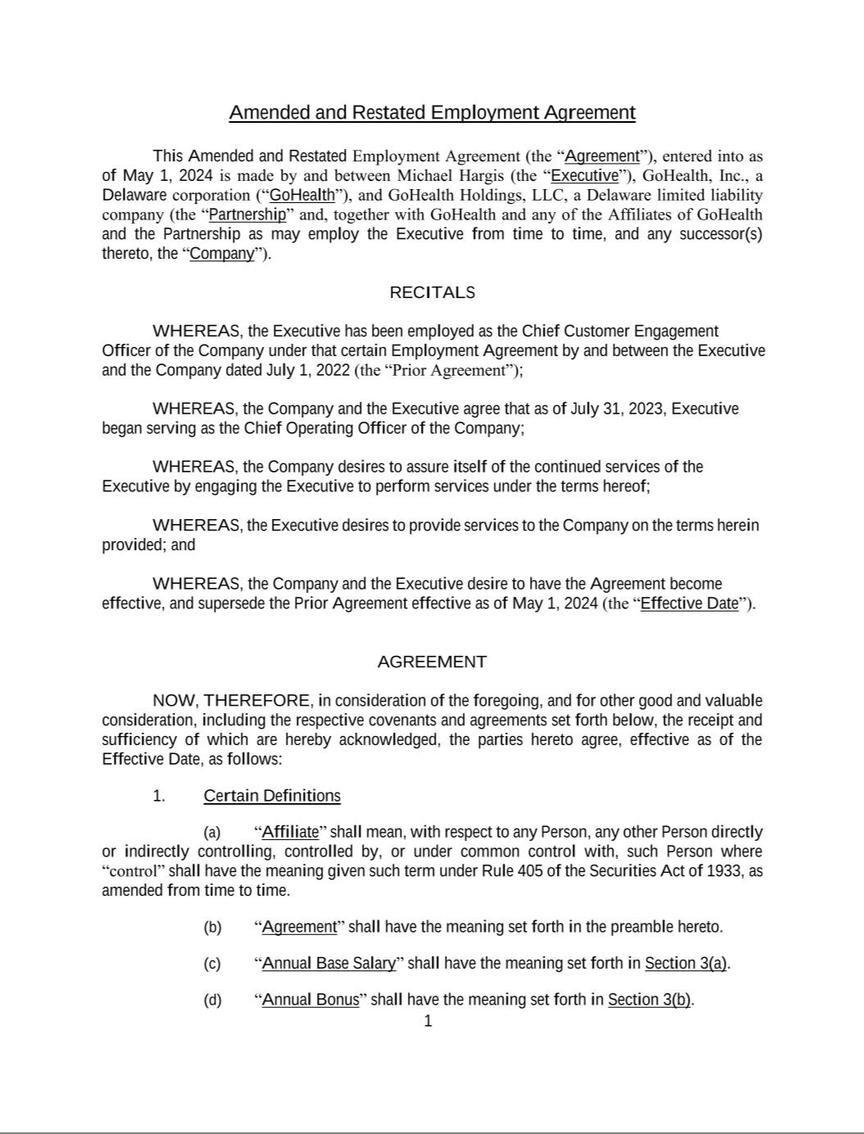

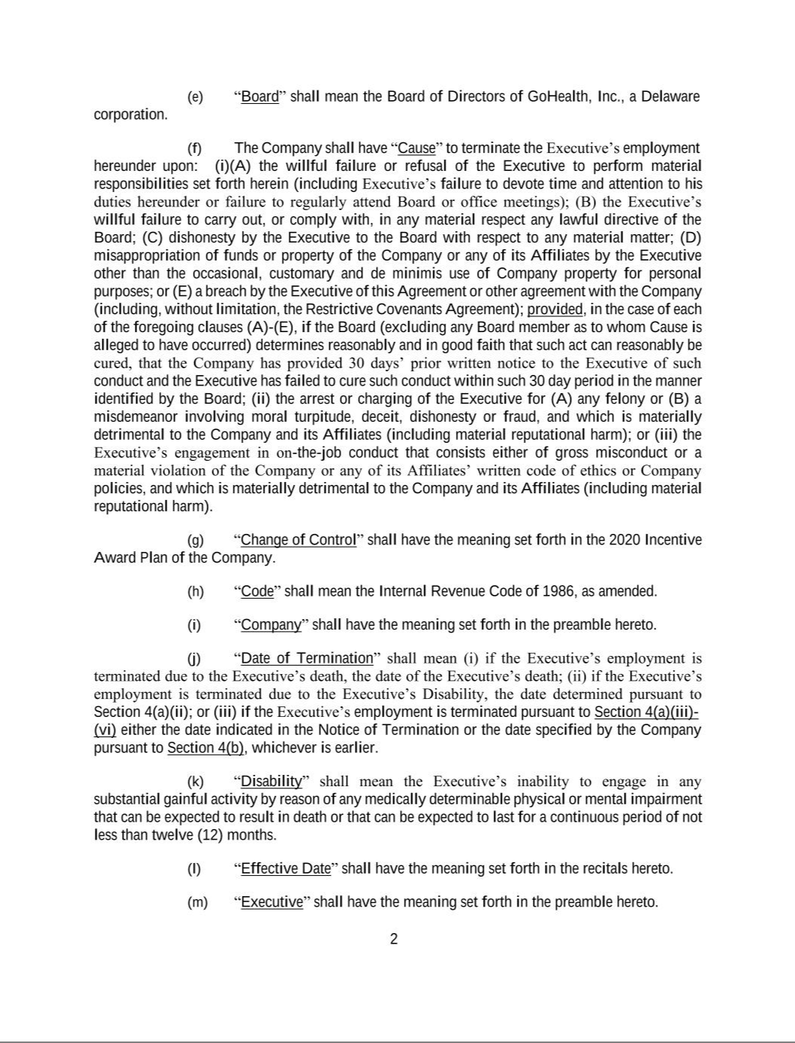

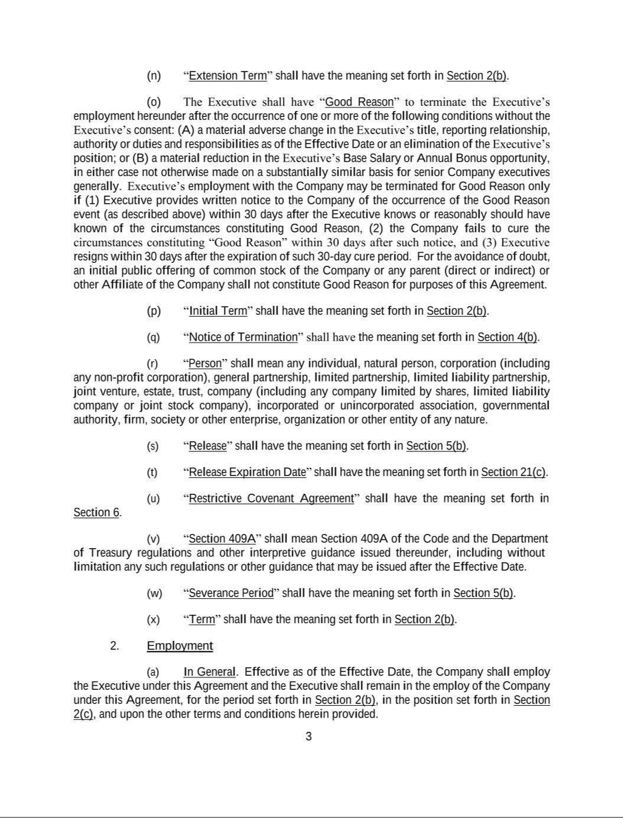

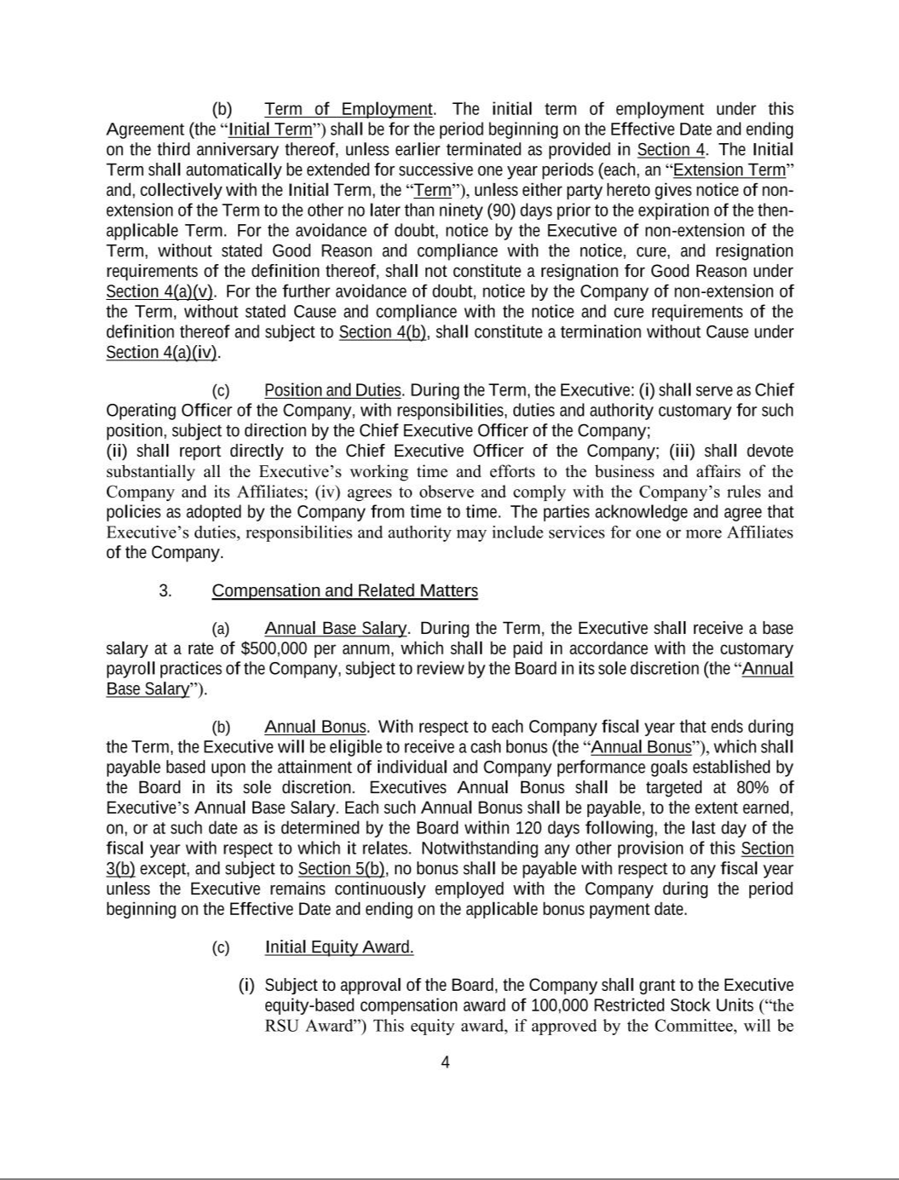

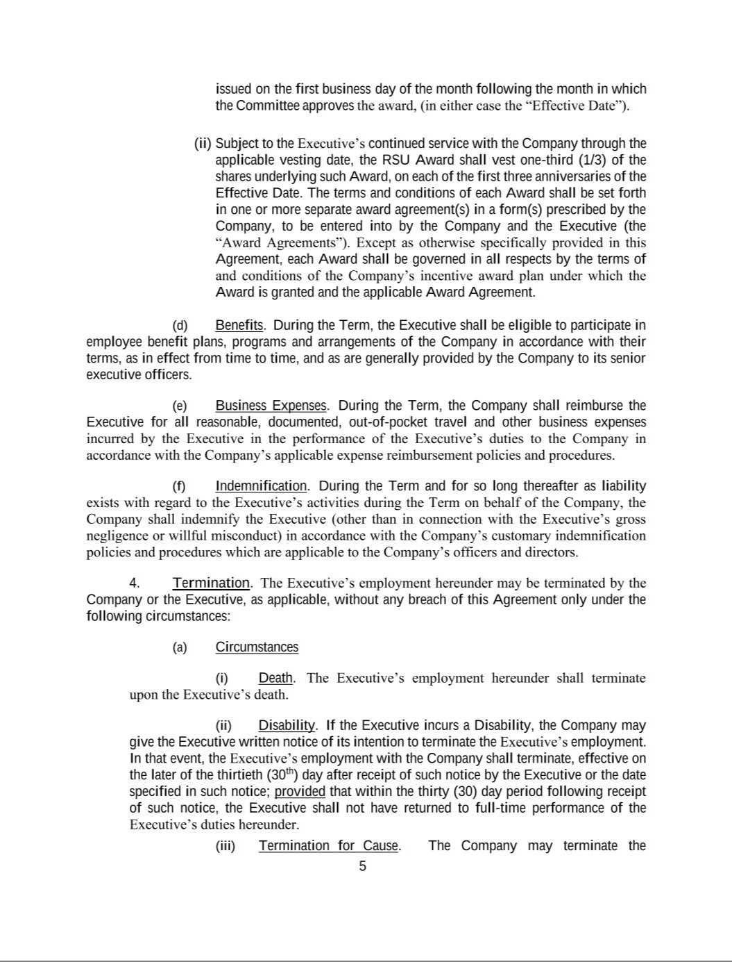

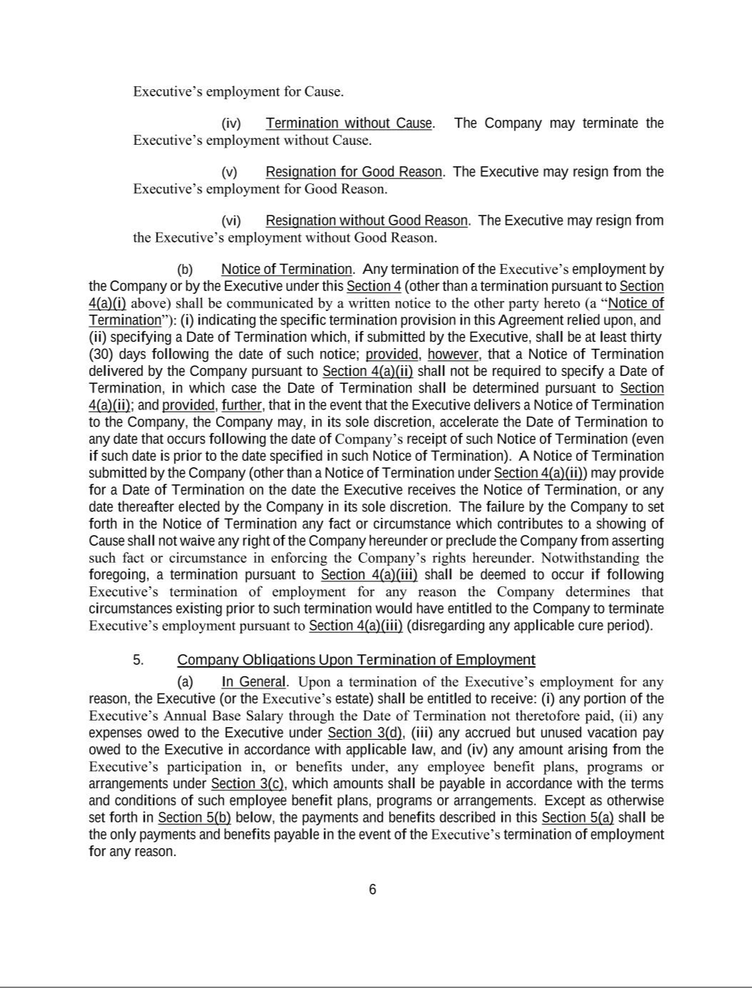

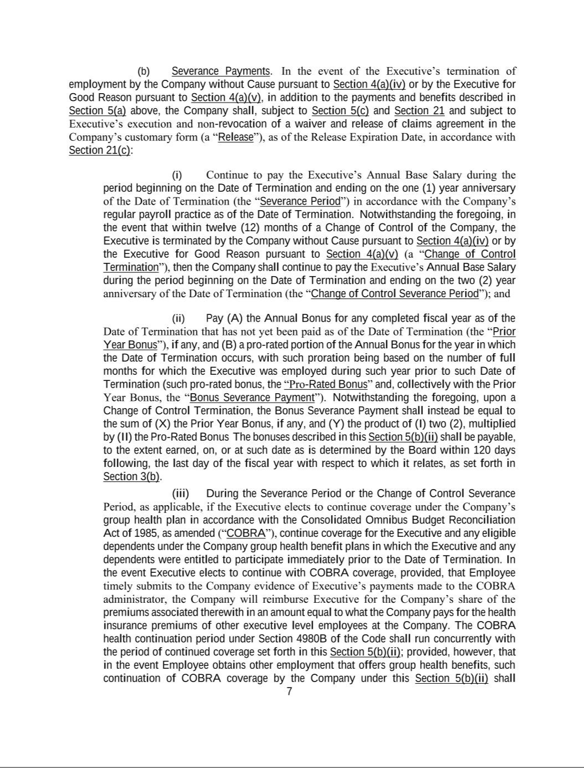

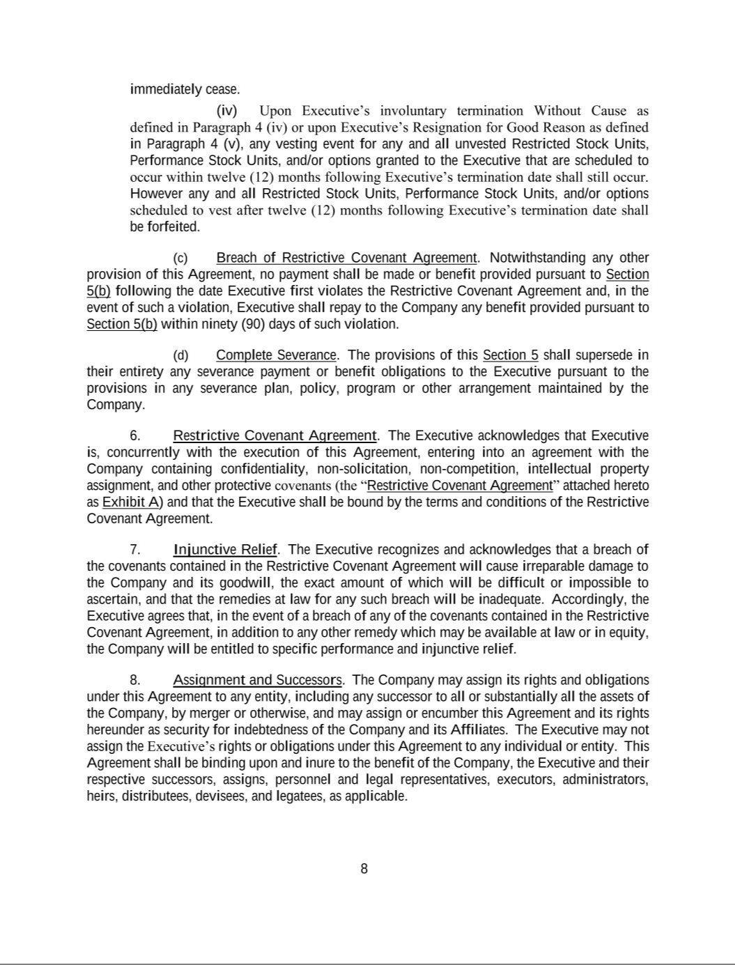

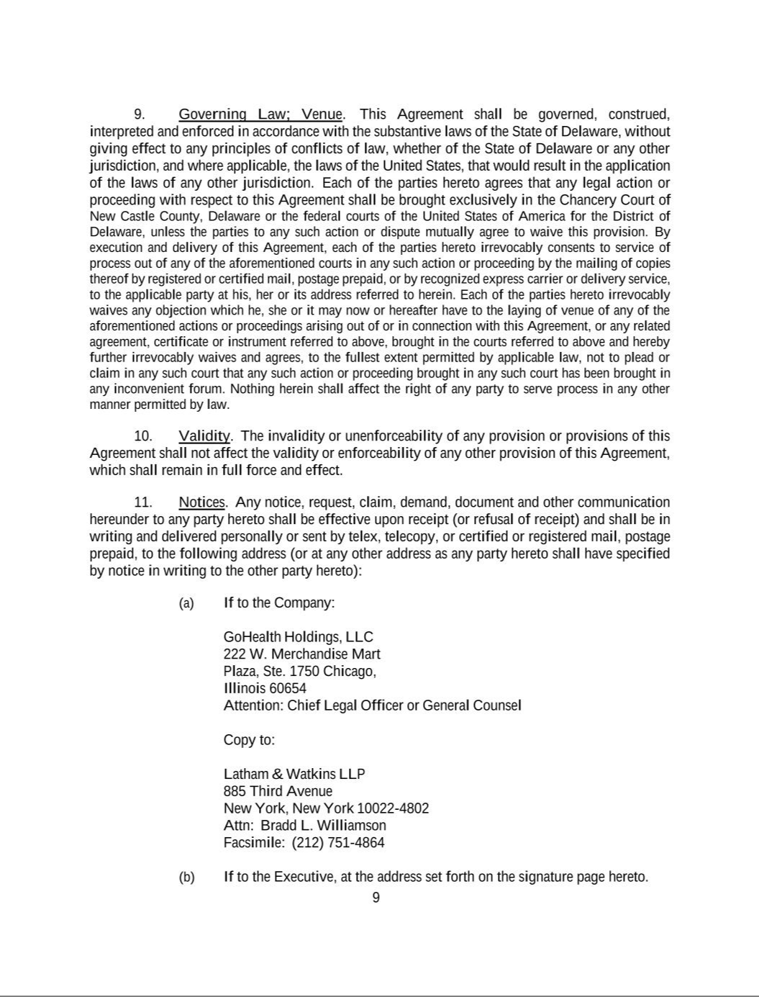

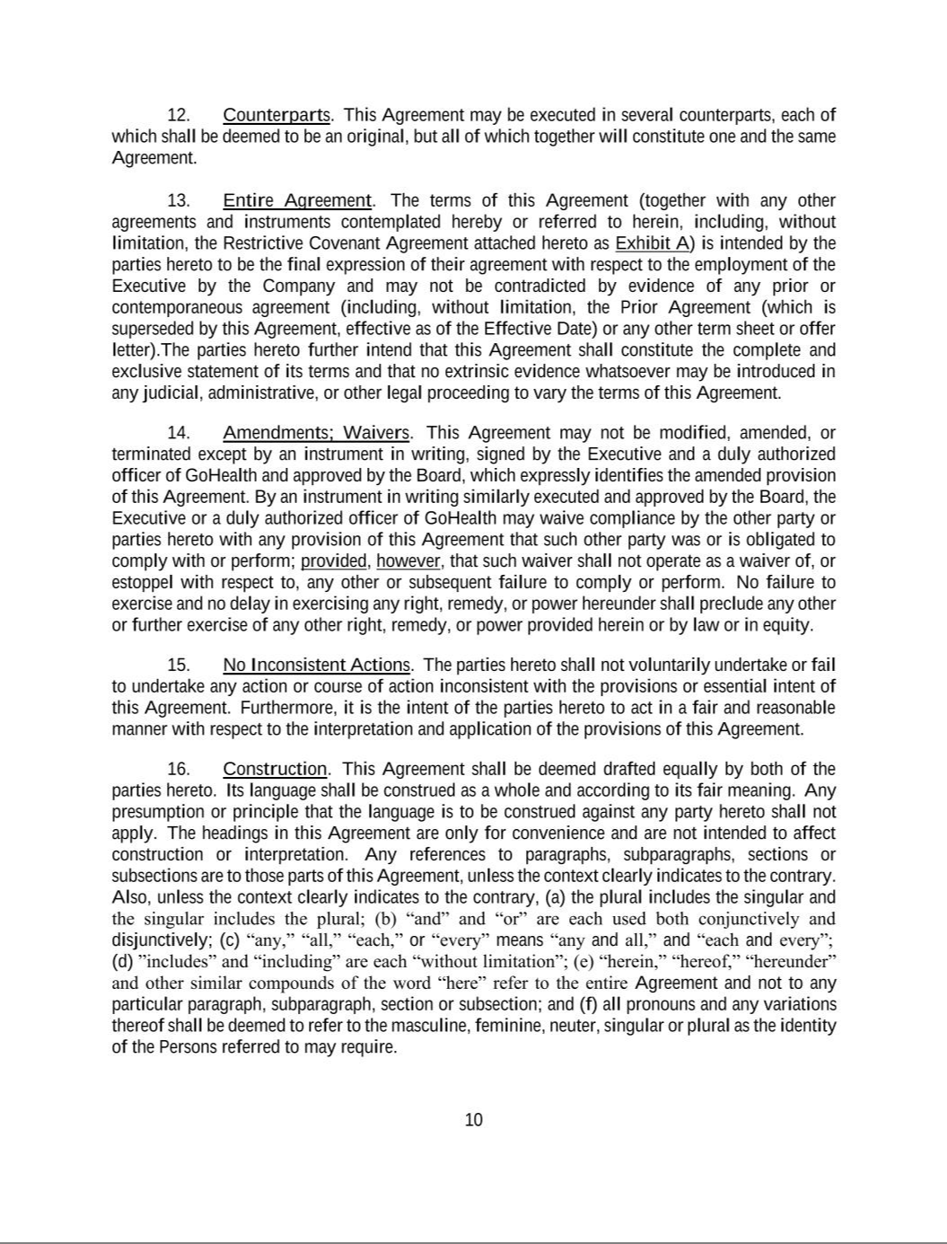

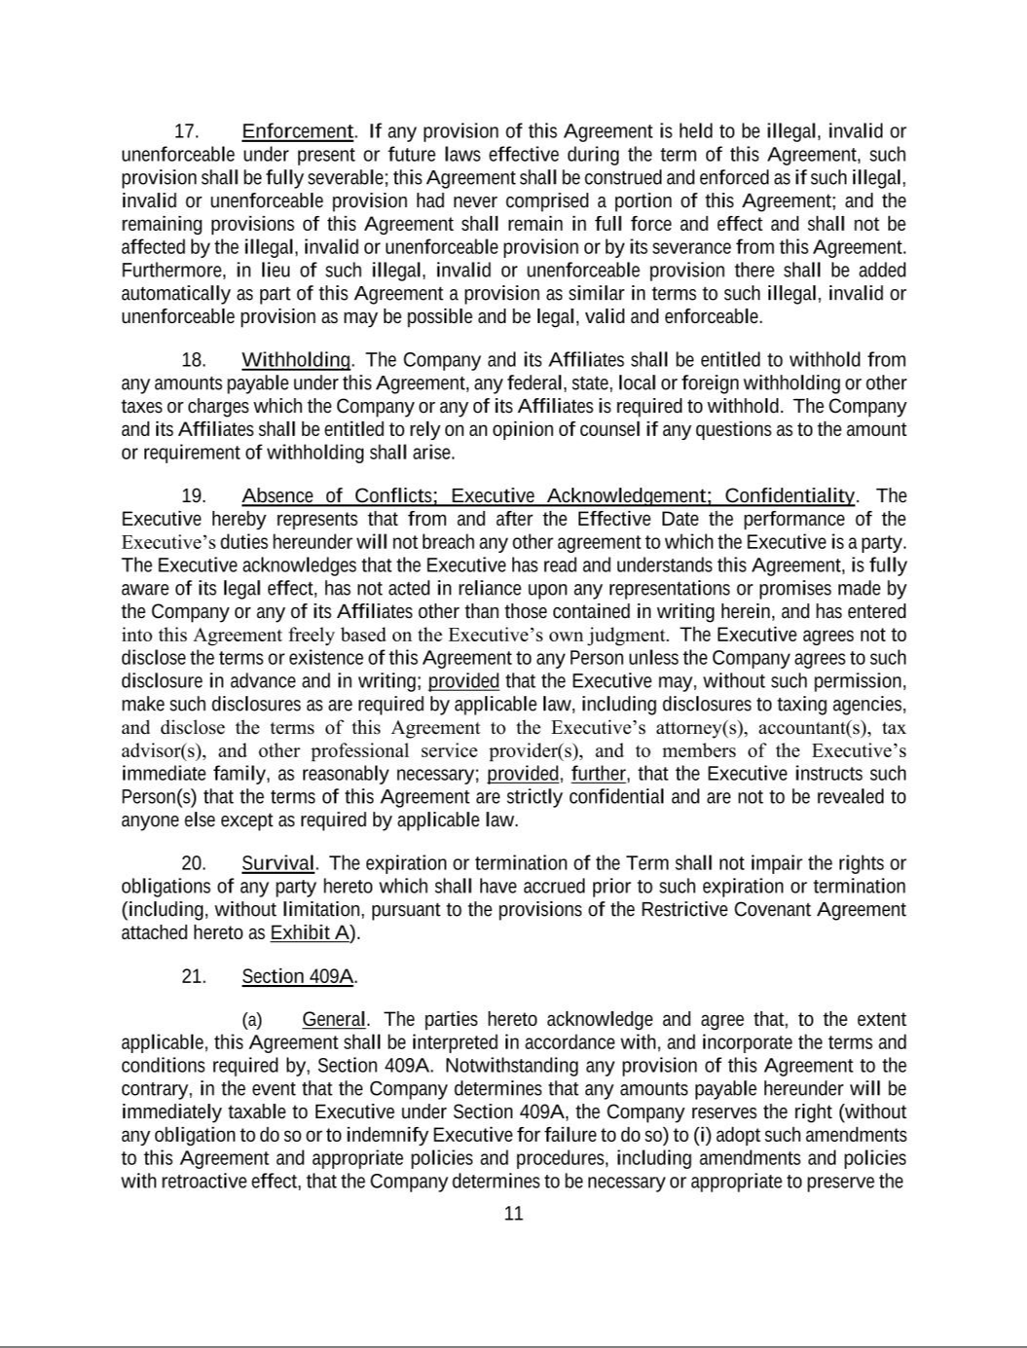

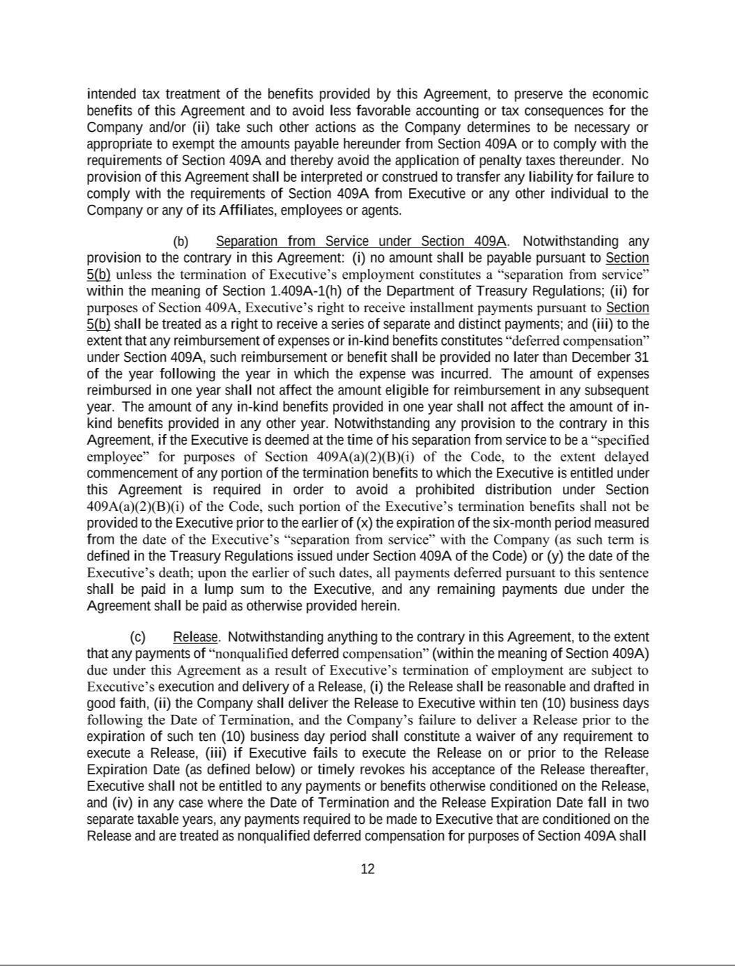

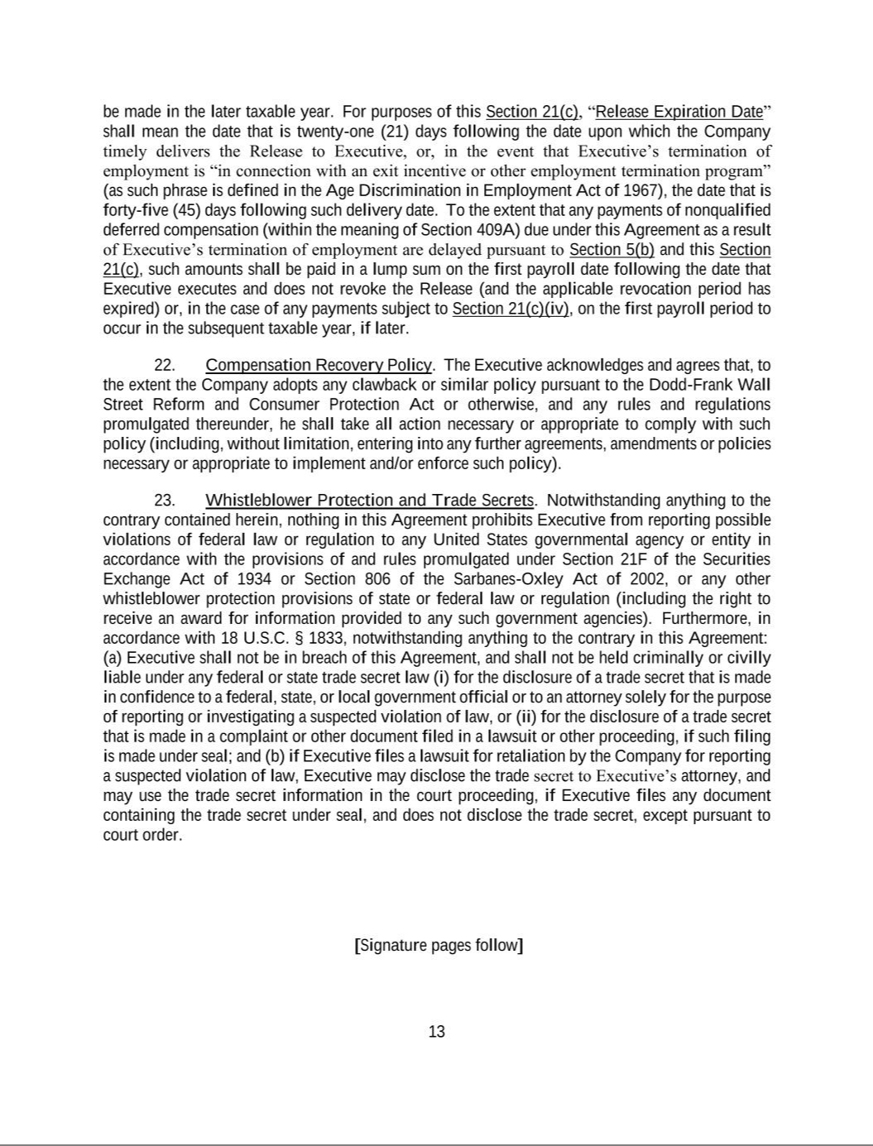

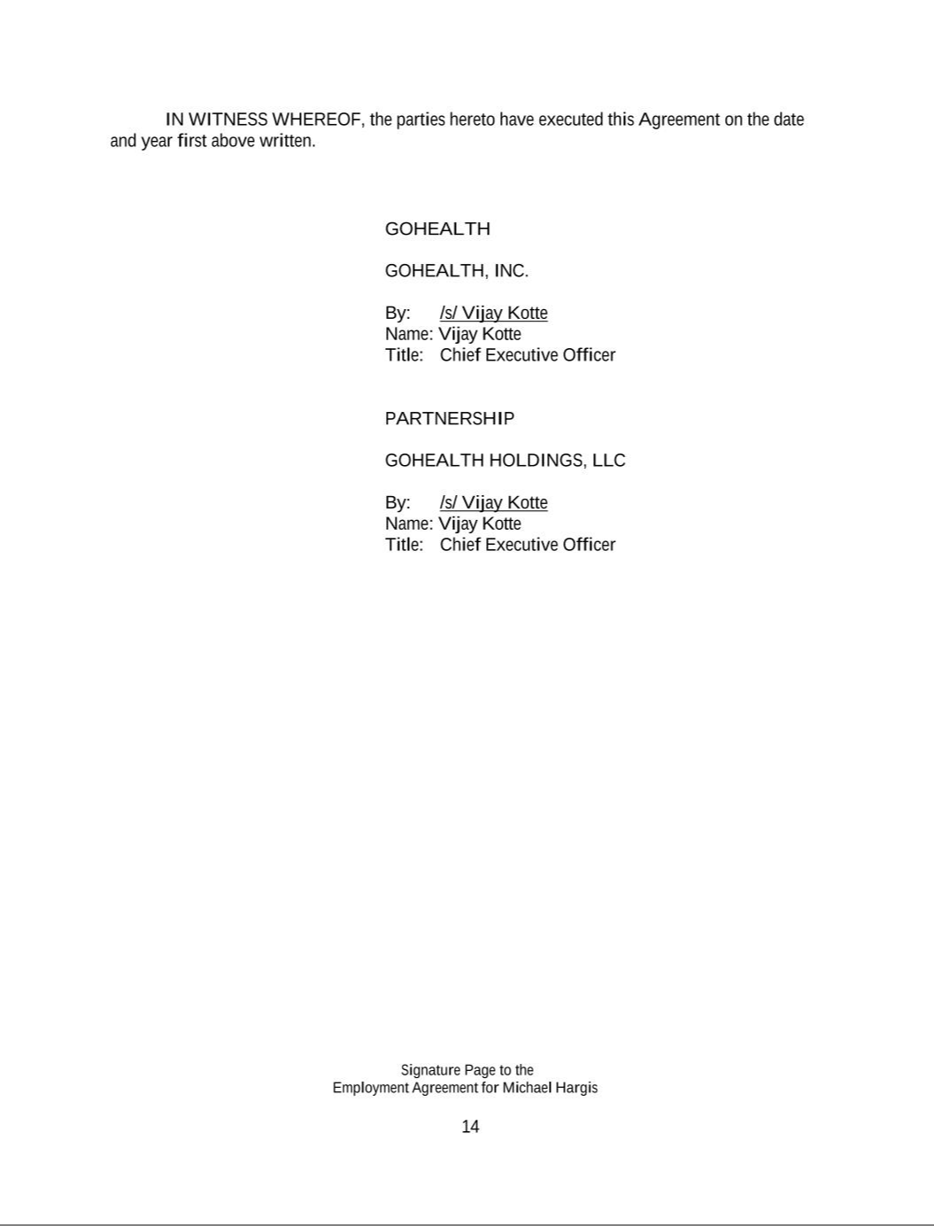



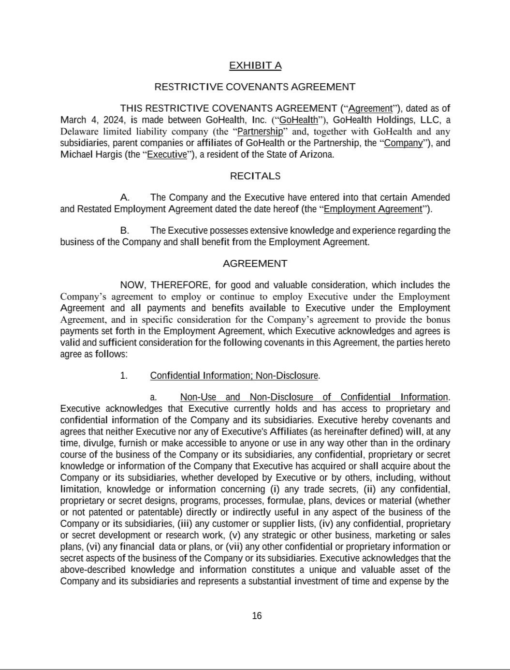

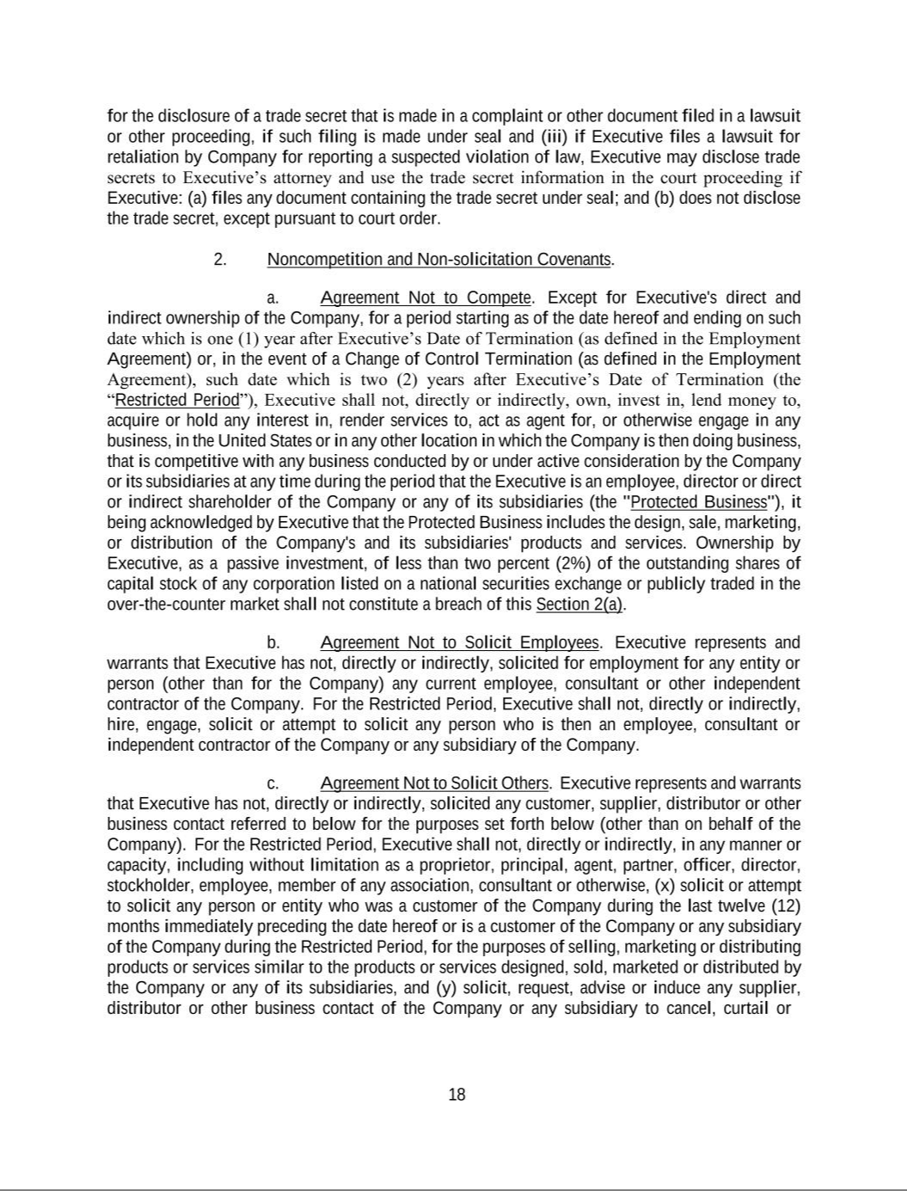

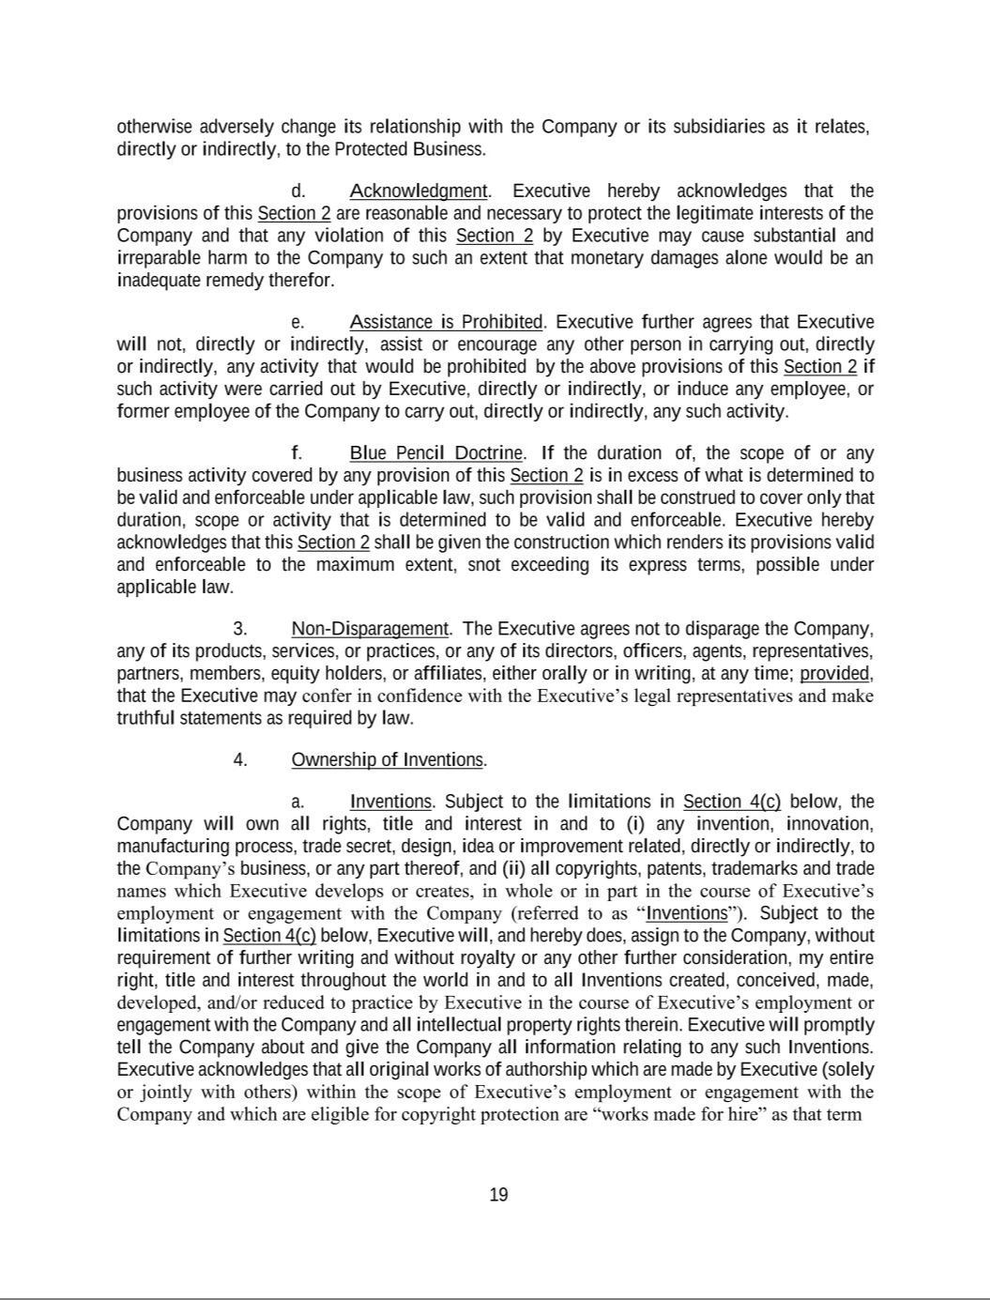

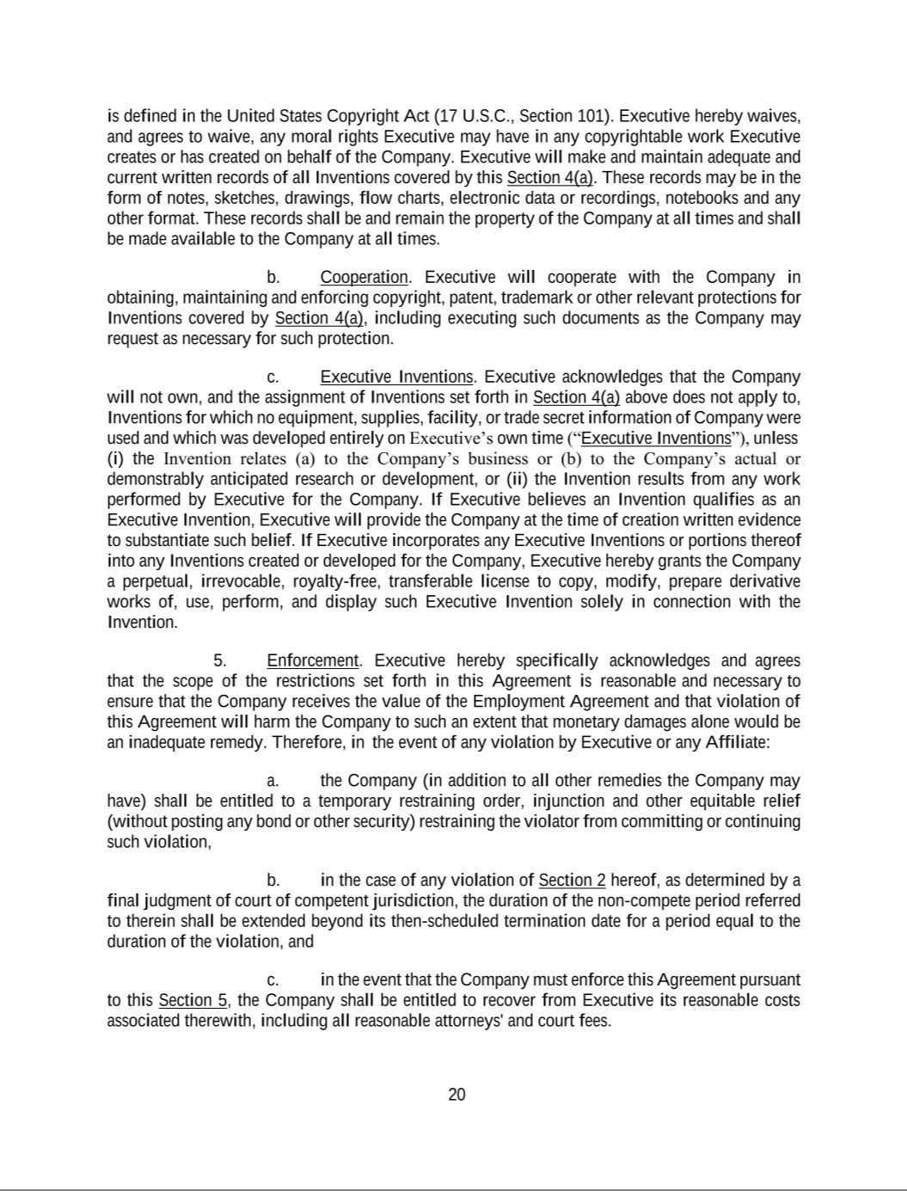

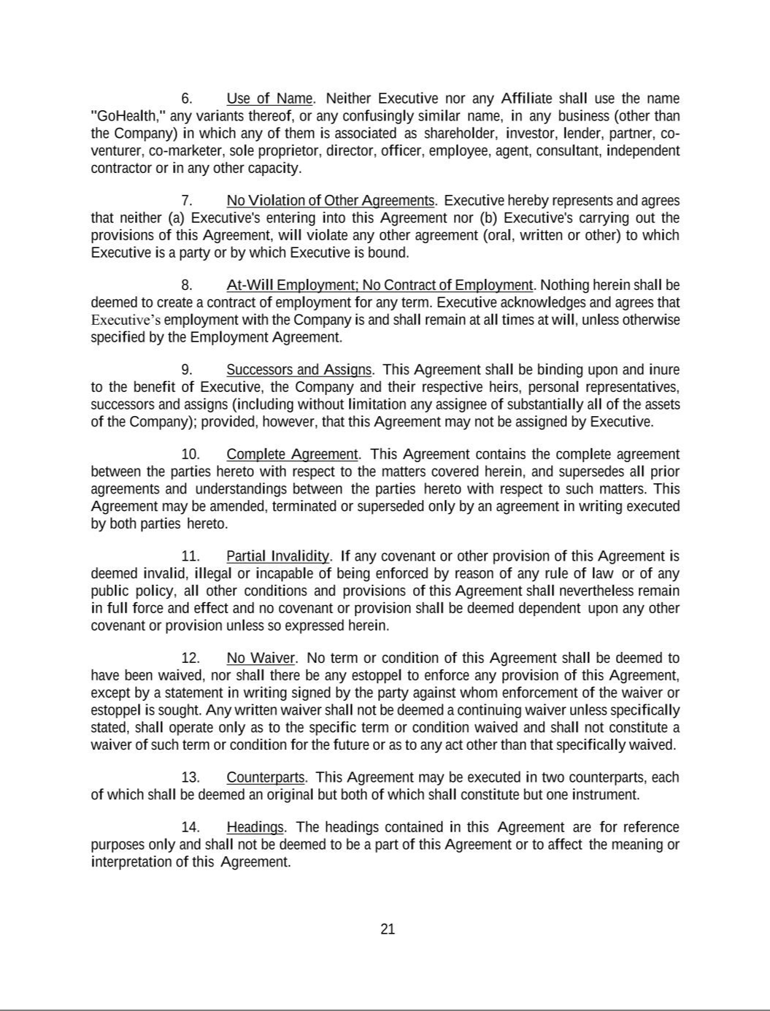

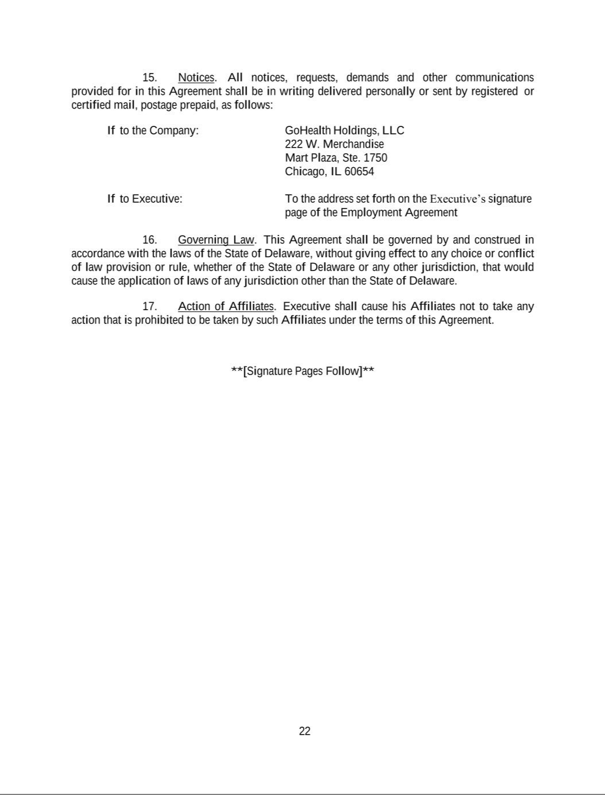

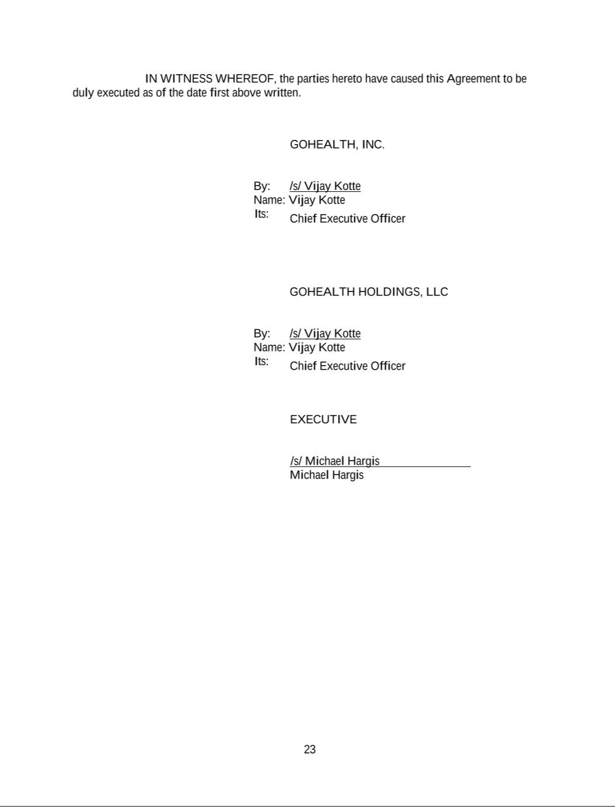

Exhibit 31.1

Certification

I, Vijay Kotte, certify that:

- I have reviewed this Quarterly Report on Form 10-Q of GoHealth, Inc.;

- Based on my knowledge, this report does not contain any untrue statement of a material fact or omit to state a material fact necessary to make the statements made, in light of the circumstances under which such statements were made, not misleading with respect to the period covered by this report;

- Based on my knowledge, the financial statements, and other financial information included in this report, fairly present in all material respects the financial condition, results of operations and cash flows of the registrant as of, and for, the periods presented in this report;

- The registrant’s other certifying officer(s) and I are responsible for establishing and maintaining disclosure controls and procedures (as defined in Exchange Act Rules 13a-15(e) and 15d-15(e)) for the registrant and have:

  - Designed such disclosure controls and procedures, or caused such disclosure controls and procedures to be designed under our supervision, to ensure that material information relating to the registrant, including its consolidated subsidiaries, is made known to us by others within those entities, particularly during the period in which this report is being prepared;

  - [omitted];

  - Evaluated the effectiveness of the registrant’s disclosure controls and procedures and presented in this report our conclusions about the effectiveness of the disclosure controls and procedures, as of the end of the period covered by this report based on such evaluation; and

  - Disclosed in this report any change in the registrant’s internal control over financial reporting that occurred during the registrant’s most recent fiscal quarter (the registrant’s fourth fiscal quarter in the case of an annual report) that has materially affected, or is reasonably likely to materially affect, the registrant’s internal control over financial reporting; and

- The registrant’s other certifying officer(s) and I have disclosed, based on our most recent evaluation of internal control over financial reporting, to the registrant’s auditors and the audit committee of the registrant’s board of directors (or persons performing the equivalent functions):

  - All significant deficiencies and material weaknesses in the design or operation of internal control over financial reporting which are reasonably likely to adversely affect the registrant’s ability to record, process, summarize and report financial information; and

  - Any fraud, whether or not material, that involves management or other employees who have a significant role in the registrant’s internal control over financial reporting.

Date: May 9, 2024 By: /s/ Vijay Kotte

Vijay Kotte

Chief Executive Officer

(Principal Executive Officer)

Exhibit 31.2

Certification

I, Jason Schulz, certify that:

- I have reviewed this Quarterly Report on Form 10-Q of GoHealth, Inc.;

- Based on my knowledge, this report does not contain any untrue statement of a material fact or omit to state a material fact necessary to make the statements made, in light of the circumstances under which such statements were made, not misleading with respect to the period covered by this report;

- Based on my knowledge, the financial statements, and other financial information included in this report, fairly present in all material respects the financial condition, results of operations and cash flows of the registrant as of, and for, the periods presented in this report;

- The registrant’s other certifying officer(s) and I are responsible for establishing and maintaining disclosure controls and procedures (as defined in Exchange Act Rules 13a-15(e) and 15d-15(e)) for the registrant and have:

  - Designed such disclosure controls and procedures, or caused such disclosure controls and procedures to be designed under our supervision, to ensure that material information relating to the registrant, including its consolidated subsidiaries, is made known to us by others within those entities, particularly during the period in which this report is being prepared;

  - [omitted];

  - Evaluated the effectiveness of the registrant’s disclosure controls and procedures and presented in this report our conclusions about the effectiveness of the disclosure controls and procedures, as of the end of the period covered by this report based on such evaluation; and

  - Disclosed in this report any change in the registrant’s internal control over financial reporting that occurred during the registrant’s most recent fiscal quarter (the registrant’s fourth fiscal quarter in the case of an annual report) that has materially affected, or is reasonably likely to materially affect, the registrant’s internal control over financial reporting; and

- The registrant’s other certifying officer(s) and I have disclosed, based on our most recent evaluation of internal control over financial reporting, to the registrant’s auditors and the audit committee of the registrant’s board of directors (or persons performing the equivalent functions):

  - All significant deficiencies and material weaknesses in the design or operation of internal control over financial reporting which are reasonably likely to adversely affect the registrant’s ability to record, process, summarize and report financial information; and

  - Any fraud, whether or not material, that involves management or other employees who have a significant role in the registrant’s internal control over financial reporting.

Date: May 9, 2024 By: /s/ Jason Schulz

Jason Schulz

Chief Financial Officer

(Principal Financial and Accounting Officer)

Exhibit 32.1

Certification Pursuant to

18 U.S.C. Section 1350, as Adopted Pursuant to

Section 906 of the Sarbanes-Oxley Act of 2002

In connection with the Quarterly Report on Form 10-Q of GoHealth, Inc. (the “Company”) for the period ended March 31, 2024 as filed with the Securities and Exchange Commission on the date hereof (the “Report”), I certify, pursuant to 18 U.S.C. § 1350, as adopted pursuant to § 906 of the Sarbanes-Oxley Act of 2002, that:

- The Report fully complies with the requirements of section 13(a) or 15(d) of the Securities Exchange Act of 1934, as amended; and

- The information contained in the Report fairly presents, in all material respects, the financial condition and results of operations of the Company.

Date: May 9, 2024 By: /s/ Vijay Kotte

Vijay Kotte

Chief Executive Officer

(Principal Executive Officer)

Exhibit 32.2

Certification Pursuant to

18 U.S.C. Section 1350, as Adopted Pursuant to

Section 906 of the Sarbanes-Oxley Act of 2002

In connection with the Quarterly Report on Form 10-Q of GoHealth, Inc. (the “Company”) for the period ended March 31, 2024 as filed with the Securities and Exchange Commission on the date hereof (the “Report”), I certify, pursuant to 18 U.S.C. § 1350, as adopted pursuant to § 906 of the Sarbanes-Oxley Act of 2002, that:

- The Report fully complies with the requirements of section 13(a) or 15(d) of the Securities Exchange Act of 1934, as amended; and

- The information contained in the Report fairly presents, in all material respects, the financial condition and results of operations of the Company.

Date: May 9, 2024 By: /s/ Jason Schulz

Jason Schulz

Chief Financial Officer

(Principal Financial and Accounting Officer)

