UNITED STATES
SECURITIES AND EXCHANGE COMMISSION

WASHINGTON, DC 20549

FORM 10-Q
(Mark One)
☒ |  |  | QUARTERLY REPORT PURSUANT TO SECTION 13 OR 15(d) OF THE SECURITIES EXCHANGE ACT OF 1934
For the quarterly period ended June 30, 2023
OR
☐ |  |  | TRANSITION REPORT PURSUANT TO SECTION 13 OR 15(d) OF THE SECURITIES EXCHANGE ACT OF 1934
For the transition period from to

Commission File Number: 001-39390

GoHealth, Inc.
(Exact name of registrant as specified in its charter)
_________________________
Delaware |  |  | 85-0563805
(State or other jurisdiction of incorporation or organization) |  |  | (I.R.S. Employer Identification No.)
214 West Huron St. |  |  |  |  |  | 60654
Chicago, |  |  | Illinois
(Address of principal executive offices) |  |  |  |  |  | (Zip Code)
(312) 386-8200
(Registrant’s telephone number, including area code)
N/A
(Former name, former address and former fiscal year, if changed since last report)
_________________________

Securities registered pursuant to Section 12(b) of the Act:
Title of each class |  |  |  |  |  | Trading Symbol(s) |  |  |  |  |  | Name of each exchange  on which registered
Class A Common Stock,  $0.0001 par value per share |  |  |  |  |  | GOCO |  |  |  |  |  | The Nasdaq Global Market
Indicate by check mark whether the registrant: (1) has filed all reports required to be filed by Section 13 or 15(d) of the Securities Exchange Act of 1934 during the preceding 12 months (or for such shorter period that the registrant was required to file such reports), and (2) has been subject to such filing requirements for the past 90 days. Yes ☒ No ☐
Indicate by check mark whether the registrant has submitted electronically every Interactive Data File required to be submitted pursuant to Rule 405 of Regulation S-T (§ 232.405 of this chapter) during the preceding 12 months (or for such shorter period that the registrant was required to submit such files). Yes ☒ No ☐
Indicate by check mark whether the registrant is a large accelerated filer, an accelerated filer, a non-accelerated filer, a smaller reporting company, or an emerging growth company. See the definitions of “large accelerated filer,” “accelerated filer,” “smaller reporting company,” and “emerging growth company” in Rule 12b-2 of the Exchange Act.
Large accelerated filer |  |  |  |  |  | ☐ |  |  | Smaller reporting company |  |  |  |  |  | ☒
Non-accelerated filer |  |  |  |  |  | ☒ |  |  | Emerging growth company |  |  |  |  |  | ☐
Accelerated filer |  |  |  |  |  | ☐
If an emerging growth company, indicate by check mark if the registrant has elected not to use the extended transition period for complying with any new or revised financial accounting standards provided pursuant to Section 13(a) of the Exchange Act. ☐
Indicate by check mark whether the registrant is a shell company (as defined in Rule 12b-2 of the Exchange Act). Yes ☐ No ☒
As of August 2, 2023, the registrant had 9,511,860 shares of Class A common stock, $0.0001 par value per share, outstanding and 12,817,922 shares of Class B common stock, $0.0001 par value per share, outstanding.

TABLE OF CONTENTS
 |  |  |  |  |  |  |  |  |  |  |  | PAGE
PART I - FINANCIAL INFORMATION
ITEM 1. |  |  |  |  |  | FINANCIAL STATEMENTS. |  |  |  |  |  | 4
 |  |  |  |  |  | CONDENSED CONSOLIDATED FINANCIAL STATEMENTS |  |  |  |  |  | 4
 |  |  |  |  |  | CONDENSED CONSOLIDATED STATEMENTS OF OPERATIONS |  |  |  |  |  | 4
 |  |  |  |  |  | CONDENSED CONSOLIDATED STATEMENTS OF COMPREHENSIVE INCOME (LOSS) |  |  |  |  |  | 5
 |  |  |  |  |  | CONDENSED CONSOLIDATED BALANCE SHEETS |  |  |  |  |  | 6
 |  |  |  |  |  | CONDENSED CONSOLIDATED STATEMENTS OF CHANGES IN STOCKHOLDERS’ EQUITY |  |  |  |  |  | 7
 |  |  |  |  |  | CONDENSED CONSOLIDATED STATEMENTS OF CASH FLOWS |  |  |  |  |  | 9
 |  |  |  |  |  | NOTES TO CONDENSED CONSOLIDATED FINANCIAL STATEMENTS |  |  |  |  |  | 10
ITEM 2. |  |  |  |  |  | MANAGEMENT’S DISCUSSION AND ANALYSIS OF FINANCIAL CONDITIONS AND RESULTS OF OPERATIONS. |  |  |  |  |  | 25
ITEM 3. |  |  |  |  |  | QUANTITATIVE AND QUALITATIVE DISCLOSURES ABOUT MARKET RISK. |  |  |  |  |  | 34
ITEM 4. |  |  |  |  |  | CONTROLS AND PROCEDURES. |  |  |  |  |  | 34
PART II - OTHER INFORMATION
ITEM 1. |  |  |  |  |  | LEGAL PROCEEDINGS. |  |  |  |  |  | 36
ITEM 1A. |  |  |  |  |  | RISK FACTORS. |  |  |  |  |  | 36
ITEM 2. |  |  |  |  |  | UNREGISTERED SALES OF EQUITY SECURITIES AND USE OF PROCEEDS. |  |  |  |  |  | 36
ITEM 3. |  |  |  |  |  | DEFAULTS UPON SENIOR SECURITIES. |  |  |  |  |  | 36
ITEM 4. |  |  |  |  |  | MINE SAFETY DISCLOSURES. |  |  |  |  |  | 36
ITEM 5. |  |  |  |  |  | OTHER INFORMATION. |  |  |  |  |  | 36
ITEM 6. |  |  |  |  |  | EXHIBITS. |  |  |  |  |  | 37
 |  |  |  |  |  | SIGNATURES |  |  |  |  |  | 38

CAUTIONARY NOTE REGARDING FORWARD-LOOKING STATEMENTS
This Quarterly Report on Form 10-Q contains forward-looking statements. We intend such forward-looking statements to be covered by the safe harbor provisions for forward-looking statements contained in Section 27A of the Securities Act of 1933, as amended, (the “Securities Act”) and Section 21E of the Securities Exchange Act of 1934, as amended, (the “Exchange Act”). All statements other than statements of historical facts contained in this Quarterly Report on Form 10-Q may be forward-looking statements. Statements regarding our future results of operations and financial position, business strategy and plans and objectives of management for future operations, including, among others, statements regarding our expected growth, future capital expenditures and debt service obligations, are forward-looking statements.
In some cases, you can identify forward-looking statements by terms, such as “may,” “will,” “should,” “expects,” “plans,” “anticipates,” “could,” “intends,” “targets,” “projects,” “contemplates,” “believes,” “estimates,” “predicts,” “potential,” “likely,” “future” or “continue” or the negative of these terms or other similar expressions. The forward-looking statements in this Quarterly Report on Form 10-Q are only predictions. Accordingly, we caution you that any such forward-looking statements are not guarantees of future performance and are subject to risks, assumptions and uncertainties that are difficult to predict. Although we believe that the expectations reflected in these forward-looking statements are reasonable as of the date made, actual results may prove to be materially different from the results expressed or implied by the forward-looking statements.
These forward-looking statements speak only as of the date of this Quarterly Report on Form 10-Q and are subject to a number of important factors that could cause actual results to differ materially from those in the forward-looking statements, including the factors described in the sections titled “Summary Risk Factors,” “Risk Factors” and “Management’s Discussion and Analysis of Financial Condition and Results of Operations” in our Annual Report on Form 10-K for the year ended December 31, 2022 (the “2022 Form 10-K”), the section titled “Management’s Discussion and Analysis of Financial Condition and Results of Operations” in this Quarterly Report on Form 10-Q and in our other filings with the Securities and Exchange Commission.
You should read this Quarterly Report on Form 10-Q and the documents that we reference in this Quarterly Report on Form 10-Q completely and with the understanding that our actual future results may be materially different from what we expect. We qualify all of our forward-looking statements by these cautionary statements. Except as required by applicable law, we do not plan to publicly update or revise any forward-looking statements contained herein, whether as a result of any new information, future events, changed circumstances or otherwise.
CERTAIN DEFINITIONS
As used in this Quarterly Report on Form 10-Q, unless the context otherwise requires:
•“we,” “us,” “our,” the “Company,” “GoHealth” and similar references refer to GoHealth, Inc., and, unless otherwise stated, all of its direct and indirect subsidiaries, including GoHealth Holdings, LLC.
•“Blocker Company” refers to an entity affiliated with Centerbridge that was an indirect owner of LLC Interests in GoHealth Holdings, LLC prior to the Transactions and is taxable as a corporation for U.S. federal income tax purposes.
•“Blocker Shareholders” refer to entities affiliated with Centerbridge, the owners of the Blocker Company prior to the Transactions, who exchanged their interests in the Blocker Company for shares of our Class A common stock and cash in connection with the consummation of the Transactions.
•“Centerbridge” refers to certain investment funds and other entities affiliated with CCP III Cayman GP Ltd., a Cayman Islands exempted company over which CCP III Cayman GP Ltd. has voting control (including any such fund or entity formed to hold shares of Class A common stock for the Blocker Shareholders).
•“Continuing Equity Owners” refer collectively to direct or indirect holders of LLC Interests and our Class B common stock immediately following consummation of the Transactions, including Centerbridge, NVX Holdings, our Founders, the Former Profits Unit Holders and certain executive officers, employees and other minority investors and their respective permitted transferees who may, following the consummation of our IPO, exchange at each of their respective options (subject in certain circumstances to time-based vesting requirements and certain other restrictions), in whole or in part from time to time, their LLC Interests (along with an equal number of shares of Class B common stock (and such shares shall be immediately cancelled)) for, at our election (determined solely by our independent directors (within the meaning of the listing rules of The Nasdaq Global Market who are disinterested), cash or newly-issued shares of our Class A common stock.
•“Founders” refer to Brandon M. Cruz, our Co-Founder and Co-Chairman of the Board, and Clinton P. Jones, our Co-Founder and Co-Chairman of the Board.
•“Former Profits Unit Holders” refers collectively to certain of our directors and certain current and former officers and employees, in each case, who directly or indirectly held existing vested and unvested profits units, which were
GoHealth, Inc. |  |  | 2023 Form 10-Q |  |  | 1

comprised of profits units that have time-based vesting conditions and profits units that have performance-based vesting conditions, of GoHealth Holdings, LLC pursuant to GoHealth Holdings, LLC’s existing profits unit plan and who received LLC Interests in exchange for their profits units in connection with the Transactions. LLC Interests received in exchange for unvested profits units remain subject to their existing time-based vesting requirements. Profit units with performance-based vesting conditions fully vested as such conditions were met in connection with our IPO.
•“GoHealth Holdings, LLC Agreement” refers to GoHealth Holdings, LLC’s amended and restated limited liability company agreement, as further amended, which became effective substantially concurrently with or prior to the consummation of our IPO.
•“LLC Interests” refer to the common units of GoHealth Holdings, LLC, including those that we purchased with a portion of the net proceeds from our IPO.
•“Norvax” refers to Norvax, LLC, a Delaware limited liability company and a subsidiary of GoHealth Holdings, LLC.
•“NVX Holdings” refers to NVX Holdings, Inc., a Delaware corporation that is controlled by the Founders.
•“Transactions” refer to our IPO and certain organizational transactions that were effected in connection with our IPO, and the application of the net proceeds therefrom.
GoHealth, Inc. is a holding company and the sole managing member of GoHealth Holdings, LLC, and its principal asset consists of LLC Interests.
KEY TERMS AND PERFORMANCE INDICATORS; NON-GAAP FINANCIAL MEASURES
Throughout this Quarterly Report on Form 10-Q, we use a number of key terms and provide a number of key performance indicators used by management. We define these terms and key performance indicators as follows:
•“Adjusted EBITDA” represents, as applicable for the period, EBITDA as further adjusted for certain items discussed in Item 2. “Management’s Discussion and Analysis of Financial Condition and Results of Operations.”
•“Adjusted EBITDA Margin” refers to Adjusted EBITDA divided by net revenues.
•“Adjusted Gross Margin per Submission” refers to Sales per Submission less Cost per Submission.
•“Conversion Rate” refers to commissionable Submissions over qualified prospects.
•“Cost of Submission” refers to the aggregate cost to convert prospects into Submissions during a particular period. Cost of Submission is comprised of revenue share, marketing and advertising expenses and customer care and enrollment expenses, excluding associated share-based compensation expense, the impact of revenue adjustments recorded in the period, but relating to performance obligations satisfied in prior periods, and such expenses related to our non-Encompass BPO Services.
•“Cost per Submission” refers to (x) the aggregate cost to convert prospects into Submissions during a particular period (comprised of revenue share, marketing and advertising expenses, and customer care and enrollment expenses, excluding share-based compensation expense) divided by (y) either (i) a completed application with our licensed agent that is submitted to the insurance health plan partner and subsequently approved by the health plan partner during the indicated period, excluding applications through our non-Encompass BPO Services or (ii) a transfer by our agent to the health plan partner through the Encompass marketplace during the indicated period.
•“EBITDA” represents net income (loss) before interest expense, income tax expense (benefit) and depreciation and amortization expense.

•“Non-Encompass BPO Services” refer to programs in which GoHealth-employed agents are dedicated to certain health plans and agencies we partner with outside of the Encompass model.
•“Sales per Submission” refers to (x) the sum of (i) aggregate commissions estimated to be collected over the estimated life of all commissionable Submissions for the relevant period based on multiple factors, including but not limited to, contracted commission rates, health plan partner mix and expected policy persistency with applied constraints, excluding revenue adjustments recorded in the period, but relating to performance obligations satisfied in prior periods, (ii) Encompass revenue, and (iii) partner marketing and enrollment services, divided by (y) the number of Submissions for such period.
GoHealth, Inc. |  |  | 2023 Form 10-Q |  |  | 2

•“Sales/Cost of Submission” refers to (x) the sum of (i) aggregate commissions estimated to be collected over the estimated life of all commissionable Submissions for the relevant period based on multiple factors, including but not limited to, contracted commission rates, health plan partner mix and expected policy persistency with applied constraints, excluding revenue adjustments recorded in the period, but relating to performance obligations satisfied in prior periods, (ii) Encompass revenue, and (iii) partner marketing and enrollment services, divided by (y) the aggregate cost to convert prospects into Submissions (comprised of revenue share, marketing and advertising expenses, and customer care and enrollment expenses, excluding share-based compensation expense) for such period. Sales and Cost of Submission exclude amounts related to non-Encompass BPO Services.
•“Submission” refers to either (i) a completed application with our licensed agent that is submitted to the health plan partner and subsequently approved by the health plan partner during the indicated period, excluding applications through our non-Encompass BPO Services or (ii) a transfer by our agent to the health plan partner through the Encompass marketplace during the indicated period.
•“LTV” refers to the Lifetime Value of Commissions, which we define as aggregate commissions estimated to be collected over the estimated life of all commissionable Submissions for the relevant period based on multiple factors, including but not limited to, contracted commission rates, health plan partner mix and expected policy persistency with applied constraints.
We use supplemental measures of our performance that are derived from our consolidated financial information, but which are not presented in our Condensed Consolidated Financial Statements prepared in accordance with U.S. generally accepted accounting principles (“GAAP”). These non-GAAP financial measures include EBITDA; Adjusted EBITDA and Adjusted EBITDA Margin. Adjusted EBITDA is the primary financial performance measure used by management to evaluate its business and monitor its results of operations.
We use non-GAAP financial measures to supplement financial information presented on a GAAP basis. We believe that excluding certain items from our GAAP results allows management to better understand our consolidated financial performance from period to period and better project our future consolidated financial performance as forecasts are developed at a level of detail different from that used to prepare GAAP-based financial measures. Moreover, we believe these non-GAAP financial measures provide our stakeholders with useful information to help them evaluate our operating results by facilitating an enhanced understanding of our operating performance and enabling them to make more meaningful period to period comparisons. There are limitations to the use of the non-GAAP financial measures presented in this Quarterly Report on Form 10-Q. For example, our non-GAAP financial measures may not be comparable to similarly titled measures of other companies. Other companies, including companies in our industry, may calculate non-GAAP financial measures differently than we do, limiting the usefulness of those measures for comparative purposes.
The non-GAAP financial measures are not meant to be considered as indicators of performance in isolation from or as a substitute for net income (loss) prepared in accordance with GAAP, and should be read only in conjunction with financial information presented on a GAAP basis. Reconciliations of each of EBITDA and Adjusted EBITDA to its most directly comparable GAAP financial measure, net income (loss), are presented in the tables below in this Quarterly Report on Form 10-Q. We encourage you to review the reconciliations in conjunction with the presentation of the non-GAAP financial measures for each of the periods presented. In future periods, we may exclude similar items, may incur income and expenses similar to these excluded items and include other expenses, costs and non-recurring items.

GoHealth, Inc. |  |  | 2023 Form 10-Q |  |  | 3

PART I - Financial Information

ITEM 1. FINANCIAL STATEMENTS.

CONDENSED CONSOLIDATED FINANCIAL STATEMENTS

GOHEALTH, INC.
CONDENSED CONSOLIDATED STATEMENTS OF OPERATIONS
(in thousands, except per share amounts, unaudited)
 |  |  |  |  |  | Three months ended Jun. 30, |  |  |  |  |  |  |  |  |  |  |  | Six months ended Jun. 30,
 |  |  |  |  |  | 2023 |  |  |  |  |  | 2022 |  |  |  |  |  | 2023 |  |  |  |  |  | 2022
Net revenues |  |  |  |  |  | 142,779 |  |  |  |  |  | 158,654 |  |  |  |  |  | 325,937 |  |  |  |  |  | 429,247
Operating expenses:
Revenue share |  |  |  |  |  | 36,422 |  |  |  |  |  | 51,074 |  |  |  |  |  | 81,884 |  |  |  |  |  | 118,997
Marketing and advertising |  |  |  |  |  | 39,269 |  |  |  |  |  | 44,714 |  |  |  |  |  | 85,012 |  |  |  |  |  | 128,747
Customer care and enrollment |  |  |  |  |  | 45,536 |  |  |  |  |  | 66,542 |  |  |  |  |  | 87,563 |  |  |  |  |  | 144,997
Technology |  |  |  |  |  | 10,511 |  |  |  |  |  | 10,749 |  |  |  |  |  | 20,054 |  |  |  |  |  | 23,508
General and administrative |  |  |  |  |  | 37,855 |  |  |  |  |  | 38,106 |  |  |  |  |  | 60,473 |  |  |  |  |  | 67,323
Amortization of intangible assets |  |  |  |  |  | 23,515 |  |  |  |  |  | 23,515 |  |  |  |  |  | 47,029 |  |  |  |  |  | 47,029
Operating lease impairment charges |  |  |  |  |  | 2,687 |  |  |  |  |  | 24,995 |  |  |  |  |  | 2,687 |  |  |  |  |  | 24,995
Total operating expenses |  |  |  |  |  | 195,795 |  |  |  |  |  | 259,695 |  |  |  |  |  | 384,702 |  |  |  |  |  | 555,596
Income (loss) from operations |  |  |  |  |  | (53,016) |  |  |  |  |  | (101,041) |  |  |  |  |  | (58,765) |  |  |  |  |  | (126,349)
Interest expense |  |  |  |  |  | 17,265 |  |  |  |  |  | 12,724 |  |  |  |  |  | 34,156 |  |  |  |  |  | 24,122
Other (income) expense, net |  |  |  |  |  | 21 |  |  |  |  |  | (13) |  |  |  |  |  | (32) |  |  |  |  |  | 50
Income (loss) before income taxes |  |  |  |  |  | (70,302) |  |  |  |  |  | (113,752) |  |  |  |  |  | (92,889) |  |  |  |  |  | (150,521)
Income tax (benefit) expense |  |  |  |  |  | (73) |  |  |  |  |  | — |  |  |  |  |  | (117) |  |  |  |  |  | 472
Net income (loss) |  |  |  |  |  | (70,229) |  |  |  |  |  | (113,752) |  |  |  |  |  | (92,772) |  |  |  |  |  | (150,993)
Net income (loss) attributable to non-controlling interests |  |  |  |  |  | (41,287) |  |  |  |  |  | (69,933) |  |  |  |  |  | (54,651) |  |  |  |  |  | (93,691)
Net income (loss) attributable to GoHealth, Inc. |  |  |  |  |  | $ | (28,942) |  |  |  |  | $ | (43,819) |  |  |  |  | $ | (38,121) |  |  |  |  | $ | (57,302)
Net loss per share (Note 7):
Net loss per share of Class A common stock — basic and diluted |  |  |  |  |  | $ | (3.27) |  |  |  |  | $ | (5.28) |  |  |  |  | $ | (4.41) |  |  |  |  | $ | (7.14)
Weighted-average shares of Class A common stock outstanding — basic and diluted |  |  |  |  |  | 9,122 |  |  |  |  |  | 8,296 |  |  |  |  |  | 9,044 |  |  |  |  |  | 8,023
The accompanying Notes are an integral part of these Condensed Consolidated Financial Statements

GoHealth, Inc. |  |  | 2023 Form 10-Q |  |  | 4

GOHEALTH, INC.
CONDENSED CONSOLIDATED STATEMENTS OF COMPREHENSIVE INCOME (LOSS)
(in thousands, unaudited)
 |  |  |  |  |  | Three months ended Jun. 30, |  |  |  |  |  |  |  |  |  |  |  | Six months ended Jun. 30,
 |  |  |  |  |  | 2023 |  |  |  |  |  | 2022 |  |  |  |  |  | 2023 |  |  |  |  |  | 2022
Net income (loss) |  |  |  |  |  | $ | (70,229) |  |  |  |  | $ | (113,752) |  |  |  |  | $ | (92,772) |  |  |  |  | $ | (150,993)
Other comprehensive income (loss):
Foreign currency translation adjustments |  |  |  |  |  | 41 |  |  |  |  |  | (345) |  |  |  |  |  | 46 |  |  |  |  |  | (462)
Comprehensive income (loss) |  |  |  |  |  | (70,188) |  |  |  |  |  | (114,097) |  |  |  |  |  | (92,726) |  |  |  |  |  | (151,455)
Comprehensive income (loss) attributable to non-controlling interests |  |  |  |  |  | (41,263) |  |  |  |  |  | (70,145) |  |  |  |  |  | (54,624) |  |  |  |  |  | (93,978)
Comprehensive income (loss) attributable to GoHealth, Inc. |  |  |  |  |  | $ | (28,925) |  |  |  |  | $ | (43,952) |  |  |  |  | $ | (38,102) |  |  |  |  | $ | (57,477)
The accompanying Notes are an integral part of these Condensed Consolidated Financial Statements.

GoHealth, Inc. |  |  | 2023 Form 10-Q |  |  | 5

GOHEALTH, INC.
CONDENSED CONSOLIDATED BALANCE SHEETS
(in thousands, except per share amounts, unaudited)

 |  |  |  |  |  | Jun. 30, 2023 |  |  |  |  |  | Dec. 31, 2022
Assets
Current assets:
Cash and cash equivalents |  |  |  |  |  | $ | 25,364 |  |  |  |  | $ | 16,464
Accounts receivable, net of allowance for doubtful accounts of $734 in 2023 and $89 in 2022 |  |  |  |  |  | 35,984 |  |  |  |  |  | 4,703
Commissions receivable - current |  |  |  |  |  | 294,319 |  |  |  |  |  | 335,796
Prepaid expense and other current assets |  |  |  |  |  | 12,431 |  |  |  |  |  | 57,593
Total current assets |  |  |  |  |  | 368,098 |  |  |  |  |  | 414,556
Commissions receivable - non-current |  |  |  |  |  | 617,243 |  |  |  |  |  | 695,637
Operating lease ROU asset |  |  |  |  |  | 17,215 |  |  |  |  |  | 21,483
Other long-term assets |  |  |  |  |  | 2,243 |  |  |  |  |  | 1,721
Property, equipment, and capitalized software, net |  |  |  |  |  | 23,870 |  |  |  |  |  | 25,282
Intangible assets, net |  |  |  |  |  | 453,583 |  |  |  |  |  | 500,611
Total assets |  |  |  |  |  | $ | 1,482,252 |  |  |  |  | $ | 1,659,290
Liabilities, Redeemable Convertible Preferred Stock and Stockholders’ Equity
Current liabilities:
Accounts payable |  |  |  |  |  | $ | 8,704 |  |  |  |  | $ | 15,148
Accrued liabilities |  |  |  |  |  | 49,802 |  |  |  |  |  | 53,334
Commissions payable - current |  |  |  |  |  | 103,953 |  |  |  |  |  | 122,023
Short-term operating lease liability |  |  |  |  |  | 6,765 |  |  |  |  |  | 8,974
Deferred revenue |  |  |  |  |  | 27,721 |  |  |  |  |  | 50,594
Current portion of long-term debt |  |  |  |  |  | — |  |  |  |  |  | 5,270
Other current liabilities |  |  |  |  |  | 13,313 |  |  |  |  |  | 10,112
Total current liabilities |  |  |  |  |  | 210,258 |  |  |  |  |  | 265,455
Non-current liabilities:
Commissions payable - non-current |  |  |  |  |  | 220,652 |  |  |  |  |  | 253,118
Long-term operating lease liability |  |  |  |  |  | 35,234 |  |  |  |  |  | 38,367
Long-term debt, net of current portion |  |  |  |  |  | 496,224 |  |  |  |  |  | 504,810
Other non-current liabilities |  |  |  |  |  | 9,823 |  |  |  |  |  | 5,839
Total non-current liabilities |  |  |  |  |  | 761,933 |  |  |  |  |  | 802,134
Commitments and Contingencies (Note 11)
Series A redeemable convertible preferred stock — $0.0001 par value; 50 shares authorized; 50 shares issued and outstanding at June 30, 2023 and December 31, 2022. Liquidation preference of $50.9 million at June 30, 2023 and December 31, 2022. |  |  |  |  |  | 49,302 |  |  |  |  |  | 49,302
Stockholders’ equity:
Class A common stock – $0.0001 par value; 1,100,000 shares authorized; 9,499 and 8,963 shares issued; 9,418 and 8,950 shares outstanding at June 30, 2023 and December 31, 2022, respectively. |  |  |  |  |  | 1 |  |  |  |  |  | 1
Class B common stock – $0.0001 par value; 616,022 and 616,259 shares authorized; 12,818 and 13,054 shares issued and outstanding at June 30, 2023 and December 31, 2022, respectively. |  |  |  |  |  | 1 |  |  |  |  |  | 1
Preferred stock – $0.0001 par value; 20,000 shares authorized (including 50 shares of Series A redeemable convertible preferred stock authorized and 200 shares of Series A-1 convertible preferred stock authorized); 50 shares issued and outstanding at June 30, 2023 and December 31, 2022. |  |  |  |  |  | — |  |  |  |  |  | —
Series A-1 convertible preferred stock— $0.0001 par value; 200 shares authorized; no shares issued and outstanding at June 30, 2023 and December 31, 2022. |  |  |  |  |  | — |  |  |  |  |  | —
Treasury stock – at cost; 81 and 13 shares of Class A common stock at June 30, 2023 and December 31, 2022, respectively. |  |  |  |  |  | (1,051) |  |  |  |  |  | (345)
Additional paid-in capital |  |  |  |  |  | 646,232 |  |  |  |  |  | 626,269
Accumulated other comprehensive income (loss) |  |  |  |  |  | (125) |  |  |  |  |  | (144)
Accumulated deficit |  |  |  |  |  | (395,144) |  |  |  |  |  | (357,023)
Total stockholders’ equity attributable to GoHealth, Inc. |  |  |  |  |  | 249,914 |  |  |  |  |  | 268,759
Non-controlling interests |  |  |  |  |  | 210,845 |  |  |  |  |  | 273,640
Total stockholders’ equity |  |  |  |  |  | 460,759 |  |  |  |  |  | 542,399
Total liabilities, redeemable convertible preferred stock and stockholders’ equity |  |  |  |  |  | $ | 1,482,252 |  |  |  |  | $ | 1,659,290
The accompanying Notes are an integral part of these Condensed Consolidated Financial Statements.

GoHealth, Inc. |  |  | 2023 Form 10-Q |  |  | 6

GOHEALTH, INC.
CONDENSED CONSOLIDATED STATEMENTS OF CHANGES IN STOCKHOLDERS’ EQUITY
(in thousands, unaudited)
 |  |  |  |  |  | Three months ended Jun. 30, 2023
 |  |  |  |  |  | Class A Common Stock |  |  |  |  |  |  |  |  |  |  |  | Class B Common Stock |  |  |  |  |  |  |  |  |  |  |  | Treasury Stock
 |  |  |  |  |  | Shares |  |  |  |  |  | Amount |  |  |  |  |  | Shares |  |  |  |  |  | Amount |  |  |  |  |  | Shares |  |  |  |  |  | Amount |  |  |  |  |  | Additional Paid-In Capital |  |  |  |  |  | Accumulated Deficit |  |  |  |  |  | Accumulated Other Comprehensive Income (Loss) |  |  |  |  |  | Non-Controlling Interest |  |  |  |  |  | Stockholders’ Equity
Balance at Apr. 1, 2023 |  |  |  |  |  | 9,002 |  |  |  |  |  | $ | 1 |  |  |  |  | 13,052 |  |  |  |  |  | $ | 1 |  |  |  |  | (20) |  |  |  |  |  | $ | (459) |  |  |  |  | $ | 630,316 |  |  |  |  | $ | (366,202) |  |  |  |  | $ | (142) |  |  |  |  | $ | 259,784 |  |  |  |  | $ | 523,299
Net income (loss) |  |  |  |  |  |  |  |  |  |  |  |  |  |  |  |  |  |  |  |  |  |  |  |  |  |  |  |  |  |  |  |  |  |  |  |  |  |  |  |  |  |  |  |  |  |  |  | (28,942) |  |  |  |  |  |  |  |  |  |  |  | (41,287) |  |  |  |  |  | (70,229)
Issuance of Class A common shares related to share-based compensation plans |  |  |  |  |  | 264 |  |  |  |  |  | — |  |  |  |  |  |  |  |  |  |  |  |  |  |  |  |  |  |  |  |  |  |  |  |  |  |  |  |  |  | 450 |  |  |  |  |  |  |  |  |  |  |  |  |  |  |  |  |  |  |  |  |  |  |  | 450
Share-based compensation expense |  |  |  |  |  |  |  |  |  |  |  |  |  |  |  |  |  |  |  |  |  |  |  |  |  |  |  |  |  |  |  |  |  |  |  |  |  |  |  |  |  | 8,681 |  |  |  |  |  |  |  |  |  |  |  |  |  |  |  |  |  |  |  |  |  |  |  | 8,681
Foreign currency translation adjustments |  |  |  |  |  |  |  |  |  |  |  |  |  |  |  |  |  |  |  |  |  |  |  |  |  |  |  |  |  |  |  |  |  |  |  |  |  |  |  |  |  |  |  |  |  |  |  |  |  |  |  |  |  | 17 |  |  |  |  |  | 24 |  |  |  |  |  | 41
Class A common shares repurchased for employee tax withholdings |  |  |  |  |  |  |  |  |  |  |  |  |  |  |  |  |  |  |  |  |  |  |  |  |  |  |  |  |  | (61) |  |  |  |  |  | (592) |  |  |  |  |  |  |  |  |  |  |  |  |  |  |  |  |  |  |  |  |  |  |  |  |  |  |  |  |  | (592)
Dividends accumulated on Series A redeemable convertible preferred stock |  |  |  |  |  |  |  |  |  |  |  |  |  |  |  |  |  |  |  |  |  |  |  |  |  |  |  |  |  |  |  |  |  |  |  |  |  |  |  |  |  | (891) |  |  |  |  |  | — |  |  |  |  |  |  |  |  |  |  |  |  |  |  |  |  |  | (891)
Forfeitures of Time-Vesting Units |  |  |  |  |  |  |  |  |  |  |  |  |  |  |  |  |  | (1) |  |  |  |  |  | — |  |  |  |  |  |  |  |  |  |  |  |  |  |  |  |  |  |  |  |  |  |  |  |  |  |  |  |  |  |  |  |  |  |  |  |  |  |  |  |  |  | —
Redemption of LLC Interests |  |  |  |  |  | 233 |  |  |  |  |  | — |  |  |  |  |  | (233) |  |  |  |  |  | — |  |  |  |  |  |  |  |  |  |  |  |  |  |  |  |  |  | 7,676 |  |  |  |  |  |  |  |  |  |  |  |  |  |  |  |  |  | (7,676) |  |  |  |  |  | —
Balance at Jun. 30, 2023 |  |  |  |  |  | 9,499 |  |  |  |  |  | $ | 1 |  |  |  |  | 12,818 |  |  |  |  |  | $ | 1 |  |  |  |  | (81) |  |  |  |  |  | $ | (1,051) |  |  |  |  | $ | 646,232 |  |  |  |  | $ | (395,144) |  |  |  |  | $ | (125) |  |  |  |  | $ | 210,845 |  |  |  |  | $ | 460,759
 |  |  | Three months ended Jun. 30, 2022
 |  |  |  |  |  | Class A Common Stock |  |  |  |  |  |  |  |  |  |  |  | Class B Common Stock |  |  |  |  |  |  |  |  |  |  |  | Treasury Stock
 |  |  |  |  |  | Shares |  |  |  |  |  | Amount |  |  |  |  |  | Shares |  |  |  |  |  | Amount |  |  |  |  |  | Shares |  |  |  |  |  | Amount |  |  |  |  |  | Additional Paid-In Capital |  |  |  |  |  | Accumulated Deficit |  |  |  |  |  | Accumulated Other Comprehensive Income (Loss) |  |  |  |  |  | Non-Controlling Interest |  |  |  |  |  | Stockholders’ Equity
Balance at Apr. 1, 2022 |  |  |  |  |  | 8,129 |  |  |  |  |  | $ | 1 |  |  |  |  | 13,289 |  |  |  |  |  | $ | 1 |  |  |  |  | (11) |  |  |  |  |  | $ | (329) |  |  |  |  | $ | 583,323 |  |  |  |  | $ | (221,800) |  |  |  |  | $ | (101) |  |  |  |  | $ | 498,833 |  |  |  |  | $ | 859,958
Net income (loss) |  |  |  |  |  |  |  |  |  |  |  |  |  |  |  |  |  |  |  |  |  |  |  |  |  |  |  |  |  |  |  |  |  |  |  |  |  |  |  |  |  |  |  |  |  |  |  | (43,819) |  |  |  |  |  |  |  |  |  |  |  | (69,933) |  |  |  |  |  | (113,752)
Issuance of Class A common shares related to share-based compensation plans |  |  |  |  |  | 562 |  |  |  |  |  | — |  |  |  |  |  |  |  |  |  |  |  |  |  |  |  |  |  |  |  |  |  |  |  |  |  |  |  |  |  | 337 |  |  |  |  |  |  |  |  |  |  |  |  |  |  |  |  |  |  |  |  |  |  |  | 337
Share-based compensation expense |  |  |  |  |  |  |  |  |  |  |  |  |  |  |  |  |  |  |  |  |  |  |  |  |  |  |  |  |  |  |  |  |  |  |  |  |  |  |  |  |  | 12,138 |  |  |  |  |  |  |  |  |  |  |  |  |  |  |  |  |  |  |  |  |  |  |  | 12,138
Foreign currency translation adjustments |  |  |  |  |  |  |  |  |  |  |  |  |  |  |  |  |  |  |  |  |  |  |  |  |  |  |  |  |  |  |  |  |  |  |  |  |  |  |  |  |  |  |  |  |  |  |  |  |  |  |  |  |  | (133) |  |  |  |  |  | (212) |  |  |  |  |  | (345)
Class A common shares repurchased for employee tax withholdings |  |  |  |  |  |  |  |  |  |  |  |  |  |  |  |  |  |  |  |  |  |  |  |  |  |  |  |  |  | (1) |  |  |  |  |  | (15) |  |  |  |  |  |  |  |  |  |  |  |  |  |  |  |  |  |  |  |  |  |  |  |  |  |  |  |  |  | (15)
Dividends accumulated on Series A redeemable convertible preferred stock |  |  |  |  |  |  |  |  |  |  |  |  |  |  |  |  |  |  |  |  |  |  |  |  |  |  |  |  |  |  |  |  |  |  |  |  |  |  |  |  |  |  |  |  |  |  |  | — |  |  |  |  |  |  |  |  |  |  |  |  |  |  |  |  |  | —
Forfeitures of Time-Vesting Units |  |  |  |  |  |  |  |  |  |  |  |  |  |  |  |  |  | (12) |  |  |  |  |  | — |  |  |  |  |  |  |  |  |  |  |  |  |  |  |  |  |  |  |  |  |  |  |  |  |  |  |  |  |  |  |  |  |  |  |  |  |  |  |  |  |  | —
Redemption of LLC Interests |  |  |  |  |  | 106 |  |  |  |  |  | — |  |  |  |  |  | (106) |  |  |  |  |  | — |  |  |  |  |  |  |  |  |  |  |  |  |  |  |  |  |  | 16,830 |  |  |  |  |  |  |  |  |  |  |  |  |  |  |  |  |  | (16,830) |  |  |  |  |  | —
Balance at Jun. 30, 2022 |  |  |  |  |  | 8,797 |  |  |  |  |  | $ | 1 |  |  |  |  | 13,171 |  |  |  |  |  | $ | 1 |  |  |  |  | (12) |  |  |  |  |  | $ | (344) |  |  |  |  | 612,628 |  |  |  |  |  | $ | (265,619) |  |  |  |  | $ | (234) |  |  |  |  | $ | 411,858 |  |  |  |  | $ | 758,321

The accompanying Notes are an integral part of these Condensed Consolidated Financial Statements.

GoHealth, Inc. |  |  | 2023 Form 10-Q |  |  | 7

GOHEALTH, INC.
CONDENSED CONSOLIDATED STATEMENTS OF CHANGES IN STOCKHOLDERS’ EQUITY
(in thousands, unaudited)
 |  |  |  |  |  | Six months ended Jun. 30, 2023
 |  |  |  |  |  | Class A Common Stock |  |  |  |  |  |  |  |  |  |  |  | Class B Common Stock |  |  |  |  |  |  |  |  |  |  |  | Treasury Stock
 |  |  |  |  |  | Shares |  |  |  |  |  | Amount |  |  |  |  |  | Shares |  |  |  |  |  | Amount |  |  |  |  |  | Shares |  |  |  |  |  | Amount |  |  |  |  |  | Additional Paid-In Capital |  |  |  |  |  | Accumulated Deficit |  |  |  |  |  | Accumulated Other Comprehensive Income (Loss) |  |  |  |  |  | Non-Controlling Interest |  |  |  |  |  | Stockholders’ Equity
Balance at Jan. 1, 2023 |  |  |  |  |  | 8,963 |  |  |  |  |  | $ | 1 |  |  |  |  | 13,054 |  |  |  |  |  | $ | 1 |  |  |  |  | (13) |  |  |  |  |  | $ | (345) |  |  |  |  | $ | 626,269 |  |  |  |  | $ | (357,023) |  |  |  |  | $ | (144) |  |  |  |  | $ | 273,640 |  |  |  |  | $ | 542,399
Net income (loss) |  |  |  |  |  |  |  |  |  |  |  |  |  |  |  |  |  |  |  |  |  |  |  |  |  |  |  |  |  |  |  |  |  |  |  |  |  |  |  |  |  |  |  |  |  |  |  | (38,121) |  |  |  |  |  |  |  |  |  |  |  | (54,651) |  |  |  |  |  | (92,772)
Issuance of Class A common shares related to share-based compensation plans |  |  |  |  |  | 302 |  |  |  |  |  | — |  |  |  |  |  |  |  |  |  |  |  |  |  |  |  |  |  |  |  |  |  |  |  |  |  |  |  |  |  | 450 |  |  |  |  |  |  |  |  |  |  |  |  |  |  |  |  |  |  |  |  |  |  |  | 450
Share-based compensation expense |  |  |  |  |  |  |  |  |  |  |  |  |  |  |  |  |  |  |  |  |  |  |  |  |  |  |  |  |  |  |  |  |  |  |  |  |  |  |  |  |  | 13,125 |  |  |  |  |  |  |  |  |  |  |  |  |  |  |  |  |  |  |  |  |  |  |  | 13,125
Foreign currency translation adjustments |  |  |  |  |  |  |  |  |  |  |  |  |  |  |  |  |  |  |  |  |  |  |  |  |  |  |  |  |  |  |  |  |  |  |  |  |  |  |  |  |  |  |  |  |  |  |  |  |  |  |  |  |  | 19 |  |  |  |  |  | 27 |  |  |  |  |  | 46
Class A common shares repurchased for employee tax withholdings |  |  |  |  |  |  |  |  |  |  |  |  |  |  |  |  |  |  |  |  |  |  |  |  |  |  |  |  |  | (68) |  |  |  |  |  | (706) |  |  |  |  |  |  |  |  |  |  |  |  |  |  |  |  |  |  |  |  |  |  |  |  |  |  | — |  |  | (706)
Dividends accumulated on Series A redeemable convertible preferred stock |  |  |  |  |  |  |  |  |  |  |  |  |  |  |  |  |  |  |  |  |  |  |  |  |  |  |  |  |  |  |  |  |  |  |  |  |  |  |  |  |  | (1,783) |  |  |  |  |  |  |  |  |  |  |  |  |  |  |  |  |  |  |  |  |  |  |  | (1,783)
Forfeitures of Time-Vesting Units |  |  |  |  |  |  |  |  |  |  |  |  |  |  |  |  |  | (2) |  |  |  |  |  | $ | — |  |  |  |  |  |  |  |  |  |  |  |  |  |  |  |  |  |  |  |  |  |  |  |  |  |  |  |  |  |  |  |  |  |  |  |  |  |  |  |  | $ | —
Redemption of LLC Interests |  |  |  |  |  | 234 |  |  |  |  |  | $ | — |  |  |  |  | (234) |  |  |  |  |  | $ | — |  |  |  |  |  |  |  |  |  |  |  |  |  |  |  |  | $ | 8,171 |  |  |  |  |  |  |  |  |  |  |  |  |  |  |  |  | $ | (8,171) |  |  |  |  | $ | —
Balance at Jun. 30, 2023 |  |  |  |  |  | 9,499 |  |  |  |  |  | $ | 1 |  |  |  |  | 12,818 |  |  |  |  |  | $ | 1 |  |  |  |  | (81) |  |  |  |  |  | $ | (1,051) |  |  |  |  | $ | 646,232 |  |  |  |  | $ | (395,144) |  |  |  |  | $ | (125) |  |  |  |  | $ | 210,845 |  |  |  |  | $ | 460,759
 |  |  |  |  |  | Six months ended Jun. 30, 2022
 |  |  |  |  |  | Class A Common Stock |  |  |  |  |  |  |  |  |  |  |  | Class B Common Stock |  |  |  |  |  |  |  |  |  |  |  | Treasury Stock
 |  |  |  |  |  | Shares |  |  |  |  |  | Amount |  |  |  |  |  | Shares |  |  |  |  |  | Amount |  |  |  |  |  | Shares |  |  |  |  |  | Amount |  |  |  |  |  | Additional Paid-In Capital |  |  |  |  |  | Accumulated Deficit |  |  |  |  |  | Accumulated Other Comprehensive Income (Loss) |  |  |  |  |  | Non-Controlling Interest |  |  |  |  |  | Stockholders’ Equity
Balance at Jan. 1, 2022 |  |  |  |  |  | 7,699 |  |  |  |  |  | $ | 1 |  |  |  |  | 13,690 |  |  |  |  |  | $ | 1 |  |  |  |  | — |  |  |  |  |  | $ | — |  |  |  |  | $ | 561,447 |  |  |  |  | $ | (208,317) |  |  |  |  | $ | (59) |  |  |  |  | $ | 539,387 |  |  |  |  | $ | 892,490
Net income (loss) |  |  |  |  |  |  |  |  |  |  |  |  |  |  |  |  |  |  |  |  |  |  |  |  |  |  |  |  |  |  |  |  |  |  |  |  |  |  |  |  |  |  |  |  |  |  |  | (57,302) |  |  |  |  |  |  |  |  |  |  |  | (93,691) |  |  |  |  |  | (150,993)
Issuance of Class A common shares related to share-based compensation plans |  |  |  |  |  | 596 |  |  |  |  |  | — |  |  |  |  |  |  |  |  |  |  |  |  |  |  |  |  |  |  |  |  |  |  |  |  |  |  |  |  |  | 337 |  |  |  |  |  |  |  |  |  |  |  |  |  |  |  |  |  |  |  |  |  |  |  | 337
Share-based compensation expense |  |  |  |  |  |  |  |  |  |  |  |  |  |  |  |  |  |  |  |  |  |  |  |  |  |  |  |  |  |  |  |  |  |  |  |  |  |  |  |  |  | 17,293 |  |  |  |  |  |  |  |  |  |  |  |  |  |  |  |  |  |  |  |  |  |  |  | 17,293
Foreign currency translation adjustments |  |  |  |  |  |  |  |  |  |  |  |  |  |  |  |  |  |  |  |  |  |  |  |  |  |  |  |  |  |  |  |  |  |  |  |  |  |  |  |  |  |  |  |  |  |  |  |  |  |  |  |  |  | (175) |  |  |  |  |  | (287) |  |  |  |  |  | (462)
Class A common shares repurchased for employee tax withholdings |  |  |  |  |  |  |  |  |  |  |  |  |  |  |  |  |  |  |  |  |  |  |  |  |  |  |  |  |  | (12) |  |  |  |  |  | (344) |  |  |  |  |  |  |  |  |  |  |  |  |  |  |  |  |  |  |  |  |  |  |  |  |  |  |  |  |  | (344)
Dividends accumulated on Series A redeemable convertible preferred stock |  |  |  |  |  |  |  |  |  |  |  |  |  |  |  |  |  |  |  |  |  |  |  |  |  |  |  |  |  |  |  |  |  |  |  |  |  |  |  |  |  |  |  |  |  |  |  |  |  |  |  |  |  |  |  |  |  |  |  |  |  |  |  |  |  | —
Forfeitures of Time-Vesting Units |  |  |  |  |  |  |  |  |  |  |  |  |  |  |  |  |  | (17) |  |  |  |  |  | $ | — |  |  |  |  |  |  |  |  |  |  |  |  |  |  |  |  |  |  |  |  |  |  |  |  |  |  |  |  |  |  |  |  |  |  |  |  |  |  |  |  | $ | —
Redemption of LLC Interests |  |  |  |  |  | 502 |  |  |  |  |  | $ | — |  |  |  |  | (502) |  |  |  |  |  | $ | — |  |  |  |  |  |  |  |  |  |  |  |  |  |  |  |  | $ | 33,551 |  |  |  |  |  |  |  |  |  |  |  |  |  |  |  |  | $ | (33,551) |  |  |  |  | $ | —
Balance at Jun. 30, 2022 |  |  |  |  |  | 8,797 |  |  |  |  |  | $ | 1 |  |  |  |  | 13,171 |  |  |  |  |  | $ | 1 |  | $ | — |  | (12) |  |  |  |  |  | $ | (344) |  |  |  |  | $ | 612,628 |  |  |  |  | $ | (265,619) |  |  |  |  | $ | (234) |  |  |  |  | $ | 411,858 |  |  |  |  | $ | 758,321

The accompanying Notes are an integral part of these Condensed Consolidated Financial Statements.

GoHealth, Inc. |  |  | 2023 Form 10-Q |  |  | 8

GOHEALTH, INC.
CONDENSED CONSOLIDATED STATEMENTS OF CASH FLOWS
(in thousands, unaudited)
 |  |  |  |  |  | Six months ended Jun. 30,
 |  |  |  |  |  | 2023 |  |  |  |  |  | 2022
Operating Activities
Net income (loss) |  |  |  |  |  | $ | (92,772) |  |  |  |  | $ | (150,993)
Adjustments to reconcile net income (loss) to net cash provided by (used in) operating activities:
Share-based compensation |  |  |  |  |  | 13,125 |  |  |  |  |  | 17,293
Depreciation and amortization |  |  |  |  |  | 5,606 |  |  |  |  |  | 5,330
Amortization of intangible assets |  |  |  |  |  | 47,029 |  |  |  |  |  | 47,029
Amortization of debt discount and issuance costs |  |  |  |  |  | 1,664 |  |  |  |  |  | 1,381
Operating lease impairment charges |  |  |  |  |  | 2,687 |  |  |  |  |  | 24,995
Non-cash lease expense |  |  |  |  |  | 2,063 |  |  |  |  |  | 2,862
Other non-cash items |  |  |  |  |  | (191) |  |  |  |  |  | 29
Changes in assets and liabilities:
Accounts receivable |  |  |  |  |  | (31,057) |  |  |  |  |  | (21,119)
Commissions receivable |  |  |  |  |  | 119,838 |  |  |  |  |  | 101,928
Prepaid expenses and other assets |  |  |  |  |  | 44,521 |  |  |  |  |  | 39,795
Accounts payable |  |  |  |  |  | (6,460) |  |  |  |  |  | (25,885)
Accrued liabilities |  |  |  |  |  | (3,531) |  |  |  |  |  | (19,898)
Deferred revenue |  |  |  |  |  | (22,873) |  |  |  |  |  | 2,155
Commissions payable |  |  |  |  |  | (50,535) |  |  |  |  |  | (26,279)
Operating lease liabilities |  |  |  |  |  | (5,341) |  |  |  |  |  | (2,993)
Other liabilities |  |  |  |  |  | 7,567 |  |  |  |  |  | 10,747
Net cash provided by (used in) operating activities |  |  |  |  |  | 31,340 |  |  |  |  |  | 6,377
Investing Activities
Purchases of property, equipment and software |  |  |  |  |  | (4,660) |  |  |  |  |  | (9,658)
Net cash provided by (used in) investing activities |  |  |  |  |  | (4,660) |  |  |  |  |  | (9,658)
Financing Activities
Proceeds from stock option exercises |  |  |  |  |  | 65 |  |  |  |  |  | —
Repayment of borrowings |  |  |  |  |  | (15,402) |  |  |  |  |  | (2,635)
Payment of preferred stock dividends |  |  |  |  |  | (1,783) |  |  |  |  |  | —
Repurchase of shares to satisfy employee tax withholding obligations |  |  |  |  |  | (706) |  |  |  |  |  | —
Debt issuance cost payments |  |  |  |  |  | — |  |  |  |  |  | (1,725)
Principal payments under capital lease obligations |  |  |  |  |  | — |  |  |  |  |  | (103)
Net cash provided by (used in) financing activities |  |  |  |  |  | (17,826) |  |  |  |  |  | (4,463)
Effect of exchange rate changes on cash and cash equivalents |  |  |  |  |  | 46 |  |  |  |  |  | (461)
Increase (decrease) in cash and cash equivalents |  |  |  |  |  | 8,900 |  |  |  |  |  | (8,205)
Cash and cash equivalents at beginning of period |  |  |  |  |  | 16,464 |  |  |  |  |  | 84,361
Cash and cash equivalents at end of period |  |  |  |  |  | $ | 25,364 |  |  |  |  | $ | 76,156
Supplemental Disclosure of Cash Flow Information
Non-cash investing and financing activities:
Purchases of property, equipment and software included in accounts payable |  |  |  |  |  | $ | 16 |  |  |  |  | $ | 683
The accompanying Notes are an integral part of these Condensed Consolidated Financial Statements.

GoHealth, Inc. |  |  | 2023 Form 10-Q |  |  | 9

GOHEALTH, INC.
NOTES TO CONDENSED CONSOLIDATED FINANCIAL STATEMENTS
(In thousands, except per share amounts, unaudited)

1. DESCRIPTION OF BUSINESS AND SIGNIFICANT ACCOUNTING POLICIES
Description of Business
GoHealth, Inc. (the “Company”) is a leading health insurance marketplace and Medicare-focused digital health company whose mission is to improve healthcare in America. The Company works with insurance health plan partners to provide solutions to efficiently enroll individuals in health insurance plans. The Company’s proprietary technology platform leverages modern machine-learning algorithms powered by two decades of insurance purchasing behavior to reimagine the optimal process for helping individuals find the best health insurance plan for their specific needs. The Company’s differentiated combination of a vertically integrated consumer acquisition platform and highly skilled and trained agents has enabled the Company to enroll millions of people in Medicare and individual and family plans since inception. Certain of the Company’s operations do business as GoHealth, LLC, a controlled subsidiary of the Company that was founded in 2008.
The Company was incorporated in Delaware on March 27, 2020, for the purpose of facilitating an initial public offering (the “IPO”) and other related transactions in order to carry on the business of GoHealth Holdings, LLC, a Delaware limited liability company, and its controlled subsidiaries (collectively, "GHH, LLC"). Following the IPO and pursuant to a reorganization into a holding company structure, the Company is a holding company and its principal asset is a controlling equity interest in GHH, LLC. As the sole managing member of GHH, LLC, the Company operates and controls all of the business and affairs of GHH, LLC, and through GHH, LLC and its subsidiaries, conducts its business.
Basis of Presentation and Significant Accounting Policies
In connection with the IPO, the Company became the sole managing member of GHH, LLC and controls the management of GHH, LLC. As a result, the Company consolidates GHH, LLC’s financial results in its Condensed Consolidated Financial Statements and reports a non-controlling interest for the economic interest in GHH, LLC held by the Continuing Equity Owners. Substantially concurrently with the consummation of the IPO, the existing limited liability company agreement of GHH, LLC was amended and restated to, among other things, recapitalize its capital structure by creating a single new class of units (the “common units”) and provide for a right of redemption of common units (subject in certain circumstances to time-based vesting requirements and certain other restrictions) in exchange for, at the Company’s election, cash or newly-issued shares of Class A common stock on a one-for-one basis. In connection with any redemption, the Company will receive a corresponding number of common units, increasing the Company’s total ownership interest in GHH, LLC.
Net income and loss is allocated to the Continuing Equity Owners on a pro-rata basis, assuming that any Class B common units that are subject to time-based vesting requirements are fully vested.
GHH, LLC is a holding company with no operating assets or operations and was formed to acquire a 100% equity interest in Norvax. On May 6, 2020, Blizzard Parent, LLC changed its name to “GoHealth Holdings, LLC.” GHH, LLC owns 100% of Blizzard Midco, LLC, which owns 100% of Norvax. For all of the periods reported in these Condensed Consolidated Financial Statements, GHH, LLC has not and does not have any material operations on a standalone basis, and all of the operations of GHH, LLC are carried out by Norvax.
The accompanying Condensed Consolidated Financial Statements have been prepared in accordance with U.S. generally accepted accounting principles (“GAAP”) for interim financial information, but do not include all information and footnote disclosures required under GAAP for annual financial statements. The accompanying Condensed Consolidated Financial Statements and related notes should be read in conjunction with the audited Consolidated Financial Statements and related notes included in our Annual Report on Form 10-K for the year ended December 31, 2022, which was filed with the Securities and Exchange Commission on March 23, 2023. In the opinion of management, the interim Condensed Consolidated Financial Statements include all adjustments, consisting only of normal recurring adjustments, necessary for the fair presentation of the Company’s financial position, results of operations and cash flows as of the dates and for the periods presented. All intercompany transactions and balances are eliminated in consolidation. Certain prior period amounts have been reclassified to conform with the current period presentation. During the first quarter of 2023, the Company reorganized its operating and reportable segments into a single operating and reportable segment. Refer to the “Segment Information” section within this Note below for further information regarding this update. The Company also changed the presentation of its disaggregation of revenue table, which is further described in Note 9. “Revenue” of the Notes to Condensed Consolidated Financial Statements. These reclassifications had no impact on the Company’s financial position, results of operations or cash flows. All share and per share amounts have been retroactively adjusted to reflect the one-for-fifteen reverse stock split. See Note 5. “Stockholders' Equity” of the Notes to Condensed Consolidated Financial Statements for more information. Revenue share on the Condensed Consolidated Statement of Operations, previously referred to as “cost of revenue” reflects a name change and does not require any financial information to be reclassified from previous periods. There have been no material changes to the Company’s significant accounting policies from those disclosed in the notes to the Company’s audited Consolidated Financial Statements as
GoHealth, Inc. |  |  | 2023 Form 10-Q |  |  | 10

of and for the year ended December 31, 2022, which were included in our Annual Report on Form 10-K for the fiscal year ended December 31, 2022.
Use of Estimates
The preparation of the Condensed Consolidated Financial Statements in conformity with GAAP requires management to make certain estimates, judgments and assumptions that affect the reported amounts of assets and liabilities at the date of the Condensed Consolidated Financial Statements and the reported amounts of revenues and expenses during the reporting periods. The Company bases its estimates on historical experience and on various other assumptions that management believes are reasonable under the circumstances, the results of which form the basis for making judgments about carrying values of assets and liabilities that are not readily apparent from other sources. Actual results could differ from those estimates.
Seasonality
The Medicare annual enrollment period occurs from October 15th to December 7th. As a result, we experience an increase in the number of Submissions during the fourth quarter and an increase in expense related to Medicare Submissions during the third and fourth quarters. Additionally, as a result of the annual Medicare Advantage open enrollment period that occurs from January 1st to March 31st, Medicare Submissions are typically second highest in our first quarter. The second and third quarters are known as special election periods and are our seasonally smallest quarters. A significant portion of our marketing and advertising expenses is driven by the number of health insurance applications submitted through us. Marketing and advertising expenses are generally higher in the fourth quarter during the Medicare annual enrollment period, but because commissions from approved customers are paid to us over time, our operating cash flows could be adversely impacted by a substantial increase in marketing and advertising expenses as a result of a higher volume of applications submitted during the fourth quarter or positively impacted by a substantial decline in marketing and advertising expenses as a result of lower volume of applications submitted during the fourth quarter.
Segment Information
Operating segments are identified as components of an enterprise about which separate discrete financial information is available and reviewed regularly by the chief operating decision-maker (“CODM”). The Company’s CODM is its chief executive officer who reviews financial information together with certain operating metrics principally to make decisions about how to allocate resources and to measure the Company’s performance. During the first quarter of 2023, the Company reorganized its operations from four operating and reportable segments to one operating and reportable segment. The change reflects how the CODM evaluates the Company’s operating and financial performance on a consolidated basis and is consistent with changes made to the Company’s internal reporting structure. Additionally, the single operating segment aligns with the Company’s shift in focus towards Medicare products. All prior period comparative segment information was recast to reflect the current single operating segment in accordance with Accounting Standards Codification (“ASC”) 280, Segment Reporting.
Recent Accounting Pronouncements
In March 2020 the Financial Accounting Standards Board issued ASU No. 2020-04, Reference Rate Reform (“ASC 848”). The purpose of ASC 848 is to provide optional guidance to ease the potential effects on financial reporting of the market-wide migration away from Interbank Offered Rates to alternative reference rates. ASC 848 applies only to contracts, hedging relationships and other transactions that reference a reference rate expected to be discontinued because of reference rate reform. The new guidance allows entities to prospectively account for contract modifications within the scope of ASC 848. Therefore, such modifications will not require entities to remeasure the modified contract at the modification date or to reassess a prior accounting conclusion. The guidance may be applied upon issuance of ASC 848 through December 31, 2024, as amended by ASU 2022-06, Reference Rate Reform (ASC 848): Deferral of the Sunset Date of Topic 848, which extended the final sunset date from December 31, 2022 to December 31, 2024. The Company adopted ASC 848 on March 15, 2023 upon entry into Amendment No. 10 to the Company’s Credit Agreement, as further discussed in Note 4, “Long-Term Debt” of these Notes to Condensed Consolidated Financial Statements. The adoption of this standard did not have an impact on the Condensed Consolidated Financial Statements and related disclosures.

2. FAIR VALUE MEASUREMENTS
The Company defines fair value as the price that would be received for an asset or paid to transfer a liability (an exit price) in the principal or most advantageous market for the asset or liability in an orderly transaction between market participants on the measurement date. Valuation techniques the Company uses to measure fair value maximize the use of observable inputs and minimize the use of unobservable inputs. The Company classifies the inputs used to measure fair value into the following hierarchy:
GoHealth, Inc. |  |  | 2023 Form 10-Q |  |  | 11

Level 1 Inputs |  |  |  |  |  | Unadjusted quoted prices in active markets for identical assets or liabilities.
Level 2 Inputs |  |  |  |  |  | Unadjusted quoted prices in active markets for similar assets or liabilities; unadjusted quoted prices for identical or similar assets or liabilities in markets that are not active; inputs other than quoted prices that are observable for the asset or liability.
Level 3 Inputs |  |  |  |  |  | Unobservable inputs for the asset or liability.
Fair Value Measurements
The carrying amount of certain financial instruments, including cash and cash equivalents, accounts receivable, unbilled receivables, accounts payable, and accrued expenses approximate fair value due to the short maturity of these instruments. The carrying value of debt approximates fair value due to the variable nature of interest rates.

As part of the Company’s continued cost savings initiatives, the Company is actively looking to terminate or sublease certain office spaces and call centers. These actions resulted in a $2.7 million operating lease impairment charge for both the three and six months ended June 30, 2023 and a $25.0 million operating lease impairment charge for both the three and six months ended June 30, 2022.

The operating lease impairment charges reduce the carrying value of the associated right-of-use (“ROU”) assets and leasehold improvements to the estimated fair values. The fair values are estimated using a discounted cash flows approach based on forecasted future cash flows expected to be derived from the property based on current sublease market rent, which is considered a level 3 input in the fair value hierarchy, and other key assumptions such as future sublease market conditions and the discount rate.

3. INTANGIBLE ASSETS, NET
Intangible Assets
The gross carrying amounts, accumulated amortization and net carrying amounts of the Company’s definite-lived amortizable intangible assets, as well as its indefinite-lived intangible trade names, are as follows:
 |  |  |  |  |  | Jun. 30, 2023
(in thousands) |  |  |  |  |  | Gross Carrying Amount |  |  |  |  |  | Accumulated Amortization |  |  |  |  |  | Net Carrying Amount
Developed technology |  |  |  |  |  | $ | 496,000 |  |  |  |  | $ | 269,257 |  |  |  |  | $ | 226,743
Customer relationships |  |  |  |  |  | 232,000 |  |  |  |  |  | 88,160 |  |  |  |  |  | 143,840
Total intangible assets subject to amortization |  |  |  |  |  | $ | 728,000 |  |  |  |  | $ | 357,417 |  |  |  |  | $ | 370,583
Indefinite-lived trade names |  |  |  |  |  |  |  |  |  |  |  |  |  |  |  |  |  | 83,000
Total intangible assets |  |  |  |  |  |  |  |  |  |  |  |  |  |  |  |  |  | $ | 453,583
 |  |  |  |  |  | Dec. 31, 2022
(in thousands) |  |  |  |  |  | Gross Carrying Amount |  |  |  |  |  | Accumulated Amortization |  |  |  |  |  | Net Carrying Amount
Developed technology |  |  |  |  |  | $ | 496,000 |  |  |  |  | $ | 233,829 |  |  |  |  | $ | 262,171
Customer relationships |  |  |  |  |  | 232,000 |  |  |  |  |  | 76,560 |  |  |  |  |  | 155,440
Total intangible assets subject to amortization |  |  |  |  |  | $ | 728,000 |  |  |  |  | $ | 310,389 |  |  |  |  | $ | 417,611
Indefinite-lived trade names |  |  |  |  |  |  |  |  |  |  |  |  |  |  |  |  |  | 83,000
Total intangible assets |  |  |  |  |  |  |  |  |  |  |  |  |  |  |  |  |  | $ | 500,611
There was no impairment of intangible assets for the three and six months ended June 30, 2023 and 2022.
As of June 30, 2023, expected amortization expense related to intangible assets for each of the five succeeding years is as follows:
GoHealth, Inc. |  |  | 2023 Form 10-Q |  |  | 12

(in thousands) |  |  |  |  |  | Developed Technology |  |  |  |  |  | Customer Relationships |  |  |  |  |  | Total
Remainder of 2023 |  |  |  |  |  | $ | 35,429 |  |  |  |  | $ | 11,600 |  |  |  |  | $ | 47,029
2024 |  |  |  |  |  | 70,857 |  |  |  |  |  | 23,200 |  |  |  |  |  | 94,057
2025 |  |  |  |  |  | 70,857 |  |  |  |  |  | 23,200 |  |  |  |  |  | 94,057
2026 |  |  |  |  |  | 49,600 |  |  |  |  |  | 23,200 |  |  |  |  |  | 72,800
2027 |  |  |  |  |  | — |  |  |  |  |  | 23,200 |  |  |  |  |  | 23,200
Thereafter |  |  |  |  |  | — |  |  |  |  |  | 39,440 |  |  |  |  |  | 39,440
Total |  |  |  |  |  | $ | 226,743 |  |  |  |  | $ | 143,840 |  |  |  |  | $ | 370,583

4. LONG-TERM DEBT
The Company’s long-term debt consisted of the following:
(in thousands) |  |  |  |  |  | Jun. 30, 2023 |  |  |  |  |  | Dec. 31, 2022
Term Loan Facilities |  |  |  |  |  | $ | 502,796 |  |  |  |  | $ | 518,133
Less: Unamortized debt discount and issuance costs |  |  |  |  |  | (6,572) |  |  |  |  |  | (8,053)
Total debt |  |  |  |  |  | $ | 496,224 |  |  |  |  | $ | 510,080
Less: Current portion of long-term debt |  |  |  |  |  | — |  |  |  |  |  | (5,270)
Total long-term debt |  |  |  |  |  | $ | 496,224 |  |  |  |  | $ | 504,810
Term Loan Facilities
On September 13, 2019, Norvax (the “Borrower”) entered into a first lien credit agreement (the “Credit Agreement”) which provided for a $300.0 million aggregate principal amount senior secured term loan facility (the “Initial Term Loan Facility”). During 2020 and 2021, the Company entered into a series of amendments to the Credit Agreement to provide for, among other items as further described below, (i) $117.0 million of incremental term loans (the “Incremental Term Loan Facility”), (ii) a new class of incremental term loans (the ”2021 Incremental Term Loans”) in an aggregate principal amount equal to $310.0 million, which was used to refinance $295.5 million of outstanding principal under the Initial Term Loan Facility, and (iii) a new class of incremental term loans (the “2021-2 Incremental Term Loans”) in an aggregate principal amount equal to $100.0 million.
On March 14, 2022, the Company entered into Amendment No. 7 to the Credit Agreement and Incremental Facility Agreement (“Amendment No. 7”). Amendment No. 7 provided that (a) the 2021 Incremental Term Loans, from and after the Amendment No. 7 Effective Date, will bear interest at either (i) alternate base rate (“ABR”) plus 5.50% per annum or (ii) LIBOR plus 6.50% per annum and (b) the 2021-2 Incremental Term Loans, from and after the Amendment No. 7 Effective Date, will bear interest at either (i) ABR plus 5.50% per annum or (ii) LIBOR plus 6.50% per annum. Amendment No. 7 further amended the Credit Agreement to remove testing of the Net Leverage Ratio for the December 31, 2021 period and increased the maximum permitted Net Leverage Ratio for future reporting periods through March 31, 2023. The Company incurred $1.7 million of debt issuance costs associated with Amendment No. 7, which are being amortized over the life of the debt to interest expense using the effective interest method.
On August 12, 2022, the Company entered into Amendment No. 8 to the Credit Agreement and Incremental Facility Agreement (“Amendment No. 8”). Amendment No. 8 provided that (a) the 2021 Incremental Term Loans, from and after the Amendment No. 8 Effective Date, will bear interest at either (i) ABR plus 6.50% per annum or (ii) LIBOR plus 7.50% per annum and (b) the 2021-2 Incremental Term Loans, from and after the Amendment No. 8 Effective Date, will bear interest at either (i) ABR plus 6.50% per annum or (ii) LIBOR plus 7.50% per annum. Amendment No. 8 further amended the Credit Agreement to increase the maximum permitted Net Leverage Ratio for future reporting periods from December 31, 2022 through June 30, 2023. The Company incurred $1.0 million of debt issuance costs associated with Amendment No. 8, which are being amortized over the life of the debt to interest expense using the effective interest method.
On November 9, 2022, the Company entered into Amendment No. 9 to the Credit Agreement (“Amendment No. 9”). Amendment No. 9 provided that the Incremental Term Loan, from and after the Amendment No. 8 Effective Date, will bear interest at either (i) ABR plus 6.50% per annum or (ii) LIBOR plus 7.50% per annum. Amendment No. 9 further amended the Credit Agreement to increase the maximum permitted Net Leverage Ratio for the September 30, 2023 reporting period.
On March 15, 2023, the Company entered into Amendment No. 10 to the Credit Agreement (“Amendment No. 10”). Amendment No. 10 amended the Credit Agreement to convert the existing London Interbank-Offered Rate (“LIBOR”)-based rate applicable to the term loan and revolving credit facilities under the Credit Agreement to a Term Secured Overnight Financing Rate (“SOFR”) with a credit spread adjustment of 0.10%, 0.15% or 0.25% per annum for interest periods of one month, three months, or six months, respectively, and a floor of 1.00%, effective on the amendment date. Amendment No. 10 provided that the Incremental Term Loan, the 2021 Incremental Term Loans, and the 2021-2 Incremental Term Loans from and after the rate set date following the Amendment No. 10 Effective Date, will bear interest at either (i) ABR plus 6.50% per annum or (ii) SOFR plus 7.50% per annum.
GoHealth, Inc. |  |  | 2023 Form 10-Q |  |  | 13

The Company collectively refers to the Initial Term Loan, Incremental Term Loan Facility, the 2021 Incremental Term Loans, and the 2021-2 Incremental Term Loans as the “Term Loan Facilities”.
As of June 30, 2023, the Company had a principal amount of $110.4 million, $296.3 million and $96.1 million outstanding under the Incremental Term Loan Facility, the 2021 Incremental Term Loans, and the 2021-2 Incremental Term Loans, respectively. As of December 31, 2022, the Company had a principal amount of $113.7 million, $305.4 million, and $99.0 million outstanding under the Incremental Term Loan Facility, the 2021 Incremental Term Loans, and the 2021-2 Incremental Term Loans, respectively. The Term Loan Facilities’ effective interest rates were 12.8% at June 30, 2023 and 11.2% at December 31, 2022.
The Term Loan Facilities are payable in quarterly installments in the principal amount of 0.25% of the original principal amount. The remaining unpaid balance on the Term Loan Facilities, together with all accrued and unpaid interest thereon, is due and payable on or prior to September 13, 2025.
Mandatory Prepayments
The Credit Agreement requires that the Borrower, following the end of each fiscal year, offer to repay the outstanding principal amount of all term loans under the Credit Facilities in an aggregate amount equal to (A) 50.0% of the excess cash flow of the Borrower and its restricted subsidiaries for such fiscal year if the Total Net Leverage Ratio (as defined in the Credit Agreement) is greater than 4.50:1.00, which percentage is reduced to 25% if the Total Net Leverage Ratio is less than or equal to 4.50:1.00 and greater than 4.00:1.00, which percentage is further reduced to 0% if the Total Net Leverage Ratio is less than or equal to 4.00:1.00, minus (B) at the option of the Borrower, (x) the aggregate amount of certain voluntary prepayments of term loans under the Credit Agreement during such fiscal year or after year-end and prior to the time such Excess Cash Flow prepayment is due, (y) the aggregate principal amount of any voluntary prepayments of indebtedness under pari passu incremental facilities, incremental equivalent debt and/or certain refinancing indebtedness, made during such fiscal year or after such fiscal year and prior to the time such prepayment is due. With respect to each required offer of prepayment, each lender of the term loans has the right to refuse any such offer. To the extent any such offer of prepayment is refused, the aggregate amount of the offered prepayment shall be retained by the Borrower and its restricted subsidiaries. Subject to these terms, the lenders accepted the Company’s offer of prepayment in connection with fiscal year 2022, and as such, the Company paid $14.0 million during the second quarter of 2023. No other mandatory prepayments have been required or made during the three and six months ended June 30, 2023 and 2022.
Principal repayment obligations are reduced by the amount of any prepayment, and as such, the $14.0 million prepayment during the second quarter of 2023 satisfied the Company’s principal repayment obligations through the second quarter of 2025.
Revolving Credit Facilities
The Credit Agreement provided for a $30.0 million aggregate principal amount senior secured revolving credit facility (the “Revolving Credit Facility”). During 2020 and 2021, the Company entered into a series of amendments to the Credit Agreement to provide for $28.0 million of incremental revolving credit (the “Incremental Revolving Credit Facilities”), and $142.0 million of incremental revolving credit (the “Incremental No. 4 Revolving Credit Facility”), respectively, for a total amount of $200.0 million.
The Company collectively refers to the Revolving Credit Facility, the Incremental Revolving Credit Facilities, and the Incremental No. 4 Revolving Credit Facility as the “Revolving Credit Facilities”. The Revolving Credit Facilities are separated into two classes of revolving commitments consisting of Class A Revolving Commitments in the amount of $30.0 million and Class B Revolving Commitments in the amount of $170.0 million.
Amendment No. 10, as described above, further provided that borrowings under the Class A Revolving Commitments bear interest at either ABR plus 5.50% per annum or SOFR plus 6.50% per annum. Borrowings under the Class B Revolving Commitments bear interest at either ABR plus 3.00% per annum or SOFR plus 4.00% per annum. The Borrower is required to pay a commitment fee of 0.50% per annum under the Revolving Credit Facilities.
The Company had no amounts outstanding under the Class A Revolving Credit Facilities and Class B Revolving Credit Facilities as of both June 30, 2023 and December 31, 2022. The Revolving Credit Facilities have a remaining capacity of $200.0 million in the aggregate as of June 30, 2023.
Outstanding borrowings under the Revolving Credit Facilities do not amortize and are due and payable on September 13, 2024.
The Borrower’s obligations under the Term Loan Facilities and Revolving Credit Facilities are guaranteed by Blizzard Midco, LLC and certain of the Borrower’s subsidiaries. All obligations under the Credit Agreement are secured by a first priority lien on substantially all of the assets of the Borrower, including a pledge of all of the equity interests of its subsidiaries. The Credit Agreement contains customary events of default and financial and non-financial covenants. The Company is in compliance with all covenants as of June 30, 2023.

5. STOCKHOLDERS' EQUITY
GoHealth, Inc. |  |  | 2023 Form 10-Q |  |  | 14

In connection with the Company’s IPO in July 2020, the Company’s board of directors (the “Board of Directors”) approved an amended and restated certificate of incorporation and amended and restated bylaws. The amended and restated certificate of incorporation authorizes the issuance of up to 1,100,000,000 shares of Class A common stock, 690,000,000 shares of Class B common stock and 20,000,000 shares of preferred stock, each having a par value of $0.0001 per share. The number of shares of Class B common stock authorized is reduced for redemptions and forfeitures as they occur.
The Company’s amended and restated certificate of incorporation and the GHH, LLC Agreement require that the Company and GHH, LLC at all times maintain a one-to-one ratio between the number of shares of Class A common stock issued by the Company and the number of LLC Interests owned by the Company, except as otherwise determined by the Company. Additionally, the Company’s amended and restated certificate of incorporation and the GoHealth Holdings, LLC Agreement require that the Company and GHH, LLC at all times maintain a one-to-one ratio between the number of shares of Class B common stock owned by the Continuing Equity Owners and their respective permitted transferees and the number of LLC Interests owned by the Continuing Equity Owners and their respective permitted transferees, except as otherwise determined by the Company. Only the Continuing Equity Owners and the permitted transferees of Class B common stock are permitted to hold shares of Class B common stock. Shares of Class B common stock are transferable for shares of Class A common stock only together with an equal number of LLC Interests.
Holders of shares of the Company’s Class A common stock are entitled to one vote for each share held of record on all matters submitted to a vote of stockholders. Each share of Class B common stock entitles its holders to one vote per share on all matters presented to the Company’s stockholders generally. Holders of shares of Class B common stock will vote together with holders of the Company’s Class A common stock as a single class on all matters presented to the Company’s stockholders for their vote or approval, except for certain amendments to the Company’s amended and restated certificate of incorporation or as otherwise required by applicable law or the amended and restated certificate of incorporation. Holders of our Class B common stock are not entitled to participate in any dividends declared by our Board of Directors. Under the terms of the Company’s amended and restated certificate of incorporation, the Company’s Board of Directors is authorized to direct the Company to issue shares of preferred stock in one or more series without stockholder approval. The Company’s Board of Directors has the discretion to determine the rights, preferences, privileges and restrictions, including voting rights, dividend rights, conversion rights, redemption privileges and liquidation preferences, of each series of preferred stock.
The Continuing Equity Owners may, subject to certain exceptions, from time to time at each of their options require GHH, LLC to redeem all or a portion of their LLC Interests in exchange for, at the Company’s election (determined by at least two of the Company’s independent directors who are disinterested), newly-issued shares of Class A common stock on a one-for-one basis, or to the extent there is cash available from a secondary offering, a cash payment equal to a volume weighted average market price of one share of the Company’s Class A common stock for each LLC Interest so redeemed, in each case, in accordance with the terms of the GoHealth Holdings, LLC Agreement.
The weighted average ownership percentages for the applicable reporting periods are used to attribute net income (loss) and other comprehensive income (loss) to the Company and the non-controlling interest holders. The non-controlling interest holders' weighted average ownership percentages for the three and six months ended June 30, 2023 were 58.8% and 59.0%, respectively. The non-controlling interest holders' weighted average ownership percentages for the three and six months ended June 30, 2022 were 61.5% and 62.6%, respectively.
Upon the Company’s dissolution or liquidation, after payment in full of all amounts required to be paid to creditors and to the holders of preferred stock having liquidation preferences, if any, holders of Class A common stock and Class B common stock will be entitled to receive ratable portions of the Company’s remaining assets available for distribution; provided, that the holders of Class B common stock shall not be entitled to receive more than $0.0001 per share of Class B common stock and upon receiving such amount, shall not be entitled to receive any of the Company’s other assets or funds with respect to such shares of Class B common stock.
Redeemable Convertible Preferred Stock
On September 23, 2022 (the “Closing Date”), the Company issued 50,000 shares of the Company’s Series A Convertible Perpetual Preferred Stock (the “Issuance”), par value $0.0001 per share (the “Series A redeemable convertible preferred stock”), to Anthem Insurance Companies, Inc. and GH 22 Holdings, Inc. (the “Purchasers”) for an aggregate purchase price of $50.0 million, at $1,000 per share of the Series A redeemable convertible preferred stock.
The Company is authorized to issue 20,000,000 shares of preferred stock with a par value of $0.0001 per share as of both June 30, 2023 and December 31, 2022, which had not been designated to any specific classes of preferred stock prior to the Closing Date. On the Closing Date, the Company designated and authorized the issuance of 50,000 shares under the Series A redeemable convertible preferred stock and 200,000 shares under the Series A-1 Convertible Non-Voting Perpetual Preferred Stock (the “Series A-1 convertible preferred stock”).
The Series A redeemable convertible preferred stock ranks senior to the shares of the Company’s Class A common stock and Class B common stock with respect to dividend rights and rights on the distribution of assets on any voluntary or involuntary
GoHealth, Inc. |  |  | 2023 Form 10-Q |  |  | 15

liquidation, dissolution or winding up of the affairs of the Company. The Series A redeemable convertible preferred stock has an initial liquidation preference of $1,000 per share, which shall increase by accumulated quarterly dividends that are not paid in cash (“compounded dividends”). Dividends on each share of Series A redeemable convertible preferred stock shall accrue at an annual rate equal to 7%. Holders of Series A-1 convertible preferred stock are only entitled to dividends if the Company declares such dividends. For the three and six months ended June 30, 2023, the Company paid $0.9 million and $1.8 million, respectively, of dividends relating to the Series A-1 convertible preferred stock.
The Series A redeemable convertible preferred stock is convertible in full at the option of the holders into the number of shares of Class A common stock equal to the quotient of (a) the sum of (x) the liquidation preference (reflecting increases for compounded dividends) plus (y) the accrued dividends with respect to each share of convertible preferred stock as of the applicable conversion date divided by (b) the conversion price ($9.60 as of June 30, 2023 and subject to adjustment based on certain changes to the Company’s Class A common stock) as of the applicable conversion date. Notwithstanding the foregoing, a holder of Series A redeemable convertible preferred stock may elect to receive upon conversion, in lieu of the shares of Class A common stock otherwise deliverable, one share of Series A-1 convertible preferred stock for every 1,000 shares of Class A common stock otherwise deliverable upon conversion. The Series A-1 convertible preferred stock will be essentially a substitute for the Class A common stock in the form of non-voting preferred stock.
The terms of the Series A redeemable convertible and A-1 convertible preferred stock contain certain anti-dilution adjustments. Subject to certain conditions, at any time after the third anniversary of the Closing Date, if the volume weighted average price per share of Class A common stock on Nasdaq is equal to or greater than 150% of the then-applicable conversion price for each of at least twenty (20) trading days, whether or not consecutive, in any period of thirty (30) consecutive trading days ending on and including the trading day immediately before the Company provides the holders with notice of its election to convert all or a portion of the Series A redeemable convertible preferred stock into the relevant number of shares of Class A common stock or Series A-1 convertible preferred stock (at the election of the holder), the Company may elect to convert all or a portion of the Series A redeemable convertible preferred stock into the relevant number of shares of Class A common stock or Series A-1 convertible preferred stock.
In the event of any voluntary or involuntary liquidation, dissolution or winding up of the affairs of the Company, the holders of shares of Series A-1 convertible preferred stock (if issued upon conversion of the Series A redeemable convertible preferred stock) will be entitled, out of assets legally available therefor, and subject to the rights of the holders of any senior stock (including the Series A redeemable convertible preferred stock) or parity stock (including the common stock) and the rights of the Company’s existing and future creditors, to receive an aggregate amount per share equal to 1,000 (as may be adjusted) times the aggregate amount to be distributed per share to holders of shares of Class A common stock. Each holder of a whole share of Series A-1 convertible preferred stock (if issued upon conversion of the Series A redeemable convertible preferred stock) shall be entitled to receive when, as and if declared by the Company’s board of directors out of funds legally available for the purpose, an amount per share equal to 1,000 (as may be adjusted) times the aggregate per share amount of all cash dividends, and 1,000 (as may be adjusted) times the aggregate per share amount (payable in kind) of all non-cash dividends or other distributions other than a dividend payable in shares of Class A common stock or a subdivision of the outstanding shares of Class A common stock (by reclassification or otherwise), declared on each share of Class A common stock since the first issuance of any share of Series A-1 convertible preferred stock. Each holder of Series A-1 convertible preferred stock (if issued upon conversion of the Series A redeemable convertible preferred stock) will have the right, at such holder’s option, to convert in full each share of such holder’s Series A-1 convertible preferred stock at such time into the number of shares of Class A common stock based upon a conversion ratio of 1,000 shares of Class A common stock for each share of Series A-1 convertible preferred stock (such ratio being subject to adjustment).
Under the Certificate of Designations, holders of the Series A redeemable convertible preferred stock are entitled to vote with the holders of the Class A common stock on an as-converted basis on all matters submitted to a vote of the holders of the Class A common stock. Notwithstanding the foregoing: (1) the lead Purchaser’s voting rights shall not exceed 9.99% of the voting rights associated with the issued and outstanding shares of capital stock of the Company at any time; and (2) the voting rights of the Purchasers holding Series A redeemable convertible preferred stock, voting on an as-converted basis with the holders of the Class A common stock and the holders of any other class or series of capital stock of the Company then entitled to vote, shall be capped at the maximum amount that would not result in requiring shareholder approval for the exercise of such voting rights pursuant to the rules of Nasdaq. The Series A-1 convertible preferred stock is not entitled to vote with the Class A common stock on matters submitted to a vote of the holders of the Class A common stock and will have no voting rights except as required by applicable law.
In addition, holders of the Preferred Stock are entitled to a separate class vote with respect to, among other things, amendments to the Company’s organizational documents that materially, adversely and disproportionately affect the Series A redeemable convertible preferred stock, authorizations or issuances by the Company of securities that are senior to or pari passu with the Series A redeemable convertible preferred stock and issuing any debt security (for the avoidance of doubt, excluding any draws under the Company’s Existing Credit Agreement referenced in the Certificate of Designations), if the Company’s Consolidated Total Net Debt (as defined in the Certificate of Designations) following such action would exceed four times the Company’s Consolidated EBITDA (as defined in the Certificate of Designations) for the Company’s most recently completed four consecutive fiscal quarters.
GoHealth, Inc. |  |  | 2023 Form 10-Q |  |  | 16

At any time following the fifth anniversary of the Closing Date, the Company may redeem the Series A redeemable convertible preferred stock, in whole or in part, for a per share amount in cash equal to the liquidation preference (reflecting increases for compounded dividends) thereof plus all accrued dividends as of the applicable redemption date. Upon certain change of control events involving the Company, (i) a holder of the Series A redeemable convertible preferred stock may, so long as such payment would not otherwise result in a breach of, or event of default under, then-existing credit agreements, indentures or other financing arrangements, require the Company to purchase and (ii) subject to a holder’s right to convert its shares of Series A redeemable convertible preferred stock into Class A common stock or Series A-1 convertible preferred stock at the then-current conversion price, the Company may elect to purchase, all or a portion of such holder’s shares of Series A redeemable convertible preferred stock that have not been so converted, in each case at a purchase price per share of Series A redeemable convertible preferred stock, payable in cash, equal to (A) if the change of control effective date occurs at any time prior to the fifth anniversary of the Closing Date, 160% of a purchaser’s original investment amount and (B) if the change of control effective date occurs on or after the fifth anniversary of the Closing Date, the liquidation preference (reflecting increases for compounded dividends) of such share of Series A redeemable convertible preferred stock plus the accrued dividends in respect of such share of Series A redeemable convertible preferred stock as of the change of control purchase date.
The Purchasers have entered into a customary registration rights agreement with respect to shares of Class A common stock held by the Purchasers issued upon any future conversion of the Series A redeemable convertible preferred stock or Series A-1 convertible preferred stock.
In connection with the Issuance, the Company, as the managing member of GHH, LLC, caused the GHH, LLC (i) to issue to the Company, in exchange for the proceeds from the Issuance, Series A preferred units (the “Preferred Units”) and (ii) to authorize another series of preferred units (the “Series A-1 Preferred Units”), in each case having an aggregate liquidation preference and having terms substantially economically equivalent to the aggregate liquidation preference and the economic terms of the Series A redeemable convertible preferred stock and the Series A-1 convertible preferred stock, respectively, and entered into Amendment No. 2 to the GoHealth Holdings, LLC Agreement (“Amendment No. 2”) to effectuate the same.

The Company classifies the Series A redeemable convertible preferred stock and Series A-1 convertible preferred stock outside of permanent equity as temporary equity since the redemption of such shares is not solely within the Company’s control. The Company does not remeasure the redeemable convertible preferred stock because it is not currently redeemable and not probable of becoming redeemable. The redeemable convertible preferred stock was recorded at fair value upon issuance, net of issuance costs of $1.6 million.

Reverse Stock Split

On November 10, 2022, the Board of Directors approved a resolution to effect a reverse stock split such that every holder of Class A common stock and Class B common stock (together, “Common Stock”) received one share of the respective class of stock for every fifteen shares of Common Stock held (the “Reverse Stock Split”). The Reverse Stock Split also adjusted the LLC Interests. The authorized shares and par value per share of the Common Stock and preferred stock were not adjusted as a result of the Reverse Stock Split. With respect to the Series A redeemable convertible preferred stock, the conversion price was automatically adjusted to account for the Reverse Stock Split for such shares. Share and per share amounts of preferred stock were not adjusted as a result of the Reverse Stock Split. The Reverse Stock Split became effective on November 17, 2022.

6. SHARE-BASED COMPENSATION PLANS
The following table summarizes share-based compensation expense by operating function for the periods presented:
 |  |  |  |  |  | Three months ended Jun. 30, |  |  |  |  |  |  |  |  |  |  |  | Six months ended Jun. 30,
(in thousands) |  |  |  |  |  | 2023 |  |  |  |  |  | 2022 |  |  |  |  |  | 2023 |  |  |  |  |  | 2022
Marketing and advertising |  |  |  |  |  | $ | 164 |  |  |  |  | $ | 215 |  |  |  |  | $ | 230 |  |  |  |  | $ | 656
Customer care and enrollment |  |  |  |  |  | 725 |  |  |  |  |  | 624 |  |  |  |  |  | 1,329 |  |  |  |  |  | 1,255
Technology |  |  |  |  |  | 921 |  |  |  |  |  | 627 |  |  |  |  |  | 1,688 |  |  |  |  |  | 1,609
General and administrative |  |  |  |  |  | 8,310 |  |  |  |  |  | 12,791 |  |  |  |  |  | 13,457 |  |  |  |  |  | 15,892
Total share-based compensation expense |  |  |  |  |  | $ | 10,120 |  |  |  |  | $ | 14,257 |  |  |  |  | $ | 16,704 |  |  |  |  | $ | 19,412
Stock Appreciation Rights
On June 6, 2022, the Founders were each granted two stock appreciation rights ("SARs") under the 2020 Employment Inducement Award Plan. The first SAR commenced on June 6, 2022, and the second SAR commenced on June 21, 2023. Each SAR will be settled in cash with an aggregate commencement date value equal to $1.5 million (the number of shares to be determined by dividing such value by the per share Black-Scholes valuation as of the date of commencement), will have an exercise price equal to the fair market value of a share of the Company’s common stock on the date of commencement and will vest in full on the three-year anniversary of the date of commencement. For the SARs with no future service requirement, the total initial fair value of the awards was recorded as an expense at the time of the grant. The fair value of the awards with a future service requirement was recognized on a straight-line basis over the requisite service period (which service period has now been
GoHealth, Inc. |  |  | 2023 Form 10-Q |  |  | 17

completed). The fair value of the SARs is revalued (mark-to-market) each reporting period using the Black-Scholes valuation model based on the Company’s period-end stock price. SARs are liability-classified awards, and as such, are recorded as a liability on the Condensed Consolidated Balance Sheet. The Company had a share-based compensation liability related to the SARs of $8.6 million and $5.0 million as of June 30, 2023 and December 31, 2022, respectively.
Performance Stock Units (“PSUs”)

During 2021, the Company granted to certain of its employees 32,579 shares of Class A common stock issuable pursuant to performance stock units (“PSUs”). The criteria for the market-based PSUs is based on the Company’s total shareholder return (“TSR”) relative to the TSR of the common stock of a predefined industry peer group. TSR is measured at the end of the performance period, which is generally the period commencing on the grant date and ending on the three-year anniversary of the grant date. Depending on the relative TSR achieved, the number of PSUs earned can vary from 0% of the target award to a maximum of 200% of the target award. The Company estimated the grant-date fair value of the awards subject to a market condition using a Monte Carlo simulation model, using the following weighted-average assumptions: risk-free interest rate of 0.2% and annualized volatility of 72.0%. The grant date fair value of the PSUs was $332.55 per share. The Company recognizes the grant date fair value of PSUs as compensation expense on a straight-line basis over the three-year performance period.
On June 7, 2022, the Company granted, to certain of its executives, an aggregate of 194,444 shares of Class A common stock issuable pursuant to volume weighted average PSUs (“VWAPs”). The number of shares issued on the three-year anniversary of the date of grant is based on volume weighted average price performance over such three year period (“Three Year VWAP”) in the following percentages: (i) 50% if the Three Year VWAP is equal to or greater than $30.00 but less than $45.00; (ii) 100% if the Three Year VWAP is equal to or greater than $45.00 but less than $60.00; (iii) 150% if the Three Year VWAP is equal to or greater than $60.00 but less than $90.00; and (iv) 200% if the Three Year VWAP is equal to or greater than $90.00. The Company estimated the grant-date fair value of the awards subject to a market condition using a Monte Carlo simulation model, using the following weighted-average assumptions: risk-free interest rate of 2.9% and annualized volatility of 94%. The grant-date fair value of the VWAPs was $8.25 per share. The Company recognizes the grant-date fair value of VWAPs as compensation expense on a straight-line basis over the three-year performance period.
On April 10, 2023, the Company granted, to certain of its executives, an aggregate of 100,000 shares of Class A common stock issuable pursuant to PSUs. The criteria for the performance-based PSUs are based on the Company’s compound annual growth rate in Adjusted EBITDA (“Adjusted EBITDA CAGR Percentage”), determined based on the Company’s Adjusted EBITDA for calendar year 2025 compared to the Company’s reported 2022 Adjusted EBITDA. Depending on the Adjusted EBITDA CAGR Percentage achieved, the number of PSUs earned can vary from 0% of the target award to a maximum of 200% of the target award and will vest on the date the Company files its Annual Report on Form 10-K for the fiscal year ending December 31, 2025, subject to the participants’ continued service with the Company through that date. The grant-date fair value of the PSUs was $14.10 per share, which was the Company’s closing stock price on the grant date. The Company will accrue compensation cost on a straight-line basis over the requisite service period for the PSUs that are expected to vest. The Company will reassess the probability of achieving the performance condition at each reporting period and record a cumulative catch-up adjustment for any changes to its assessment, which could be either a reversal or increase in expense.
For the three and six months ended June 30, 2023, the Company recorded share-based compensation expense related to PSUs of $0.8 million and $1.5 million, respectively. For the three and six months ended June 30, 2022, the Company recorded share-based compensation expense related to PSUs of $0.2 million and $1.0 million, respectively.

7. NET LOSS PER SHARE
Basic loss per share is computed by dividing net loss attributable to common stockholders by the weighted-average number of shares of Class A common stock outstanding during the period. Diluted loss per share is computed giving effect to all potentially dilutive shares. Diluted loss per share for all periods presented is the same as basic loss per share as the inclusion of potentially issuable shares would be antidilutive.
A reconciliation of the numerator and denominator used in the calculation of basic and diluted net loss per share of Class A common stock is as follows:
GoHealth, Inc. |  |  | 2023 Form 10-Q |  |  | 18

 |  |  |  |  |  | Three months ended Jun. 30, |  |  |  |  |  |  |  |  |  |  |  | Six months ended Jun. 30,
(in thousands, except per share amounts) |  |  |  |  |  | 2023 |  |  |  |  |  | 2022 |  |  |  |  |  | 2023 |  |  |  |  |  | 2022
Numerator:
Net loss |  |  |  |  |  | $ | (70,229) |  |  |  |  | $ | (113,752) |  |  |  |  | $ | (92,772) |  |  |  |  | $ | (150,993)
Less: Net loss attributable to non-controlling interests |  |  |  |  |  | (41,287) |  |  |  |  |  | (69,933) |  |  |  |  |  | (54,651) |  |  |  |  |  | (93,691)
Net loss attributable to GoHealth, Inc. |  |  |  |  |  | (28,942) |  |  |  |  |  | (43,819) |  |  |  |  |  | (38,121) |  |  |  |  |  | (57,302)
Less: Dividends accumulated on redeemable convertible preferred stock |  |  |  |  |  | 891 |  |  |  |  |  | — |  |  |  |  |  | 1,783 |  |  |  |  |  | —
Net loss attributable to common stockholders |  |  |  |  |  | (29,833) |  |  |  |  |  | (43,819) |  |  |  |  |  | (39,904) |  |  |  |  |  | (57,302)
Denominator:
Weighted-average shares of Class A common stock outstanding—basic |  |  |  |  |  | 9,122 |  |  |  |  |  | 8,296 |  |  |  |  |  | 9,044 |  |  |  |  |  | 8,023
Effect of dilutive securities |  |  |  |  |  | — |  |  |  |  |  | — |  |  |  |  |  | — |  |  |  |  |  | —
Weighted-average shares of Class A common stock outstanding—diluted |  |  |  |  |  | 9,122 |  |  |  |  |  | 8,296 |  |  |  |  |  | 9,044 |  |  |  |  |  | 8,023
Net loss per share of Class A common stock—basic and diluted |  |  |  |  |  | $ | (3.27) |  |  |  |  | $ | (5.28) |  |  |  |  | $ | (4.41) |  |  |  |  | $ | (7.14)
The following number of shares were excluded from the calculation of diluted loss per share because the effect of including such potentially dilutive shares would have been antidilutive:
 |  |  |  |  |  | Jun. 30,
(in thousands) |  |  |  |  |  | 2023 |  |  |  |  |  | 2022
Class A common stock issuable pursuant to equity awards |  |  |  |  |  | 2,460 |  |  |  |  |  | 1,387
Class A common stock issuable pursuant to conversion of redeemable convertible preferred stock |  |  |  |  |  | 3,873 |  |  |  |  |  | —
Class B common stock |  |  |  |  |  | 12,818 |  |  |  |  |  | 13,170
Shares of Class B common stock do not share in earnings and are not participating securities. Accordingly, separate presentation of loss per share of Class B common stock under the two-class method has not been presented. Shares of Series A redeemable convertible preferred stock are not participating securities as holders receive a contractual dividend. Accordingly, separate presentation of loss per share of Series A redeemable convertible preferred stock under the two-class method has not been presented.

8. INCOME TAXES
The Company is taxed as a corporation for income tax purposes and is subject to federal, state, and local taxes on the income allocated to it from GHH, LLC based upon the Company’s economic interest in GHH, LLC. The Company is the sole managing member of GHH, LLC and, as a result, consolidates the financial results of GHH, LLC. GHH, LLC is a limited liability company taxed as a partnership for income tax purposes, and the subsidiaries of GHH, LLC are limited liability companies for income tax purposes except for a subsidiary and its foreign subsidiary, which are taxed as a corporation and foreign disregarded entity, respectively. As such, GHH, LLC does not pay any federal income taxes, as income or loss is included in the tax returns of the individual members. Additionally, certain wholly-owned entities taxed as corporations are subject to federal, state, and foreign income taxes in the jurisdictions in which they operate, and accruals for such taxes are included in the Condensed Consolidated Financial Statements.
The Company’s effective tax rate for the three and six months ended June 30, 2023 was 0.10% and 0.13%, respectively. The Company’s effective tax rate for the three and six months ended June 30, 2022 was 0.00% and (0.31)%, respectively. The effective tax rate for each period is lower than the statutory tax rate primarily due to the effect of loss entities for which the Company excludes from its effective tax rate calculation and loss attributable to non-controlling interests.
Tax Receivable Agreement
In connection with the IPO, the Company entered into a Tax Receivable Agreement with GHH, LLC, the Continuing Equity Owners and the Blocker Shareholders that will provide for the payment by the Company to the Continuing Equity Owners and the Blocker Shareholders of 85% of the amount of tax benefits, if any, that the Company actually realizes (or in some circumstances is deemed to realize). The amounts payable under the Tax Receivable Agreement will vary depending upon a number of factors, including the amount, character, and timing of the taxable income of the Company in the future. As of December 31, 2022 and June 30, 2023, the liability related to the Tax Receivable Agreement was $0.6 million. Should the Company determine that changes to amounts currently recorded arising from the Tax Receivable Agreement are considered probable at a future date based on new information, such additional amounts will be recorded within income from continuing operations at that time.

9. REVENUE
GoHealth, Inc. |  |  | 2023 Form 10-Q |  |  | 19

Revenue Recognition for Variable Consideration
The Company’s variable consideration includes the total estimated lifetime value (“LTV”) it expects to receive for selling an insurance product after the health plan partner approves an application. The consideration is variable based on the amount of time it estimates a policy will remain in force, which is based on historical experience or health plan partner experience to the extent available, industry data and expectations as to future retention rates. Additionally, the Company considers the application of a constraint and only recognizes the amount of variable consideration that it believes is probable that it will be entitled to receive and will not be subject to a significant revenue reversal in the future.
On a quarterly basis, the Company re-estimates LTV at a vintage level for outstanding vintages, which takes into account cash received as compared to the original estimates and reviews and monitors changes in the data used to estimate LTV. Changes in LTV may result in an increase or a decrease to revenue and a corresponding change to commissions receivable. The Company analyzes these differences and to the extent the Company believes differences in the estimates are indicative of a change to prior period LTVs, the Company will adjust revenue for the affected vintages at the time such determination is made and when it is probable that a significant reversal in the amount of cumulative revenue recognized will not occur. For the three and six months ended June 30, 2023, the Company recorded no revenue adjustments. For the three and six months ended June 30, 2022, the Company recorded negative revenue adjustments of $3.6 million and $6.2 million, respectively, for changes in estimates relating to performance obligations satisfied in prior periods.
Disaggregation of Revenue
The table below depicts the disaggregation of revenue and is consistent with how the Company evaluates its financial performance:
 |  |  |  |  |  | Three months ended Jun. 30, |  |  |  |  |  |  |  |  |  |  |  | Six months ended Jun. 30,
(in thousands) |  |  |  |  |  | 2023 |  |  |  |  |  | 2022 |  |  |  |  |  | 2023 |  |  |  |  |  | 2022
Medicare Revenue
Agency Revenue
Commission Revenue1 |  |  |  |  |  | $ | 87,403 |  |  |  |  | $ | 109,027 |  |  |  |  | $ | 184,934 |  |  |  |  | $ | 300,720
Partner Marketing and Other Revenue |  |  |  |  |  | 23,195 |  |  |  |  |  | 21,379 |  |  |  |  |  | 50,319 |  |  |  |  |  | 55,406
Total Agency Revenue |  |  |  |  |  | 110,598 |  |  |  |  |  | 130,406 |  |  |  |  |  | 235,253 |  |  |  |  |  | 356,126
Non-Agency Revenue |  |  |  |  |  | 28,104 |  |  |  |  |  | 3,548 |  |  |  |  |  | 73,076 |  |  |  |  |  | 9,300
Total Medicare Revenue |  |  |  |  |  | 138,702 |  |  |  |  |  | 133,954 |  |  |  |  |  | 308,329 |  |  |  |  |  | 365,426
Other Revenue
Non-Encompass BPO Services Revenue |  |  |  |  |  | 2,528 |  |  |  |  |  | 23,119 |  |  |  |  |  | 9,322 |  |  |  |  |  | 58,056
Other Revenue |  |  |  |  |  | 1,549 |  |  |  |  |  | 1,581 |  |  |  |  |  | 8,286 |  |  |  |  |  | 5,765
Total Other Revenue |  |  |  |  |  | 4,077 |  |  |  |  |  | 24,700 |  |  |  |  |  | 17,608 |  |  |  |  |  | 63,821
Total Net Revenue |  |  |  |  |  | $ | 142,779 |  |  |  |  | $ | 158,654 |  |  |  |  | $ | 325,937 |  |  |  |  | $ | 429,247

(1)Commissions revenue excludes commissions generated through the Company’s non-Encompass BPO Services as well as from the sale of individual and family plan insurance products.

Medicare Revenue: The primary services provided by the Company relate to the sale and administration of Medicare insurance products through either the agency model or the non-agency model. The agency model refers to the commission revenue and partner marketing revenue the Company receives when GoHealth agents or the Company’s independent network of outsourced agents enroll the consumer and submit the policy application to the health plan partner, becoming the agent of record. The Company recognizes commission revenue from the sale of insurance products at the point when health plan partners approve an insurance application produced by the Company. The Company records as commission revenue the expected amount of initial commissions received from the health plan partners and any renewal commissions to be paid on such placement as long as the policyholder remains with the same insurance product, which represents the LTV it expects to receive for selling the product after the health plan partner approves an application. As part of its estimation process, the Company constrains revenue such that the amount of revenue recognized is the amount the Company believes is probable will not result in a significant reversal in the future. The Company records partner marketing services over time based on delivering call volumes or providing marketing services.

Non-agency revenue refers to services provided by the Company that support enrollment and engagement activities in which the Company is not the agent of record. The non-agency model moves away from the agency structure in that cash is collected in advance or in close proximity to the point in time revenue is recognized. Non-agency revenue includes enrollment and engagement services through Encompass Connect and Encompass Engage. Encompass Connect is designed to provide enrollment related services to our participating partners. The Company is compensated for generating and transferring leads to the health plan partners, at which time the health plan partner representative will enroll and submit the application, becoming the agent of record. Revenue is recognized at the point in time the lead is transferred. Encompass Engage includes post-enrollment member outreach and engagement services, including facilitating onboarding experiences customized to members’ plan and health needs. The Company recognizes Encompass Engage revenue over time based on member retention and providing post-enrollment services.
GoHealth, Inc. |  |  | 2023 Form 10-Q |  |  | 20

Other Revenue: Other revenue is comprised of Non-Encompass BPO Services, which refers to programs in which GoHealth-employed agents are dedicated to certain health plans and agencies we partner with outside of the Encompass model. These services include commissions revenue and partner marketing revenue that is directly attributable to non-Encompass BPO Services. The remaining revenue relates primarily to revenue generated from the sale of individual and family plan insurance products and ancillary services.
Contract Assets and Liabilities
The Company records contract assets and contract liabilities from contracts with customers as it relates to commissions receivable, commissions payable and deferred revenue. Commissions receivable represents estimated variable consideration for commissions to be received from health plan partners for performance obligations that have been satisfied. Commissions payable represents estimated commissions to be paid to the Company’s external agents and other partners. Deferred revenue includes amounts collected for partner marketing services, non-agency revenue, and technology licensing and implementation fees in advance of the Company satisfying its performance obligations for such customers. The decrease in deferred revenue during the six months ended June 30, 2023, was primarily due to less cash received in the current quarter for marketing, administrative, and prospect qualification fees in advance of performing partner marketing and enrollment services that we expect to satisfy within the next twelve months.
The Company had unbilled receivables for performance-based enrollment fees and non-agency revenue as of June 30, 2023 and December 31, 2022 of $0.8 million and $39.6 million, respectively, which are recorded in prepaid expenses and other current assets on the Condensed Consolidated Balance Sheets. There are no other contract assets or contract liabilities recorded by the Company.
For the three and six months ended June 30, 2023, the Company recognized $4.8 million and $45.3 million, respectively, of revenue that was deferred as of December 31, 2022. For both the three and six months ended June 30, 2022, the Company recognized $0.1 million of revenue that was deferred as of December 31, 2021.
Commissions Receivable
Commissions receivable activity is summarized as follows:
 |  |  |  |  |  |  |  | Six months ended Jun. 30,
(in thousands) |  |  |  |  |  |  |  |  |  | 2023 |  |  |  |  |  | 2022
Beginning balance |  |  |  |  |  |  |  |  |  | $ | 1,031,433 |  |  |  |  | $ | 1,262,507
Commission revenue |  |  |  |  |  |  |  |  |  | 188,157 |  |  |  |  |  | 327,677
Cash receipts |  |  |  |  |  |  |  |  |  | (308,061) |  |  |  |  |  | (429,605)
Allowance for credit loss |  |  |  |  |  |  |  |  |  | 33 |  |  |  |  |  | 67
Ending balance |  |  |  |  |  |  |  |  |  | $ | 911,562 |  |  |  |  | $ | 1,160,646
Less: Commissions receivable - current |  |  |  |  |  |  |  |  |  | 294,319 |  |  |  |  |  | 198,647
Commissions receivable - non-current |  |  |  |  |  |  |  |  |  | $ | 617,243 |  |  |  |  | $ | 961,999
The Company’s contracts with health plan partners expose it to credit risk because a financial loss could be incurred if the counterparty does not fulfill its financial obligation. While the Company is exposed to credit losses due to the potential non-performance of its counterparties, the Company considers the risk of this remote. The Company estimates the allowance for credit losses using available information from internal and external sources, related to historical experiences, current conditions and forecasts. Estimates of loss given default are determined by using historical collections data as well as historical information obtained through research and review of other peer companies. The estimated exposure of default is determined by applying these internal and external factors to the commission receivable balances. The Company estimates the maximum credit risk in determining the commissions receivable amount recorded on the balance sheet.
Significant Customers
The following table presents health plan partners representing 10% or more of the Company’s total revenue for the periods indicated:
GoHealth, Inc. |  |  | 2023 Form 10-Q |  |  | 21

 |  |  |  |  |  | Three months ended Jun. 30, |  |  |  |  |  |  |  |  |  |  |  | Six months ended Jun. 30,
 |  |  |  |  |  | 2023 |  |  |  |  |  | 2022 |  |  |  |  |  | 2023 |  |  |  |  |  | 2022
Humana |  |  |  |  |  | 41 |  | % |  |  |  | 29 |  | % |  |  |  | 39 |  | % |  |  |  | 26 |  | %
United |  |  |  |  |  | 20 |  | % |  |  |  | 17 |  | % |  |  |  | 20 |  | % |  |  |  | 18 |  | %
Elevance Health |  |  |  |  |  | 17 |  | % |  |  |  | 23 |  | % |  |  |  | 18 |  | % |  |  |  | 24 |  | %
Centene |  |  |  |  |  | 7 |  | % |  |  |  | 14 |  | % |  |  |  | 7 |  | % |  |  |  | 15 |  | %
Concentration of Credit Risk
The Company does not require collateral or other security in granting credit. As of June 30, 2023, two customers each represented 10% or more of the Company’s total accounts receivable and unbilled receivables and, in aggregate, represented 91%, or $33.5 million, of the combined total. As of December 31, 2022, three customers each represented 10% or more of the Company’s total accounts receivable and unbilled receivables and, in aggregate, represented 85%, or $37.6 million, of the combined total.

10. LEASES
The Company has entered into operating agreements with lease periods expiring between 2023 and 2032. Lease expense for operating lease payments is recognized on a straight-line basis over the lease term.
The Company entered into a lease agreement for a site in Chicago at the Merchandise Mart for our corporate headquarters. The lease commenced on July 5, 2023 with a lease term through June 30, 2028.
Components of lease expense are as follows, all recorded within operating expenses in the Condensed Consolidated Statement of Operations:
 |  |  |  |  |  | Three months ended Jun. 30, |  |  |  |  |  |  |  |  |  |  |  | Six months ended Jun. 30,
(in thousands) |  |  |  |  |  | 2023 |  |  |  |  |  | 2022 |  |  |  |  |  | 2023 |  |  |  |  |  | 2022
Finance lease cost1 |  |  |  |  |  | $ | — |  |  |  |  | $ | 41 |  |  |  |  | $ | — |  |  |  |  | $ | 102
Operating lease cost |  |  |  |  |  | 1,956 |  |  |  |  |  | 2,055 |  |  |  |  |  | 4,048 |  |  |  |  |  | 4,002
Short-term lease cost2 |  |  |  |  |  | 14 |  |  |  |  |  | 170 |  |  |  |  |  | 33 |  |  |  |  |  | 253
Variable lease cost3 |  |  |  |  |  | 131 |  |  |  |  |  | 93 |  |  |  |  |  | 254 |  |  |  |  |  | 137
Sublease income |  |  |  |  |  | (396) |  |  |  |  |  | (274) |  |  |  |  |  | (784) |  |  |  |  |  | (549)
Total net lease expense |  |  |  |  |  | $ | 1,705 |  |  |  |  | $ | 2,085 |  |  |  |  | $ | 3,551 |  |  |  |  | $ | 3,945
(1)Primarily consists of amortization of finance lease right-of-use assets and an immaterial amount of interest on finance lease liabilities recorded in operating expenses and interest expense in the Condensed Consolidated Statements of Operations.
(2)Includes costs related to leases, which at the commencement date, have a lease term of 12 months or less.
(3)Includes costs incurred by the Company for the right to use an underlying asset that vary because of changes in facts or circumstances occurring after the commencement date, other than the passage of time.

As part of the Company’s continued cost savings initiatives, the Company is actively looking to terminate or sublease certain office spaces and call centers. These actions resulted in a $2.7 million operating lease impairment charge for the three and six months ended June 30, 2023 and a $25.0 million operating lease impairment charge for the three and six months ended June 30, 2022. Refer to Note 2. “Fair Value Measurements” for further details.
As of June 30, 2023, future minimum lease payments for operating leases consisted of the following:
(in thousands) |  |  |  |  |  |  |  | Operating Leases
Remainder of 2023 |  |  |  |  |  |  |  | $ | 5,454
2024 |  |  |  |  |  |  |  | 8,026
2025 |  |  |  |  |  |  |  | 6,703
2026 |  |  |  |  |  |  |  | 5,528
2027 |  |  |  |  |  |  |  | 5,683
Thereafter |  |  |  |  |  |  |  | 26,279
Total lease payments |  |  |  |  |  |  |  | $ | 57,673
Less: Imputed interest |  |  |  |  |  |  |  | (15,674)
Present value of lease liabilities |  |  |  |  |  |  |  | $ | 41,999
Supplemental cash flow information related to leases are as follows:
GoHealth, Inc. |  |  | 2023 Form 10-Q |  |  | 22

 |  |  |  |  |  | Three months ended Jun. 30, |  |  |  |  |  |  |  |  |  |  |  | Six months ended Jun. 30,
(in thousands) |  |  |  |  |  | 2023 |  |  |  |  |  | 2022 |  |  |  |  |  | 2023 |  |  |  |  |  | 2022
Cash paid for amounts included in the measurement of lease liabilities:
Operating cash flows from operating leases |  |  |  |  |  | $ | 3,705 |  |  |  |  | $ | 2,054 |  |  |  |  | $ | 7,048 |  |  |  |  | $ | 3,886
Operating lease assets obtained in exchange for new lease obligations:
Operating lease assets obtained in exchange for new lease obligations(1) |  |  |  |  |  | $ | — |  |  |  |  | $ | 26,405 |  |  |  |  | $ | — |  |  |  |  | $ | 26,405
Reduction in operating lease ROU assets and lease liabilities due to reassessment of lease terms |  |  |  |  |  | $ | — |  |  |  |  | $ | 4,155 |  |  |  |  | $ | — |  |  |  |  | $ | 4,155
(1)On May 12, 2020, the Company entered into a lease agreement with Wilson Tech 5, LLC, for a proposed site in Lindon, Utah, which commenced on June 8, 2022.
The weighted average remaining operating lease term and discount rate are as follows:
 |  |  |  |  |  | Jun. 30,
 |  |  |  |  |  | 2023 |  |  |  |  |  | 2022
Weighted average remaining lease term (in years): |  |  |  |  |  | 7.6 years |  |  |  |  |  | 7.5 years
Weighted average discount rate: |  |  |  |  |  | 8.1 |  | % |  |  |  | 8.0 |  | %

11. COMMITMENTS AND CONTINGENCIES
Legal Proceedings
In September 2020, three purported securities class action complaints were filed in the United States District Court for the Northern District of Illinois against the Company, certain of its officers and directors, and certain underwriters, private equity firms, and investment vehicles alleging that the Registration Statement filed in connection with the IPO was negligently prepared and, as a result, contained untrue statements of material fact, omitted material facts necessary to make the statements contained therein not misleading, and failed to make necessary disclosures required under the rules and regulations governing its preparation, including the Securities Act of 1933 (the “Securities Class Action”). Compensatory damages and reasonable costs and expenses incurred in the Securities Class Action were sought by the plaintiffs. On December 10, 2020, the court in the earliest filed action consolidated the three complaints, appointed lead plaintiffs and lead counsel for the consolidated action, and captioned the consolidated action “In re GoHealth, Inc. Securities Litigation.” On February 25, 2021, lead plaintiffs filed a consolidated complaint. On April 26, 2021, the Company and officer and director defendants filed a motion to dismiss the complaint. On April 5, 2022, that motion was denied. On May 31, 2022, the Company and officer and director defendants filed an answer to the consolidated complaint and, on June 21, 2022, they filed an amended answer. On September 23, 2022, lead plaintiffs filed a motion for class certification, which remains pending. The court has not yet set a trial date.
On May 19, 2021, a derivative action (the “Derivative Action”) was filed in the United States District Court for the Northern District of Illinois, purportedly on behalf of the Company and against certain of the Company’s officers and directors, alleging breaches of fiduciary duty and other claims, based on substantially the same factual allegations as in the Securities Class Action. On June 6, 2022, the Derivative Action was stayed pursuant to the parties’ stipulation.

The Company disputes each claim in the above referenced matters and intends to defend the pending actions noted above. The ultimate outcome of any damages that may become payable if its defense is unsuccessful in whole or in part is not probable nor estimable at this time. While the Company feels confident in its defense of these pending matters, there can be no assurance that it will prevail and that any damages that may be awarded will not be material to the results of operations or financial condition of the Company. We are contesting the Securities Class Action and the Derivative Action, but may pursue settlement negotiations in one or both cases, as we deem appropriate.

Although outcomes of these cases are uncertain until final disposition, the Company establishes an accrual for such matter when a loss is deemed to be probable and reasonably estimable. To date, the Company has recorded a $12.0 million accrual for the Securities Class Action and the Derivative Action. The amount of the accrual is an estimate and is based on the Company’s understanding of the action, the specifics of the case and management’s best estimate of the potential loss to be incurred at this time. This estimate will be adjusted from time to time to reflect any changes in circumstances. It is possible that actual future losses related to the Securities Class Action and the Derivative Action will exceed the current accrual level.

12. RELATED PARTY TRANSACTIONS

The Company is party to various lease agreements with 214 W Huron LLC, 220 W Huron Street Holdings LLC, 215 W Superior LLC, and Wilson Tech 5, LLC, each of which are controlled by significant shareholders of the Company, to lease its corporate offices in Chicago, Illinois. The Company pays rent, operating expenses, maintenance, and utilities under the terms of the leases. For the three and six months ended June 30, 2023 the Company made aggregate lease payments of $1.5 million and $2.9
GoHealth, Inc. |  |  | 2023 Form 10-Q |  |  | 23

million, respectively. For the three and six months ended June 30, 2022 the Company made aggregate lease payments of $0.7 million and $1.0 million, respectively.
On January 1, 2020, the Company entered into a non-exclusive aircraft dry lease agreement with an entity wholly-owned and controlled by certain significant shareholders of the Company. The agreement allows the Company to use an aircraft owned by this entity for business and on an as-needed basis. The agreement has no set term and is terminable without cause by either party upon 30 days’ prior written notice. Under the agreement, the Company is required to pay $6,036.94 per flight hour for use of the aircraft. For the three and six months ended June 30, 2023 the Company recorded no expense under the lease. For the three and six months ended June 30, 2022 the Company recorded $0.2 million and $0.6 million, respectively, under the lease.

13. RESTRUCTURING COSTS
During the second and third quarters of fiscal year 2022, the Company implemented restructuring initiatives as part of its strategic transformation to drive efficiency and optimize costs. On June 3, 2022, the Board approved the separation and replacement of key management roles, including Chief Operating Officer, Chief Financial Officer, Chief Strategy Officer, and President. On August 9, 2022, the Company eliminated 828 full-time positions, representing approximately 23.7% of the workforce, primarily within the customer care and enrollment group. The majority of the restructuring charges incurred relate to employee termination benefits and will be settled in cash through the second quarter of 2024. The restructuring activities related to this plan were materially complete as of December 31, 2022. The Company evaluates restructuring charges in accordance with ASC 420 Exit or Disposal Cost Obligations and ASC 712 Compensation—Nonretirement Post-Employment Benefits.
The Company incurred no restructuring and other related charges during the three and six months ended June 30, 2023 and 2022.
The following table provides the changes in the Company’s restructuring and other related charges that will be settled in cash, included in accrued liabilities on the Condensed Consolidated Balance Sheets:
(in thousands) |  |  |  |  |  |  |  | Restructuring charges
Balance at January 1, 2023 |  |  |  |  |  |  |  | $ | 2,083
Charges incurred |  |  |  |  |  |  |  | —
Cash paid |  |  |  |  |  |  |  | (826)
Balance at June 30, 2023 |  |  |  |  |  |  |  | $ | 1,257

GoHealth, Inc. |  |  | 2023 Form 10-Q |  |  | 24

ITEM 2. MANAGEMENT’S DISCUSSION AND ANALYSIS OF FINANCIAL CONDITIONS AND RESULTS OF OPERATIONS.
This section presents management’s perspective on our financial condition and results of operations. The following discussion and analysis is intended to highlight and supplement data and information presented elsewhere in this Quarterly Report on Form 10-Q, including the Condensed Consolidated Financial Statements and related Notes, and should be read in conjunction with the accompanying tables. To the extent that this discussion describes prior performance, the descriptions relate only to the periods listed, which may not be indicative of our future financial outcomes. In addition to historical information, this discussion contains forward-looking statements that involve risks, uncertainties and assumptions that could cause results to differ materially from management’s expectations. Factors that could cause such differences are discussed under the heading “Cautionary Note Regarding Forward-Looking Statements” in this Quarterly Report on Form 10-Q and under the heading “Item 1A. Risk Factors.” in the 2022 Annual Report on Form 10-K. The risks and uncertainties described in the 2022 Annual Report on Form 10-K are not the only ones we face. Additional risks and uncertainties not presently known to us or that we currently deem immaterial may also materially adversely affect our business, financial condition, or results of operations. We assume no obligation to update any of these forward-looking statements.
Unless otherwise noted, all dollars are in thousands. In certain cases, numbers and percentages in the tables below may not foot due to rounding.

Overview
We are a leading health insurance marketplace and Medicare-focused digital health company whose mission is to improve access to healthcare in America. Our proprietary technology platform leverages modern machine-learning algorithms powered by nearly two decades of insurance behavioral data to reimagine the optimal process for helping individuals find the best health insurance plan for their specific needs. Our differentiated combination of a vertically integrated consumer acquisition platform and highly skilled and trained agents has enabled us to enroll millions of people in Medicare and individual and family plans since our inception. With a current commissionable market of nearly $30 billion, over 10,000 Americans turning 65 years old every day and our significant presence in the Medicare space, we believe we will continue to be one of the top choices for insurance advice to help navigate one of the most important purchasing decisions individuals make.
Update on Business Trends and Strategy
The Company is part of a dynamic market and, as expectations evolve, the Company likewise works to evolve in parallel its business strategies and priorities. In response to the pressures on LTVs in 2021 and 2022 that we previously observed and discussed, the Company focused its efforts on delivering efficiency, with an emphasis on operational efficiency as opposed to revenue maximization. As a result, in 2022 we implemented steps to transition to the Encompass model, which is our preferred operating platform that puts the customer at the center of all our activities, including how we market, support enrollment activities, provide administrative services, utilize our proprietary technology, and ultimately deliver a high quality solution to those we serve. The Encompass model supports all Medicare services, including agency and non-agency revenue. Agency revenue refers to the commission revenue and partner marketing revenue the Company receives when GoHealth agents or the Company’s independent network of outsourced agents enroll the consumer and submit the policy application to the health plan partner, becoming the agent of record. Non-agency revenue refers to services provided by the Company that support enrollment and engagement activities in which the Company is not the agent of record. The non-agency model moves away from the agency structure in that cash is collected in advance or in close proximity to the point in time revenue is recognized, and was previously labeled “Encompass Revenue.”
We refined the size of our sales force to align with our focus on quality, and we expanded our services by offering Encompass Connect and Encompass Engage to our health plan partner members. Encompass Connect is designed to focus on consumer acquisition and to provide enrollment related services to our participating health plan partners. Using machine learning technology, our agents aim to effectively qualify and match individuals with the best plan. This combination of technology and experienced agents delivers a personalized matching process that incorporates consumers’ top priorities and helps them to understand associated tradeoffs across various benefits as they select and enroll in a plan. During the second quarter of 2023, we expanded our Encompass Connect contracts and model to include our external partners.
Encompass Engage includes post-enrollment member outreach and engagement services. Our agents strive to alleviate the confusion that consumers often feel by facilitating an onboarding experience customized to a member’s plan and health needs.

With leading proprietary technology and consumer insights, our end-to-end Encompass model offers a differentiated way for Medicare beneficiaries to navigate the complex Medicare Advantage plan selection process and begin to utilize their new plan benefits with greater confidence. By working closely with our benefit consultants and dedicated health plan enrollment specialists, we believe individuals can better understand the plan options available and receive more detailed, plan-specific information during the enrollment process. Coupled with the execution of our new member onboarding action plans, consumers who enroll through our Encompass model have exhibited higher customer persistency.

GoHealth, Inc. |  |  | 2023 Form 10-Q |  |  | 25

Additionally, the Company made the strategic decision to exit its non-Encompass BPO Services, or services in which we dedicate certain agents to specific health plan partners and agencies outside of the Encompass model, to focus on our core business. The exit was completed during the second quarter of 2023. During the three and six months ended June 30, 2023, non-Encompass BPO Services contributed $2.5 million and $9.3 million of net revenue, respectively. During the three and six months ended June 30, 2022, non-Encompass BPO Services contributed $23.1 million and $58.1 million of net revenue, respectively.

During the first quarter of 2023, the Company reorganized its operations from four operating and reportable segments to one operating and reportable segment. The change reflects how the CODM evaluates the Company’s operating and financial performance on a consolidated basis and is consistent with changes made to the Company’s internal reporting structure. Additionally, the single operating segment aligns with the Company’s shift in focus towards Medicare products. All prior period comparative segment information was recast to reflect the current single operating segment in accordance with ASC 280, Segment Reporting.

Ownership
GoHealth, Inc. is the sole managing member of GHH, LLC. Although we have a minority economic interest in GHH, LLC, we have the sole voting interest in, and control of the business and affairs of, GHH, LLC and its direct and indirect subsidiaries. As a result, GoHealth, Inc. consolidates GHH, LLC and records significant non-controlling interest in a consolidated entity in GoHealth, Inc.’s Condensed Consolidated Financial Statements for the economic interest in GHH, LLC held directly or indirectly by the Continuing Equity Owners. The weighted average ownership percentages for the applicable reporting periods are used to attribute net income (loss) and other comprehensive income (loss) to the Company and the non-controlling interest holders. The non-controlling interest holders' weighted average ownership percentages for the three and six months ended June 30, 2023 was 58.8% and 59.0%, respectively. The non-controlling interest holders' weighted average ownership percentages for the three and six months ended June 30, 2022 were 61.5% and 62.6%, respectively.
The percentage ownership of total shares of Class A and Class B common stock issued and outstanding as of June 30, 2023, is as follows:
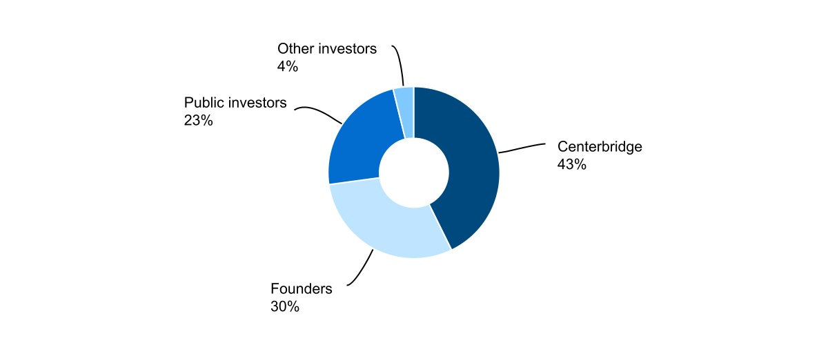
The percentage of ownership noted above is inclusive of only Class A and Class B common stock issued and outstanding. It does not include the Series A redeemable convertible preferred stock or the impact of any conversion of such, should a conversion occur. For more information on the Series A redeemable convertible preferred stock, please refer to Note 5 “Stockholders' Equity” of the Notes to Condensed Consolidated Financial Statements.
The Company implemented the Reverse Stock Split, which became effective on November 17, 2022. Please refer to Note 5 “Stockholders' Equity” of the Notes to Condensed Consolidated Financial Statements for more information on the Reverse Stock Split.
GoHealth, Inc. is subject to U.S. federal, state and local income taxes with respect to our allocable share of any taxable income of GHH, LLC and is taxed at the prevailing corporate tax rates. In addition to tax expenses, we also incur expenses related to our status as a public company, plus payment obligations under the Tax Receivable Agreement (“TRA”), which could be significant. We intend to cause GHH, LLC to make distributions to us in an amount sufficient to allow us to pay these expenses and fund any payments due under the TRA.

GoHealth, Inc. |  |  | 2023 Form 10-Q |  |  | 26

Results of Operations
The following is our consolidated results of operations for the three and six months ended June 30, 2023 and 2022:
 |  |  |  |  |  | Three months ended Jun. 30, |  |  |  |  |  |  |  |  |  |  |  | Six months ended Jun. 30,
(in thousands) |  |  |  |  |  | 2023 |  |  |  |  |  | 2022 |  |  |  |  |  | 2023 |  |  |  |  |  | 2022
Net revenues |  |  |  |  |  | 142,779 |  |  |  |  |  | 158,654 |  |  |  |  |  | 325,937 |  |  | — |  |  | 429,247
Operating expenses:
Revenue share |  |  |  |  |  | 36,422 |  |  |  |  |  | 51,074 |  |  |  |  |  | 81,884 |  |  |  |  |  | 118,997
Marketing and advertising |  |  |  |  |  | 39,269 |  |  |  |  |  | 44,714 |  |  |  |  |  | 85,012 |  |  |  |  |  | 128,747
Customer care and enrollment |  |  |  |  |  | 45,536 |  |  |  |  |  | 66,542 |  |  |  |  |  | 87,563 |  |  |  |  |  | 144,997
Technology |  |  |  |  |  | 10,511 |  |  |  |  |  | 10,749 |  |  |  |  |  | 20,054 |  |  |  |  |  | 23,508
General and administrative |  |  |  |  |  | 37,855 |  |  |  |  |  | 38,106 |  |  |  |  |  | 60,473 |  |  |  |  |  | 67,323
Amortization of intangible assets |  |  |  |  |  | 23,515 |  |  |  |  |  | 23,515 |  |  |  |  |  | 47,029 |  |  |  |  |  | 47,029
Operating lease impairment charges |  |  |  |  |  | 2,687 |  |  |  |  |  | 24,995 |  |  |  |  |  | 2,687 |  |  |  |  |  | 24,995
Total operating expenses |  |  |  |  |  | 195,795 |  |  |  |  |  | 259,695 |  |  |  |  |  | 384,702 |  |  | — |  |  | 555,596
Income (loss) from operations |  |  |  |  |  | (53,016) |  |  |  |  |  | (101,041) |  |  |  |  |  | (58,765) |  |  | — |  |  | (126,349)
Interest expense |  |  |  |  |  | 17,265 |  |  |  |  |  | 12,724 |  |  |  |  |  | 34,156 |  |  |  |  |  | 24,122
Other (income) expense, net |  |  |  |  |  | 21 |  |  |  |  |  | (13) |  |  |  |  |  | (32) |  |  |  |  |  | 50
Income (loss) before income taxes |  |  |  |  |  | (70,302) |  |  |  |  |  | (113,752) |  |  |  |  |  | (92,889) |  |  |  |  |  | (150,521)
Income tax expense (benefit) |  |  |  |  |  | (73) |  |  |  |  |  | — |  |  |  |  |  | (117) |  |  |  |  |  | 472
Net income (loss) |  |  |  |  |  | (70,229) |  |  |  |  |  | (113,752) |  |  |  |  |  | (92,772) |  |  |  |  |  | (150,993)
Net income (loss) attributable to non-controlling interests |  |  |  |  |  | (41,287) |  |  |  |  |  | (69,933) |  |  |  |  |  | (54,651) |  |  |  |  |  | (93,691)
Net income (loss) attributable to GoHealth, Inc. |  |  |  |  |  | $ | (28,942) |  |  |  |  | $ | (43,819) |  |  |  |  | $ | (38,121) |  |  |  |  | $ | (57,302)
Non-GAAP financial measures:
EBITDA |  |  |  |  |  | $ | (26,669) |  |  |  |  | $ | (74,617) |  |  |  |  | $ | (6,098) |  |  |  |  | $ | (74,040)
Adjusted EBITDA |  |  |  |  |  | $ | 788 |  |  |  |  | $ | (31,741) |  |  |  |  | $ | 29,566 |  |  |  |  | $ | (20,668)
Adjusted EBITDA margin |  |  |  |  |  | 0.6 |  | % |  |  |  | (20.0) |  | % |  |  |  | 9.1 |  | % |  |  |  | (4.8) |  | %
The following is our net revenues for the three and six months ended June 30, 2023 and 2022:
Net Revenues |  |  |  |  |  | Three months ended Jun. 30,
 |  |  |  |  |  | 2023 |  |  |  |  |  | 2022 |  |  |  |  |  | $ Change |  |  |  |  |  | % Change
 |  |  |  |  |  | $ | 142,779 |  |  |  |  | $ | 158,654 |  |  |  |  | $ | (15,875) |  |  |  |  | (10.0) |  | %
 |  |  |  |  |  | Six months ended Jun. 30,
 |  |  |  |  |  | 2023 |  |  |  |  |  | 2022 |  |  |  |  |  | $ Change |  |  |  |  |  | % Change
 |  |  |  |  |  | $ | 325,937 |  |  |  |  | $ | 429,247 |  |  |  |  | $ | (103,310) |  |  |  |  | (24.1) |  | %
The decrease for the three months ended June 30, 2023 compared to the prior year period was primarily attributable to a decrease in revenues associated with the strategic decision to exit our non-Encompass BPO services (services in which we dedicate certain agents to specific health plan partners and agencies outside of the Encompass model), to focus on our core business. The decrease was partially offset by a 4%, increase in Medicare revenue. The decrease for the six months ended June 30, 2023 compared to the prior year period was primarily attributable to a decrease in agent headcount and associated opportunities, which drove a 16% decrease in Medicare revenue, as well as a decrease in revenues associated with the strategic decision to exit our non-Encompass BPO services.
The following are our key components of operating expenses and results thereof for the three and six months ended June 30, 2023 and 2022:
Revenue share |  |  |  |  |  | Three months ended Jun. 30, |  |  |  |  |  |  |  |  |  |  |  |  |  |  |  |  |  |  |  |  |  |  |  | % of Net Revenues
 |  |  |  |  |  | 2023 |  |  |  |  |  | 2022 |  |  |  |  |  | $ Change |  |  |  |  |  | % Change |  |  |  |  |  | 2023 |  |  | 2022
 |  |  |  |  |  | $ | 36,422 |  |  |  |  | $ | 51,074 |  |  |  |  | $ | (14,652) |  |  |  |  | (28.7) |  | % |  |  |  | 25.5% |  |  | 32.2%
 |  |  |  |  |  | Six months ended Jun. 30, |  |  |  |  |  |  |  |  |  |  |  |  |  |  |  |  |  |  |  |  |  |  |  | % of Net Revenues
 |  |  |  |  |  | 2023 |  |  |  |  |  | 2022 |  |  |  |  |  | $ Change |  |  |  |  |  | % Change |  |  |  |  |  | 2023 |  |  | 2022
 |  |  |  |  |  | $ | 81,884 |  |  |  |  | $ | 118,997 |  |  |  |  | $ | (37,113) |  |  |  |  | (31.2) |  | % |  |  |  | 25.1% |  |  | 27.7%
GoHealth, Inc. |  |  | 2023 Form 10-Q |  |  | 27

The decrease for the three months ended June 30, 2023 compared to the prior year period was primarily attributable to declines in certain direct partner campaigns with revenue-sharing components. The decrease for the six months ended June 30, 2023 was primarily attributable to declines in certain direct partner campaigns with revenue-sharing components as well as a decrease in Submissions generated by our independent network of outsourced agents, which decreased the amount of expense we recognized pursuant to our revenue-sharing agreements.
Marketing and advertising expense |  |  |  |  |  | Three months ended Jun. 30, |  |  |  |  |  |  |  |  |  |  |  |  |  |  |  |  |  |  |  |  |  |  |  | % of Net Revenues
 |  |  |  |  |  | 2023 |  |  |  |  |  | 2022 |  |  |  |  |  | $ Change |  |  |  |  |  | % Change |  |  |  |  |  | 2023 |  |  | 2022
 |  |  |  |  |  | $ | 39,269 |  |  |  |  | $ | 44,714 |  |  |  |  | $ | (5,445) |  |  |  |  | (12.2) |  | % |  |  |  | 27.5% |  |  | 28.2%
 |  |  |  |  |  | Six months ended Jun. 30, |  |  |  |  |  |  |  |  |  |  |  |  |  |  |  |  |  |  |  |  |  |  |  | % of Net Revenues
 |  |  |  |  |  | 2023 |  |  |  |  |  | 2022 |  |  |  |  |  | $ Change |  |  |  |  |  | % Change |  |  |  |  |  | 2023 |  |  | 2022
 |  |  |  |  |  | $ | 85,012 |  |  |  |  | $ | 128,747 |  |  |  |  | $ | (43,735) |  |  |  |  | (34.0) |  | % |  |  |  | 26.1% |  |  | 30.0%
The decreases for both the three and six months ended June 30, 2023 compared to the prior year periods were primarily attributable to an intentional pullback on marketing and advertising spend as the Company focused on higher quality Submissions through targeted marketing.
Customer care and enrollment |  |  |  |  |  | Three months ended Jun. 30, |  |  |  |  |  |  |  |  |  |  |  |  |  |  |  |  |  |  |  |  |  |  |  | % of Net Revenues
 |  |  |  |  |  | 2023 |  |  |  |  |  | 2022 |  |  |  |  |  | $ Change |  |  |  |  |  | % Change |  |  |  |  |  | 2023 |  |  | 2022
 |  |  |  |  |  | $ | 45,536 |  |  |  |  | $ | 66,542 |  |  |  |  | $ | (21,006) |  |  |  |  | (31.6) |  | % |  |  |  | 31.9% |  |  | 41.9%
 |  |  |  |  |  | Six months ended Jun. 30, |  |  |  |  |  |  |  |  |  |  |  |  |  |  |  |  |  |  |  |  |  |  |  | % of Net Revenues
 |  |  |  |  |  | 2023 |  |  |  |  |  | 2022 |  |  |  |  |  | $ Change |  |  |  |  |  | % Change |  |  |  |  |  | 2023 |  |  | 2022
 |  |  |  |  |  | $ | 87,563 |  |  |  |  | $ | 144,997 |  |  |  |  | $ | (57,434) |  |  |  |  | (39.6) |  | % |  |  |  | 26.9% |  |  | 33.8%
The decrease for both the three and six months ended June 30, 2023 compared to the prior year periods were primarily attributable to reduced agent headcount as we focused on improving operational efficiencies.
Technology expense |  |  |  |  |  | Three months ended Jun. 30, |  |  |  |  |  |  |  |  |  |  |  |  |  |  |  |  |  |  |  |  |  |  |  | % of Net Revenues
 |  |  |  |  |  | 2023 |  |  |  |  |  | 2022 |  |  |  |  |  | $ Change |  |  |  |  |  | % Change |  |  |  |  |  | 2023 |  |  | 2022
 |  |  |  |  |  | $ | 10,511 |  |  |  |  | $ | 10,749 |  |  |  |  | $ | (238) |  |  |  |  | (2.2) |  | % |  |  |  | 7.4% |  |  | 6.8%
 |  |  |  |  |  | Six months ended Jun. 30, |  |  |  |  |  |  |  |  |  |  |  |  |  |  |  |  |  |  |  |  |  |  |  | % of Net Revenues
 |  |  |  |  |  | 2023 |  |  |  |  |  | 2022 |  |  |  |  |  | $ Change |  |  |  |  |  | % Change |  |  |  |  |  | 2023 |  |  | 2022
 |  |  |  |  |  | $ | 20,054 |  |  |  |  | $ | 23,508 |  |  |  |  | $ | (3,454) |  |  |  |  | (14.7) |  | % |  |  |  | 6.2% |  |  | 5.5%
The slight decrease for the three months ended June 30, 2023 compared to the prior year period was primarily attributable to a ramp up in hiring within the technology support functions as we continue to invest in and enhance our technology to drive overall efficiency in our model and improve the consumer experience, despite an overall reduced headcount compared to the prior year period. The decrease for the six months ended June 30, 2023 compared to the prior year period was primarily attributable to reduced headcount in our technology support functions.
General and administrative expense |  |  |  |  |  | Three months ended Jun. 30, |  |  |  |  |  |  |  |  |  |  |  |  |  |  |  |  |  |  |  |  |  |  |  | % of Net Revenues
 |  |  |  |  |  | 2023 |  |  |  |  |  | 2022 |  |  |  |  |  | $ Change |  |  |  |  |  | % Change |  |  |  |  |  | 2023 |  |  | 2022
 |  |  |  |  |  | 37,855 |  |  |  |  |  | 38,106 |  |  |  |  |  | $ | (251) |  |  |  |  | (0.7) |  | % |  |  |  | 26.5% |  |  | 24.0%
 |  |  |  |  |  | Six months ended Jun. 30, |  |  |  |  |  |  |  |  |  |  |  |  |  |  |  |  |  |  |  |  |  |  |  | % of Net Revenues
 |  |  |  |  |  | 2023 |  |  |  |  |  | 2022 |  |  |  |  |  | $ Change |  |  |  |  |  | % Change |  |  |  |  |  | 2023 |  |  | 2022
 |  |  |  |  |  | $ | 60,473 |  |  |  |  | $ | 67,323 |  |  |  |  | $ | (6,850) |  |  |  |  | (10.2) |  | % |  |  |  | 18.6% |  |  | 15.7%
The decrease for the three months ended June 30, 2023 compared to the prior year period was primarily attributable to reduced headcount in our corporate infrastructure, partially offset by an increase in expenses related to legal fees. The decrease for the six months ended June 30, 2023 compared to the prior year period was primarily attributable to reduced headcount in our corporate infrastructure as well as a reduction of expenses related to consulting and professional services, partially offset by an increase in expenses related to legal fees.
GoHealth, Inc. |  |  | 2023 Form 10-Q |  |  | 28

Amortization of intangible assets |  |  |  |  |  | Three months ended Jun. 30, |  |  |  |  |  |  |  |  |  |  |  |  |  |  |  |  |  |  |  |  |  |  |  | % of Net Revenues
 |  |  |  |  |  | 2023 |  |  |  |  |  | 2022 |  |  |  |  |  | $ Change |  |  |  |  |  | % Change |  |  |  |  |  | 2023 |  |  | 2022
 |  |  |  |  |  | 23,515 |  |  |  |  |  | 23,515 |  |  |  |  |  | $ | — |  |  |  |  | — |  | % |  |  |  | 16.5% |  |  | 14.8%
 |  |  |  |  |  | Six months ended Jun. 30, |  |  |  |  |  |  |  |  |  |  |  |  |  |  |  |  |  |  |  |  |  |  |  | % of Net Revenues
 |  |  |  |  |  | 2023 |  |  |  |  |  | 2022 |  |  |  |  |  | $ Change |  |  |  |  |  | % Change |  |  |  |  |  | 2023 |  |  | 2022
 |  |  |  |  |  | $ | 47,029 |  |  |  |  | $ | 47,029 |  |  |  |  | $ | — |  |  |  |  | — |  | % |  |  |  | 14.4% |  |  | 11.0%
Amortization of intangible assets expense was $23.5 million for both the three and six months ended June 30, 2023 and 2022, and relates to the amortization of developed technology and customer relationships.
Interest expense |  |  |  |  |  | Three months ended Jun. 30, |  |  |  |  |  |  |  |  |  |  |  |  |  |  |  |  |  |  |  |  |  |  |  | % of Net Revenues
 |  |  |  |  |  | 2023 |  |  |  |  |  | 2022 |  |  |  |  |  | $ Change |  |  |  |  |  | % Change |  |  |  |  |  | 2023 |  |  | 2022
 |  |  |  |  |  | 17,265 |  |  |  |  |  | 12,724 |  |  |  |  |  | $ | 4,541 |  |  |  |  | 35.7 |  | % |  |  |  | 12.1% |  |  | 8.0%
 |  |  |  |  |  | Six months ended Jun. 30, |  |  |  |  |  |  |  |  |  |  |  |  |  |  |  |  |  |  |  |  |  |  |  | % of Net Revenues
 |  |  |  |  |  | 2023 |  |  |  |  |  | 2022 |  |  |  |  |  | $ Change |  |  |  |  |  | % Change |  |  |  |  |  | 2023 |  |  | 2022
 |  |  |  |  |  | $ | 34,156 |  |  |  |  | $ | 24,122 |  |  |  |  | $ | 10,034 |  |  |  |  | 41.6 |  | % |  |  |  | 10.5% |  |  | 5.6%
The increases for both the three and six months ended June 30, 2023 compared to the prior year periods were primarily attributable to an increase in interest rates on our Term Loan Facilities.

Non-GAAP Financial Measures
We use supplemental measures of our performance that are derived from our consolidated financial information, but which are not presented in our Condensed Consolidated Financial Statements prepared in accordance with GAAP. These non-GAAP financial measures include net income (loss) before interest expense, income tax (benefit) expense and depreciation and amortization expense, or EBITDA; Adjusted EBITDA; Adjusted EBITDA margin; Sales per Submission; Cost per Submission and Adjusted Gross Margin per Submission. Adjusted EBITDA is the primary financial performance measure used by management to evaluate the business and monitor its results of operations. Sales per Submission, Cost per Submission and Adjusted Gross Margin per Submission are key operating metrics used by management to understand the Company’s underlying financial performance and trends.
Adjusted EBITDA represents EBITDA as further adjusted for certain items summarized in the table below. Adjusted EBITDA margin represents Adjusted EBITDA divided by net revenue. Sales per Submission represents Medicare Revenue per Submission as further adjusted for certain items summarized in the table within the Key Business Performance and Operating Metrics section below. Cost per Submission represents Operating Expense per Submission as further adjusted for certain items summarized in the table within the Key Business Performance and Operating Metrics section below. Adjusted Gross Margin represents Sales per Submission less Cost per Submission.
We use non-GAAP financial measures to supplement financial information presented on a GAAP basis. We believe that excluding certain items from our GAAP results allows management to better understand our consolidated financial performance from period to period and better project our future consolidated financial performance as forecasts are developed at a level of detail different from that used to prepare GAAP-based financial measures. Moreover, we believe these non-GAAP financial measures provide our stakeholders with useful information to help them evaluate our operating results by facilitating an enhanced understanding of our operating performance and enabling them to make more meaningful period to period comparisons. There are limitations to the use of the non-GAAP financial measures presented in this Quarterly Report on Form 10-Q. For example, our non-GAAP financial measures may not be comparable to similarly titled measures of other companies. Other companies, including companies in our industry, may calculate non-GAAP financial measures differently than we do, limiting the usefulness of those measures for comparative purposes.
The non-GAAP financial measures are not meant to be considered as indicators of performance in isolation from or as a substitute for net income (loss) prepared in accordance with GAAP, and should be read only in conjunction with financial information presented on a GAAP basis. Reconciliations of each of EBITDA, Adjusted EBITDA, Sales per Submission, Cost per Submission and Adjusted Gross Margin per Submission to its most directly comparable GAAP financial measure, are presented in the tables below in this Quarterly Report on Form 10-Q. We encourage you to review the reconciliations in conjunction with the presentation of the non-GAAP financial measures for each of the periods presented. In future periods, we may exclude similar items, may incur income and expenses similar to these excluded items and include other expenses, costs and non-recurring items.
GoHealth, Inc. |  |  | 2023 Form 10-Q |  |  | 29

The following table sets forth the reconciliations of GAAP net income (loss) to EBITDA and Adjusted EBITDA for the periods presented:
 |  |  |  |  |  | Three months ended Jun. 30, |  |  |  |  |  |  |  |  |  |  |  | Six months ended Jun. 30,
Non-GAAP Financial Measures |  |  |  |  |  | 2023 |  |  |  |  |  | 2022 |  |  |  |  |  | 2023 |  |  |  |  |  | 2022
Net revenues |  |  |  |  |  | $ | 142,779 |  |  |  |  | $ | 158,654 |  |  |  |  | $ | 325,937 |  |  |  |  | $ | 429,247
Net income (loss) |  |  |  |  |  | (70,229) |  |  |  |  |  | (113,752) |  |  |  |  |  | (92,772) |  |  |  |  |  | (150,993)
Interest expense |  |  |  |  |  | 17,265 |  |  |  |  |  | 12,724 |  |  |  |  |  | 34,156 |  |  |  |  |  | 24,122
Income tax expense (benefit) |  |  |  |  |  | (73) |  |  |  |  |  | — |  |  |  |  |  | (117) |  |  |  |  |  | 472
Depreciation and amortization expense |  |  |  |  |  | 26,368 |  |  |  |  |  | 26,411 |  |  |  |  |  | 52,635 |  |  |  |  |  | 52,359
EBITDA |  |  |  |  |  | (26,669) |  |  |  |  |  | (74,617) |  |  |  |  |  | (6,098) |  |  |  |  |  | (74,040)
Share-based compensation expense (1) |  |  |  |  |  | 10,120 |  |  |  |  |  | 14,257 |  |  |  |  |  | 16,704 |  |  |  |  |  | 19,412
Legal fees (2) |  |  |  |  |  | 12,730 |  |  |  |  |  | — |  |  |  |  |  | 14,353 |  |  |  |  |  | —
Operating lease impairment charges (3) |  |  |  |  |  | 2,687 |  |  |  |  |  | 24,995 |  |  |  |  |  | 2,687 |  |  |  |  |  | 24,995
Severance costs (4) |  |  |  |  |  | 1,920 |  |  |  |  |  | 3,624 |  |  |  |  |  | 1,920 |  |  |  |  |  | 5,015
Professional services (5) |  |  |  |  |  | — |  |  |  |  |  | — |  |  |  |  |  | — |  |  |  |  |  | 3,950
Adjusted EBITDA |  |  |  |  |  | $ | 788 |  |  |  |  | $ | (31,741) |  |  |  |  | $ | 29,566 |  |  |  |  | $ | (20,668)
Adjusted EBITDA Margin |  |  |  |  |  | 0.6 |  | % |  |  |  | (20.0) |  | % |  |  |  | 9.1 |  | % |  |  |  | (4.8) |  | %

(1)Represents non-cash share-based compensation expense relating to equity awards, as well share-based compensation expense relating to liability classified awards that will be settled in cash.
(2)Represents non-routine legal fees and accruals unrelated to our core operations.
(3)Represents operating lease impairment charges, reducing the carrying value of the associated ROU assets and leasehold improvements to the estimated fair values.
(4)Represents costs associated with the termination of executive employment and associated fees unrelated to restructuring activities.
(5)Represents costs associated with non-recurring consulting fees and other professional services.

Adjusted EBITDA |  |  |  |  |  | Three months ended Jun. 30, |  |  |  |  |  |  |  |  |  |  |  |  |  |  |  |  |  |  |  |  |  |  |  | % of Net Revenues
 |  |  |  |  |  | 2023 |  |  |  |  |  | 2022 |  |  |  |  |  | $ Change |  |  |  |  |  | % Change |  |  |  |  |  | 2023 |  |  |  |  |  | 2022
 |  |  |  |  |  | $ | 788 |  |  |  |  | $ | (31,741) |  |  |  |  | $ | 32,529 |  |  |  |  | (102.5) |  | % |  |  |  | 0.6 |  | % |  |  |  | (20.0) |  | %
 |  |  |  |  |  | Six months ended Jun. 30, |  |  |  |  |  |  |  |  |  |  |  |  |  |  |  |  |  |  |  |  |  |  |  | % of Net Revenues
 |  |  |  |  |  | 2023 |  |  |  |  |  | 2022 |  |  |  |  |  | $ Change |  |  |  |  |  | % Change |  |  |  |  |  | 2023 |  |  |  |  |  | 2022
 |  |  |  |  |  | $ | 29,566 |  |  |  |  | $ | (20,668) |  |  |  |  | $ | 50,234 |  |  |  |  | (243.1) |  | % |  |  |  | 9.1 |  | % |  |  |  | (4.8) |  | %
The increases for both the three and six months ended June 30, 2023 compared to the prior year periods were primarily due to our focus on driving high-quality Medicare services for our beneficiaries through the Encompass operating model. Our improved operating efficiencies were enabled by reduced headcount, targeted marketing, and enhancements in our proprietary technology.

Key Business Performance and Operating Metrics
In addition to traditional financial metrics, we rely upon certain business and operating metrics to evaluate our business performance and facilitate our operations. Below are the most relevant business and operating metrics, besides EBITDA and Adjusted EBITDA, for our single operating and reportable segment.
The following tables set forth the reconciliations of Medicare Revenue per Submission, Operating Expense per Submission, and Gross Margin per Submission to Sales per Submission, Cost Per Submission, and Adjusted Gross Margin per Submission for the periods indicated (unaudited):
GoHealth, Inc. |  |  | 2023 Form 10-Q |  |  | 30

 |  |  |  |  |  | Three months ended Jun. 30, |  |  |  |  |  |  |  |  |  |  |  | Six months ended Jun. 30,
 |  |  |  |  |  | 2023 |  |  |  |  |  | 2022 |  |  |  |  |  | 2023 |  |  |  |  |  | 2022
Sales per Submission
Medicare Revenue per Submission |  |  |  |  |  | $ | 852 |  |  |  |  | $ | 865 |  |  |  |  | $ | 819 |  |  |  |  | $ | 879
Lookback Adjustments reported during the indicated periods1 |  |  |  |  |  | — |  |  |  |  |  | 20 |  |  |  |  |  | — |  |  |  |  |  | 14
Sales per Submission |  |  |  |  |  | $ | 852 |  |  |  |  | $ | 885 |  |  |  |  | $ | 819 |  |  |  |  | $ | 893
Cost per Submission
Operating Expense per Submission |  |  |  |  |  | $ | 1,202 |  |  |  |  | $ | 1,677 |  |  |  |  | $ | 1,022 |  |  |  |  | $ | 1,337
Indirect operating expenses2 |  |  |  |  |  | (458) |  |  |  |  |  | (629) |  |  |  |  |  | (346) |  |  |  |  |  | (392)
Lookback Adjustments reported during the indicated periods1 |  |  |  |  |  | — |  |  |  |  |  | 6 |  |  |  |  |  | — |  |  |  |  |  | 4
Exit of non-Encompass BPO Services |  |  |  |  |  | (14) |  |  |  |  |  | (127) |  |  |  |  |  | (21) |  |  |  |  |  | (114)
Share-based compensation expense3 |  |  |  |  |  | (5) |  |  |  |  |  | (5) |  |  |  |  |  | (4) |  |  |  |  |  | (5)
Cost per Submission |  |  |  |  |  | $ | 725 |  |  |  |  | $ | 922 |  |  |  |  | $ | 651 |  |  |  |  | $ | 830
Gross Margin per Submission4 |  |  |  |  |  | $ | (350) |  |  |  |  | $ | (812) |  |  |  |  | $ | (203) |  |  |  |  | $ | (458)
Adjusted Gross Margin per Submission5 |  |  |  |  |  | $ | 127 |  |  |  |  | $ | (37) |  |  |  |  | $ | 168 |  |  |  |  | $ | 63

(1)Excludes the impact of Lookback Adjustments on non-Encompass BPO Services.
(2)Indirect operating expenses include technology and general and administrative expenses, inclusive of associated share-based compensation expense, as well as amortization of intangible assets and operating lease impairment charges.
(3)Shared-based compensation expense included within marketing and advertising expenses and customer care and enrollment expenses.
(4)Medicare Revenue per Submission less Operating Expense per Submission.
(5)Sales per Submission less Cost per Submission.

Submissions
Submissions are counted when an individual either (i) completes an application with our licensed agent that is submitted to the health plan partner and subsequently approved by the health plan partner during the indicated period, excluding applications through our non-Encompass BPO Services or (ii) is transferred by our agent to the health plan partner through the Encompass marketplace during the indicated period. Not all Submissions will go into effect, as some individuals may fail to enroll or once enrolled may switch out of a policy within the disenrollment period during the first 90 days of the policy.
The following table presents the number of Submissions for the periods presented:
Submissions |  |  |  |  |  | Three months ended Jun. 30,
 |  |  |  |  |  | 2023 |  |  |  |  |  | 2022 |  |  |  |  |  | Change |  |  |  |  |  | % Change
 |  |  |  |  |  | 162,837 |  |  |  |  |  | 154,893 |  |  |  |  |  | $ | 7,944 |  |  |  |  | 5.1 |  | %
 |  |  |  |  |  | Six months ended Jun. 30,
 |  |  |  |  |  | 2023 |  |  |  |  |  | 2022 |  |  |  |  |  | Change |  |  |  |  |  | % Change
 |  |  |  |  |  | $ | 376,482 |  |  |  |  | 415,559 |  |  |  |  |  | $ | (39,077) |  |  |  |  | (9.4) |  | %
The increase for the three months ended June 30, 2023 was attributable to an increase in opportunities resulting from our focus on higher quality Submissions through targeted marketing. The decrease for the six months ended June 30, 2023 compared to the prior year period was primarily driven by a decrease in agent headcount and associated opportunities resulting from our strategic focus on driving high-quality Medicare services and operational efficiencies.
Sales Per Submission
Sales per Submission represents (x) the sum of (i) aggregate commissions estimated to be collected over the estimated life of all commissionable Submissions for the relevant period based on multiple factors, including but not limited to, contracted commission rates, health plan partner mix and expected policy persistency with applied constraints, excluding revenue adjustments recorded in the period, but relating to performance obligations satisfied in prior periods, (ii) Encompass revenue, and (iii) partner marketing and enrollment services, divided by (y) the number of Submissions for such period, as reported above. Aggregate commissions is equal to the sum of the commission revenue due upon the initial sale of a policy, and when applicable, an estimate of future renewal commissions per commissionable Submissions, and this figure excludes commissions through our non-Encompass BPO Services. The estimate of the future renewal commissions is determined by using the contracted renewal commission rates constrained by a persistency-adjusted renewal period. The persistency-adjusted renewal period is determined based on our historical experience and available industry and health plan partner historical data. Persistency-adjustments allow us to estimate renewal revenue only to the extent probable that a material reversal in revenue would not be expected to occur. These factors may result in varying values from period to period. Sales per Submission represents revenues only from policies sold during the period, but excludes policies originally submitted in prior periods.
GoHealth, Inc. |  |  | 2023 Form 10-Q |  |  | 31

The following table presents the Sales per Submission for the periods presented:
Sales Per Submission |  |  |  |  |  | Three months ended Jun. 30,
 |  |  |  |  |  | 2023 |  |  |  |  |  | 2022 |  |  |  |  |  | $ Change |  |  |  |  |  | % Change
 |  |  |  |  |  | $ | 852 |  |  |  |  | $ | 885 |  |  |  |  | $ | (33) |  |  |  |  | (3.7) |  | %
 |  |  |  |  |  | Six months ended Jun. 30,
 |  |  |  |  |  | 2023 |  |  |  |  |  | 2022 |  |  |  |  |  | $ Change |  |  |  |  |  | % Change
 |  |  |  |  |  | $ | 819 |  |  |  |  | $ | 893 |  |  |  |  | $ | (74) |  |  |  |  | (8.3) |  | %
The decreases for both the three and six months ended June 30, 2023 compared to the prior year periods were primarily driven by a change in health plan partner mix, as well as an increased constraint on agency commission, partially offset by improved effectuation.
Sales/Cost of Submission and Cost Per Submission
Sales/Cost of Submission represents (x) the sum of (i) aggregate commissions estimated to be collected over the estimated life of all commissionable Submissions for the relevant period based on multiple factors, including but not limited to, contracted commission rates, health plan partner mix and expected policy persistency with applied constraints, excluding revenue adjustments recorded in the period, but relating to performance obligations satisfied in prior periods, and such expenses related to our non-Encompass BPO Services, (ii) Encompass revenue, and (iii) partner marketing and enrollment services, divided by (y) the aggregate cost to convert prospects into Submissions (comprised of revenue share, marketing and advertising expenses and customer care and enrollment expenses, excluding associated share-based compensation expense, the impact of revenue adjustments recorded in the period, but relating to performance obligations satisfied in prior periods, and such expenses related to our non-Encompass BPO Services) for such period. The estimate of the future renewal commissions is determined by using the contracted renewal commission rates constrained by a persistency-adjusted renewal period. The persistency-adjusted renewal period is determined based on our historical experience and available industry and health plan partner historical data. Persistency adjustments allow us to estimate renewal revenue only to the extent probable that a material reversal in revenue would not be expected to occur. These factors may result in varying values from period to period. See “Risk Factors—Risks Related to Our Business—Our operating results may be adversely impacted by factors that impact our estimate of LTV” in the 2022 Form 10-K..
Cost per Submission refers to (x) the aggregate cost to convert prospects into Submissions during a particular period (comprised of revenue share, marketing and advertising expenses, and customer care and enrollment expenses, excluding associated share-based compensation expense, the impact of revenue adjustments recorded in the period, but relating to performance obligations satisfied in prior periods, and such expenses related to our non-Encompass BPO Services) divided by (y) either (i) a completed application with our licensed agent that is submitted to the insurance health plan partner and subsequently approved by the health plan partner during the indicated period, excluding applications through our non-Encompass BPO Services or (ii) a transfer by our agent to the health plan partner through the Encompass marketplace during the indicated period.
The following are our Sales/Cost of Submission, Cost of Submission (in thousands) and Cost Per Submission for the three and six months ended June 30, 2023 and 2022.
 |  |  |  |  |  | Three months ended Jun. 30, |  |  |  |  |  |  |  |  |  |  |  |  |  |  | Six months ended Jun. 30,
 |  |  |  |  |  | 2023 |  |  |  |  |  | 2022 |  |  |  |  |  |  |  |  | 2023 |  |  |  |  |  | 2022
Sales/Cost of Submission |  |  |  |  |  | 1.2 |  |  |  |  |  | 1.0 |  |  |  |  |  |  |  |  | 1.3 |  |  |  |  |  | 1.1
Cost of Submission |  |  |  |  |  | $ | 118,080 |  |  |  |  | $ | 142,853 |  |  |  |  |  |  |  | 245,250 |  |  |  |  |  | $ | 345,103
Cost per Submission |  |  |  |  |  | $ | 725 |  |  |  |  | $ | 922 |  |  |  |  |  |  |  | 651 |  |  |  |  |  | $ | 830
The increases in Sales/Cost of Submission for both the three and six months ended June 30, 2023 compared to the prior year periods and the decreases in Cost of Submission and Cost per Submission for both the three and six months ended June 30, 2023 compared to the prior year periods were primarily attributable to our strategic shift towards the Encompass operating model with improved operating efficiencies.

Liquidity and Capital Resources
Overview
Our liquidity needs primarily include working capital and debt service requirements. At June 30, 2023, cash and cash equivalents totaled $25.4 million. We believe that our current sources of liquidity, which include cash and cash equivalents and funds available under the Credit Facilities, as described further below, will be sufficient to meet our projected operating and debt service requirements for at least the next 12 months. During the year ended December 31, 2022, we raised $50.0 million through
GoHealth, Inc. |  |  | 2023 Form 10-Q |  |  | 32

the issuance and sale of Series A redeemable convertible preferred stock. Short-term liquidity needs will primarily be funded through the Revolving Credit Facilities, as described further below, if necessary. As of June 30, 2023, the Company had no amounts outstanding under the Revolving Credit Facilities and had a remaining capacity of $200.0 million.To the extent that our current liquidity is insufficient to fund future activities, we may need to raise additional funds, which may include the sale of equity securities or through debt financing arrangements. The incurrence of additional debt financing would result in debt service obligations, and any future instruments governing such debt could provide for operating and financing covenants that could restrict our operations.
The following table presents a summary of cash flows for the six months ended June 30, 2023 and 2022:
 |  |  |  |  |  | Six months ended Jun. 30,
(in thousands) |  |  |  |  |  | 2023 |  |  |  |  |  | 2022
Net cash provided by (used in) operating activities |  |  |  |  |  | $ | 31,340 |  |  |  |  | $ | 6,377
Net cash provided by (used in) investing activities |  |  |  |  |  | (4,660) |  |  |  |  |  | (9,658)
Net cash provided by (used in) financing activities |  |  |  |  |  | (17,826) |  |  |  |  |  | (4,463)
Operating Activities
Cash provided by operating activities primarily consists of net income (loss) adjusted for certain non-cash items including share-based compensation, depreciation and amortization, amortization of intangible assets, amortization of debt discount and issuance costs, non-cash lease expense and the effect of changes in working capital and other activities.
Collection of commissions receivable depends upon the timing of the receipt of commission payments. If there were to be a delay in receiving a commission payment from a health plan partner within a quarter, the operating cash flows for that quarter could be adversely impacted.
A significant portion of marketing and advertising expense is driven by the number of qualified prospects required to generate the Submissions. Marketing and advertising costs are expensed and generally paid as incurred and since commission revenue is recognized upon approval of a submission but commission payments are paid to us over time, there are working capital requirements to fund the upfront cost of acquiring new policies.
Net cash provided by operating activities was $31.3 million for the six months ended June 30, 2023, compared to $6.4 million for the six months ended June 30, 2022. The $25.0 million increase was driven by a decrease in net loss of $58.2 million, an increase in accounts payable of $19.4 million, a decrease in commissions receivable of $17.9 million, an increase in accrued liabilities of $16.4 million, and a decrease in prepaid expenses and other assets of $4.7 million, partially offset by a decrease in deferred revenue of $25.0 million, a decrease in commissions payable of $24.3 million, a decrease in operating lease impairment charges of $22.3 million, an increase in accounts receivable of $9.9 million, and other adjustments for non-cash items of $10.2 million.
Investing Activities
Net cash used in investing activities decreased to $4.7 million for the six months ended June 30, 2023, from $9.7 million for the six months ended June 30, 2022. The decrease was primarily driven by a decrease in capitalized internal-use software related to new technology, software, and systems, as well as a decrease in purchases of property and equipment.
Financing Activities
Net cash used in financing activities was $17.8 million for the six months ended June 30, 2023, up from $4.5 million for the six months ended June 30, 2022. The increase was primarily driven by a $12.8 million increase in the repayment of borrowings.
Credit Facilities
Term Loan Facilities
As of June 30, 2023, the Company had a principal amount of $110.4 million, $296.3 million and $96.1 million outstanding under the Incremental Term Loan Facility, the 2021 Incremental Term Loans, and the 2021-2 Incremental Term Loans, respectively. The Term Loan Facilities’ effective interest rates were 12.8% at June 30, 2023.
The Term Loan Facilities are payable in quarterly installments in the principal amount of 0.25% of the original principal amount. The remaining unpaid balance on the Term Loan Facilities, together with all accrued and unpaid interest thereon, is due and payable on or prior to September 13, 2025.
GoHealth, Inc. |  |  | 2023 Form 10-Q |  |  | 33

Mandatory Prepayments
During the second quarter of 2023, the Company made a $14.0 million mandatory prepayment to its lenders in connection with fiscal year 2022. Principal repayment obligations are reduced by the amount of any prepayment, and as such, the $14.0 million prepayment during the second quarter of 2023 satisfied the Company’s principal repayment obligations through the second quarter of 2025. No other mandatory prepayments have been required or made during the three and six months ended June 30, 2023. See Note 4, “Long-Term Debt,” to the Condensed Consolidated Financial Statements in this Quarterly Report on Form 10-Q for additional information regarding the Company’s mandatory prepayment.
Revolving Credit Facilities
The Company collectively refers to the Revolving Credit Facility, the Incremental Revolving Credit Facilities, and the Incremental No. 4 Revolving Credit Facility as the “Revolving Credit Facilities”. The Revolving Credit Facilities are separated into two classes of revolving commitments consisting of Class A Revolving Commitments in the amount of $30.0 million and Class B Revolving Commitments in the amount of $170.0 million.
The Company had no amounts outstanding under the Class A Revolving Credit Facilities and Class B Revolving Credit Facilities as of both June 30, 2023 and December 31, 2022. The Revolving Credit Facilities have a remaining capacity of $200.0 million in the aggregate as of June 30, 2023.
Outstanding borrowings under the Revolving Credit Facilities do not amortize and are due and payable on September 13, 2024.
See Note 4, “Long-Term Debt,” to the Condensed Consolidated Financial Statements in this Quarterly Report on Form 10-Q for additional information regarding the Company’s Credit Facilities.

Recent Accounting Pronouncements
For a discussion of new accounting pronouncements recently adopted and not yet adopted, see Part 1, Note 1, “Description Of Business And Significant Accounting Policies,” to the Condensed Consolidated Financial Statements included elsewhere in this Quarterly Report on Form 10-Q.

Critical Accounting Policies and Estimates
The preparation of our Condensed Consolidated Financial Statements in conformity with GAAP requires management to make estimates and assumptions that affect the reported amounts of revenues, expenses, assets, and liabilities and disclosure of contingent assets and liabilities in our financial statements. We regularly assess these estimates; however, actual amounts could differ from those estimates. The most significant items involving management’s estimates include estimates of revenue recognition, commissions receivable, and commissions payable. The impact of changes in estimates is recorded in the period in which they become known.
An accounting policy is considered to be critical if the nature of the estimates or assumptions is material due to the levels of subjectivity and judgment necessary to account for highly uncertain matters or the susceptibility of such matters to change, and the effect of the estimates and assumptions on financial condition or operating performance. The accounting policies we believe to reflect our more significant estimates, judgments and assumptions that are most critical to understanding and evaluating our reported financial results are: (1) revenue recognition and commissions receivable, (2) share-based compensation, (3) intangible assets, (4) impairment of operating lease ROU assets, (5) income taxes and (5) liabilities pursuant to tax receivable agreements (“TRAs”).
Our critical accounting policies are described under the heading “Management’s Discussion and Analysis of Financial Condition and Results of Operations—Critical Accounting Policies” in our 2022 Form 10-K. During the three and six months ended June 30, 2023, there were no material changes to our critical accounting policies from those discussed in our 2022 Form 10-K.

ITEM 3. QUANTITATIVE AND QUALITATIVE DISCLOSURES ABOUT MARKET RISK.
As a smaller reporting company, we are not required to include disclosure under this item.

ITEM 4. CONTROLS AND PROCEDURES
Limitations on Effectiveness of Controls and Procedures
In designing and evaluating our disclosure controls and procedures, management recognizes that any controls and procedures, no matter how well designed and operated, can provide only reasonable assurance of achieving the desired control objectives. In addition, the design of disclosure controls and procedures must reflect the fact that there are resource constraints and that
GoHealth, Inc. |  |  | 2023 Form 10-Q |  |  | 34

management is required to apply judgment in evaluating the benefits of possible controls and procedures relative to their costs. Also, projections of any evaluation of effectiveness to future periods are subject to the risk that controls may become inadequate because of changes in conditions, or that the degree of compliance with the policies or procedures may deteriorate. Because of the inherent limitations in a cost-effective control system, misstatements due to error or fraud may occur and not be detected.
Evaluation of Disclosure Controls and Procedures
Our management, with the participation of our chief executive officer and chief financial officer, evaluated, as of the end of the period covered by this Quarterly Report on Form 10-Q, the effectiveness of our disclosure controls and procedures (as defined in Rules 13a-15(e) and 15d-15(e) under the Exchange Act). Based on that evaluation, our chief executive officer and chief financial officer concluded that our disclosure controls and procedures were not effective as of June 30, 2023, because of the material weakness in internal control over financial reporting described below. A material weakness is a deficiency, or a combination of deficiencies, in internal control over financial reporting, such that there is a reasonable possibility that a material misstatement of our annual or interim financial statements will not be prevented or detected on a timely basis.

Based on this evaluation and those criteria, our management concluded that our internal control over financial reporting was ineffective as of June 30, 2023, because we identified a material weakness related to the ineffective design and operation of process level controls that addressed the completeness and accuracy of key financial data utilized in the recognition of commission revenue, including estimating the total constrained lifetime value of commission revenue and the related revenue share and balance sheet accounts, and the Company did not retain sufficient contemporaneous documentation to demonstrate the operation of review controls over commission revenue at a sufficient level of precision. We reviewed the results of our management’s assessment with our Audit Committee.

We continue to strengthen our internal control over financial reporting and are committed to ensuring that such controls are designed and operating effectively. We will be implementing process and control improvements to address the above material weakness that include, but are not limited to: i) establishing specific management review procedures to ensure completeness and accuracy of key financial data utilized in the recognition of commission revenue and the contemporaneous documentation of such reviews, ii) providing additional training related to validating the accuracy of data used in key review controls and the level of documentation required, and iii) investing in our corporate infrastructure to ensure adequate technology and resources to support our financial reporting process and internal control framework. During the second quarter of 2022, the Company hired a Chief Actuarial Officer who has been partnering with our data scientists, to bring additional experience and oversight of commission revenue and its related process and controls.

When fully implemented and operational, we believe the measures described above will remediate the control deficiencies that have led to the material weakness.

Notwithstanding the existence of the material weakness as described above, our management has concluded that the Condensed Consolidated Financial Statements included in this Quarterly Report on Form 10-Q fairly present, in all material respects, our financial position, results of operations and cash flows as of the dates, and for the periods presented, in conformity with U.S. GAAP.

Changes in Internal Control over Financial Reporting
Except for the material weakness identified above, there were no changes in our internal controls over financial reporting identified in management’s evaluation pursuant to Rules 13a-15(d) or 15d-15(d) of the Exchange Act during the quarter ended June 30, 2023 that materially affected, or are reasonably likely to materially affect, our internal control over financial reporting.

GoHealth, Inc. |  |  | 2023 Form 10-Q |  |  | 35

PART II - Other Information

ITEM 1. LEGAL PROCEEDINGS.
Refer to Note 11, “Commitments And Contingencies,” of the Notes to the Condensed Consolidated Financial Statements for information about legal proceedings.

ITEM 1A. RISK FACTORS.

Our business could be adversely affected as a result of uncertainty regarding proposals or other actions taken by stockholders related to the consideration of a possible future transaction.

In May 2023, our Board of Directors received an unsolicited proposal from a group of buyers that includes Centerbridge and the Founders to acquire all of the outstanding shares of Class A common stock and LLC Interests not already owned by the potential buyers. In August 2023, we announced that, following careful review and consideration with its independent financial and legal advisors, a Special Committee of the Board of the Directors rejected this proposal. Addressing the unsolicited proposal, similar future proposals and any other actions by stockholders or others relating to a potential transaction involving ownership of the Company could interfere with our ability to execute our strategic plans, make it more difficult to attract and retain qualified executives and employees, cause management distraction, require us to utilize more resources than anticipated towards review of strategic alternatives and result in the loss of potential business opportunities, any of which could have a material negative impact on the Company. In addition, our business and operations may be harmed to the extent that our customers, suppliers and others believe that we cannot effectively compete in the marketplace without completing a transaction, or there is customer, supplier or employee uncertainty surrounding the future direction of the product and service offerings and our strategy on a continued basis. There can be no assurance that any transaction will be completed now or in the future.

Further, the unsolicited proposal, similar future proposals and any actual or perceived actions by our stockholders or others relating to a potential transaction involving the Company may cause significant fluctuations in our stock price based upon temporary or speculative market perceptions or other factors that do not necessarily reflect the Company’s underlying fundamentals and prospects.

ITEM 2. UNREGISTERED SALES OF EQUITY SECURITIES AND USE OF PROCEEDS.
None.

ITEM 3. DEFAULTS UPON SENIOR SECURITIES.
None.

ITEM 4. MINE SAFETY DISCLOSURES.
Not applicable.

ITEM 5. OTHER INFORMATION.

None.

GoHealth, Inc. |  |  | 2023 Form 10-Q |  |  | 36

ITEM 6. EXHIBITS.
Exhibit Index
 |  |  |  |  |  |  |  |  |  |  |  | Incorporated by Reference
Exhibit  Number |  |  |  |  |  | Description |  |  |  |  |  | Form |  |  |  |  |  | File No. |  |  |  |  |  | Exhibit |  |  |  |  |  | Filing  Date |  |  |  |  |  | Filed/  Furnished  Herewith
3.1 |  |  |  |  |  | Amended and Restated Certificate of Incorporation of GoHealth, Inc. |  |  |  |  |  | 10-Q |  |  |  |  |  | 001-39390 |  |  |  |  |  | 3.1 |  |  |  |  |  | 8/20/2020
3.2 |  |  |  |  |  | Amended and Restated Bylaws of GoHealth, Inc. |  |  |  |  |  | 10-Q |  |  |  |  |  | 001-39390 |  |  |  |  |  | 3.2 |  |  |  |  |  | 8/20/2020
3.3 |  |  |  |  |  | Certificate of Designations of Series A Convertible Perpetual Preferred Stock of GoHealth, Inc. |  |  |  |  |  | 8-K |  |  |  |  |  | 001-39390 |  |  |  |  |  | 3.1 |  |  |  |  |  | 9/26/2022
3.4 |  |  |  |  |  | Certificate of Designations of Series A-1 Convertible Non-Voting Perpetual Preferred Stock of GoHealth, Inc. |  |  |  |  |  | 8-K |  |  |  |  |  | 001-39390 |  |  |  |  |  | 3.2 |  |  |  |  |  | 9/26/2022
4.1 |  |  |  |  |  | Specimen Stock Certificate evidencing the shares of Class A common stock. |  |  |  |  |  | S-1 |  |  |  |  |  | 333-239287 |  |  |  |  |  | 4.1 |  |  |  |  |  | 6/19/2020
4.2 |  |  |  |  |  | Description of Registrant’s Securities |  |  |  |  |  | 10-K |  |  |  |  |  | 01-39390 |  |  |  |  |  | 4.2 |  |  |  |  |  | 3/16/2021
10.1# |  |  |  |  |  | Separation and General Release Agreement, dated July 28, 2023, by and between Shane Cruz, Norvax, LLC, GoHealth, Inc., and GoHealth Holdings, LLC |  |  |  |  |  |  |  |  |  |  |  |  |  |  |  |  |  |  |  |  |  |  |  |  |  |  |  |  |  | *
31.1 |  |  |  |  |  | Certification of Chief Executive Officer pursuant to Exchange Act Rule 13a-14(a). |  |  |  |  |  |  |  |  |  |  |  |  |  |  |  |  |  |  |  |  |  |  |  |  |  |  |  |  |  | *
31.2 |  |  |  |  |  | Certification of Chief Financial Officer pursuant to Exchange Act Rule 13a-14(a). |  |  |  |  |  |  |  |  |  |  |  |  |  |  |  |  |  |  |  |  |  |  |  |  |  |  |  |  |  | *
32.1 |  |  |  |  |  | Certification of Principal Executive Officer pursuant to 18 U.S.C. Section 1350. |  |  |  |  |  |  |  |  |  |  |  |  |  |  |  |  |  |  |  |  |  |  |  |  |  |  |  |  |  | **
32.2 |  |  |  |  |  | Certification of Chief Financial Officer pursuant to 18 U.S.C. Section 1350. |  |  |  |  |  |  |  |  |  |  |  |  |  |  |  |  |  |  |  |  |  |  |  |  |  |  |  |  |  | **
101.INS |  |  |  |  |  | Inline XBRL Instance Document – the instance document does not appear in the Interactive Data File because its XBRL tags are embedded within the Inline XBRL document. |  |  |  |  |  |  |  |  |  |  |  |  |  |  |  |  |  |  |  |  |  |  |  |  |  |  |  |  |  | *
101.SCH |  |  |  |  |  | Inline XBRL Taxonomy Extension Schema Document |  |  |  |  |  |  |  |  |  |  |  |  |  |  |  |  |  |  |  |  |  |  |  |  |  |  |  |  |  | *
101.CAL |  |  |  |  |  | Inline XBRL Taxonomy Extension Calculation Linkbase Document |  |  |  |  |  |  |  |  |  |  |  |  |  |  |  |  |  |  |  |  |  |  |  |  |  |  |  |  |  | *
101.DEF |  |  |  |  |  | Inline XBRL Taxonomy Extension Definition Linkbase Document |  |  |  |  |  |  |  |  |  |  |  |  |  |  |  |  |  |  |  |  |  |  |  |  |  |  |  |  |  | *
101.LAB |  |  |  |  |  | Inline XBRL Taxonomy Extension Label Linkbase Document |  |  |  |  |  |  |  |  |  |  |  |  |  |  |  |  |  |  |  |  |  |  |  |  |  |  |  |  |  | *
101.PRE |  |  |  |  |  | Inline XBRL Taxonomy Extension Presentation Linkbase Document |  |  |  |  |  |  |  |  |  |  |  |  |  |  |  |  |  |  |  |  |  |  |  |  |  |  |  |  |  | *
104 |  |  |  |  |  | Cover Page Interactive Data File (formatted as Inline XBRL and contained in Exhibit 101) |  |  |  |  |  |  |  |  |  |  |  |  |  |  |  |  |  |  |  |  |  |  |  |  |  |  |  |  |  | *
* Filed herewith.
** Furnished herewith.
# Indicates management contract or compensatory plan.

GoHealth, Inc. |  |  | 2023 Form 10-Q |  |  | 37

SIGNATURES
Pursuant to the requirements of Section 13 or 15(d) of the Securities Exchange Act of 1934, the Registrant has duly caused this report to be signed on its behalf by the undersigned thereunto duly authorized.
GoHealth, Inc.
(Registrant)
Date: |  |  | August 10, 2023 |  |  | By: |  |  | /s/ Vijay Kotte
Vijay Kotte
Chief Executive Officer
(Principal Executive Officer)
Date: |  |  | August 10, 2023 |  |  | By: |  |  | /s/ Jason Schulz
Jason Schulz
Chief Financial Officer
(Principal Financial and Accounting Officer)
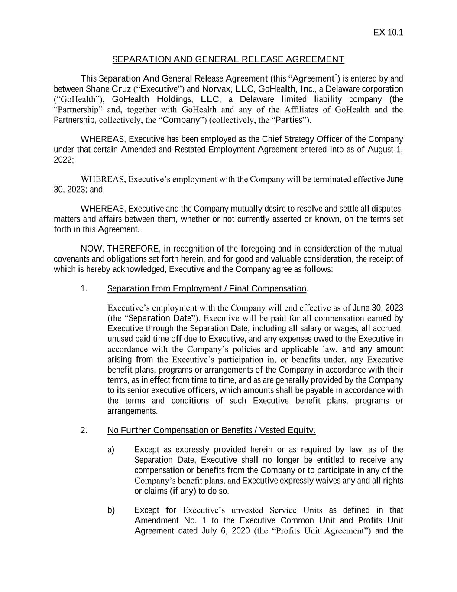
GoHealth, Inc. |  |  | 2023 Form 10-Q |  |  | 38

EX 10.1 SEPARATION AND GENERAL RELEASE AGREEMENT This Separation And General Release Agreement (this “Agreement”) is entered by and between Shane Cruz (“Executive”) and Norvax, LLC, GoHealth, Inc., a Delaware corporation (“GoHealth”), GoHealth Holdings, LLC, a Delaware limited liability company (the “Partnership” and, together with GoHealth and any of the Affiliates of GoHealth and the Partnership, collectively, the “Company”) (collectively, the “Parties”). WHEREAS, Executive has been employed as the Chief Strategy Officer of the Company under that certain Amended and Restated Employment Agreement entered into as of August 1, 2022; WHEREAS, Executive’s employment with the Company will be terminated effective June 30, 2023; and WHEREAS, Executive and the Company mutually desire to resolve and settle all disputes, matters and affairs between them, whether or not currently asserted or known, on the terms set forth in this Agreement. NOW, THEREFORE, in recognition of the foregoing and in consideration of the mutual covenants and obligations set forth herein, and for good and valuable consideration, the receipt of which is hereby acknowledged, Executive and the Company agree as follows: 1. Separation from Employment / Final Compensation. Executive’s employment with the Company will end effective as of June 30, 2023 (the “Separation Date”). Executive will be paid for all compensation earned by Executive through the Separation Date, including all salary or wages, all accrued, unused paid time off due to Executive, and any expenses owed to the Executive in accordance with the Company’s policies and applicable law, and any amount arising from the Executive’s participation in, or benefits under, any Executive benefit plans, programs or arrangements of the Company in accordance with their terms, as in effect from time to time, and as are generally provided by the Company to its senior executive officers, which amounts shall be payable in accordance with the terms and conditions of such Executive benefit plans, programs or arrangements. 2. No Further Compensation or Benefits / Vested Equity. a) Except as expressly provided herein or as required by law, as of the Separation Date, Executive shall no longer be entitled to receive any compensation or benefits from the Company or to participate in any of the Company’s benefit plans, and Executive expressly waives any and all rights or claims (if any) to do so. b) Except for Executive’s unvested Service Units as defined in that Amendment No. 1 to the Executive Common Unit and Profits Unit Agreement dated July 6, 2020 (the “Profits Unit Agreement”) and the

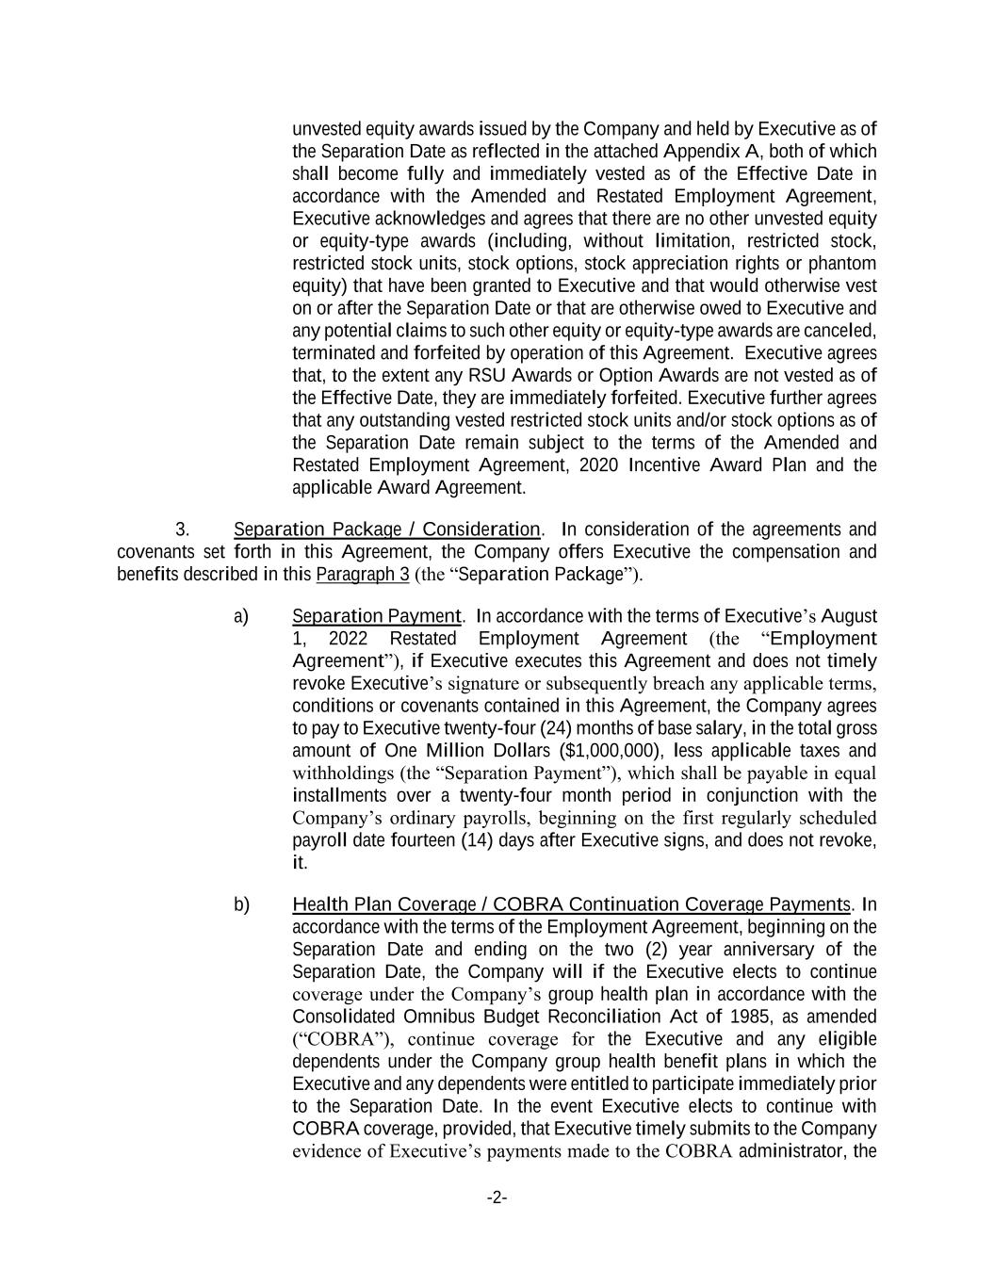
-2- unvested equity awards issued by the Company and held by Executive as of the Separation Date as reflected in the attached Appendix A, both of which shall become fully and immediately vested as of the Effective Date in accordance with the Amended and Restated Employment Agreement, Executive acknowledges and agrees that there are no other unvested equity or equity-type awards (including, without limitation, restricted stock, restricted stock units, stock options, stock appreciation rights or phantom equity) that have been granted to Executive and that would otherwise vest on or after the Separation Date or that are otherwise owed to Executive and any potential claims to such other equity or equity-type awards are canceled, terminated and forfeited by operation of this Agreement. Executive agrees that, to the extent any RSU Awards or Option Awards are not vested as of the Effective Date, they are immediately forfeited. Executive further agrees that any outstanding vested restricted stock units and/or stock options as of the Separation Date remain subject to the terms of the Amended and Restated Employment Agreement, 2020 Incentive Award Plan and the applicable Award Agreement. 3. Separation Package / Consideration. In consideration of the agreements and covenants set forth in this Agreement, the Company offers Executive the compensation and benefits described in this Paragraph 3 (the “Separation Package”). a) Separation Payment. In accordance with the terms of Executive’s August 1, 2022 Restated Employment Agreement (the “Employment Agreement”), if Executive executes this Agreement and does not timely revoke Executive’s signature or subsequently breach any applicable terms, conditions or covenants contained in this Agreement, the Company agrees to pay to Executive twenty-four (24) months of base salary, in the total gross amount of One Million Dollars ($1,000,000), less applicable taxes and withholdings (the “Separation Payment”), which shall be payable in equal installments over a twenty-four month period in conjunction with the Company’s ordinary payrolls, beginning on the first regularly scheduled payroll date fourteen (14) days after Executive signs, and does not revoke, it. b) Health Plan Coverage / COBRA Continuation Coverage Payments. In accordance with the terms of the Employment Agreement, beginning on the Separation Date and ending on the two (2) year anniversary of the Separation Date, the Company will if the Executive elects to continue coverage under the Company’s group health plan in accordance with the Consolidated Omnibus Budget Reconciliation Act of 1985, as amended (“COBRA”), continue coverage for the Executive and any eligible dependents under the Company group health benefit plans in which the Executive and any dependents were entitled to participate immediately prior to the Separation Date. In the event Executive elects to continue with COBRA coverage, provided, that Executive timely submits to the Company evidence of Executive’s payments made to the COBRA administrator, the

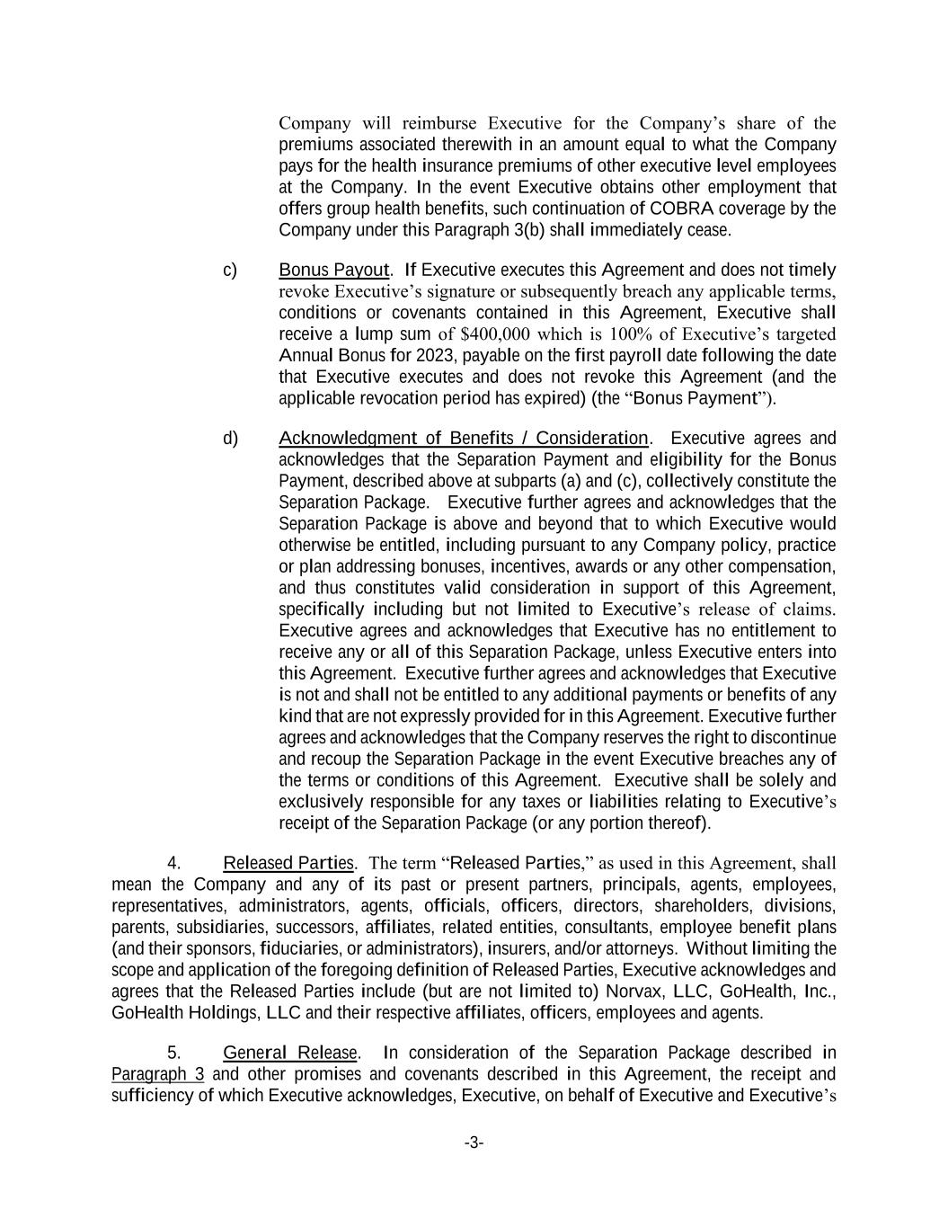
-3- Company will reimburse Executive for the Company’s share of the premiums associated therewith in an amount equal to what the Company pays for the health insurance premiums of other executive level employees at the Company. In the event Executive obtains other employment that offers group health benefits, such continuation of COBRA coverage by the Company under this Paragraph 3(b) shall immediately cease. c) Bonus Payout. If Executive executes this Agreement and does not timely revoke Executive’s signature or subsequently breach any applicable terms, conditions or covenants contained in this Agreement, Executive shall receive a lump sum of $400,000 which is 100% of Executive’s targeted Annual Bonus for 2023, payable on the first payroll date following the date that Executive executes and does not revoke this Agreement (and the applicable revocation period has expired) (the “Bonus Payment”). d) Acknowledgment of Benefits / Consideration. Executive agrees and acknowledges that the Separation Payment and eligibility for the Bonus Payment, described above at subparts (a) and (c), collectively constitute the Separation Package. Executive further agrees and acknowledges that the Separation Package is above and beyond that to which Executive would otherwise be entitled, including pursuant to any Company policy, practice or plan addressing bonuses, incentives, awards or any other compensation, and thus constitutes valid consideration in support of this Agreement, specifically including but not limited to Executive’s release of claims. Executive agrees and acknowledges that Executive has no entitlement to receive any or all of this Separation Package, unless Executive enters into this Agreement. Executive further agrees and acknowledges that Executive is not and shall not be entitled to any additional payments or benefits of any kind that are not expressly provided for in this Agreement. Executive further agrees and acknowledges that the Company reserves the right to discontinue and recoup the Separation Package in the event Executive breaches any of the terms or conditions of this Agreement. Executive shall be solely and exclusively responsible for any taxes or liabilities relating to Executive’s receipt of the Separation Package (or any portion thereof). 4. Released Parties. The term “Released Parties,” as used in this Agreement, shall mean the Company and any of its past or present partners, principals, agents, employees, representatives, administrators, agents, officials, officers, directors, shareholders, divisions, parents, subsidiaries, successors, affiliates, related entities, consultants, employee benefit plans (and their sponsors, fiduciaries, or administrators), insurers, and/or attorneys. Without limiting the scope and application of the foregoing definition of Released Parties, Executive acknowledges and agrees that the Released Parties include (but are not limited to) Norvax, LLC, GoHealth, Inc., GoHealth Holdings, LLC and their respective affiliates, officers, employees and agents. 5. General Release. In consideration of the Separation Package described in Paragraph 3 and other promises and covenants described in this Agreement, the receipt and sufficiency of which Executive acknowledges, Executive, on behalf of Executive and Executive’s

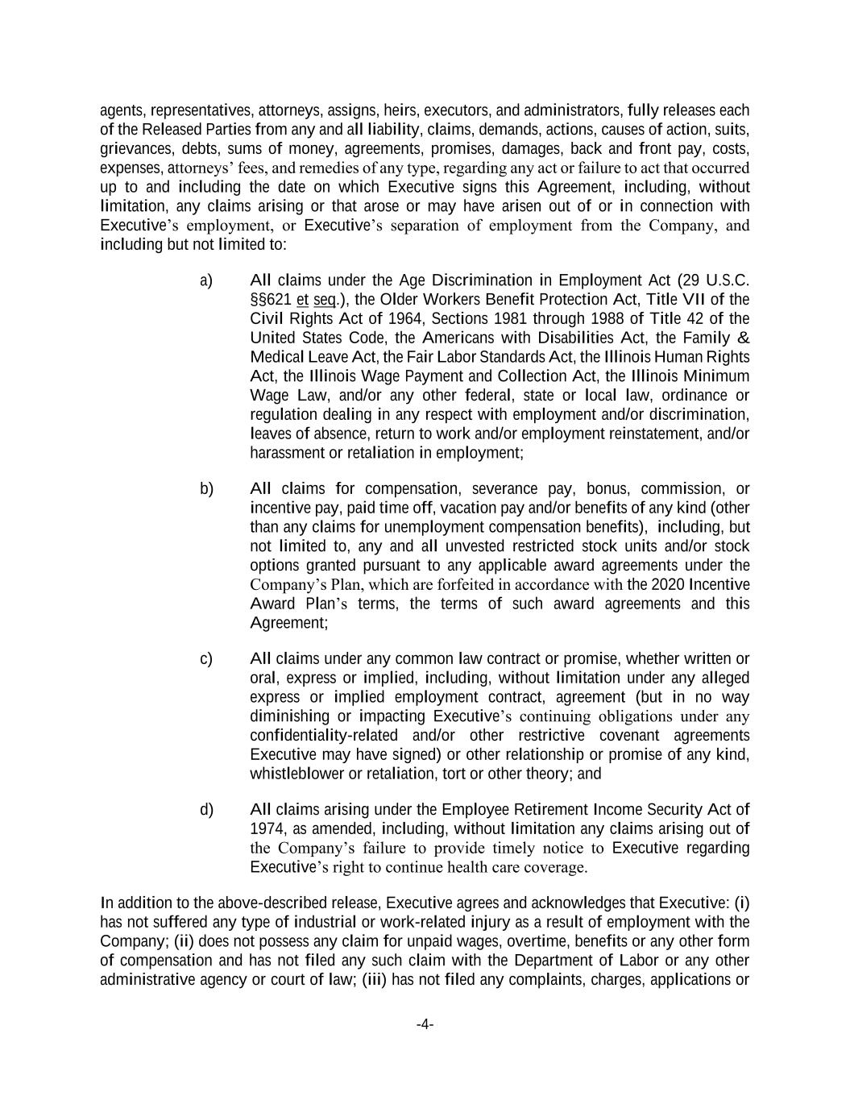
-4- agents, representatives, attorneys, assigns, heirs, executors, and administrators, fully releases each of the Released Parties from any and all liability, claims, demands, actions, causes of action, suits, grievances, debts, sums of money, agreements, promises, damages, back and front pay, costs, expenses, attorneys’ fees, and remedies of any type, regarding any act or failure to act that occurred up to and including the date on which Executive signs this Agreement, including, without limitation, any claims arising or that arose or may have arisen out of or in connection with Executive’s employment, or Executive’s separation of employment from the Company, and including but not limited to: a) All claims under the Age Discrimination in Employment Act (29 U.S.C. §§621 et seq.), the Older Workers Benefit Protection Act, Title VII of the Civil Rights Act of 1964, Sections 1981 through 1988 of Title 42 of the United States Code, the Americans with Disabilities Act, the Family & Medical Leave Act, the Fair Labor Standards Act, the Illinois Human Rights Act, the Illinois Wage Payment and Collection Act, the Illinois Minimum Wage Law, and/or any other federal, state or local law, ordinance or regulation dealing in any respect with employment and/or discrimination, leaves of absence, return to work and/or employment reinstatement, and/or harassment or retaliation in employment; b) All claims for compensation, severance pay, bonus, commission, or incentive pay, paid time off, vacation pay and/or benefits of any kind (other than any claims for unemployment compensation benefits), including, but not limited to, any and all unvested restricted stock units and/or stock options granted pursuant to any applicable award agreements under the Company’s Plan, which are forfeited in accordance with the 2020 Incentive Award Plan’s terms, the terms of such award agreements and this Agreement; c) All claims under any common law contract or promise, whether written or oral, express or implied, including, without limitation under any alleged express or implied employment contract, agreement (but in no way diminishing or impacting Executive’s continuing obligations under any confidentiality-related and/or other restrictive covenant agreements Executive may have signed) or other relationship or promise of any kind, whistleblower or retaliation, tort or other theory; and d) All claims arising under the Employee Retirement Income Security Act of 1974, as amended, including, without limitation any claims arising out of the Company’s failure to provide timely notice to Executive regarding Executive’s right to continue health care coverage. In addition to the above-described release, Executive agrees and acknowledges that Executive: (i) has not suffered any type of industrial or work-related injury as a result of employment with the Company; (ii) does not possess any claim for unpaid wages, overtime, benefits or any other form of compensation and has not filed any such claim with the Department of Labor or any other administrative agency or court of law; (iii) has not filed any complaints, charges, applications or

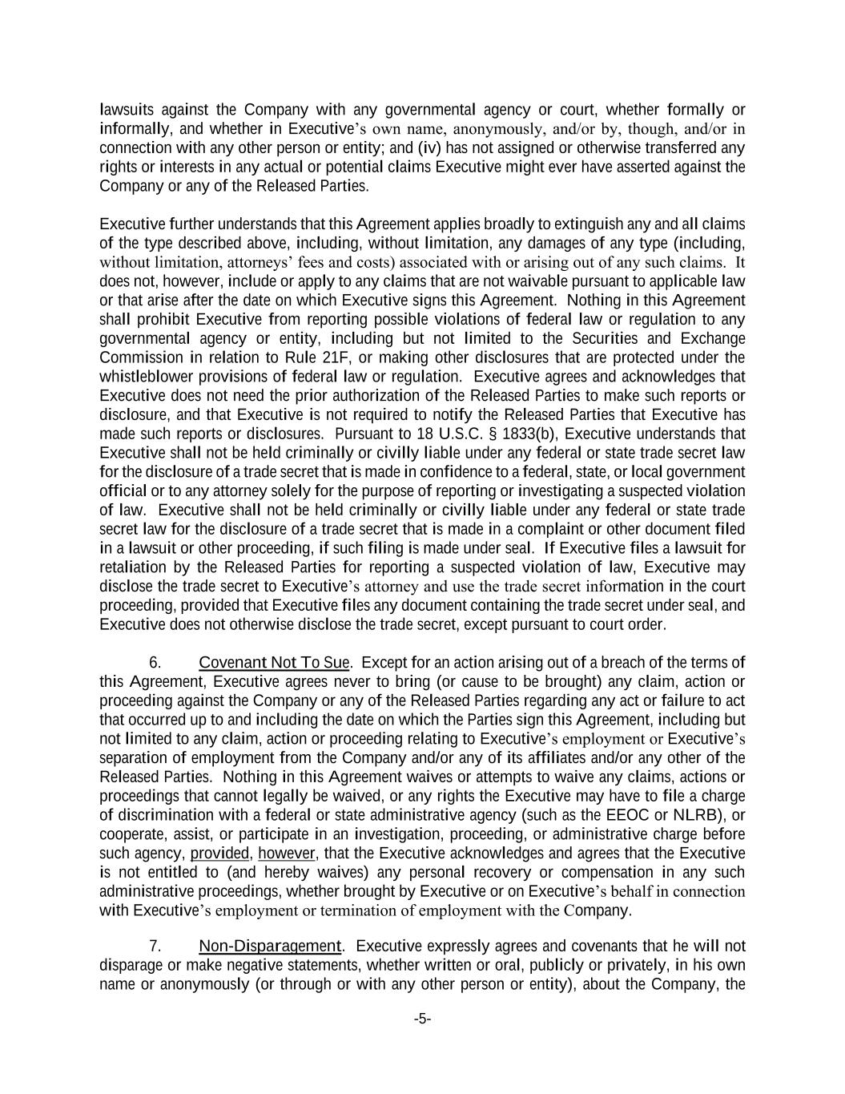
-5- lawsuits against the Company with any governmental agency or court, whether formally or informally, and whether in Executive’s own name, anonymously, and/or by, though, and/or in connection with any other person or entity; and (iv) has not assigned or otherwise transferred any rights or interests in any actual or potential claims Executive might ever have asserted against the Company or any of the Released Parties. Executive further understands that this Agreement applies broadly to extinguish any and all claims of the type described above, including, without limitation, any damages of any type (including, without limitation, attorneys’ fees and costs) associated with or arising out of any such claims. It does not, however, include or apply to any claims that are not waivable pursuant to applicable law or that arise after the date on which Executive signs this Agreement. Nothing in this Agreement shall prohibit Executive from reporting possible violations of federal law or regulation to any governmental agency or entity, including but not limited to the Securities and Exchange Commission in relation to Rule 21F, or making other disclosures that are protected under the whistleblower provisions of federal law or regulation. Executive agrees and acknowledges that Executive does not need the prior authorization of the Released Parties to make such reports or disclosure, and that Executive is not required to notify the Released Parties that Executive has made such reports or disclosures. Pursuant to 18 U.S.C. § 1833(b), Executive understands that Executive shall not be held criminally or civilly liable under any federal or state trade secret law for the disclosure of a trade secret that is made in confidence to a federal, state, or local government official or to any attorney solely for the purpose of reporting or investigating a suspected violation of law. Executive shall not be held criminally or civilly liable under any federal or state trade secret law for the disclosure of a trade secret that is made in a complaint or other document filed in a lawsuit or other proceeding, if such filing is made under seal. If Executive files a lawsuit for retaliation by the Released Parties for reporting a suspected violation of law, Executive may disclose the trade secret to Executive’s attorney and use the trade secret information in the court proceeding, provided that Executive files any document containing the trade secret under seal, and Executive does not otherwise disclose the trade secret, except pursuant to court order. 6. Covenant Not To Sue. Except for an action arising out of a breach of the terms of this Agreement, Executive agrees never to bring (or cause to be brought) any claim, action or proceeding against the Company or any of the Released Parties regarding any act or failure to act that occurred up to and including the date on which the Parties sign this Agreement, including but not limited to any claim, action or proceeding relating to Executive’s employment or Executive’s separation of employment from the Company and/or any of its affiliates and/or any other of the Released Parties. Nothing in this Agreement waives or attempts to waive any claims, actions or proceedings that cannot legally be waived, or any rights the Executive may have to file a charge of discrimination with a federal or state administrative agency (such as the EEOC or NLRB), or cooperate, assist, or participate in an investigation, proceeding, or administrative charge before such agency, provided, however, that the Executive acknowledges and agrees that the Executive is not entitled to (and hereby waives) any personal recovery or compensation in any such administrative proceedings, whether brought by Executive or on Executive’s behalf in connection with Executive’s employment or termination of employment with the Company. 7. Non-Disparagement. Executive expressly agrees and covenants that he will not disparage or make negative statements, whether written or oral, publicly or privately, in his own name or anonymously (or through or with any other person or entity), about the Company, the

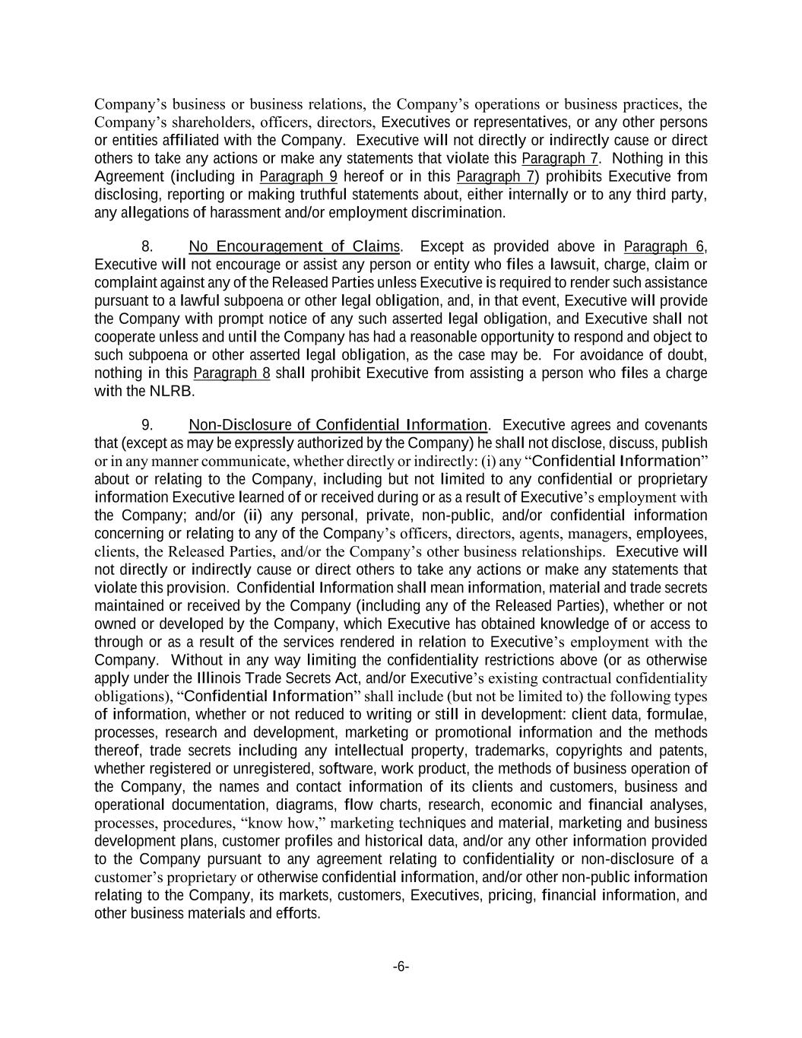
-6- Company’s business or business relations, the Company’s operations or business practices, the Company’s shareholders, officers, directors, Executives or representatives, or any other persons or entities affiliated with the Company. Executive will not directly or indirectly cause or direct others to take any actions or make any statements that violate this Paragraph 7. Nothing in this Agreement (including in Paragraph 9 hereof or in this Paragraph 7) prohibits Executive from disclosing, reporting or making truthful statements about, either internally or to any third party, any allegations of harassment and/or employment discrimination. 8. No Encouragement of Claims. Except as provided above in Paragraph 6, Executive will not encourage or assist any person or entity who files a lawsuit, charge, claim or complaint against any of the Released Parties unless Executive is required to render such assistance pursuant to a lawful subpoena or other legal obligation, and, in that event, Executive will provide the Company with prompt notice of any such asserted legal obligation, and Executive shall not cooperate unless and until the Company has had a reasonable opportunity to respond and object to such subpoena or other asserted legal obligation, as the case may be. For avoidance of doubt, nothing in this Paragraph 8 shall prohibit Executive from assisting a person who files a charge with the NLRB. 9. Non-Disclosure of Confidential Information. Executive agrees and covenants that (except as may be expressly authorized by the Company) he shall not disclose, discuss, publish or in any manner communicate, whether directly or indirectly: (i) any “Confidential Information” about or relating to the Company, including but not limited to any confidential or proprietary information Executive learned of or received during or as a result of Executive’s employment with the Company; and/or (ii) any personal, private, non-public, and/or confidential information concerning or relating to any of the Company’s officers, directors, agents, managers, employees, clients, the Released Parties, and/or the Company’s other business relationships. Executive will not directly or indirectly cause or direct others to take any actions or make any statements that violate this provision. Confidential Information shall mean information, material and trade secrets maintained or received by the Company (including any of the Released Parties), whether or not owned or developed by the Company, which Executive has obtained knowledge of or access to through or as a result of the services rendered in relation to Executive’s employment with the Company. Without in any way limiting the confidentiality restrictions above (or as otherwise apply under the Illinois Trade Secrets Act, and/or Executive’s existing contractual confidentiality obligations), “Confidential Information” shall include (but not be limited to) the following types of information, whether or not reduced to writing or still in development: client data, formulae, processes, research and development, marketing or promotional information and the methods thereof, trade secrets including any intellectual property, trademarks, copyrights and patents, whether registered or unregistered, software, work product, the methods of business operation of the Company, the names and contact information of its clients and customers, business and operational documentation, diagrams, flow charts, research, economic and financial analyses, processes, procedures, “know how,” marketing techniques and material, marketing and business development plans, customer profiles and historical data, and/or any other information provided to the Company pursuant to any agreement relating to confidentiality or non-disclosure of a customer’s proprietary or otherwise confidential information, and/or other non-public information relating to the Company, its markets, customers, Executives, pricing, financial information, and other business materials and efforts.

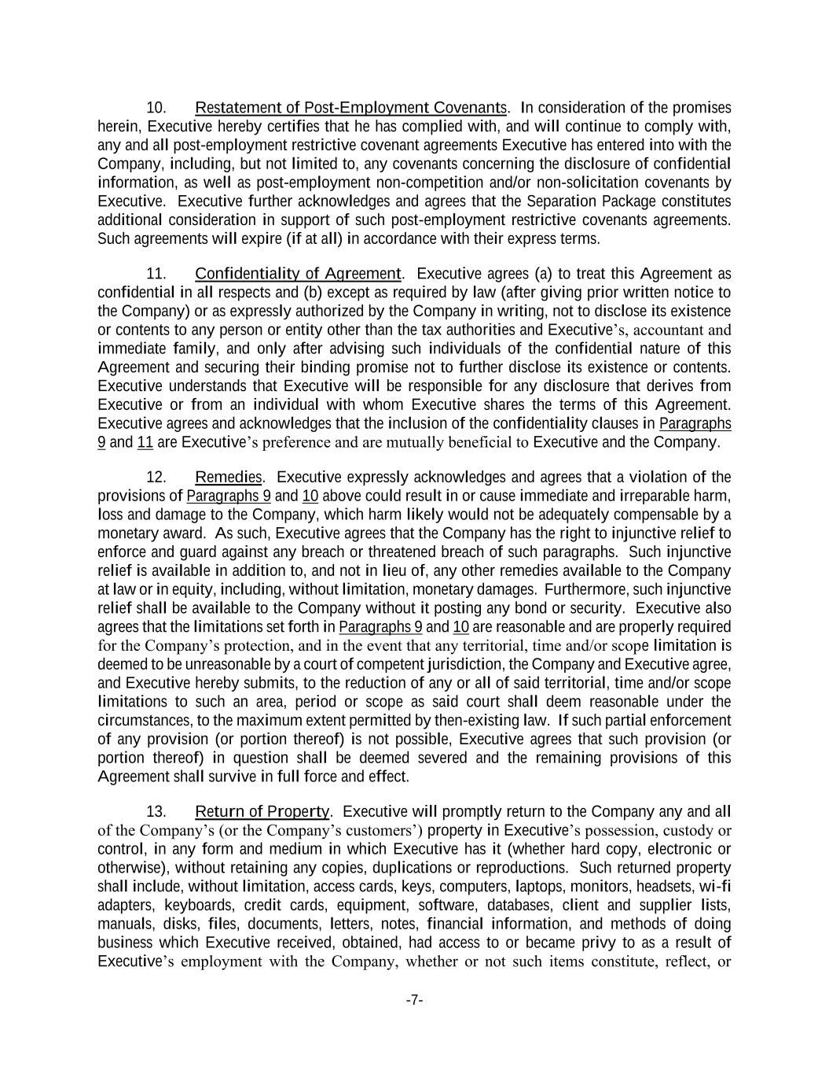
-7- 10. Restatement of Post-Employment Covenants. In consideration of the promises herein, Executive hereby certifies that he has complied with, and will continue to comply with, any and all post-employment restrictive covenant agreements Executive has entered into with the Company, including, but not limited to, any covenants concerning the disclosure of confidential information, as well as post-employment non-competition and/or non-solicitation covenants by Executive. Executive further acknowledges and agrees that the Separation Package constitutes additional consideration in support of such post-employment restrictive covenants agreements. Such agreements will expire (if at all) in accordance with their express terms. 11. Confidentiality of Agreement. Executive agrees (a) to treat this Agreement as confidential in all respects and (b) except as required by law (after giving prior written notice to the Company) or as expressly authorized by the Company in writing, not to disclose its existence or contents to any person or entity other than the tax authorities and Executive’s, accountant and immediate family, and only after advising such individuals of the confidential nature of this Agreement and securing their binding promise not to further disclose its existence or contents. Executive understands that Executive will be responsible for any disclosure that derives from Executive or from an individual with whom Executive shares the terms of this Agreement. Executive agrees and acknowledges that the inclusion of the confidentiality clauses in Paragraphs 9 and 11 are Executive’s preference and are mutually beneficial to Executive and the Company. 12. Remedies. Executive expressly acknowledges and agrees that a violation of the provisions of Paragraphs 9 and 10 above could result in or cause immediate and irreparable harm, loss and damage to the Company, which harm likely would not be adequately compensable by a monetary award. As such, Executive agrees that the Company has the right to injunctive relief to enforce and guard against any breach or threatened breach of such paragraphs. Such injunctive relief is available in addition to, and not in lieu of, any other remedies available to the Company at law or in equity, including, without limitation, monetary damages. Furthermore, such injunctive relief shall be available to the Company without it posting any bond or security. Executive also agrees that the limitations set forth in Paragraphs 9 and 10 are reasonable and are properly required for the Company’s protection, and in the event that any territorial, time and/or scope limitation is deemed to be unreasonable by a court of competent jurisdiction, the Company and Executive agree, and Executive hereby submits, to the reduction of any or all of said territorial, time and/or scope limitations to such an area, period or scope as said court shall deem reasonable under the circumstances, to the maximum extent permitted by then-existing law. If such partial enforcement of any provision (or portion thereof) is not possible, Executive agrees that such provision (or portion thereof) in question shall be deemed severed and the remaining provisions of this Agreement shall survive in full force and effect. 13. Return of Property. Executive will promptly return to the Company any and all of the Company’s (or the Company’s customers’) property in Executive’s possession, custody or control, in any form and medium in which Executive has it (whether hard copy, electronic or otherwise), without retaining any copies, duplications or reproductions. Such returned property shall include, without limitation, access cards, keys, computers, laptops, monitors, headsets, wi-fi adapters, keyboards, credit cards, equipment, software, databases, client and supplier lists, manuals, disks, files, documents, letters, notes, financial information, and methods of doing business which Executive received, obtained, had access to or became privy to as a result of Executive’s employment with the Company, whether or not such items constitute, reflect, or

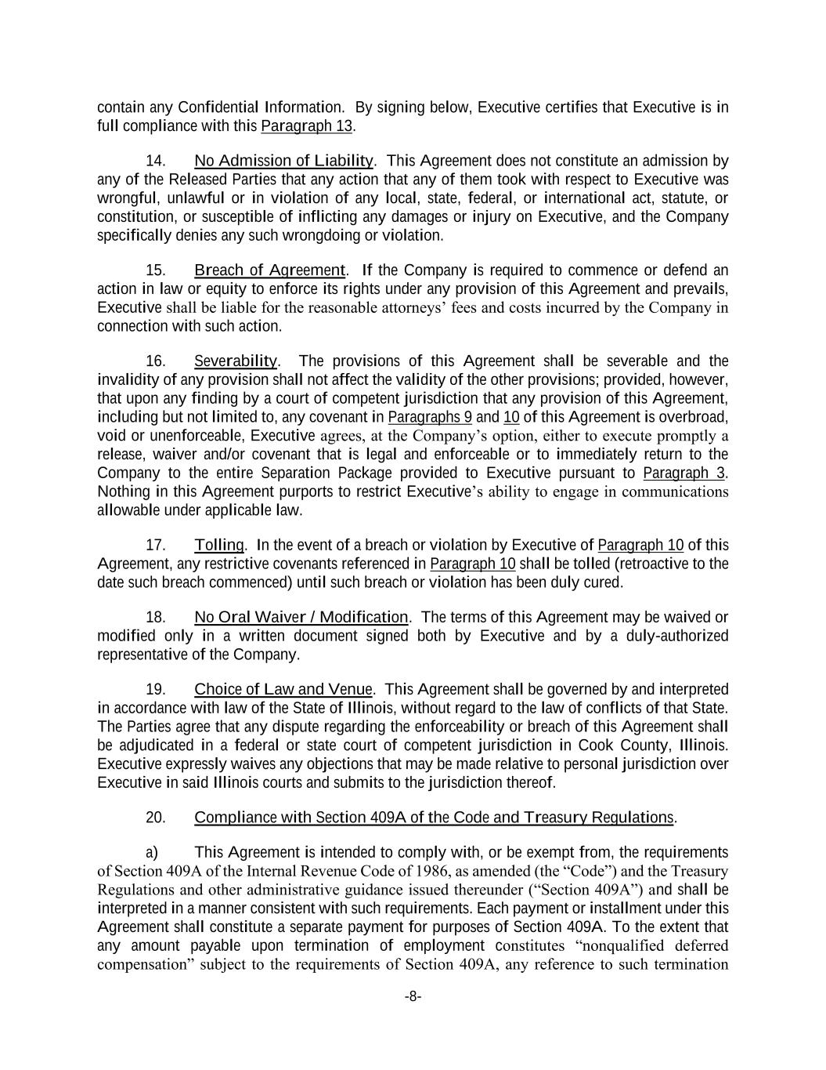
-8- contain any Confidential Information. By signing below, Executive certifies that Executive is in full compliance with this Paragraph 13. 14. No Admission of Liability. This Agreement does not constitute an admission by any of the Released Parties that any action that any of them took with respect to Executive was wrongful, unlawful or in violation of any local, state, federal, or international act, statute, or constitution, or susceptible of inflicting any damages or injury on Executive, and the Company specifically denies any such wrongdoing or violation. 15. Breach of Agreement. If the Company is required to commence or defend an action in law or equity to enforce its rights under any provision of this Agreement and prevails, Executive shall be liable for the reasonable attorneys’ fees and costs incurred by the Company in connection with such action. 16. Severability. The provisions of this Agreement shall be severable and the invalidity of any provision shall not affect the validity of the other provisions; provided, however, that upon any finding by a court of competent jurisdiction that any provision of this Agreement, including but not limited to, any covenant in Paragraphs 9 and 10 of this Agreement is overbroad, void or unenforceable, Executive agrees, at the Company’s option, either to execute promptly a release, waiver and/or covenant that is legal and enforceable or to immediately return to the Company to the entire Separation Package provided to Executive pursuant to Paragraph 3. Nothing in this Agreement purports to restrict Executive’s ability to engage in communications allowable under applicable law. 17. Tolling. In the event of a breach or violation by Executive of Paragraph 10 of this Agreement, any restrictive covenants referenced in Paragraph 10 shall be tolled (retroactive to the date such breach commenced) until such breach or violation has been duly cured. 18. No Oral Waiver / Modification. The terms of this Agreement may be waived or modified only in a written document signed both by Executive and by a duly-authorized representative of the Company. 19. Choice of Law and Venue. This Agreement shall be governed by and interpreted in accordance with law of the State of Illinois, without regard to the law of conflicts of that State. The Parties agree that any dispute regarding the enforceability or breach of this Agreement shall be adjudicated in a federal or state court of competent jurisdiction in Cook County, Illinois. Executive expressly waives any objections that may be made relative to personal jurisdiction over Executive in said Illinois courts and submits to the jurisdiction thereof. 20. Compliance with Section 409A of the Code and Treasury Regulations. a) This Agreement is intended to comply with, or be exempt from, the requirements of Section 409A of the Internal Revenue Code of 1986, as amended (the “Code”) and the Treasury Regulations and other administrative guidance issued thereunder (“Section 409A”) and shall be interpreted in a manner consistent with such requirements. Each payment or installment under this Agreement shall constitute a separate payment for purposes of Section 409A. To the extent that any amount payable upon termination of employment constitutes “nonqualified deferred compensation” subject to the requirements of Section 409A, any reference to such termination

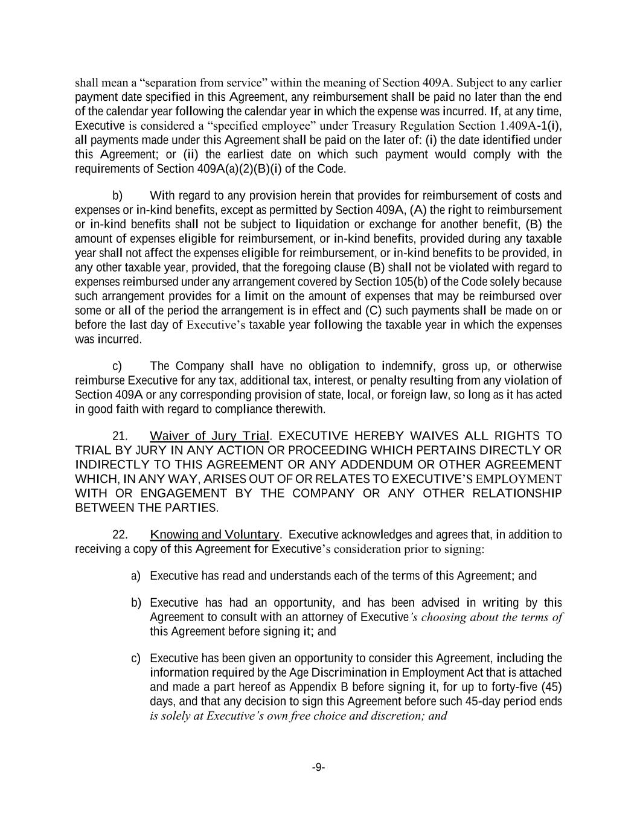
-9- shall mean a “separation from service” within the meaning of Section 409A. Subject to any earlier payment date specified in this Agreement, any reimbursement shall be paid no later than the end of the calendar year following the calendar year in which the expense was incurred. If, at any time, Executive is considered a “specified employee” under Treasury Regulation Section 1.409A-1(i), all payments made under this Agreement shall be paid on the later of: (i) the date identified under this Agreement; or (ii) the earliest date on which such payment would comply with the requirements of Section 409A(a)(2)(B)(i) of the Code. b) With regard to any provision herein that provides for reimbursement of costs and expenses or in-kind benefits, except as permitted by Section 409A, (A) the right to reimbursement or in-kind benefits shall not be subject to liquidation or exchange for another benefit, (B) the amount of expenses eligible for reimbursement, or in-kind benefits, provided during any taxable year shall not affect the expenses eligible for reimbursement, or in-kind benefits to be provided, in any other taxable year, provided, that the foregoing clause (B) shall not be violated with regard to expenses reimbursed under any arrangement covered by Section 105(b) of the Code solely because such arrangement provides for a limit on the amount of expenses that may be reimbursed over some or all of the period the arrangement is in effect and (C) such payments shall be made on or before the last day of Executive’s taxable year following the taxable year in which the expenses was incurred. c) The Company shall have no obligation to indemnify, gross up, or otherwise reimburse Executive for any tax, additional tax, interest, or penalty resulting from any violation of Section 409A or any corresponding provision of state, local, or foreign law, so long as it has acted in good faith with regard to compliance therewith. 21. Waiver of Jury Trial. EXECUTIVE HEREBY WAIVES ALL RIGHTS TO TRIAL BY JURY IN ANY ACTION OR PROCEEDING WHICH PERTAINS DIRECTLY OR INDIRECTLY TO THIS AGREEMENT OR ANY ADDENDUM OR OTHER AGREEMENT WHICH, IN ANY WAY, ARISES OUT OF OR RELATES TO EXECUTIVE’S EMPLOYMENT WITH OR ENGAGEMENT BY THE COMPANY OR ANY OTHER RELATIONSHIP BETWEEN THE PARTIES. 22. Knowing and Voluntary. Executive acknowledges and agrees that, in addition to receiving a copy of this Agreement for Executive’s consideration prior to signing: a) Executive has read and understands each of the terms of this Agreement; and b) Executive has had an opportunity, and has been advised in writing by this Agreement to consult with an attorney of Executive’s choosing about the terms of this Agreement before signing it; and c) Executive has been given an opportunity to consider this Agreement, including the information required by the Age Discrimination in Employment Act that is attached and made a part hereof as Appendix B before signing it, for up to forty-five (45) days, and that any decision to sign this Agreement before such 45-day period ends is solely at Executive’s own free choice and discretion; and

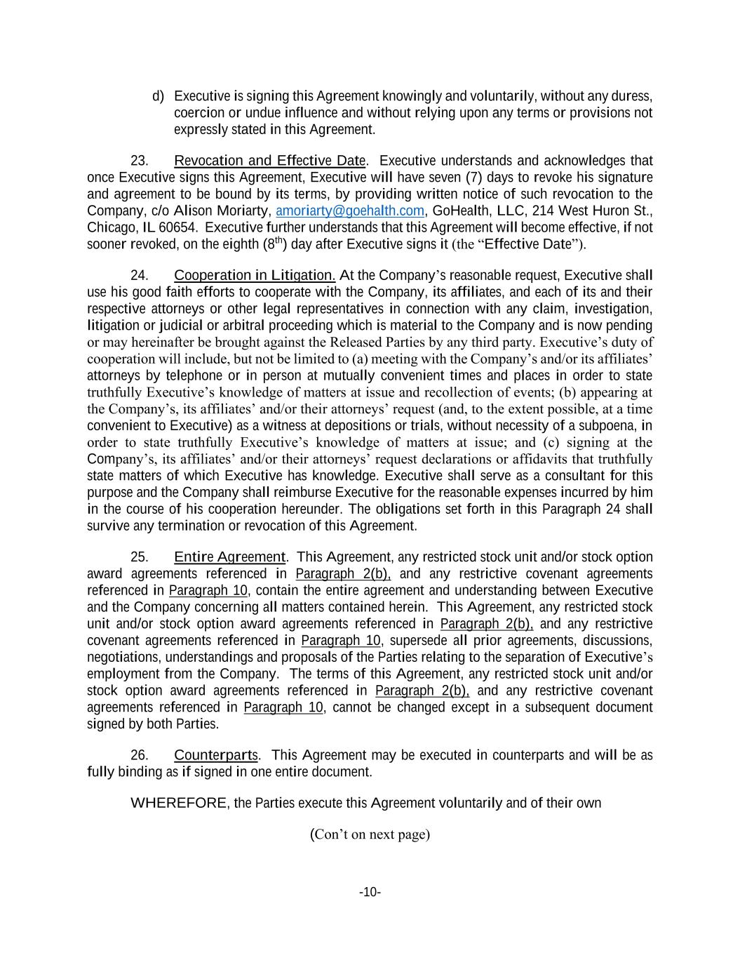
-10- d) Executive is signing this Agreement knowingly and voluntarily, without any duress, coercion or undue influence and without relying upon any terms or provisions not expressly stated in this Agreement. 23. Revocation and Effective Date. Executive understands and acknowledges that once Executive signs this Agreement, Executive will have seven (7) days to revoke his signature and agreement to be bound by its terms, by providing written notice of such revocation to the Company, c/o Alison Moriarty, amoriarty@goehalth.com, GoHealth, LLC, 214 West Huron St., Chicago, IL 60654. Executive further understands that this Agreement will become effective, if not sooner revoked, on the eighth (8th) day after Executive signs it (the “Effective Date”). 24. Cooperation in Litigation. At the Company’s reasonable request, Executive shall use his good faith efforts to cooperate with the Company, its affiliates, and each of its and their respective attorneys or other legal representatives in connection with any claim, investigation, litigation or judicial or arbitral proceeding which is material to the Company and is now pending or may hereinafter be brought against the Released Parties by any third party. Executive’s duty of cooperation will include, but not be limited to (a) meeting with the Company’s and/or its affiliates’ attorneys by telephone or in person at mutually convenient times and places in order to state truthfully Executive’s knowledge of matters at issue and recollection of events; (b) appearing at the Company’s, its affiliates’ and/or their attorneys’ request (and, to the extent possible, at a time convenient to Executive) as a witness at depositions or trials, without necessity of a subpoena, in order to state truthfully Executive’s knowledge of matters at issue; and (c) signing at the Company’s, its affiliates’ and/or their attorneys’ request declarations or affidavits that truthfully state matters of which Executive has knowledge. Executive shall serve as a consultant for this purpose and the Company shall reimburse Executive for the reasonable expenses incurred by him in the course of his cooperation hereunder. The obligations set forth in this Paragraph 24 shall survive any termination or revocation of this Agreement. 25. Entire Agreement. This Agreement, any restricted stock unit and/or stock option award agreements referenced in Paragraph 2(b), and any restrictive covenant agreements referenced in Paragraph 10, contain the entire agreement and understanding between Executive and the Company concerning all matters contained herein. This Agreement, any restricted stock unit and/or stock option award agreements referenced in Paragraph 2(b), and any restrictive covenant agreements referenced in Paragraph 10, supersede all prior agreements, discussions, negotiations, understandings and proposals of the Parties relating to the separation of Executive’s employment from the Company. The terms of this Agreement, any restricted stock unit and/or stock option award agreements referenced in Paragraph 2(b), and any restrictive covenant agreements referenced in Paragraph 10, cannot be changed except in a subsequent document signed by both Parties. 26. Counterparts. This Agreement may be executed in counterparts and will be as fully binding as if signed in one entire document. WHEREFORE, the Parties execute this Agreement voluntarily and of their own (Con’t on next page)

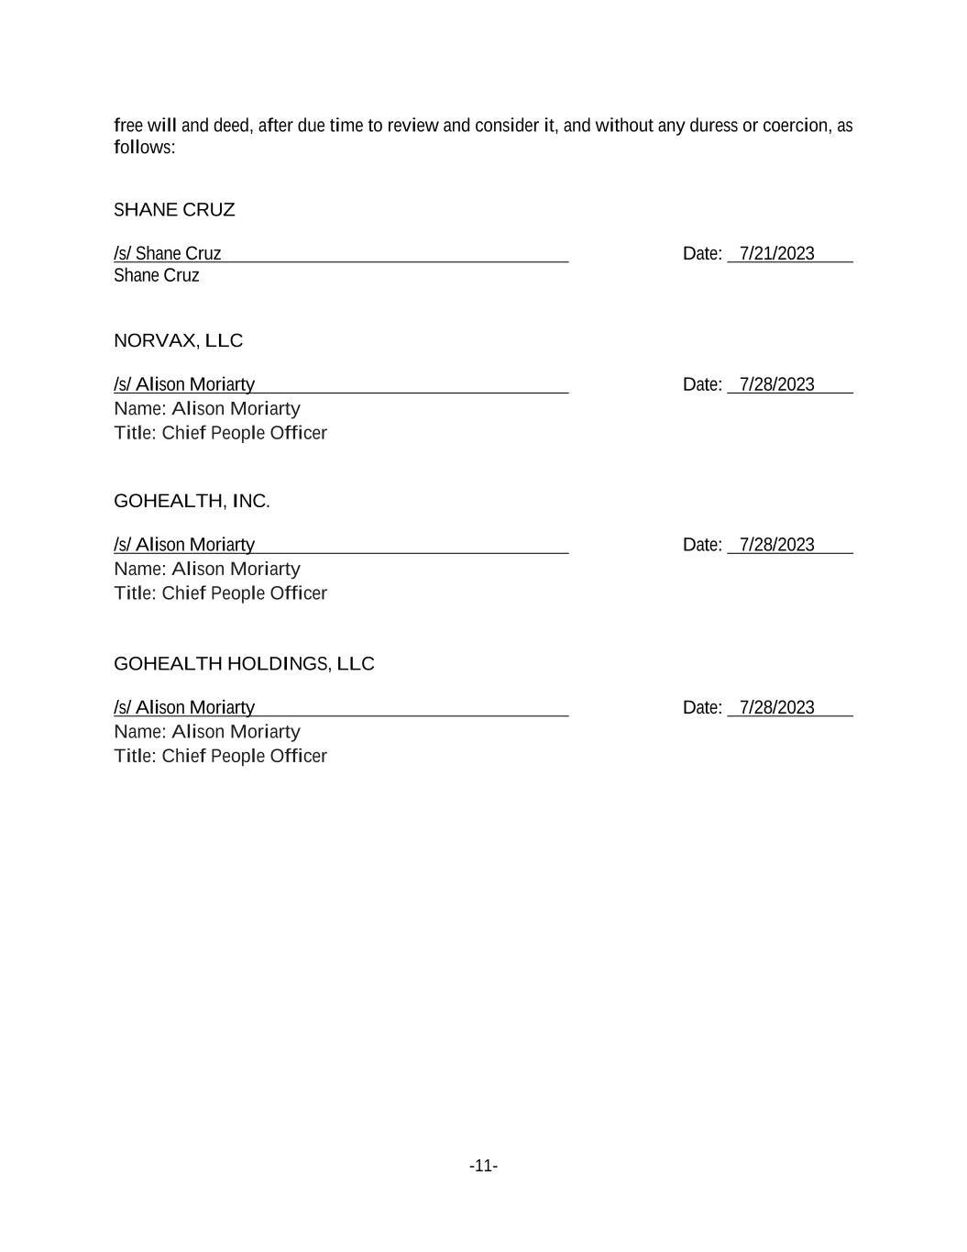
-11- free will and deed, after due time to review and consider it, and without any duress or coercion, as follows: SHANE CRUZ /s/ Shane Cruz Date: 7/21/2023 Shane Cruz NORVAX, LLC /s/ Alison Moriarty Date: 7/28/2023 Name: Alison Moriarty Title: Chief People Officer GOHEALTH, INC. /s/ Alison Moriarty Date: 7/28/2023 Name: Alison Moriarty Title: Chief People Officer GOHEALTH HOLDINGS, LLC /s/ Alison Moriarty Date: 7/28/2023 Name: Alison Moriarty Title: Chief People Officer

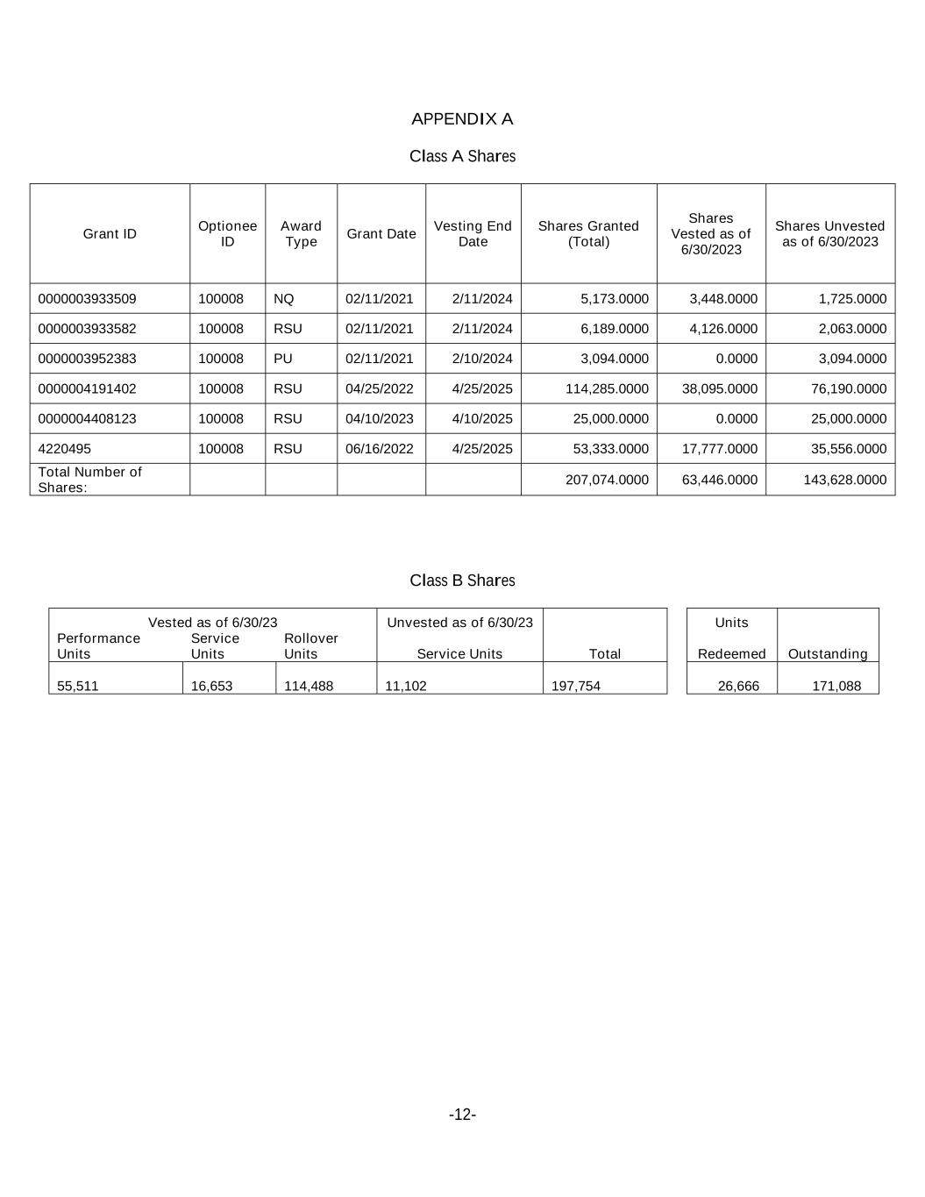
-12- APPENDIX A Class A Shares Grant ID Optionee ID Award Type Grant Date Vesting End Date Shares Granted (Total) Shares Vested as of 6/30/2023 Shares Unvested as of 6/30/2023 0000003933509 100008 NQ 02/11/2021 2/11/2024 5,173.0000 3,448.0000 1,725.0000 0000003933582 100008 RSU 02/11/2021 2/11/2024 6,189.0000 4,126.0000 2,063.0000 0000003952383 100008 PU 02/11/2021 2/10/2024 3,094.0000 0.0000 3,094.0000 0000004191402 100008 RSU 04/25/2022 4/25/2025 114,285.0000 38,095.0000 76,190.0000 0000004408123 100008 RSU 04/10/2023 4/10/2025 25,000.0000 0.0000 25,000.0000 4220495 100008 RSU 06/16/2022 4/25/2025 53,333.0000 17,777.0000 35,556.0000 Total Number of Shares: 207,074.0000 63,446.0000 143,628.0000 Class B Shares Vested as of 6/30/23 Unvested as of 6/30/23 Units Performance Units Service Units Rollover Units Service Units Total Redeemed Outstanding 55,511 16,653 114,488 11,102 197,754 26,666 171,088

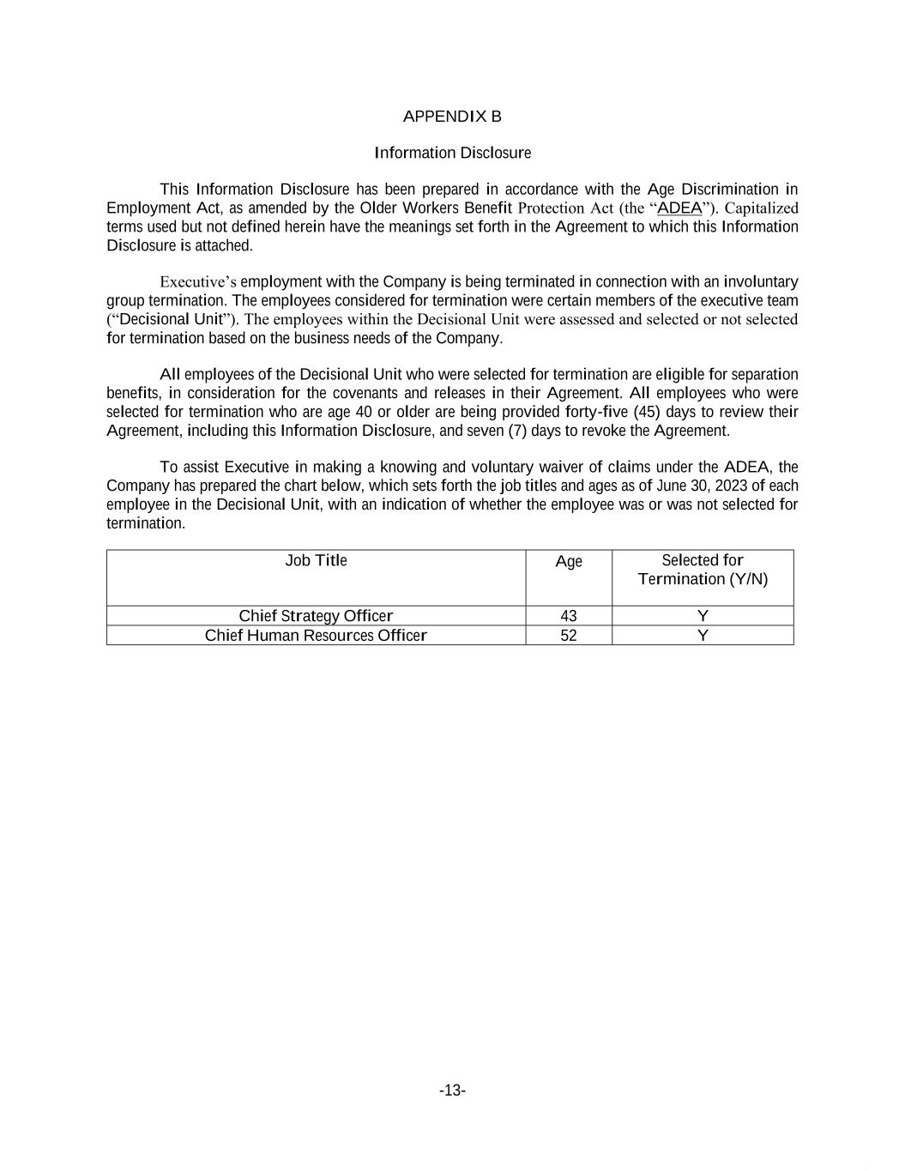
-13- APPENDIX B Information Disclosure This Information Disclosure has been prepared in accordance with the Age Discrimination in Employment Act, as amended by the Older Workers Benefit Protection Act (the “ADEA”). Capitalized terms used but not defined herein have the meanings set forth in the Agreement to which this Information Disclosure is attached. Executive’s employment with the Company is being terminated in connection with an involuntary group termination. The employees considered for termination were certain members of the executive team (“Decisional Unit”). The employees within the Decisional Unit were assessed and selected or not selected for termination based on the business needs of the Company. All employees of the Decisional Unit who were selected for termination are eligible for separation benefits, in consideration for the covenants and releases in their Agreement. All employees who were selected for termination who are age 40 or older are being provided forty-five (45) days to review their Agreement, including this Information Disclosure, and seven (7) days to revoke the Agreement. To assist Executive in making a knowing and voluntary waiver of claims under the ADEA, the Company has prepared the chart below, which sets forth the job titles and ages as of June 30, 2023 of each employee in the Decisional Unit, with an indication of whether the employee was or was not selected for termination. Job Title Age Selected for Termination (Y/N) Chief Strategy Officer 43 Y Chief Human Resources Officer 52 Y

Exhibit 31.1
Certification
I, Vijay Kotte, certify that:
1.I have reviewed this Quarterly Report on Form 10-Q of GoHealth, Inc.;
2.Based on my knowledge, this report does not contain any untrue statement of a material fact or omit to state a material fact necessary to make the statements made, in light of the circumstances under which such statements were made, not misleading with respect to the period covered by this report;
3.Based on my knowledge, the financial statements, and other financial information included in this report, fairly present in all material respects the financial condition, results of operations and cash flows of the registrant as of, and for, the periods presented in this report;
4.The registrant’s other certifying officer(s) and I are responsible for establishing and maintaining disclosure controls and procedures (as defined in Exchange Act Rules 13a-15(e) and 15d-15(e)) for the registrant and have:
(a)Designed such disclosure controls and procedures, or caused such disclosure controls and procedures to be designed under our supervision, to ensure that material information relating to the registrant, including its consolidated subsidiaries, is made known to us by others within those entities, particularly during the period in which this report is being prepared;
(b)[omitted];
(c)Evaluated the effectiveness of the registrant’s disclosure controls and procedures and presented in this report our conclusions about the effectiveness of the disclosure controls and procedures, as of the end of the period covered by this report based on such evaluation; and
(d)Disclosed in this report any change in the registrant’s internal control over financial reporting that occurred during the registrant’s most recent fiscal quarter (the registrant’s fourth fiscal quarter in the case of an annual report) that has materially affected, or is reasonably likely to materially affect, the registrant’s internal control over financial reporting; and
5.The registrant’s other certifying officer(s) and I have disclosed, based on our most recent evaluation of internal control over financial reporting, to the registrant’s auditors and the audit committee of the registrant’s board of directors (or persons performing the equivalent functions):
(a)All significant deficiencies and material weaknesses in the design or operation of internal control over financial reporting which are reasonably likely to adversely affect the registrant’s ability to record, process, summarize and report financial information; and
(b)Any fraud, whether or not material, that involves management or other employees who have a significant role in the registrant’s internal control over financial reporting.
Date: |  |  | August 10, 2023 |  |  | By: |  |  | /s/ Vijay Kotte
Vijay Kotte
Chief Executive Officer
(Principal Executive Officer)

Exhibit 31.2
Certification
I, Jason Schulz, certify that:
1.I have reviewed this Quarterly Report on Form 10-Q of GoHealth, Inc.;
2.Based on my knowledge, this report does not contain any untrue statement of a material fact or omit to state a material fact necessary to make the statements made, in light of the circumstances under which such statements were made, not misleading with respect to the period covered by this report;
3.Based on my knowledge, the financial statements, and other financial information included in this report, fairly present in all material respects the financial condition, results of operations and cash flows of the registrant as of, and for, the periods presented in this report;
4.The registrant’s other certifying officer(s) and I are responsible for establishing and maintaining disclosure controls and procedures (as defined in Exchange Act Rules 13a-15(e) and 15d-15(e)) for the registrant and have:
(a)Designed such disclosure controls and procedures, or caused such disclosure controls and procedures to be designed under our supervision, to ensure that material information relating to the registrant, including its consolidated subsidiaries, is made known to us by others within those entities, particularly during the period in which this report is being prepared;
(b)[omitted];
(c)Evaluated the effectiveness of the registrant’s disclosure controls and procedures and presented in this report our conclusions about the effectiveness of the disclosure controls and procedures, as of the end of the period covered by this report based on such evaluation; and
(d)Disclosed in this report any change in the registrant’s internal control over financial reporting that occurred during the registrant’s most recent fiscal quarter (the registrant’s fourth fiscal quarter in the case of an annual report) that has materially affected, or is reasonably likely to materially affect, the registrant’s internal control over financial reporting; and
5.The registrant’s other certifying officer(s) and I have disclosed, based on our most recent evaluation of internal control over financial reporting, to the registrant’s auditors and the audit committee of the registrant’s board of directors (or persons performing the equivalent functions):
(a)All significant deficiencies and material weaknesses in the design or operation of internal control over financial reporting which are reasonably likely to adversely affect the registrant’s ability to record, process, summarize and report financial information; and
(b)Any fraud, whether or not material, that involves management or other employees who have a significant role in the registrant’s internal control over financial reporting.
Date: |  |  | August 10, 2023 |  |  | By: |  |  | /s/ Jason Schulz
Jason Schulz
Chief Financial Officer
(Principal Financial and Accounting Officer)

Exhibit 32.1
Certification Pursuant to
18 U.S.C. Section 1350, as Adopted Pursuant to
Section 906 of the Sarbanes-Oxley Act of 2002
In connection with the Quarterly Report on Form 10-Q of GoHealth, Inc. (the “Company”) for the period ended June 30, 2023 as filed with the Securities and Exchange Commission on the date hereof (the “Report”), I certify, pursuant to 18 U.S.C. § 1350, as adopted pursuant to § 906 of the Sarbanes-Oxley Act of 2002, that:
(1)The Report fully complies with the requirements of section 13(a) or 15(d) of the Securities Exchange Act of 1934, as amended; and
(2)The information contained in the Report fairly presents, in all material respects, the financial condition and results of operations of the Company.
Date: |  |  | August 10, 2023 |  |  | By: |  |  | /s/ Vijay Kotte
Vijay Kotte
Chief Executive Officer
(Principal Executive Officer)

Exhibit 32.2
Certification Pursuant to
18 U.S.C. Section 1350, as Adopted Pursuant to
Section 906 of the Sarbanes-Oxley Act of 2002
In connection with the Quarterly Report on Form 10-Q of GoHealth, Inc. (the “Company”) for the period ended June 30, 2023 as filed with the Securities and Exchange Commission on the date hereof (the “Report”), I certify, pursuant to 18 U.S.C. § 1350, as adopted pursuant to § 906 of the Sarbanes-Oxley Act of 2002, that:
(1)The Report fully complies with the requirements of section 13(a) or 15(d) of the Securities Exchange Act of 1934, as amended; and
(2)The information contained in the Report fairly presents, in all material respects, the financial condition and results of operations of the Company.
Date: |  |  | August 10, 2023 |  |  | By: |  |  | /s/ Jason Schulz
Jason Schulz
Chief Financial Officer
(Principal Financial and Accounting Officer)

